WORLD METEOROLOGICAL ORGANIZATION

REGIONAL ASSOCIATION III (South-America)

RA-III

WIS IMPLEMENTATION PLAN

2014 - 2016



May 2014

Version control

Version | By | Date | Changes
0.1 | WG-ITD | 12/05/2014 | Initial draft based on RA-V WIS Implementation Plan v0.5.
0.2 | WG-ITD | 15/05/2014 | Interim WG-ITD workshop draft
0.3 | WG-ITD | 16/05/2014 | Final WG-ITD workshop draft

__________

Content
- Executive Summary
- Introduction
- Scope and purpose of the RA-III WIS Implementation Plan
- Description of WIS
  - WIS Services
  - The structure of WIS
  - WIS Centres
  - WIS data networks
  - Benefits of WIS
  - WMO information sources and regulations on WIS
- WIS in Region III (South America)
  - Current status of RA-III telecommunication
  - WIS centres in RA-III
- WIS planning and implementation by RA-III Members
  - Pre-requisites for participation WIS operation by an NMHS as an NC
  - Pre-requisites for participation of WIS operation by other centres
- Challenges associated with WIS implementation in RA-III
  - Insufficient bandwidth of communication links
  - General WIS acceptance
  - Lack of staff resources for operational WIS centre
  - Discovery Metadata knowledge
- RA-III WIS Implementation Plan – Execution and Timeline
  - Approval
  - Regional coordination and monitoring
  - National Implementation Plans
  - Capacity building – training and support
  - Goals and timeline
  - Progress and Performance Monitoring

Appendices:
Appendix I: Action Plan for implementing a NC in RA-III under WIS
Appendix II: Action Plan for implementing a DCPC in RA-III under WIS
Appendix III: Sample letters
Appendix IV: NC Demonstration Test Cases
Appendix V: List of acronyms
Appendix VI: Contact points for this plan
Appendix VII: Survey Benchmark

1- Executive Summary
Benefits for the Member countries of WMO Regional Association III (South America) arising from the full implementation of WIS (the WMO Information system) will include:
- Continued and enhanced operation of the GTS (WMO's Global Telecommunication System) providing a reliable and timely collection and dissemination service for time-critical and operation-critical data and products;
- The GTS will continue to make better use of public communications including the Internet where appropriate, and supported by advanced satellite distribution systems;
- The GTS data management framework will continue to pursue fast and efficient coding practices and data representations;
- A new system of catalogues available through a Global Information System Centre (GISC) portal, enabling online search, discovery and access of available data and products. This facilitates access to a much greater range of current and archived data and products;
- Download or re-runs of GTS data and products published in the past 24 hours;
- Simplified processes for Member countries to update GTS routing and provide information about available data and products.
The WIS Implementation Plan (WIS-IP) is aimed at guiding RA-III Members to implement WIS functionality in their identified centres and to become effective WIS users in a timely and harmonized manner. Therefore, it concentrates on enablement of new WIS functionality by NMHSs as National Centres (NC), i.e. it focuses on helping the members of RA-III to set up WIS functionality in their National Centres (NC) connected to their principal GISC in the Region. Although the establishment of Data Collection or Production Centres (DCPC) has been mentioned briefly, the implementation detail is not covered by this document, because implementation procedures for DCPCs are documented in the Manual on WIS and WIS Demonstration Process “Procedures and Guidelines”.
The WIS-IP outlines: the features of WIS; the benefits for Members to be connected to WIS; the current status of WIS in RA-III; the telecommunication network used for meteorological data and products; then goes on to describe steps for implementation in RA-III. The list of countries in RA-III together with their proposed principal GISC provides an overview of the structure of WIS after its regional implementation. The steps an NMHS has to take to function as a WIS NC are described in detail. The initial steps to establish a DCPC are also mentioned. Sample step-by-step implementation approach for these two cases is provided in the Appendices.
Challenges associated with the WIS implementation in RA-III are identified, together with possible remedies. The responsibilities of the GISCs in the WIS implementation monitoring are described with their importance for the successful implementation of the plan. The participation and cooperation of the national WIS Focal Points is stressed. The future activities to implement the plan are listed with the goal that most of the RA-III Members will be WIS enabled by the end of 2015.
Member countries and specifically their national WIS Focal Points are urged to maintain active collaboration with their principal GISC. For many RA-III countries that is GISC-Brasilia for which the contact details are provided in Appendix VI.

2. Introduction
In 2003, the World Meteorological Congress (Cg-14) stated that an overarching approach for solving the data management problems for all WMO and related international programmes, a single coordinated global infrastructure was required. This solution was named the WMO Information System (WIS) with the following features:
- WIS would be used for the collection and sharing of information for all WMO and related international programmes;
- WIS would provide a flexible and extensible structure allowing the participating centres to enhance their capabilities as their national and international responsibilities grow;
- Implementation of WIS should build upon the most successful components of existing WMO information systems in an evolutionary process;
- WIS development should pay special attention to a smooth and coordinated transition;
- The basis for the core communication network should be the communication links used within the World Weather Watch (WWW) for the high priority real-time data;
- WIS should utilize international industry standards for protocols, hardware and software.
Between Cg-14 (2003) and Cg-15 (2007), good progress was made in demonstrating the technological solutions for WIS through pilots and prototypes projects.
Cg-15 agreed that the WMO Information System should provide three fundamental types of services to meet the different requirements, as follows:
- Routine collection and dissemination service for time-critical and operation-critical data and products;
- Data discovery, access and retrieval service;
- Timely delivery service for data and products.
Cg-15 also emphasized that the WIS implementation should build upon existing WMO information systems in a smooth and evolutionary process. It agreed that the WIS implementation plan should have two parts that would be developed in parallel:
- Part A: the continued consolidation and further improvements of the GTS for time-critical and operation-critical data, including its extension to meet operational requirements of WMO Programmes in addition to the World Weather Watch (including improved management of services);
- Part B: an extension of the information services through flexible data discovery, access and retrieval services to authorized users, as well as flexible timely delivery services.
Cg-15 further emphasized that the support and involvement of all NMHSs, including regional associations and technical commissions in the WIS development was a crucial factor for ensuring a successful implementation and a shared ownership of the system.
During the period 2007 – 2011, between Cg-15 and Cg-XVI, under the leadership of the CBS, the development of WIS progressed both in terms of technological solutions and preparation of regulatory and guidance material for its implementation. Thus, Cg-XVI (2011) noted the significant progress achieved by Members in implementing WIS with 18 Members/organizations that have entered into the first round of the demonstration process for a total of 13 GISCs and 56 DCPCs (some of these centres had been in pre-operational mode since May 2010). Congress accepted the recommendation by CBS on the designation of the initial set of WIS centres. Congress requested that after the initial designation of WIS centres, further designations will be performed by EC in accordance with the Manual on WIS.
Cg-XVI stated that WIS had moved from a development stage into an operational stage and advised Members and relevant international organizations that WIS activities in 2012-2015 should focus on:
- Complete WIS implementation across all WMO Centres;
- Capacity building to ensure support of all WMO Members;
- Leveraging WIS advantages for all WMO Programmes; and
- Taking advantage of WIS in all WMO Data Management.
Cg-XVI became a turning point for intensive global, regional and national planning for the implementation of WIS and emphasized that although the implementation of the new functionality of WIS had been advanced in a few core centres, many Members were yet to begin their implementation. Cg-XVI expected that the full implementation of WIS by all Members will take at least the whole of the 2012-2015 financial period.
Congress set-up the following major activities and implementation target dates, urging all Members and the Secretary-General to identify the necessary resources for reaching the objectives:
- Improving the knowledge and capabilities of Members to benefit from WIS functionality, in particular least developed countries, developing countries and small island states through regional workshops and information sessions: 2012-2013;
- Implementation of WIS at all NMHS national centres (NCs): 2012-2015;
- Implementation of remaining candidate GISCs: 2012-2013;
- Implementation of more DCPCs, i.e. WIS interfaces at WMO Programmes’ centres: 2012-2015;
Amendments to the Manual on WIS for enhanced operational arrangements of WIS centres, especially GISCs: 2014.
The introduction on WIS presented above shows that the implementation of WIS in the WMO community opens the new chapter for the global data exchange. The benefits for the Member countries of WMO Regional Association III (South Americas) arising from the full implementation of WIS will include:
- Continued and enhanced operation of the GTS (WMO's Global Telecommunication System) providing a reliable and timely collection and dissemination service for time-critical and operation-critical data and products;
- The GTS will make better use of public communications including the Internet where appropriate, and supported by advanced satellite distribution systems;
- The GTS data management framework will continue to pursue fast and efficient coding practices and data representations;
- A new system of catalogues available through a GISC portal, enabling online search, discovery and access of available data and products. This facilitates access to a much greater range of current and archived data and products;
- Download or re-runs of GTS data and products published in the past 24 hours;
- Simplified processes for Member countries to update GTS routing and provide information about available data and products.

At the 15th session of World Meteorological Organization (WMO) Regional Association 3 (RA-III), Colombia (September 2010), and at the first session of the RA-III Management Group, the following subsidiary bodies were established:
- Working Group on Infrastructure and technology Development (WG-ITD)
- Working Group on Climatology
- Working Group on Hydrology
The structure of WG-ITD is indicated below. Mr Jose Arimatea de Sousa Brito (Brazil) and Mr Gaston Torres (Chile) were designated Chair and Vice chair of WG-ITD, respectively.
Chairman of the Working Group;
Vice-chairman of the WG;
Sub-group on Competences in matters of telecommunications;
Sub-group on Competences in matters of data management;
Sub-group on Integrated Observing Systems;
Sub-group on Regional aspects of Data Processing and Forecasting World System;
Sub-group on Regional Aspects of Public Meteorological Services.
The objective of the Working Group on Infrastructure and Technology Development (WG-ITD) is to contribute to the improvement of infrastructure (data and information services) for weather, climate and water in Region III through implementation of the WMO Integrated Global Observing System (WIGOS) and WMO Information System (WIS).
One of the tasks for WG-ITD is to develop the RA-III WIS Implementation plan. A new structure will be submitted to RA III to better address WIS and WIGOS implementation in RA III
In conclusion, the RA-III-WIS Implementation Plan is an all-inclusive guiding document for RA-III Members to follow in building an effective and efficient WIS infrastructure, in line with the guidance given by Cg-XVI for a fast transition from development to implementation phase of the WIS.

3. Scope and purpose of RA-III WIS Implementation Plan
The RA-III WIS Implementation Plan is aimed at guiding RA-III Members to implement WIS functionality in their identified centres and to become effective WIS users in a timely and harmonized manner. Therefore, it concentrates on enablement of new WIS functionality by NMHSs as National Centres (NC). Included in the scope of this plan is assisting Members to understand the benefits of WIS and convey these benefits to stakeholders.
In order to facilitate the implementation process, RA-III GISCs should establish close contacts with the NCs in their areas of responsibility. They are GISC Brasilia supported by GISCs Washington and Toulouse. In particular, GISCs should act as “help desks” and provide assistance to build the capacity of the NCs to handle the required discovery metadata. Also, the plan states the standards for WIS compliance of NCs for the guidance of Members and their principal GISCs.
The regional dimension of the implementation process is addressed in this WIS-IP. This dimension is important because it facilitates a synchronized and coordinated implementation by all Members and partner organizations of the Region. The existing capacity gaps, both technical and human resource related, could be addressed through the cooperation and assistance mechanisms of the Regional Association, which would accelerate the implementation and bring the expected benefits to all Members.
The Plan also provides practical guidance and a step-by-step approach towards the WIS implementation by Members in their National Centres. A primary task for the NMHSs is ensuring compliance with the WIS requirements established by the WMO regulatory material WMO Technical Regulations, Volume I (WNO-No. 49) and its Annex VII, Manual on the WMO Information System (WMO-No. 1060).

4. Description of WIS
WIS is the global infrastructure for managing and making available weather, water and climate information. WIS meets the requirements for routine collection and automated dissemination of observed data and products, as well as data discovery, access and retrieval services for all weather, climate, water and related data and products provided by centres and Member countries in the framework of all WMO Programmes.

4.1 WIS Services
While WIS builds on and extends the GTS, it is also a new approach to data discovery and data provision in the meteorological community. WIS goes far beyond providing telecommunication services, and offers new and modern data management services to its users. These are essentially the possibility to discover all data and products of the wider WMO community, as well as the means and information on how to obtain the data. For this purpose, all information within WIS is described by discovery metadata in accordance to the WMO Metadata Core Profile. It is assumed that WIS by including the GTS and the Internet will have sufficient bandwidth/link capacity available to fulfill future user needs. To this end, WIS provides three types of services:
    - Routine collection and dissemination service for time-critical and operation-critical data and products: This service is an extension of the current GTS. It is based on subscription to real-time “push and forward” distribution systems, including multicast and broadcast, and implemented mostly through dedicated telecommunication means providing a guaranteed quality of service. An important component of this service will be the “all hazards warning network” facilitating warnings to be distributed from one point in WIS to all other points within 2 minutes.
    - Service for the timely delivery of non time-critical, operationally critical or voluminous data and products: This is a new service which allows users to subscribe to data that would not otherwise have been available through the GTS because it is too voluminous or because the delivery is not so critically time- or operationally- dependent. Thus, the delivery method for these data does not need to use the capacity of the GTS. It is also suitable for those users not connected to the GTS. The service is focused on a “push” mechanism and implemented mostly via public data-communication networks, such as the Internet. As with the time and operationally critical service (1), users may use the discovery service (3) to search for the information they would like to access or subscribe to.
    - Data Discovery, Access and Retrieval (DAR) service: This is a new service where the user can use a variety of discovery services to search for data, products or other information registered within the WIS. Depending on the access policy for the data, the user may also access and download the data. The service is based on a request/reply “pull” mechanism and is to be implemented mainly through the Internet, but the user may also subscribe to receive data or products via the GTS or any other delivery mechanism available between the information provider and the user (for example via e-mail, SMS, facsimile, courier or postal services). In this way, WIS users can potentially discover and access all WMO data and products without having an extensive knowledge of the information practices and procedures of the WMO Programme responsible for the data or product. Note that if a user has an account at a GISC, then, depending on the data policy, it may be able to access information directly from the GISC, all of which hold information that is available for global exchange for at least 24 hours.

4.2 The structure of WIS
The WIS services described above are realized by WMO Members and associated centres through three types of WIS centres as well as the WIS data communication network. WIS centres need to be endorsed by WMO in accordance with the regulations described in the WMO Technical Regulations (WMO No. 49) and the Manual on WIS (WMO No. 1060).
The concept of interoperability guarantees that the overall functionality of WIS is realized by each WIS centre through implementing the specifications required for this type of centre.
The four core components are:
- Global Information System Centres (GISC)
- Data Collection or Production Centres (DCPC)
- National Centres (NC)
- Data networks

4.3 WIS Centres
GISCs collect and distribute information for routine global dissemination, such as GTS data. They serve as collection and distribution centres in their areas of responsibility and they provide access points for any request for data held within the WIS. A WIS user accessing the web portal of any GISC will be able to browse any data catalogue of information available in WIS.
DCPCs are connected to the GISCs and are responsible for the collection or generation of specialized sets of data, forecast products, processed or value-added information beyond the scope of NCs, and/or for providing archiving services.
NCs collect, produce and distribute data and products on a national basis and coordinate or authorize the use of the WIS by national users, normally under a policy established by the respective Permanent Representative with WMO.
The terms NC, DCPC and GISC are used for describing the necessary functions, not actual organizational entities. There may be organizations, such as NMHSs, which combine all three functions within their structure. There may be several GISCs in a Regional Association (RA). NCs and DCPCs can be associated with several GISC but have to choose one of the GISCs as their principal GISC for the purposes of uploading and managing discovery metadata. The following diagram provides an overview of the various components:

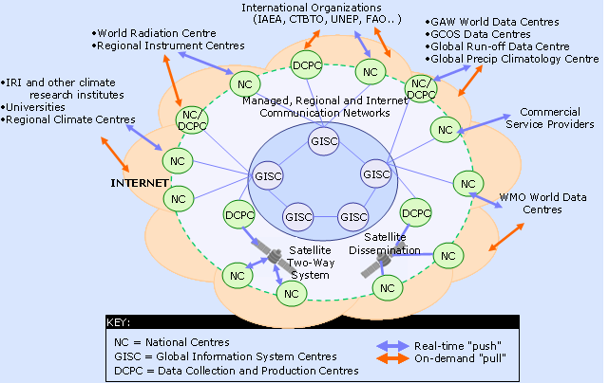
Figure 1: WIS core components and Information Exchange

4.4 WIS data networks
The WIS network structure consists of a WIS Core Network connecting all GISCs to each other. Each GISC has an Area Meteorological Data Communication Networks (AMDCN) connecting them to NCs and DCPCs in their area of responsibility. This is illustrated in Figure 2. An NC or DCPC may be in multiple AMDCNs. The AMDCNs incorporate GTS infrastructure and may involve single, partial or multiple regional meteorological telecommunication networks.
The data communication networks that can be used in WIS include:
  - The Main Telecommunication Network (MTN) of the GTS forms the WIS Core Network.
  - GISCs are also connected by the Internet, which presently is being used for discovery metadata synchronization.
  - The GTS (MTN and RMTN) provides the dedicated network component of the AMDCNs, especially for meeting real-time exchange requirements and the all hazards network. Note that the GTS includes extensive use of Internet through Virtual Private Networks (VPN) in many areas where no alternatives exist.
  - Satellite distribution systems such as those described by the Integrated Global Data Dissemination Service (IGDDS) form an essential part of the GTS and therefore the WIS, especially for the support of remote areas where terrestrial communication systems do not effectively meet the need. This includes data collection systems for remote platforms as well as for distribution of data and products related to the WMO Space Programme.
  - Terrestrial links or managed data network services.
  - The Internet, either open or utilizing VPN, which will be used in the AMDCNs to increase bandwidth capacity to many centres as well as providing connectivity for non-GTS centres and for individual users accessing WIS.
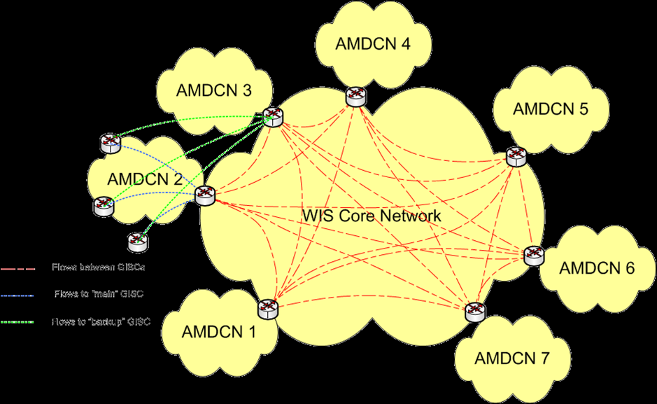
Figure 2: WIS network topology

4.5 Benefits of WIS
As an integrated part of WIS from the World Weather Watch Programme (WWW), the aim of the GTS is to ensure delivery of time-critical and operation-critical data, products and services for all WMO Programmes, including warnings to and from NMHSs. GTS realizes this through the "Routine collection and dissemination service for time-critical and operation-critical data and products", mentioned above.
The GTS will continue to develop and incorporate new technology, linking all WMO Members with a dedicated, secure network. This network will continue to be supported by advanced satellite distribution systems. In addition, the GTS will also be able to supplement the private networks and make better use of public communications such as the Internet, where appropriate.
The GTS data management framework will include the development of data representations, including fast and efficient coding practices that allow increasingly voluminous data streams to reach countries with less advanced or low capacity communication systems. New functionality of WIS for GTS users will include:
- Online discovery of which data and products are available on the GTS by interactively accessing a GISC portal;
- Download or re-runs of GTS data and products published during the past 24 hours. This is of interest for users that have missed data because of a failure of IT systems, equipment or networks;
- Updating of GTS routeing based on online subscription services rather than service messages requesting the GTS Point of Contacts to change the routeing. An NMHS may configure its own routeing information. Thus, a centre needs only deal with its associated GISC for changing subscription and publishing schedules;
- Configure upload of data to the GTS. Rather than requesting the GTS Point of Contact and WMO to change information about the data that is uploaded to the GTS, the NMHS may do the configuration.
- Ensure that the ownership and availability of the data provided is advertised by using the DAR metadata.
Existing centres within WMO Member States that comply with the required WIS functions and technical specifications will be designated as one of the three types of WIS centre. While Members can chose to apply for a type of centre matching their level of responsibilities and commitment, the expected mapping of WWW centres into WIS centres remains to be:

WWW Centre | WIS Centre
NMC | NC
RSMC | DCPC
WMC | DCPC and/or GISC
RTH | DCPC
RTH on MTN | DCPC and/or GISC
Others | NC and/or DCPC

4.6 WMO information sources and regulations on WIS
Information on all aspects of WIS is available on the WMO website at: http://www.wmo.int/wis
The implementation of the WIS is coordinated through a Global Project and Implementation Plan available at: http://www.wmo.int/pages/prog/www/WIS/documents/WIS-ProjectPlan-v1-2-1.doc.
The technical regulations related to WIS are published in the WMO Technical Regulations (WMO-No.49), Volume 1, General Meteorological Standards and Recommended Practices, Part I, Section 3, and in Annex VII, Manual on the WMO Information System (WMO-No.1060). Practical guidance on the implementation of the technical regulations is provided in the Guide to the WMO Information System (WMO-No. 1061).

5. WIS in Region III (South-America)

5.1 Current status of RA-III telecommunication
The current GTS in RA-III is a hierarchical structure with three Regional Telecommunications Hubs (RTH); Brasilia, Buenos Aires and Maracay. All Members are connected to at least one RTH. The data is sent from RTH to RTH and then from the RTHs to the other nodes connected to it. The current communication links between the centres are given in Fig. 3a and 3b below.
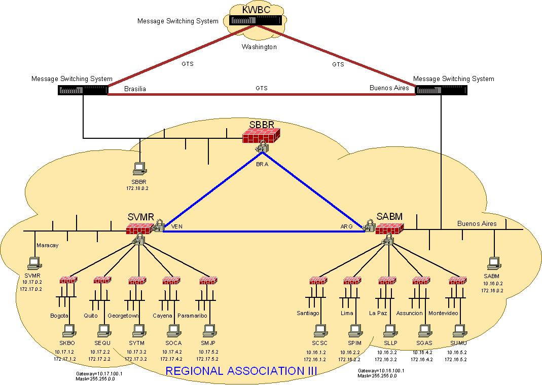
Figure 3a: Communication network in RA-III
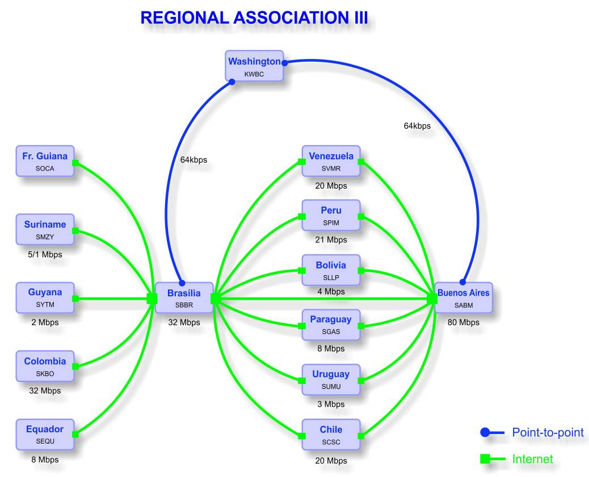
Figure 3b Connectivity Diagram and connection speeds
GISC Brasilia has still to join the Regional Meteorological Data Communication Network (RMDCN) however; GISC Brasilia provides an Internet Protocol (IP) network infrastructure utilising VPN technology over the Internet. Table 1 shows access speeds for Members’ centres. GISC Brasilia provides the gateway for the meteorological community in RA-III though bilaterally agreed links to other GISCs including Washington. Brasilia will be connected to all GISCs once it establishes its RMDCN connection.

Table 1 Internet connection speeds for RA III centres
Country | CCCC | Internet Access May 2014
Argentina | SABM | 80 Mbits/s + (150 Mbits/s on demand next 2 months)
Bolivia | SLLP | 4 Mbits/s
Brasil | SBBR | 32 Mbits/s
Chile | SCSC | 20 Mbits/s + 100 Mbits/s
Colombia | SKBO | 32 Mbits/s + 16 Mbits/s
Ecuador | SEQU | 8 Mbits/s + 8 Mbits/s
French Guiana | SOCA
Guyana | SYTM | 2 Mbits/s
Paraguay | SGAS | 8 Mbits/s
Peru | SPIM | 21 Mbits/s
Suriname | SMZY | 5120/1024 kbits/s
Uruguay | SUMU | 3 Mbits/s + 8 Mbits/s
Venezuela | SVMR | 20 Mbits/s + 2 x 2Mbits/s
The architecture of RA III GTS was developed to take into account improved and cost effective secure connectivity. It has proven to be very effective and robust. WG-ITD plans to undertake a review of the architecture with an aim to modernising the components and further enhance the performance and capacity of the network.

5.2 Status of WIS Centres in Region III (South-America)
The procedures for the designation of the three types of WIS centres are provided in the Manual on WIS (WMO No. 1060), Part II. After successful completion of the designation procedure, the centre is included in Appendix B to the Manual, Approved WMO Information System Centres.
Note: Information on the current status of the designation of centres by Members is available on: http://www.wmo.int/pages/prog/www/WIS/centres/index_en.php .
- GISCs in RA-III
GISC Brasilia is the only GISC located in RA-III having been conditionally designated by Congress in June 2011. It was endorsed by CBS in April 2013 and plans to be fully operational in 2015.
- DCPCs in RA-III
Table 2 below provides information on the DCPCs in RA-III with their planned functions and designation status (as of February 2014).

Table 2 DCPCs in RA III
Member /  Org | Function | Principal GISC | Const. Body | Endorsement CBS | Congress/EC
Argentina | RSMC-Geographical | Brasilia | CBS | Not submitted to TT-CAC
Argentina | VAAC | Brasilia | CAeM | Not submitted to TT-CAC
Argentina | RTH | Brasilia | CBS | Not submitted to TT-CAC
Argentina | RIC | Brasilia | CBS | Not submitted to TT-CAC
Argentina | Regional Ozone Centre | Brasilia | CAS | Not submitted to TT-CAC
Brazil | RTH | Brasilia | CBS | Approved by Cg/EC | 2011-06-01

- NCs in RA-III
In accordance with the Manual on WIS (WMO No. 1060), each WMO Member shall notify WMO of the name and location of its centre(s) that are to be designated as NC(s). It is therefore expected that each Member will have at least one NC in WIS.
In February 2012, WMO circulated a letter to all Members inquiring information from the Permanent Representatives regarding: 1) nomination of a principle GIS which will be associated with the WIS centre(s) of the Member; and, 2) nomination of a focal point for WIS/GTS related matters).
Table 3 below presents the current status of the designation of NCs in RA-III with their associated GISC and Focal Points.

Table 3 RA III NCs
Member /  Org | Function | Principal GISC | Focal Point (FP) | FP confirmed to WMO
Argentina | NMC | Brasilia | GIANNI, José Luis | Yes
Bolivia | NMC | Brasilia | REVILLA, Antonio Terán | Yes
Brazil | NMC | Brasilia | REZENDE, Jose Mauro | Yes
Chile | NMC | Brasilia | LAZCANO Luis | Yes
Colombia | NMC | Brasilia | FRANCO BUITRAGO, Julio César | Yes
Ecuador | NMC | Brasilia | CRUZ, Edison | Yes
France | WSO (French Guiana) | Toulouse
Guyana | NMC | Brasilia | Ms DANNY, Haymawattie | Yes
Paraguay | NMC | Brasilia | RODUS, Raúl | Yes
Peru | NMC | Brasilia | SOLIS, Olimpio | Yes
Suriname | NMC | Brasilia | Mrs WARSODIKROMA, T | Yes
Uruguay | NMC | Brasilia | ESPINOZA, Marcelo Chico | Yes
Venezuela | NMC | Brasilia | GARCIA, Kleiver José | Yes
Note: In view of the important role the national WIS focal points plays in the coordination of the WIS implementation, the Members who have not yet responded to the WMO circular letter are strongly encouraged to do soon as soon as possible. Members should also keep the WMO Secretariat informed of any changes of the status and operation of their centres and/or changes of their focal points information.

6. WIS planning and implementation by RA-III Members
In planning the WIS implementation at national level, Members should strive to comply with the relevant WMO technical regulations, that include procedures, specifications and functional requirements, provided in the WMO Technical Regulations (WMO-No. 49), Volume I, Part 1, Section 3, and the Manual on WIS, (WMO-No. 1060). The Guide to WIS (WMO-No. 1061) complements the technical regulations with additional description and explanation of the WIS, which would assist Members in their implementation actions.

6.1 Pre-requisites for participate WIS operation by an NMHS as NC
For a NMHS, there are several requirements to be met by a current GTS centre and thus become a compliant NC. They are mostly concerned with administrative issues and less with technical matters.
When a centre plans to use WIS, the PR of the country should nominate a “WIS Focal Point” and a “Principal GISC”.
- WIS Focal point
The WIS Focal point should be a member of staff who is familiar with the service, in particular the current GTS support. The person will receive all WIS related information with regard to the country on one hand, but is expected on the other hand to inform WMO and its relevant bodies about any progress or problems encountered when using WIS. He/she will attend training courses organized by WMO or WIS centres and serve as the national distributor of WIS knowledge, in particular the concept of metadata. It is envisaged that the WIS Focal point will provide the necessary monitoring information.
Since the structure of WIS assumes that an NC is connected to a GISC for its WIS functions and thus participates in the AMDCN organized by that GISC, it is necessary to set up the required administrative links with the GISC. In principle, an NC may belong to the users of any GISC, unless the network connectivity only allows one choice. In any case, an agreement should be reached between the NC and the GISC about their relationship, including identifying their “Principal GISC” for the purposes of managing discovery metadata, of which the WMO should be notified together with the nomination of the WIS Focal point (see Appendix).
For users who want to access GISC system for services and request an account on the GISC system, the GISC is required to seek permission from the WIS Focal Point of the country where the users are from.
- Principal GISC
The principal GISC will ensure within its AMDCN that all connected centres will receive all the data meant for them, be it globally distributed, additional or addressed data. The principal GISC will also collect the data sent by NCs and distribute them in accordance with GTS/WIS regulations. It will maintain the global metadata catalogue and provide means for its AMDCN centres to create/update those parts of the discovery metadata catalogue describing their own data and products, possibly via Internet access.
The principal GISC is to be contacted first by any of its connected centres about any issue related to WIS. It will organize regular meetings with the WIS Focal Points of the centres belonging to its AMDCN and provide training material and courses as required. It will support the metadata activities in its area of responsibility in a suitable manner and provide data for the regional WIS monitoring.
Member countries and specifically their national WIS Focal Points are urged to maintain active collaboration with their principal GISC. For many RA-III countries that is GISC-Brasilia for which the contact details are provided in Appendix VI.
Besides the principal, a back-up GISC is required for operational continuity in case the partial or total failure of the principal GISC. To guarantee at least the dissemination and collection of the globally distributed GTS data, the principal GISC need to consider a communication connection being established between NCs and the backup GISC, in collaboration with the NC and the backup GISC. Agreement needs to be reached on the network specific details, the conditions when it should be used and the actual services provided by it. The primary role of the backup GISC is to ensure data and products continue to be collected and distributed within RA III and shared with other regions. Regular tests should be carried out to ensure the availability of the back-up when suddenly required. Details of further back-up arrangements to be provided still need further work by the relevant CBS WIS expert teams. The backup GISC for Brasilia is GISC Washington.
In addition to direct interaction with their principal GISC Brasilia, local arrangements for data flow and metadata management in RA III have certain centres working through RTH Buenos Aires as follows. It is planned to provide initial WIS functionality for metadata and subscription management at GISC Brasilia and RTH Buenos Aires where Fr Guina, Suriname, Guiana, Colombia, Venezuela will operate with GISC Brasilia, the remaining countries through RTH Buenos Aires.
- Connectivity
RA-III members are connected to RTH Brasilia, RTH Buenos Aires and RTH Maracay through VPN over the Internet. Connection to WMC Washington is via fixed line between Brasilia and Washington, and from Buenos Aires fixed line to Washington. This provides alternative routes between Washington and RA III. Both centres are making efforts to connect to the RMDCN (WIS Core Network) as soon as possible.
- Bandwidth
The GTS in RA III is based on the internet. As per guidance from CBS, effective bandwidth and access speeds for the RA III GTS are measured by the centres access speed to the Internet. Current access speeds are recorded in Table 1 maintained by the Working Group on Infrastructure and technology development
- Discovery Metadata
Whereas the GTS data is defined by its header which is recorded in the relevant volumes, held by WMO, the data in WIS is described by a discovery metadata record in accordance to the WMO Metadata Core Profile and is stored in a metadata catalogue for each GISC and shared amongst all GISCs at regular intervals. It is the responsibility of the data owner to generate the corresponding discovery metadata record and to maintain it. However, in order to facilitate the initial deployment of WIS, Météo France generated metadata records for all data currently exchanged via the GTS. In the longer term though, these initial records have to be taken over by the relevant data owners and updated if required. In addition, if any new data is being considered for exchange, a corresponding discovery metadata record has to be generated and sent to the principal GISC in advance of the data.
Each NC, therefore, requires personnel with metadata knowledge and responsibility. To train the staff of NCs in discovery metadata handling, their principal GISC will offer regular training courses in addition to WMO sponsored training events like the WMO WIS Centre Jump-Start Offer. Each NC should make sure that staff are knowledgeable about the WMO Metadata Core Profile and are able to update its metadata records.
- Access to metadata editor
The editor for metadata records consists of a software tool which can be used locally by an NC or remotely at a GISC which makes this service available to NCs. New or modified records have to be made available to the principal GISC for feeding them into the WIS.
- Demonstration of WIS Compliance
A National Centre will need to demonstrate its compliance with WIS standards as laid out in the Manual on WIS. This is achieved by the centre working with the principal GISC to successfully complete the three test cases in Appendix IV and advising the secretariat that the GISC has endorsed the centre as having demonstrated its compliance with relevant WIS standards.

6.1 Pre-requisites for participation of WIS operation by other centres
There may be other WIS centres besides the NC of an NMHS within a country. For example, the NMHS might also operate one or more DCPCs for specialized data or there may be multiple DCPCs run by different organizations like hydrology and oceanographic centres. It is also possible, though unlikely, that a centre other than the NMHS could operate an NC.
- DCPC
As stated earlier, a DCPC is the WIS categorization of a programme centre that provides programme-specific data, e.g. An RTH is a centre supporting the GTS, or a RSMC providing specialize products under the GDPFS. Therefore, it has to be sponsored by a WMO programme and connected to a GISC in the region with sufficient bandwidth. In addition, special software to support the WIS functions of the centre has to be implemented. Once this has been achieved, the relevant PR may submit a proposal to WMO for the DCPC to be accepted, nominating a staff member responsible and stating the commitment to operate the DCPC after its validation.
In accordance with the Manual on WIS, a number of certifications and tests by WMO and, in particular, the CBS expert team designated for this role, will subsequently be carried out. When all operational and administrative requirements have been met successfully, including the handling of metadata in accordance with WMO Metadata Core Profile, CBS will propose to the EC that the DCPC becomes part of WIS.
- NC
Any NC additional to that of the NMHS will have to adhere to the same procedures as stated in 6.1 Its WIS centre Focal point should work closely with the national WIS Focal point of the NMHS who will be the main WIS interface of the country.

7. Challenges associated with WIS implementation in RA-III

7.1 General WIS acceptance
The benefits of WIS rely to a large extent on the global acceptance of WIS as the standard communication, discovery and access platform for WMO and associated institutions. Although WIS has been declared operational in January 2013, many NMHC centres in RA-III are still in the process of learning and understanding WIS. It is, therefore, necessary to raise the awareness of WIS in the region. GISCs should help centres to gain in-depth knowledge of how WIS works and what the benefits are. Other WMO initiatives such as WIGOS and GFCS are encouraged to use WIS as their information system, which will ensure the full benefits of WIS to all WMO Programmes and activities.

7.2 Lack of staff resources for operational WIS centre
Depending on the type of WIS centre being considered, there may be a concern of staff resources. For example, to operate a DCPC, staffs are required, who understands the software/system such as DAR to support the metadata. For an NC, the requirements can usually be met by the available resources for the on-going GTS support. Generally, staffs need to be trained to run WIS system and handle WIS related requests.

7.3 Discovery Metadata knowledge
Initially, there may be a lack of relevant metadata knowledge amongst the staff of the prospective WIS centre. It is therefore important to train staff on the WMO Metadata Core Profile and metadata in general. In addition, the WMO would try to arrange for training courses and support the attendance of relevant staff from developing countries. The necessary training material should be widely circulated. Furthermore, centres may take the WIS Jump-Start offered by the WMO secretariat or GISCs.

8. RA-III WIS Implementation Plan – Execution and Timeline

8.1 Approval
This Implementation Plan prepared by WG-ITD will be presented to RA III- XVI for approval.

8.2 Regional coordination and monitoring
The regional WIS implementation will be coordinated by RA-III WG-ITD, with the support from GISC Brasilia. An important aspect of the regional approach is the monitoring of the implementation actions that would allow quick identification and response to the problems and deficiencies. Without monitoring, there is a high risk that the implementation of WIS in some parts of RA-III would be delayed. The monitoring procedures will be defined to include regular information flow between RA-III WIS Focal Points, and WG-ITD. GISCs and DCPCs will play an important role in the monitoring as described in 8.6 below.

8.3 National implementation plans
Members are expected to develop their national WIS Implementation Plans by Dec 2014. The national WIS Focal point should communicate the national plans to the RA-III WG-ITD the target dates for the planned operation of WIS centres (NC, DCPC). The national plans should be coordinated with the principal GISC and should be in agreement with the RA-III WIS Implementation Timeline.

8.4 Capacity building – training and support
Noting the WIS competencies identified by CBS and the need to enable WIS functionality by all Members by the end of 2015, an essential activity in RA III is to provide “train the trainer” metadata management training as soon as possible. It is suggested that at least one expert be trained in each NMHS. Members are encouraged to utilise the WIS competencies and training guide in undertaking their capacity development and staffing.
Regional capacity development should utilize the GISC Brasilia and RTH Buenos Aires, for capacity building through regional horizontal cooperation.

8.5 Goals and timeline
The main goal of the WIS implementation in RA-III is that the majority of RA-III Members should be WIS users by December 2015, which means that most NMHSs are:
- Certified as a NC or DCPC, according to the WMO WIS centre certification procedure outlined in the Manual on WIS. The principal GISC of those NMHSs shall help in this process by providing technical support and conducting test for all WIS related operations together with the NCs or DCPCs.
- Able to participate in major WIS operations, i.e. a NC or DCPC should be able to obtain data and products from WIS system of its principal GISC, and to provide its own observation data and other products, along with the associated metadata, to its principal GISC.
The WIS implementation efforts so far and future timeline is as follow:
- May 2014: RA-III WG-ITD meeting – set the direction for WIS (and WIGOS) implementation.
- September 2014: RA-III -XVI to review Regional WIS Implementation Plan.
- Early 2015: GISC Brasilia launch and WIS training workshop.
- Adjacent to GISC Brasilia Launch, and subject to funding approval, conduct “train the trainer” metadata management workshop.
- April – December 2015: Act on the National WIS Implementation plan by each member, with the help and support from its Principal GISC, to archive the goal outline at the beginning of this paragraph.

8.6 Progress and Performance Monitoring
RA-III WG-ITD in conjunction with GISC Brasilia and RTH Buenos Aires will play an active role in monitoring the progress of the WIS implementation in the region. A half-yearly report will be issued to the RA III Management Group including updates from the RA III online WIS Survey to report the overall progress of the implementation. The members of the WG-ITD should also report their experience with metadata and problems encountered, as well as other implementation related issues, so that this information can be shared among the members through the half-yearly report.
Further improvement of the communications connectivity in RA-III is an ongoing task, which is crucial for the success of WIS implementation in the region. It is important to cooperate with other Task Teams within WG-ITD to work on this task.

APPENDIX I – NC Action Plan
Implementing a NC in RA-III under WIS
- Make (national) decision to join WIS as a NC.
- Identify the Principal GISC.
- Nominate the WIS Focal Point for the NC. The person should preferably be knowledgeable on current GTS operation and the concept of WIS.
- Review the status of the information technology and communication network, in particular the bandwidth to the current RTH and the bandwidth of the Internet connection.
- Review the current GTS operation in terms of data exchange and ensure that the communication network is sufficient to send and receive data a reliable and timely fashion under WIS. If this is not the case, the improvement of the communication network would be a priority. Solutions, such as increasing the bandwidth existing network or adopting additional communication means (e.g. satellite communication etc.) need to be implemented.
- Communicate with the chosen Principal GISC for support in the process of NC certification. Test cases listed in Appendix IV need to be carried out in cooperation with the GISC and approved by GISC.
- Set up a communication link to the principal GISC and create user accounts at the GISC for using the GISC systems.
- Decide whether the metadata generation/update should be supported locally or remotely by the GISC. In view of this decision, set up the necessary software environment: either by installing the metadata editor on a local server or by setting-up a connection to the GISC to use the metadata editing facility on GISC system.
- Inform WMO by letter from the PR on a) the decision to become an NC and the endorsement from the Principal GISC after the success in performing the test cases; b) the choice of the principal GISC and the nomination of the WIS Focal point, if haven’t done so yet.
- Train a staff member and, if possible, a back-up in the WMO metadata Core Profile by sending them to training courses organized by WMO or the GISC. It is also possible to ask for on-site support/training through the WMO WIS Jumpstart Offer.
- Take over responsibility for the metadata records describing the data submitted by the NMHS and modify/update them, if necessary.
- Start using the WIS functionality for sending and receiving data with their associated metadata.
- Join the user group of the GISC by attending meetings and other organized events.
- Support the monitoring of the regional WIS operation by responding to queries and/or questionnaires from the Principal GISC, which collects information, including availability of service, network traffic status, errors and other comments etc.

APPENDIX II – DCPC Action Plan
Implementing a DCPC in RA-III under WIS
- Make (national) decision to join WIS as a DCPC. Inform WMO, in particular CBS, by letter from the Director of the Organization about the wish to become a DCPC.
- Identify the Principal GISC.
- Nominate the WIS Focal Point for the DCPC. The person should preferably be knowledgeable on current GTS operation and the concept of WIS.
- Review the status of the communication network, in particular the bandwidth to the current RTH and the bandwidth of the Internet connection.
- Review the current GTS operation in terms of data exchange and ensure that the communication network is sufficient to send and receive data a reliable and timely fashion under WIS. If this is not the case, make sure that an upgrade of the communication network is planned and implemented prior to the operation as a DCPC.
- Select and install system(s) that can provide required services by a DCPC, as described in the Manual on WIS, in particular the metadata management, which is new under WIS.
- Communicate with the chosen Principal GISC for support in the process of DCPC certification. Contact CBS ET-WISC to organize demonstration of DCPC capability, in order to be endorsed by CBS and designated by WMO Cg as a DCPC.
- In accordance with the Manual on WIS, collaborate with the relevant CBS ET’s to pass all the necessary tests for a DCPC, which are outlined in the WIS Demonstration Process “Procedures and Guidelines” (http://www-db.wmo.int/WIS/centres/guidance.doc).
- Once the tests have been passed successfully and the centre has been endorsed by WMO Congress / EC, set up operations as a DCPC
- Join the user group of the GISC by attending meetings and other organized events.
- Support the monitoring of the regional WIS operation by responding to queries and/or questionnaires from the Principal GISC, which collects information, including availability of service, network traffic status, errors and other comments etc

APPENDIX III - Sample letter by PR of country to WMO for Establishment of NC, nomination of the WIS Focal point and the Principal GISC

To: the Secretary-General
WMO

Subject: Proposal for designation of WIS National Centre.

Dear Secretary-General,
In accordance with the Manual on the WMO Information System (WMO-No. 1060), para 2.4.2, and as part of the national plan for the implementation of the WIS, I would like to request that the centre [name, location], which is part of the [name of the NMHS], be designated as a National Centre (NC) of the WMO Information System (WIS), in accordance with the established procedure. I would like to inform you that the principal Global Information System Centre (GISC) associated to NC [name] should be [GISC name].
For coordination of WIS-related issues, I hereby nominate Mr/Ms [name, position, email address, phone] as the national WIS Focal Point.
Please update the records accordingly.
I look forward to receiving your advice on the action taken on the above request.
Yours sincerely

Permanent Representative of [WMO Member]

APPENDIX IV – NC Demonstration Test Cases

Test Case Name: NC Demonstration Test Case 1
Uploading of Discovery Metadata for Data and Products into DAR catalogue
Test Case ID | NC-TC1
Component | Metadata Management
Purpose of test
Validate the function of adding, updating and deleting metadata records from NC to the Principal GISC.

All metadata records must be checked against the relevant schemas. (e.g. The record should be rejected if not fitting the schema)

Note 1: The term “upload” refers to the movement of metadata records between the a National Centre that provides the metadata and the WIS centre that manages the DAR catalogue hosted by the Principal GISC. It can actually be implemented as a “pull” initiated from the DAR catalogue site, or as a “push” initiated by the metadata provider.

Note 2: this functionalities can be implemented as:
- A web interface allowing registered users to manage their metadata interactively
- A machine-to-machine interface allowing automated batch processing of metadata.

All GISCs support both methods. The NC may choose one or both methods
Relevant technical specifications
- Tech specs 1 (Uploading of metadata)
- Tech specs 8 (DAR Catalogue Search and Retrieval)
Precondition
- Network connection (dedicated and/or public connection) exists between the NC and GISC
- GISC has a file upload facility for collecting metadata from other WIS centre(s)
- GISC has a fully functional DAR catalogue
- GISC has a registered user/process that is authorized to manage metadata of a given WIS centre
- GISC has a web interface to the DAR catalogue that allow searches (see WIS-TC6)
Test Steps
 | Description | Expected Results | Actual Results
1 | A user/process adds a valid metadata record to the DAR catalogue | The metadata record must be found when browsing/searching the DAR catalogue
2 | A user/process modifies a record from the DAR catalogue, | The modification should be immediately visible when browsing/searching the DAR catalogue
3 | A user/process deletes a record from the DAR catalogue, | The deleted record should not be found when browsing/searching the DAR catalogue
… | A authorized user/process attempts to upload an invalid metadata record | The user/process must be notified of the fact that the metadata record is invalid. The addition/update operation is aborted. The DAR catalogue is unchanged.
… | A authorized user/process attempts to upload a record with a unique identifier that is already in the DAR catalogue | The DAR catalogue should not contain record with duplicate identifiers. Either:  1. The new metadata record replaces the old metadata record. The old metadata record should not be present in the catalogue. The new metadata record must be found when browsing/searching the catalogue  2. The user/process must be notified of the fact that the record is a duplicate. The addition/update operation is aborted. The DAR catalogue is unchanged.  Note: it is essential to ensure an update is an edit and not an accidental duplication
… | Access control No unauthorized addition 1 | A non-authorized user/process should not be able to add a metadata record to the DAR catalogue
… | Access control – No unauthorized addition 2 | A user/process should not be able to add a metadata record to the DAR catalogue representing data from another WIS centre
… | Access control No unauthorized modification 1 | A non-authorized user/process should not be able to modify a metadata record from the DAR catalogue
… | Access control No unauthorized modification 2 | A user/process should not be able to modify a metadata record from the DAR catalogue that belongs to another WIS centre
… | Access control No unauthorized deletion 1 | A non-authorized user/process should not be able to delete a metadata record to the DAR catalogue
… | Access control No unauthorized deletion 2 | A user/process should not be able to delete a metadata record from the DAR catalogue that belongs to another WIS centre

Centre |  | Organization |  | Country
Test Date

Test Case Name: NC Demonstration Test Case 2
Uploading and downloading of data between WIS centres

Test Case ID | NC-TC2
Component
Purpose of test
Validate the upload and download of data and products and association with metadata
Requirements Covered
- Tech specs 2 (Uploading of data and products)
- Tech specs 10 (Downloading file via dedicated network)
- Tech specs 11 (Downloading file via non-dedicated network)
- Tech specs 12 (Downloading file via other methods)
Precondition
- Network connection (dedicated and/or public connection) between the NC and GISC (includes via RTH where relevant
- Have file upload and download facilities (FTP, mail, HTTP, …)
- Have data available for upload or download
- Have DAR facilities available at GISC.
Test Steps
 | Description | Expected Results | Actual Results
1 | a. upload a file which is associated with a metadata record in the DAR catalogue of the GISC to a GISC centre  b. use DAR facilities to search the metadata then retrieve the file | a. The uploaded file has been delivered to the GISC and match with the corresponding metadata  b. The file can be downloaded

Centre |  | Organization |  | Country
Test Date

Test Case Name: NC Demonstration Test Case 3
Maintenance of users, roles, authorization and authentication
Test Case ID | NC-TC3
Component | Management of users and access
Purpose of test
Create and exercise a variety of user types.

Note: A centre may GISC user control interface
Relevant Technical Specifications
- Tech specs 4 (Maintenance of User Identification and Role Information)
- Tech specs 6 (Authentication of a User)
- Tech specs 7 (Authorization of a User Role)
- Tech specs 13 (Maintenance of Dissemination Metadata)
Precondition
- The Centre has authority to provide access to users (ie PR approval)
- A process is in place between the NC and GISC for the Centre to authorize its users to use the GISC with appropriate access levels.
- The user interface is via the internet (i.e. web page)
Test Steps
 | Description | Expected Results | Actual Results
1 | Provide access for an external user to search metadata | Temporary user can search metadata, but not access data from the GISC or cache, or subscribe to data.
 | - User goes to search web page  - User makes metadata search  - Tries to access data | - User has access to search page  - User finds metadata  - User tries to access data and is referred to authorisation page at data source. Cannot access data without validating in an authorized user role
2 | Create accounts with access to WIS metadata and data for a WMO centre authorized user | Two users are created. One with access to metadata only, the other with the ability to access the Centre subscription service or ad hoc request from the cache
 | - User goes to registered user web page  - User is required to login or create account  - User registers account and selects role of valid WMO member with authority to access WIS data (eg is from WMO NC)  - User enters login details  - User makes metadata search  - Tries to access WMO globally available data from the centre  - User tries to access additional data at centre that he is not authorized to access  - Tries to access data or product at another site  - User subscribes to data for future delivery from centre  - User returns on another session and reuses login to search or subscribe  - User edits subscription details  - User cancels a subscription  - User logs out or leaves centre’s site and tries to return to a bookmarked page at a later date and access data | - User has access to login page  - New user, so has to create an account  - User account is validated as a WMO NC member and account is created. The user receives a user login (eg code via email or encrypted symbol)  - User is logged in. As user us validated as WMO NC member, he is allocated access to search and access to download data from cache and to subscription services  - User finds metadata  - User successfully accesses data from centre  - User receives advice that he is not authorized to access this data and referred to access page where he can request change in user role or re-login as another user  - User is referred to authorisation page at other site.  - User receives scheduled data via agreed method at agreed time  - User maintains successful access with same access rights  - Users subscription details are updated and reflected in subsequent deliveries  - Users subscription details are updated and receives no further deliveries  - Attempting to use a bookmarked page from earlier session to access data, directs the user to the registered user login page.
4 | User checks status of account and subscriptions | User can view his account and subscription details, including historic and future transactions, and the status of current transactions
…

Centre |  | Organization |  | Country
Test Date

APPENDIX V - List of acronyms
AMDCN | Area Meteorological Data Communication Network
CBS | Commission for Basic Systems
Cg | Congress
DAR | Data Access and Recovery
DCPC | Data Collection or Production Centre
ECMWF | European Centre for Medium-range Weather Forecasts
ET-WISC | CBS Expert Team on WIS Centres (responsible for GISC/DCPC demonstration process)
GFCS | Global Framework for Climate Services
GISC | Global Information System Centre
GTS | World Weather Watch Global Telecommunication System
IGDDS | Integrated Global Data Dissemination Service
IMTN | Improved Main Telecommunication Network
MPLS | Multi-protocol Label Switching
MTN | Main Telecommunication Network
NC | National Centre
NMHS | National Meteorological and Hydrological Service
PR | Permanent Representative
RA | Regional Association
RMDCN | Regional Meteorological Data Communication Network
RMTN | Regional Meteorological Telecommunications Network
RTH | Regional Telecommunication Hub
WG-ITD | RA III Working Group on Infrastructure and Technology Development
VPN | Virtual Private Network
WIGOS | WMO Integrated Global Observing System
WIS | WMO Information System
WMO | World Meteorological Organization
WWW | World Weather Watch

Appendix VI. Contact points for this plan
The following contact details are referred to within the text of the plan. These are recorded in this Appendix so that they can be updated without changing the text of the plan itself.

GISC Brasilia
Mr Jose Mauro de REZENDE , WIS Focal Point
Instituto Nacional de Meteorología (INMET)
Eixo Monumental Sul - Via S1 - Sudoeste
70680-900 BRASILIA
D.F.
Brazil
Fax: +55 61 2102 4650
Tel: +55 61 2102 4621
Email: jmauro.rezende@inmet.gov.br

Appendix VII – WIS implementation Monitoring (Survey Results)
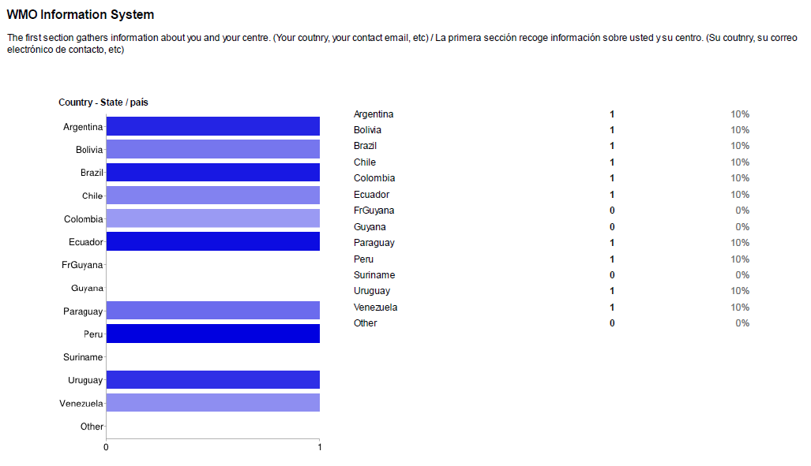
Figure 4 Country

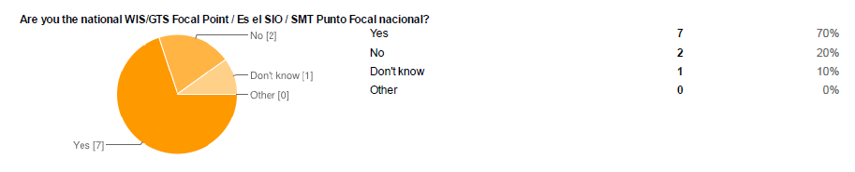
Figure 5 WIS Focal Point

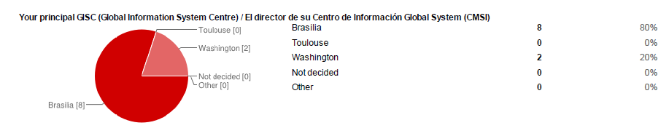
Figure 6 Principal GISC
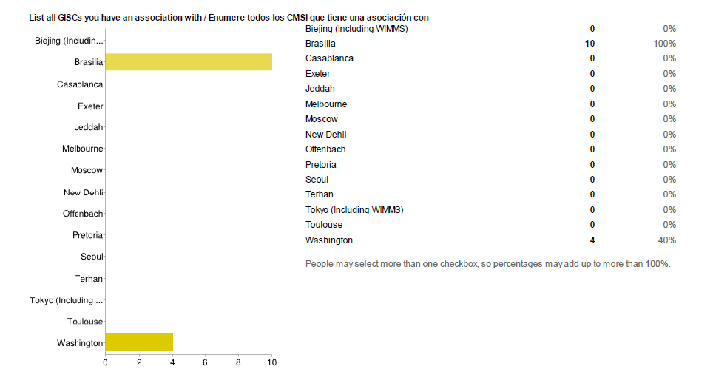
Figure 7 Associated GISCs

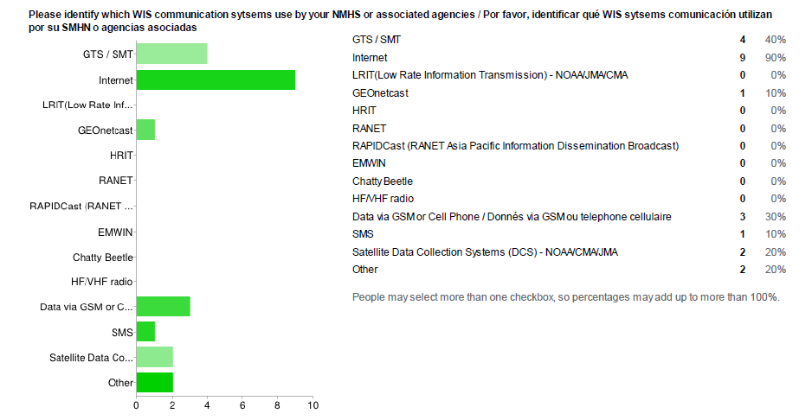
Figure 8 Communication technologies

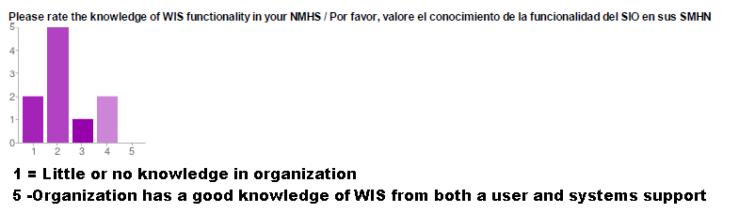
Figure 9 Level of organizational knowledge of WIS

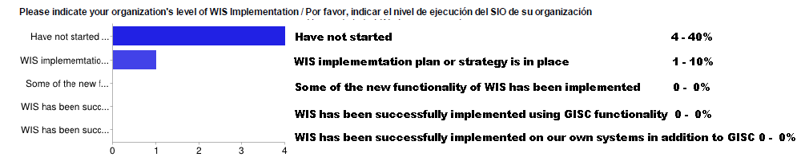
Figure 10 WIS implementation progress

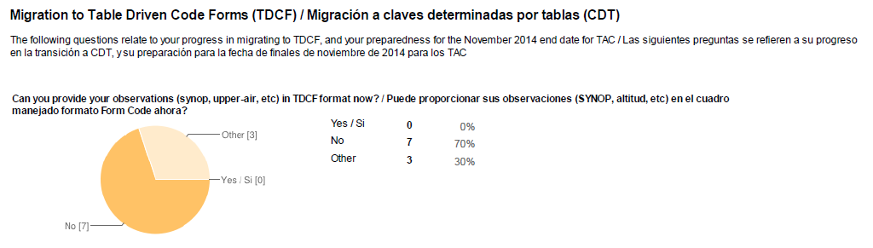
Figure 11 Progress in TDCF Migration

----

Manual on the WMO Information System (WMO No 1060) - http://wis.wmo.int/wis-manual
WIS Demonstration Process Guidelines - http://www-db.wmo.int/WIS/centres/guidance.doc
A full description of the existing GTS structure and networks can be found in the Manual on the GTS (WMO-No. 386). http://wis.wmo.int/gts-manual
see http://www.ecmwf.int/services/computing/rmdcn/
The current status is based WMO WIS Centres Database. Focal Point is based responses to the letter of 10 February 2012 (http://www.wmo.int/pages/prog/www/WIS/circular_letters_questionnaires.html) requesting PRs to nominate WIS focal points and Principal GISCs.
Terms of Reference for WIS Focal Points http://www.wmo.int/pages/prog/www/CBS/Lists_WorkGroups/CBS/cross-cutting/fp%20wis-gts/tors
WIS Jump Start - http://www.wmo.int/pages/prog/www/WIS/documents/JumpStartFlyer.doc
WIS Demonstration Process - http://www-db.wmo.int/WIS/centres/guidance.doc

