Status report of WIS center (Russia)

Purpose of the document and summary
The following document lines out the activities from GISC Moscow (http://gisc.mecom.ru). GISC Moscow implementation has started in 2011 and completed in December 2012. GISC Moscow received CBS endorsement in September 2012, successfully passed audit in March 2013 and received designation from WMO EC in June 2013. Governmental order for official operational status of GISC Moscow in Russia was signed in the January 2014.

Timeline

The following list provides a time order overview about GISC Moscow activities:
- February 2011 – start of GISC Moscow prototype (7 of 15 WIS TS ) development
- October 2011 - GISC Moscow prototype evaluation
- November 2011 – start of GISC Moscow full version (all WIS TS) development
- May 2012 – end of GISC Moscow full version (all WIS TS) development
- June 2012 – Start GISC Moscow test operations
- June 2012 – GISC backup agreement with GISC Offenbach
- August 2012 – GISC backup partial tests with GISC Offenbach were implemented
- September 2012 - CBS Demonstration
- November 2012 – GISC Moscow evaluation
- March 2013 - GISC Moscow passes audit successfully
- 4Q 2013 - Start GISC Moscow operations
- October 2013 – GISC Moscow HA-cluster architecture was improved
- December 2013 – GISC Moscow WIMMS metadata set was updated
- January 2014 – Official order within Roshydromet to change the GISC Moscow status from pre-operational to operational

- Telecommunication
GISC-Moscow is connected via following lines - 10Mbps RMDCN, 100Mbps Internet, 10Mbps Internet.
Current status of GTS circuits connected with RTH Moscow:
№ | Circuit | Status | Type of circuit | Circuit speed (bps) |  | Protocol | Data type
 |  |  |  | Moscow side | NHMS side | Protocol | Data type
1 | Exeter | MTN | MPLS | 2 M | 6 M | FTP WMO,  Simple FTP | Messages: A/N, BIN, FAX,  Files: NOAA satellite data
2 | Prague | MTN | MPLS | 2 M | 5,1 M | FTP WMO | Messages: A/N, BIN, FAX
3 | Sofia | MTN | MPLS | 2 M | 1,5 M | FTP WMO | Messages: A/N, BIN, FAX
4 | New-Delhi | MTN | MPLS | 2 M | 2 M | FTP WMO | Messages: A/N, BIN
5 | Cairo | MTN | Dedicated (digital) | 64 K | 64 K | FTP WMO | Messages: A/N, BIN
6 | Norrkoping | RMTN | MPLS | 2 M | 8,2 M | FTP WMO | Messages: A/N, BIN, FAX
7 | Minsk | RMTN | Dedicated (digital) | 128 K | 128 K | TCP/IP-Socket (Special) | Messages: A/N, BIN, FAX,  BIN-RADAR
8 | Kiev | RMTN | Dedicated (digital) | 256 K | 256 K | FTP WMO | Messages: A/N, BIN, FAX,  BIN-RADAR
9 | Tbilisi | RMTN | Through Internet | Internet | Internet | FTP WMO,  Web-access | Messages: A/N, BI, FAX
10 | Baku | RMTN | Through Internet | Internet | Internet | Email,  Web-access | Messages: A/N, FAX
11 | Erevan | RMTN | Through Internet | Internet | Internet | Email,  Web-access | Messages: A/N, BIN, FAX
12 | Kishinev | RMTN | Dedicated (digital/analog) | 19,2 K | 19,2 K | TCP/IP-Socket (Special)  Web-access | Messages: A/N, FAX,  BIN-RADAR
13 | Almaty | RMTN | Dedicated (digital) | 64 K | 64 K | TCP/IP-Socket (Special) | Messages: A/N, BIN, FAX,
14 | Beijing | Inter-regional | MPLS | 2 M | 3 M | FTP WMO | Messages: A/N, BIN, FAX,  Files: CMA and METOP Satellite data
15 | Novosibirsk | Inter-regional | VPLS | 1 M | 1M | TCP/IP-Socket (Special) | Messages: A/N, BIN,FAX,  BIN-RADAR
16 | Khabarovsk | Inter-regional | VPLS | 1M | 1M | TCP/IP-Socket (Special),  Simple FTP | Messages: A/N, BIN, FAX,  BIN-RADAR  Files: Satellite images
17 | Tashkent | Inter-regional | Dedicated (digital) | 64 K | 64 K | TCP/IP-Socket (Special) | Messages: A/N, BIN, FAX
18 | Hanoi | Inter-regional | Through Internet | Internet | Internet | FTP WMO | Messages: A/N, BIN
19 | Tehran | Inter-regional | Through Internet | Internet | Internet | FTP WMO | Messages: A/N, BIN
20 | Bucharest | bilateral | MPLS | 2 M | 256 K | FTP WMO | Messages: A/N, BIN
21 | Melbourne | bilateral | Through Internet | Internet | Internet | FTP WMO | Messages: A/N, BIN

Daily traffic volume on the GTS at RTH Moscow (MBytes/day) (see fig.1)

Figure 1 - Daily traffic volume on the GTS at RTH Moscow by year

Following expected DCPCs are already connected to VPLS network:
- RIHMI-WDC (Obninsk);
- Radioactive pollution modeling center (Obninsk);
- World Radiation Data Centre (WRDC) (St-Petersburg);
- WDC Sea Ice (St-Petersburg);
- RTH/RSMC (Khabarovsk);
- RTH/RSMC (Novosibirsk).

- Hardware and software infrastructure

Following diagram presents current architecture of GISC Moscow and its component view (fig.2).
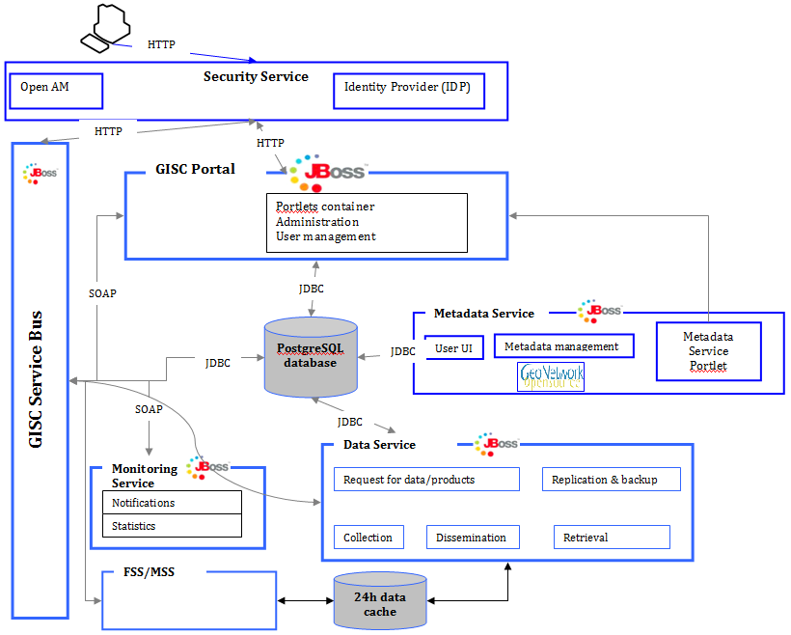
Figure 2 – Technical architecture of GISC/DCPC
This solution will be utilized to for the establishment of the expected DCPCs in the area of responsibility of GISC Moscow.
In October 2013 GISC hardware and software architecture has been improved by the new HA-cluster (High Availability Cluster) model (see fig.3). This includes an automatic stand-by scenario which takes in to account components dependencies. This reduced the overall recovery time to some minutes and ensured the stability of all GISC components within the GISC Moscow.
Some improvements were made in the GISC Portal user interface such:
- Faster DAR interface loading
- Faster 24h cache loading
- Upgraded GISC monitoring capabilities (delivery and dissemination)

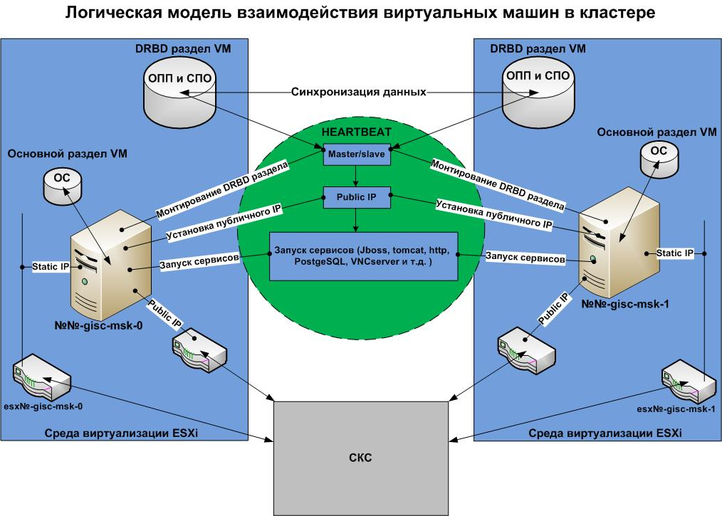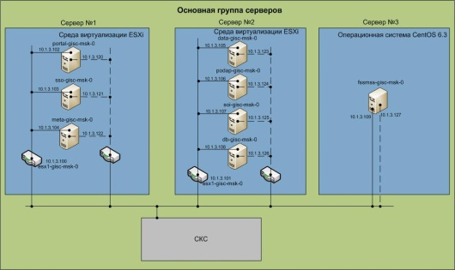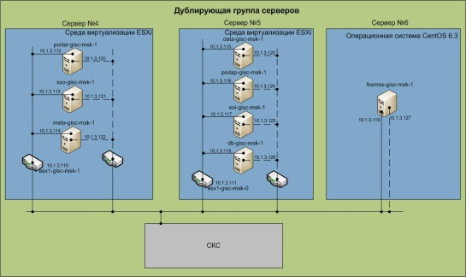
Figure 3 – GISC HA-cluster mode

- Interconnection with other GISCs
GISC Moscow provides constant-base metadata harvesting from GISC Tokyo, GISC Seoul, GISC Beijing, GISC Offenbach, GISC Toulouse, GISC Exeter and GISC Melbourne.

- DCPC and NC
All NCs and DCPCs are now submitting their data via GTS.
Following DCPCs are planned to start operation in 2014:
- Euro-Asian Climate Center/WMC (Moscow);
- JCOMM (Obninsk);
- Radioactive pollution modeling center (Obninsk);
- World Radiation Data Centre (WRDC) (St-Petersburg);
- WDC Sea Ice (St-Petersburg);
- WDC Hydrology (St-Petersburg);
- RHM/RSMC (Khabarovsk);
- RHM/RSMC (Novosibirsk).

- GISC Backup

GISC Moscow has bilateral agreements on backup with GISC Offenbach and GISC Toulouse.
GISC backup with GISC Offenbach:
Backup scheme was developed and implemented. All 26 NMHSs from GISC Offenbachs AMDCN are uploading their data intended for global exchange to GISC Moscow. GISC Moscow will issue soon accounts that the 26 NMHSs can download /subscribe data. Monthly regularly telephone conference between operation were arranged. Agreement on sharing logs of MSS/FSS for the essential data form area of responsibility for monitoring and performance needs was made.
GISC backup with GISC Toulouse:
Meeting with GISC Toulouse was held on 28-29 January 2014, Moscow, Russia. Meeting selected persons in charge of GISC Moscow – GISC Toulouse backup process. It was agreed to have list of NCs of GISC Moscow AoR for back-upped by GISC Toulouse; NCs of GISC Moscow AoR will send all of their data in parallel to GISC. GISC Toulouse and GISC Moscow have reviewed and edited document “GISC backup procedures. Define recommendation for GISC backup procedures”.
- GISC 24h data cache
GISC Moscow proves HTTP access to 24h data cache with overall volume of 3.5 GBytes per day. GISC Moscow is considering providing the FTP access to the 24h Cache.
- Metadata
In the end of 2013 WIMMS GISC Moscow metadata set was re-generated using the metadata generator kindly offered by GISC Offenbach.

References
[1] GISC Moscow (http://gisc.mecom.ru)
--------------------

