Review of the current status of implementation of TCP/IP procedures and applications at WIS centers

Current status of implementation of the GTS circuits
Current status of GTS circuits connected with the RTH Tokyo is shown in Table 1 and configuration on connectivity is shown in Figure 1.
- Topic:
  - Establishment of new link with Offenbach; Oct 2012
  - Fully replacement of the MSS; Oct 2013
  - Migrated the current RMDCN (Orange Business Services) to RMDCN Next Generation (Interoute); Feb 2014
  - Météo-France and JMA will establish the direct link in a short time.
- Details are shown here;
  - http://www.jma.go.jp/jma/jma-eng/jma-center/rth/GTS_upgrades.html

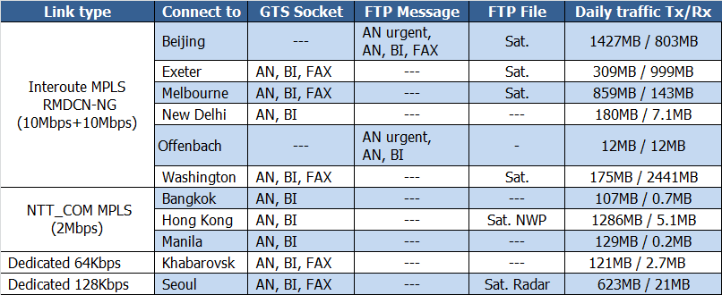
Table 1 Implementation status of GTS circuits connected to RTH Tokyo

Implementation status of TCP/IP protocol and applications
2.1 TCPIP
TCP/IP protocol is used on all the GTS circuits connected to the RTH Tokyo. Simple FTP is used to receive satellite data from Washington, Melbourne, Beijing, Seoul and Hong Kong and to relay subset of them to Washington, Melbourne, Beijing, Seoul and Hong Kong. Products of JMA's one week ensemble forecast model are also distributed to Hong Kong by simple FTP. Currently, data and products are exchanged in the following manner.
From
Washington: GET by Tokyo
Melbourne: PUT by Melbourne with file renaming
Exeter: PUT by Exeter with file renaming
Offenbach: PUT by Offenbach with file renaming
Beijing: PUT by Beijing with file renaming
Seoul: PUT by Seoul with file renaming
Hong Kong: PUT by Hong Kong with file renaming
To
Washington: PUT by Tokyo with file renaming
Melbourne: PUT by Tokyo with file renaming
Exeter: PUT by Tokyo with file renaming
Offenbach: PUT by Tokyo with file renaming
Beijing: GET by Beijing
Hong Kong: PUT by Tokyo with file renaming
Seoul: PUT by Tokyo with file renaming

Note) GTS file naming convention is used in these file exchange

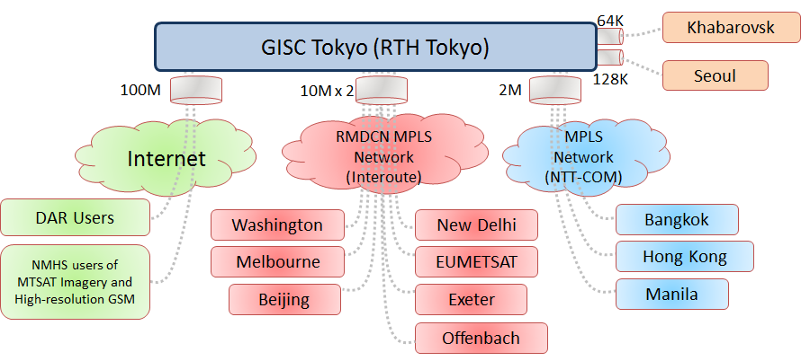
Figure 1: Configuration of the GTS circuit connected to the RTH Tokyo

WIS
4.1 Status of JMA
- Global Information System Centre (GISC)
- 8 Data Collection or Production Centres (DCPC)
- RTH
  - RSMC-Typhoon
  - RSMC-Geographical
  - RSMC-ATM
  - Satellite Centre
  - GPC-LRF (Forecast)
  - RCC (Tokyo Climate Centre)
  - WDC-GG (Greenhouse Gases)

4.2 GISC Tokyo
Services:
- Part A - Global Telecommunication System (GTS)
- Part B - Data Discovery, Access and Retrieval (DAR) Services [Internet]
  - Metadata management
    - Metadata search
    - Web interface for metadata creation and modification
  - GISC cache
    - Warnings, WMO format data
    - Facilitate data subscription
  - Help desk
  - Gateway to data services by DCPC
    - SATAID service - MTSAT imagery & more
    - Global Spectral Model products in 0.5 deg and 0.25 deg
- GISC Backup

Establishment of the Disaster Recovery Site (DRS)
Please note that JMA has a plan to establish the Disaster Recovery Site (DRS) on west side of Japan (Osaka city, 500km far from Tokyo) in 2015.

Traffic analyze
5.1 Traffic volume is increasing in two years.
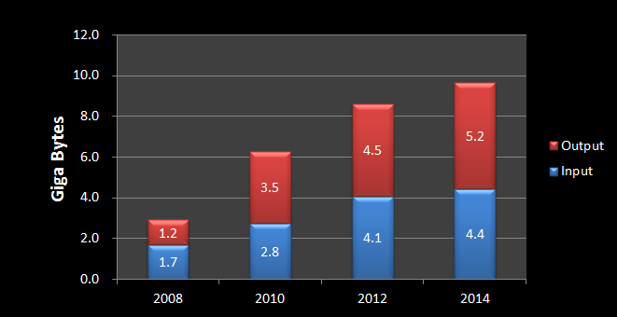
Figure 2 Statistics of data volume
5.2 Data volume in each channel
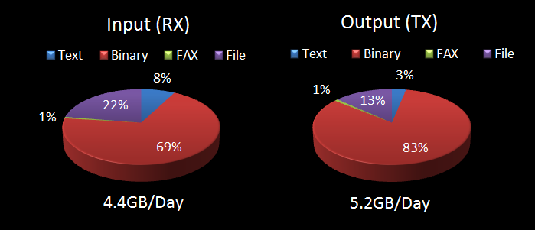
Figure 3 Statistics of data volume in each channel
5.3 Traffic status of the Tokyo-Washington link
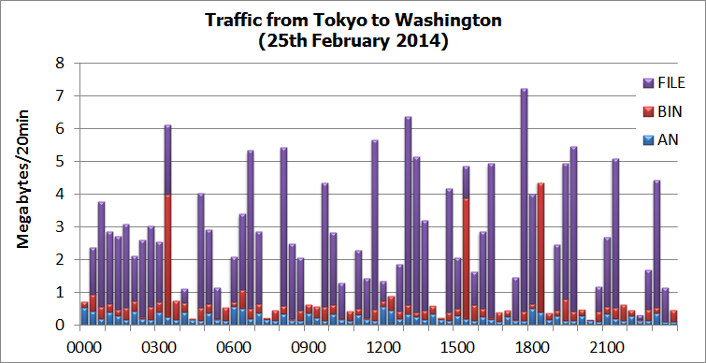
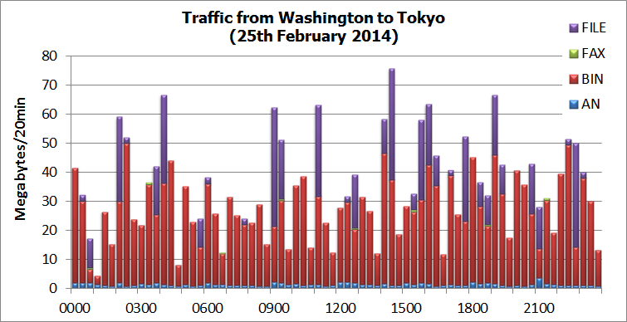
5.4 Traffic status of the Tokyo-Melbourne link
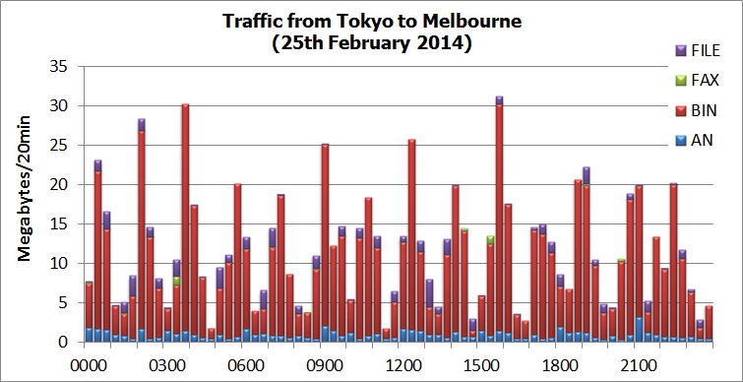
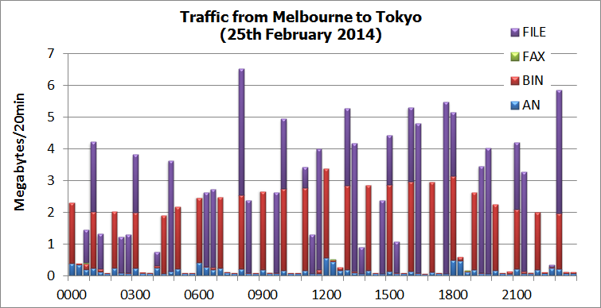

5.5 Traffic status of the Tokyo-Beijing link
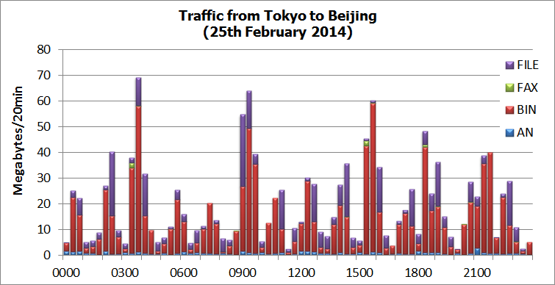
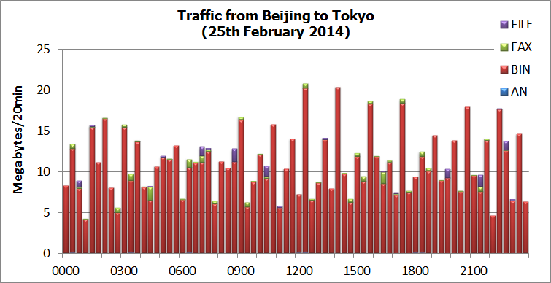

5.6 Traffic status of the Tokyo-Exeter link
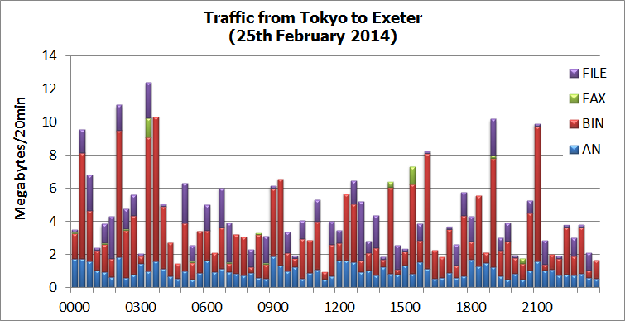
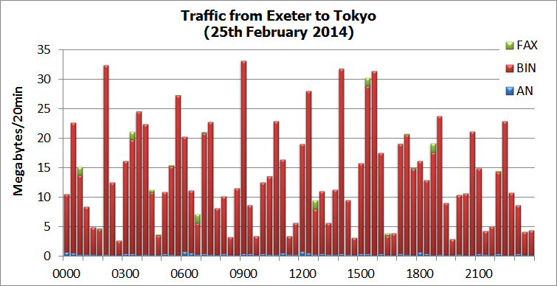

5.7 Traffic status of the Tokyo-Offenbach link
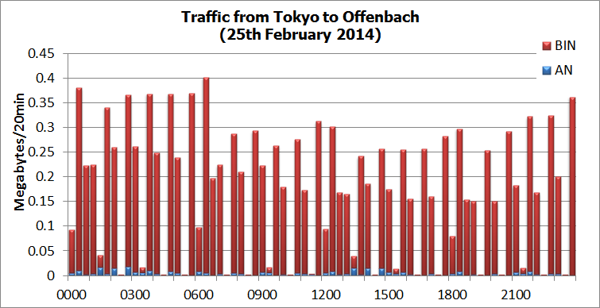
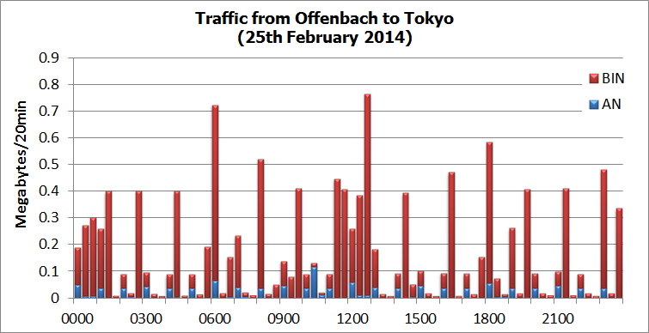

5.8 Traffic status of the Tokyo-New Delhi link
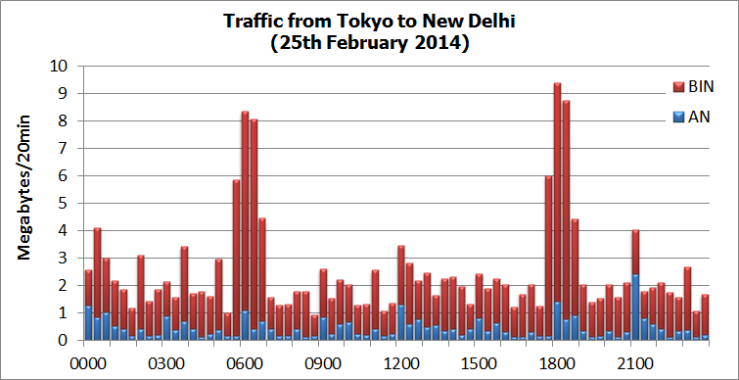
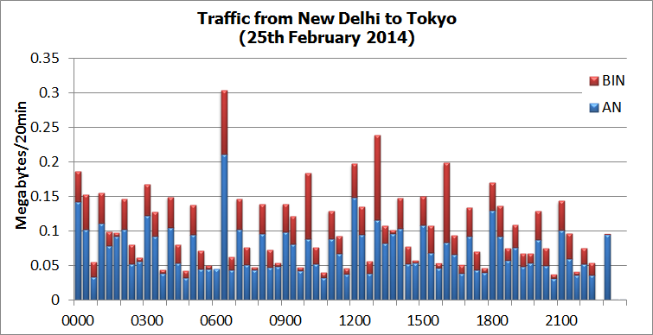

5.9 Traffic status of the Tokyo-Bangkok link
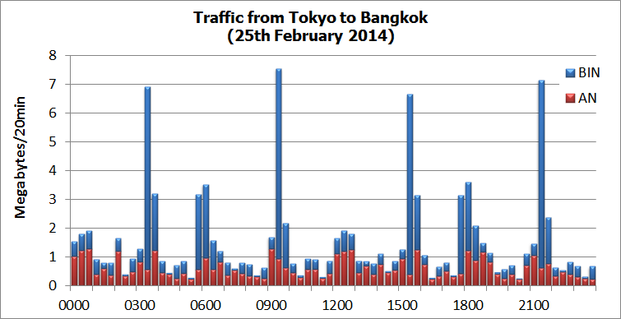
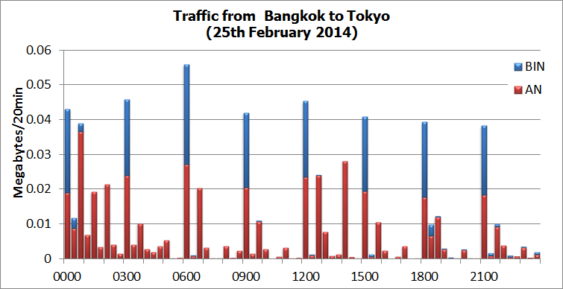

5.10 Traffic status of the Tokyo-Khabarovsk link
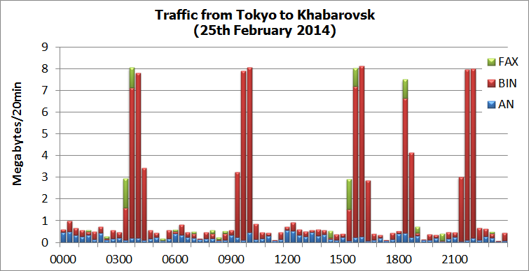
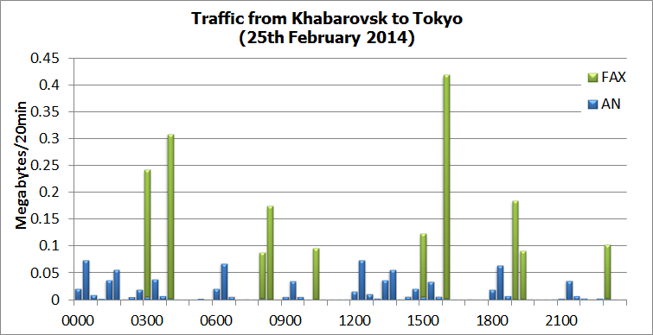

5.11 Traffic status of the Tokyo-Hong Kong link
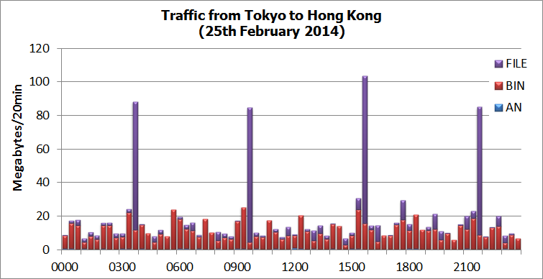
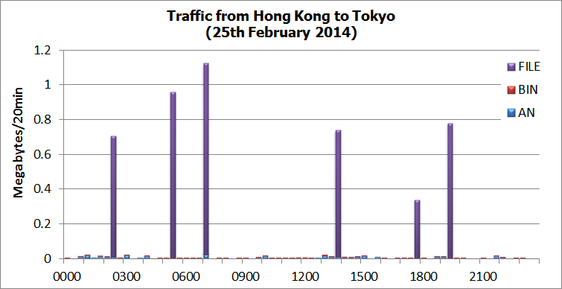

5.12 Traffic status of the Tokyo-Seoul link
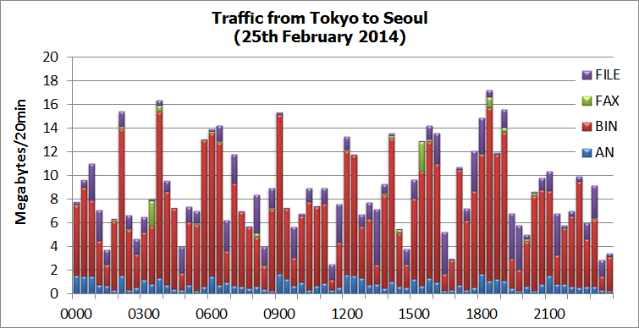
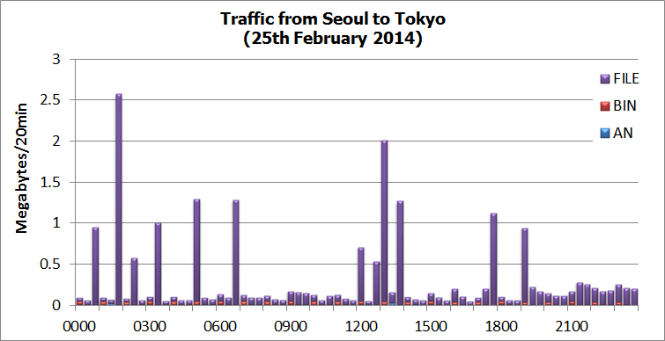

5.13 Traffic status of the Tokyo-Manila link
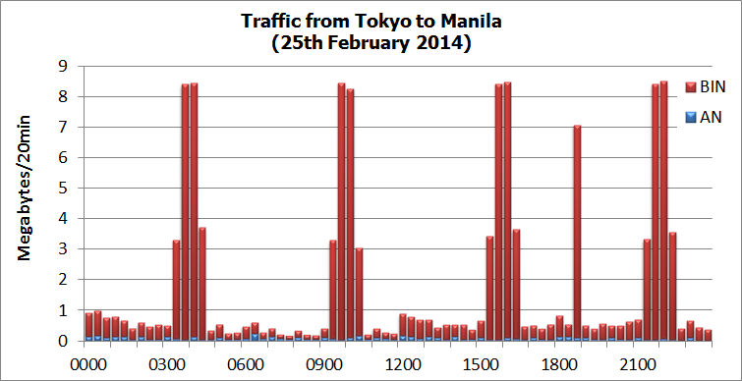
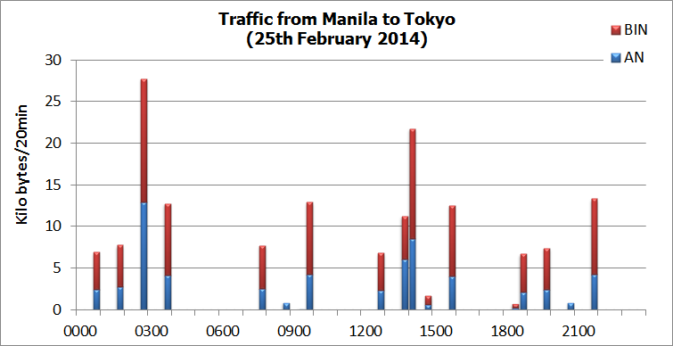

5.14 Traffic status of the Internet for WIS part-B (DAR).



