TT-GISC/07 Data policies management

Policy description
WMO Core Metadata 1.3 uses the following vocabulary "WMOEssential", and "WMOAdditional" and “WMOOther” for classifying data that have implied access and use constraints.
This description could not be clear to an unfamiliar user in WMO jargon.

Current example of data policy description:

<gmd:resourceConstraints>
<gmd:MD_LegalConstraints>
<gmd:accessConstraints>
<gmd:MD_RestrictionCode
codeList="http://standards.iso.org/ittf/PubliclyAvailableStandards/ISO_19139_Schemas/resources/Codelist/gmxCodelists.xml#MD_RestrictionCode" codeListValue="otherRestrictions">otherRestrictions</gmd:MD_RestrictionCode>
</gmd:accessConstraints>
<gmd:useConstraints>
<gmd:MD_RestrictionCode codeList="http://standards.iso.org/ittf/PubliclyAvailableStandards/ISO_19139_Schemas/resources/Codelist/gmxCodelists.xml#MD_RestrictionCode" codeListValue="otherRestrictions">otherRestrictions</gmd:MD_RestrictionCode>
</gmd:useConstraints>
<gmd:otherConstraints>
<gco:CharacterString>WMOEssential</gco:CharacterString>
</gmd:otherConstraints>
<gmd:otherConstraints>
<gco:CharacterString>GTSPriority2</gco:CharacterString>
</gmd:otherConstraints>
</gmd:MD_LegalConstraints>
</gmd:resourceConstraints>

Proposition to clarify the data policy by adding in metadata a short license description and including a link to a license type (WMO, ICAO, NC/DCPC, Creative Commons license … web site) for consultation.

Example of what could be policy description for Essential or Additional data:

<gmd:resourceConstraints>
<gmd:MD_LegalConstraints>
<gmd:accessConstraints>
<gmd:MD_RestrictionCode
codeList="http://standards.iso.org/ittf/PubliclyAvailableStandards/ISO_19139_Schemas/resources/Codelist/gmxCodelists.xml#MD_RestrictionCode" codeListValue="otherRestrictions">otherRestrictions</gmd:MD_RestrictionCode>
</gmd:accessConstraints>
<gmd:useConstraints>
<gmd:MD_RestrictionCode codeList="http://standards.iso.org/ittf/PubliclyAvailableStandards/ISO_19139_Schemas/resources/Codelist/gmxCodelists.xml#MD_RestrictionCode" codeListValue="otherRestrictions">otherRestrictions</gmd:MD_RestrictionCode>
</gmd:useConstraints>
<gmd:otherConstraints>
<gco:CharacterString>WMOEssential</gco:CharacterString>
</gmd:otherConstraints>
<gmd:otherConstraints>
<gco:CharacterString>No limitation. WMO Data License applied to the data resource – derived from WMO Resolution 25 and Resolution 40. WMO Essential Data: free and unrestricted international exchange of basic meteorological data and products.
http://www.wmo.int/pages/about/Resolution40_en.html
</gco:CharacterString>
</gmd:otherConstraints>
<gmd:otherConstraints>
<gco:CharacterString>GTSPriority2</gco:CharacterString>
</gmd:otherConstraints>
</gmd:MD_LegalConstraints>
</gmd:resourceConstraints>

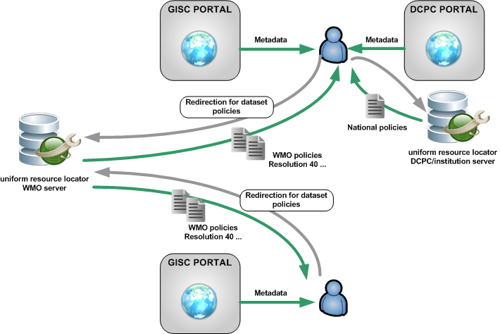
In any case the license definition is under the responsibility of the owner of the intellectual property rights in the data.
Another point is the condition of use which is not defined, for example it will be useful to indicate the restriction of use for a data like “inappropriate for maritime”…

Guide of data policies implementation in metadata
A guide including recommendation for data policies would be useful for NC and DCPC. A document is referenced in WMO Core 1.3: http://wis.wmo.int/MD_DataPolicy but no guidance is available on the website.
A “licence template” should be available including terminology recommendation the purpose would be to harmonize the dataset licences and make easier the user to understand the terms and to compare different licences.
Note that European INSPIRE project proposes some recommendations (Compliant with the ISO 19115) for data policies regarding:
- Conditions applying to access and use
- Limitations on public access
This can be useful for our need.

Data access
There is a need to check the consistency between data type and policy (especially for aviation OPMET) such as:
- Check that access to data is compliant with dataset policies by accessing data using public user and restricted user.
- Check that a modification of data access rights is proper take into consideration.

Dedicated set of public data
There is a strong interest in public access data. A set referencing only free and unrestricted access data would be useful for “external users”.

Recommended Text

1/ The license definition is under the responsibility of the owner of the intellectual property rights in the data.
2/ Aviation OPMET data policies are not covered by WMO Resolution 25 and WMO Resolution 40. The data policy in term of access and use on WIS shall be discussed with ICAO.
3/ A guide of data policies and license recommendation shall be proposed to WMO community. This guide will recommended license template and terminology in order to harmonize dataset policy.
4/Current description of data policy is not clear to an unfamiliar user in WMO jargon. Information about condition applying to access and use is missing. At least a short description of access and use shall be provided in the metadata including a link to a license.
5/ IPET-MDRD should study the possibility to comply WMO Core Metadata Profile with INSPIRE project regarding the “constraints related to access and use”.
6/ In order to check how GISC deal with data policy, TT-CAC shall establish a method by which access to a GISC cache is reviewed/audit.

ANNEXE 1: EXAMPLE OF POLICY USAGE IN INSPIRE

<gmd:resourceConstraints>
<gmd:MD_Constraints>
<gmd:useLimitation>
<gco:CharacterString>The data are made available on request to the author without charge for use in research, education and commercial work. Users of the data must publish their results based on using these data in open literature without any delay linked to other, e.g. commercial, objectives. Users must submit a copy of their results based on these data to the author who produced the data. No redistribution of the data for commercial re-use or reselling, however processed or derived, by any party who receives the data is allowed. Data must not be supplied as a whole or in part to any third party without the prior authorisation of the author. Users should help improve the quality of the data and its delivery by giving feedback where appropriate. All data use, however small, derived or embedded, must be acknowledged. The author may request co-authorship of the first publication arising from use of the data. Although every care has been taken in preparing and testing the data, the author cannot guarantee that the data are correct in all circumstances; neither does the author accept any liability whatsoever for any error or omission in the data, its availability, or for any loss or damage arising from its use. * Full text available at: http://europa.eu.int/eur-lex/pri/en/oj/dat/2003/l_345/l_34520031231en00900096.pdf
</gco:CharacterString>
</gmd:useLimitation>
</gmd:MD_Constraints>
</gmd:resourceConstraints>
<gmd:resourceConstraints>
<gmd:MD_LegalConstraints>
<gmd:accessConstraints>
<gmd:MD_RestrictionCode codeList="http://standards.iso.org/ittf/PubliclyAvailableStandards/ISO_19139_Schemas/resources/Codelist/ML_gmxCodelists.xml#MD_RestrictionCode" codeListValue="otherRestrictions">otherRestrictions</gmd:MD_RestrictionCode>
</gmd:accessConstraints>
<gmd:otherConstraints>
<gco:CharacterString>
(e) intellectual property rights
</gco:CharacterString>
</gmd:otherConstraints>
</gmd:MD_LegalConstraints>
</gmd:resourceConstraints>

