TT-GISC/10 Harmonization of file format of 24h cache
ET-WISC 2013 final report mention under item 4.11.4 that the GISCs should harmonize the Cache file format.

Progress
At ET-WISC meeting, 2013, DWD and JMA reported about investigation of differences of the file format of each 24h cache. The result is:
- There are only minor differences, but these can result in serious inconvenience to the users, especially in case of active GISC backup procedures.
And the meeting encouraged all GISCs to use the full “Meteorological bulletin” as default representation of GTS-bulletin data instances. (See Final Report 77, 78, 79)
Additionally, JMA investigated file format of alphanumeric of Exeter and Tehran and binary format of operational GISCs. The result is same as previous report. Four type of file format can be seen at 24h cache of GISCs

Investigation results

Alphanumeric format
- GISCs Beijing, Exeter, Melbourne, Offenbach, Seoul, Tokyo, Toulouse, Tehran (alphabetical order, the result of Beijing, Melbourne, Offenbach, Seoul, Tokyo, Toulouse, See Doc 56 of ET WISC MEETING [15-18 JULY 2013])
- Target GTS bulletin SMJP01 RJTD

Exeter
The file format of Exeter includes:
- Text part
File Name | A_SMJP01RJTD090000_C_RJTD_20131209000000_d53fbd35ecc97ed94aa6bbf7a4e42a0e.txt
Head | AAXX 09004  47401 11/75 62608 10011 21072 30131 40146 53001 69902 72682 86200
(Hex View)
Foot | 47991 16/// /0110 10241 20169 30133 40143 50008 60082  333 20195=
(Hex View)

Tehran
The file format of Tehran includes:
- Message Length, Format Identifier
- Starting Line
- Abbreviated heading
- Text part
- End of message signals
File Name | 2013_12_050600_SMJP01_RJTD_.txt
Head | 0000141300  853  SMJP01 RJTD 050600  AAXX 05064  47401 11/65 72607 10052 21031 30063 40077 55003 69901 72582 8227/=
(Hex View) | 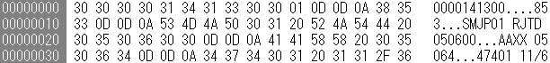
Foot | 47991 16/// /3212 10244 20230 30076 40086 53007 60051=  [ETX]
(Hex View)

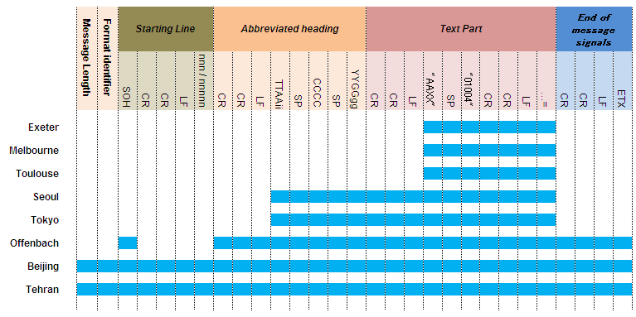
File format (alphanumeric) of GISCs

Binary format
- GISCs Beijing, Exeter, Melbourne, Offenbach, Seoul, Tokyo, Toulouse, Tehran (alphabetical order)
- Target GTS bulletin ISIC01 RJTD

Beijing
The file format of Beijing includes:
- Message Length, Format Identifier
- Starting Line
- Abbreviated heading
- Text part (BUFR)
- End of message signals
File Name | A_ISIC01RJTD042100_C_RJTD_20131204211919.bin
Head | 0000780900  48123  ISIC01 RJTD 042100  BUFR
(Hex View)
(Hex View)

Exeter
The file format of Exeter includes:
- Text part (BUFR)
File Name | A_ISIC01RJTD042100_C_RJTD_20131204210000_1594db83ed973d9108b636b6ac3f38e8.bin
Head | BUFR
(Hex View)
(Hex View)

Melbourne
The file format of Melbourne includes:
- Text part (BUFR)
File Name | A_ISIC01RJTD042100_C_RJTD_20131204210000_1594db83ed973d9108b636b6ac3f38e8.bin
Head | BUFR
(Hex View)
(Hex View)

Offenbach
The file format of Offenbach includes:
- Starting Line
- Abbreviated heading
- Text part (BUFR)
- End of message signals
File Name | A_ISIC01RJTD042100_C_RJTD_20131204212200.bin
Head | ISIC01 RJTD 042100  BUFR
(Hex View)
(Hex View)

Seoul
The file format of Seoul includes:
- Abbreviated heading
- Text part (BUFR)
File Name | A_ISIC01RJTD042100_C_RJTD_20131204211945_80_99b48c2f7ac06afbfc0efc92141e9c88.bin
Head | ISIC01 RJTD 042100  BUFR
(Hex View)
(Hex View)

Tokyo
The file format of Tokyo includes:
- Abbreviated heading
- Text part (BUFR)
File Name | A_ISIC01RJTD042100_C_RJTD_20131204211945_80.bufr
Head | ISIC01 RJTD 042100  BUFR
(Hex View)
(Hex View)

Toulouse
The file format of Toulouse includes:
- Text part (BUFR)
File Name | A_ISIC01RJTD042100_C_RJTD_20131204210000_1594db83ed973d9108b636b6ac3f38e8.bin
Head | BUFR
(Hex View)
(Hex View)

Tehran
The file format of Tehran includes:
- Message Length, Format Identifier
- Starting Line
- Abbreviated heading
- Text part (BUFR)
- End of message signals
File Name | 041500_12_041500_ISIC01_RJTD_.bufr
Head | 0000780700  249  ISIC01 RJTD 041500  BUFR
(Hex View)
(Hex View)

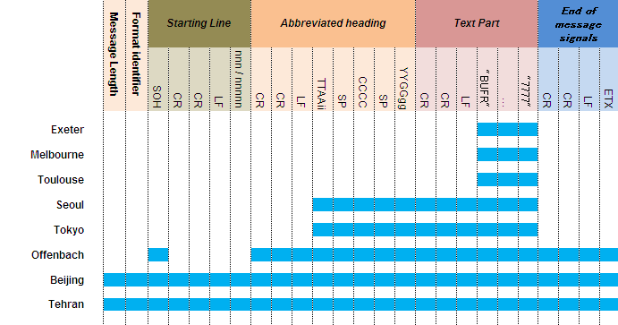
File format (binary) of GISCs

Interoperability with the GTS
The message from GTS can be stored to 24h cache, also the file of 24h cache should be able to send to GTS. For re-transmission to the GTS, it should be not drop necessary parts (Abbreviated heading) from original message. Regarding 'Starting Line' part, It will be added when the message is created and sent for GTS transmission in the MSS with 'Message Length' and 'Format identifier' part .

Filename (is just a filename)
The data files stored in the 24h cache have regular filenames with file name convention. So users can recognize what kind of data from file name. The other side, the data file might be downloaded with another file name such as temp1, temp2. In that sense, GISCs must keep ‘Abbreviated heading’ part in file.

Inconvenience for users.
According to the investigation result above, four patterns of file format of 24h cache were confirmed. While a user downloads the data files from one GISC, there will be no problem for reading/processing data files. But when users switch data provider to another GISC, there will be the possibility that user can not read/process data files because of such a difference of file format.
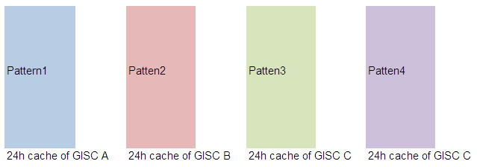
Current status of 24h cache of GISCs

Sharing information of 24h cache is GISC’s task. WIS manual say “3.5.3.1 Each GISC shall collect from its area information that is intended for global exchange and shall share such information with other GISCs so that all GISCs have a common holding of information available for global exchange.” There is some ways to share data files, but when GISCs share data files from 24h cache directly, then several type of file format will be seen in 24h cache of one GISC.

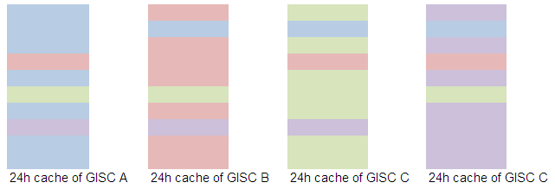
After Synchronization data files from 24h cache directly

Convert!
Convert!
Convert!
Convert!
Convert!
Convert!
Convert!
Convert!
Convert!
Convert!
Convert!
Convert!

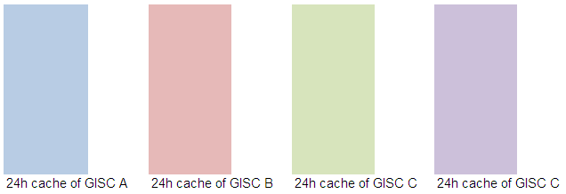
GISCs must convert data file format.

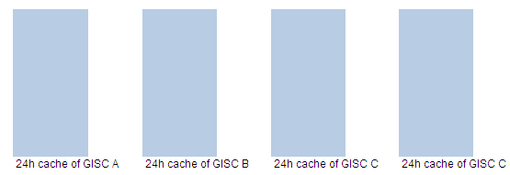
Ideal status

References:
[1] Report of the sixth session of ET-WISC (2013) (Annex 11) - http://wis.wmo.int/doc=2799
[2] Manual on GTS Attachment II-15 para 5.2 - http://library.wmo.int/opac/index.php?lvl=notice_display&id=47

Recommended Text
Mr. Shigeharu NISHIKAWA reported additional investigation for file format of 24h cache to complement DWD and JMA’s report of ET-WISC meeting, 2013. He emphasized decision of previous ET-WISC meeting about file format of 24h cache, ‘the meeting encouraged all GISCs to use the full “Meteorological bulletin” as default representation of GTS-bulletin data instances.’. He also mentioned interoperability with the GTS, about filename and inconvenience for users.

