3.1 Status reports of WIS Centres

Status Report of GISC Casablanca (WMO Region I)

In November 2010, the CBS Expert Team on GISC-DCPC demonstration process (ET-GDDP) audited the existing capabilities of the National Center. During this meeting, some points of development were identified,
At the end of 2011, MFI consultancy report for the implementation of WIS centers in Morocco was provided and a technical solution was defined based on two axes:
- The upgrade of the existing AMSS (TRANSMET SYSTEM), this upgrade consist on the renewing of the hardware equipments and the upgrade of the software solution to fulfill the latest requirements such as the conversion TAC / BUFR and the inclusion of secure protocol for data transfer.
- The acquirement of an independent solution compatible with the existing AMSS and providing all GISC functionalities (DAR catalogues, 24 hour data cache interface, metadata, authentication, web interface….)
The GISC of Toulouse was also identified as potential backup GISC center.
Based on the adopted solution, a document on technical specifications and terms of reference was established. The administrative procedure for the RFP (request for proposals) and the launch of the tender was delayed (end of 2013) due to the political context leading to a new government.

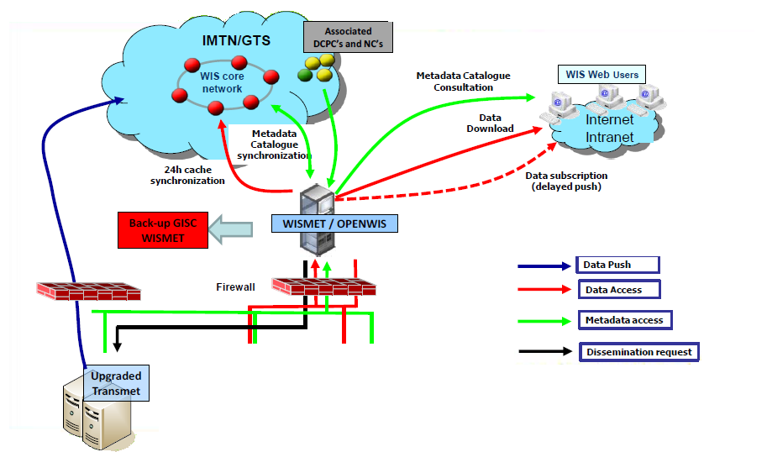

Status Report of Casablanca NC -(WMO Region I)

The National Meteorological Service of Morocco has strengthened the data collection process by implementing a new telecommunication scheme based on VPN-MPLS. Since September 2012, all synoptic stations, weather radar sites and meteorological stations in airports are connected to the VPN.
During the same phase 2010-2012 and in matter of weather observation and weather watch, a set of 156 new automatic weather stations, a new weather radar and 02 new upper air stations were implemented. Currently, All data are collected at the central level and those data will be injected to the GTS by the year 2014.
A daily monitoring solution of the meteorological messages produced at the national level was developed and quality management indicators were defined.
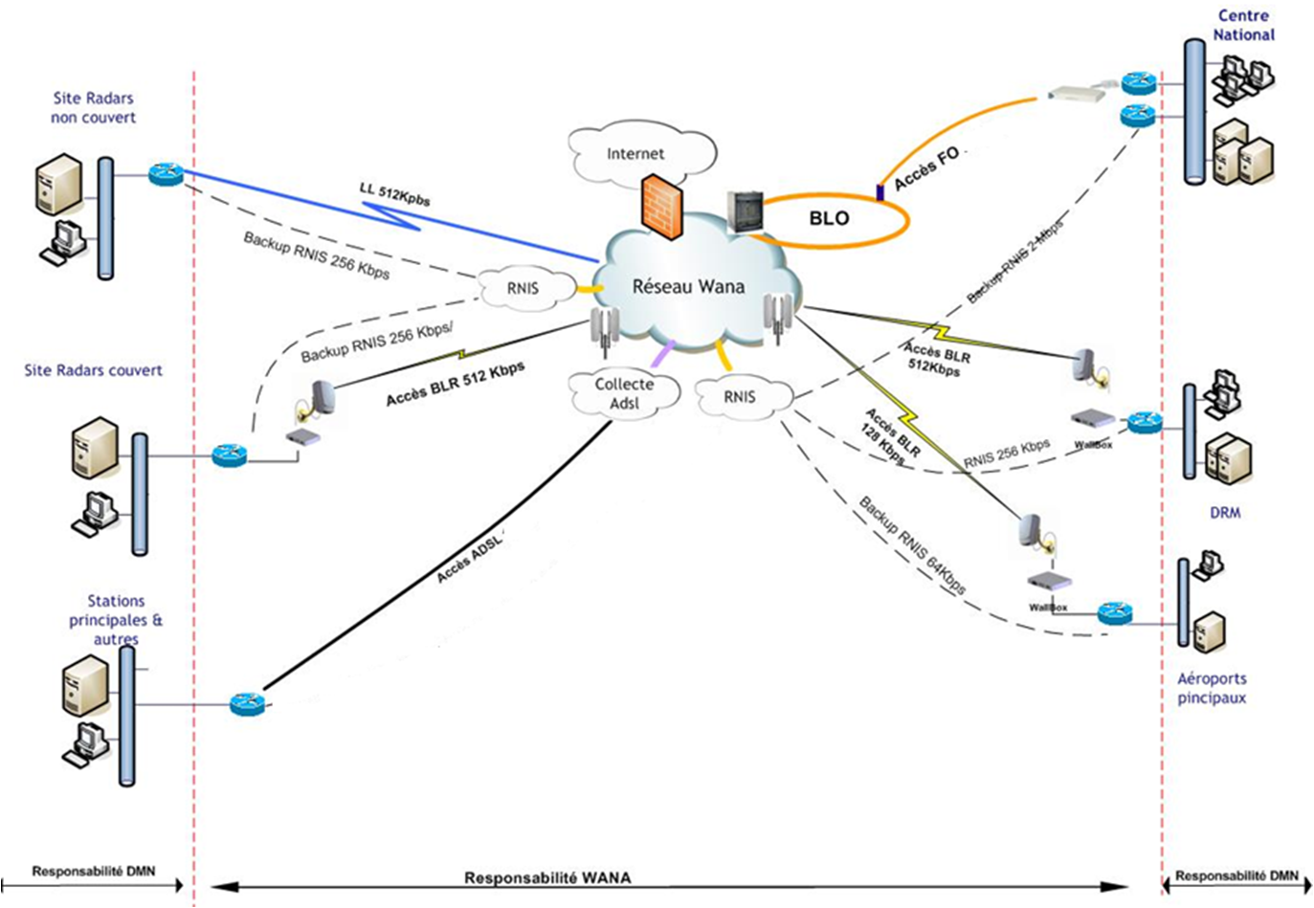
VPN-MPLS Telecommunication scheme of the Moroccan Meteorological Service
Daily monitoring of meteorological messages (an example of SYNOP messages)

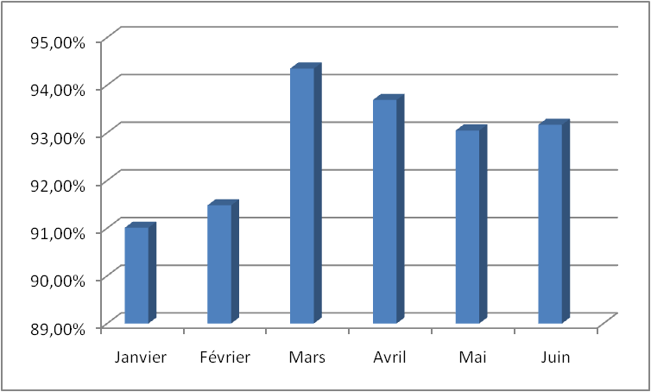
Evolution of the rate of received meteorological messages for the first half of 2013

3.5 Contribution to RMDCN, AMDCN, GTS

As an ECMWF co-operating state, the NMS meteorological service of Morocco was connected to the RMDCN in 2009 using one access link with backup at a rate of 768kbps. Currently, the NMS of Morocco is planning to join the RMDCN-NG at a rate of 2Mbps.
The NMS of Morocco is connected to the GTS through the RMDCN. An Internet high speed link is also used to exchange with Meteo-France (currently, it’s used as backup for NWP files transmission). This link was duplicated in 2013 with a second Internet high speed link provided by another Telecom operator.

7.3 GISC workshops and training activities

As already discussed with the CBS Expert Team on GISC-DCPC demonstration process (ET-GDDP), The GISC of Casablanca could play an important role for conducting outreach and training actions for the members of the AR-I and especially for the French speaking countries.

