Data Policy and authorizations for GISC, DCPC and NC, OpenWIS Philosophy

Security and Management of data access policies

Presentation plan
- Security Service Requirements
  - Generalities - Functions Overview
  - Data Policies
  - User Roles
- Proposed Business model (implemented in openwis)
- Annex

Security Service Requirements

Generalities - Functions Overview
The Security Service of the GISC (WMO Functions A2 & A4) has to provide:
Authentication: Identifying who the user is.
Authorisation: Identifying what the user is allowed to do.
An architecture has to be proposed for the identity management within the GISC domain and across domains (Virtual Organization), as well for local and remote Authentication / Authorization scenarios.
After the authentication and the authorisation to log on the portal, the system has to manage the authorisations on the data (for viewing or downloading)
In the following text, matching with the WMO rules, we propose a business model

Data Policies
The data policies can be understood at different levels:
- Global : Essential, Additional , Others
- Regional: DCPC management
- Local NC management
- …..

A dataset, thanks to the metadata, is binded with a data policy
For a data policy, privileges are allotted to a group of users.
Data policy information needs to be obtained remotely from where it is stored, and correctly interpreted. Data policy information may not be available for data / products from remote GISC domains. For such remote products, the user has to go on the remote Web site.
The User Role associated with access policies on metadata and services will allow the system to check the access rights of a given user for a particular action.

User Roles
User roles may be defined as a list of accessible system functionalities, and the definition of roles considered a configuration issue. A register of roles may also be envisaged, either central or synchronised among trusted Centres.
In the proposed architecture, the role of a user is determined by both:
- The user profile
- The list of user groups (the user belong to one or several groups).

Proposed Business model (implemented in openwis)

A User can be part of several Groups.
A User has a User Profile.
We introduce the concept of data policy which allows defining a set of privileges (operation allowed) for every locally defined group.
It consists in the combination of User Profile, Groups and operations allowed that define which tasks the User can perform on the system or on specific metadata records.
The operations are also used to grant access to distribution options for specific metadata records.
Access policies for metadata and data as well as their associated services will be derived from the notion of Data Policy.
User profiles
The User Profiles used are:
    - guest: not authenticated
    - user: registered user (belongs to one or several groups)
    - editor: user portal only, the rights of being able to actually edit a metadata will be given by the group ownership
    - operator: administration portal only
    - accessadmin: administration portal only
    - administrator: administration portal only

A Data Policy defines a set of privileges for locally defined user groups. A metadata record is associated to one data policy.
Operations
The operations used in OpenWIS are (for a data policy):
    - download (request or subscription)
    - edit (metadata)
    - public email
    - public FTP
    - RMDCN email
    - RMDCN FTP
    - Secured FTP

The secured transfers concern User to Centre, Centre to User and Centre to Centre communications. Example for a particular data Policy:
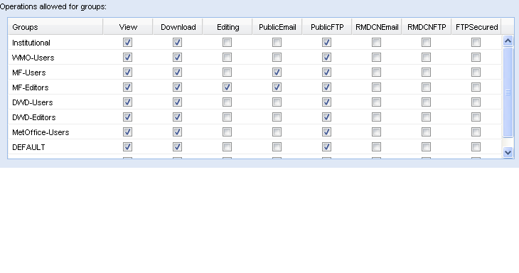
The definition of User Roles and Data Policies needs to be shared among trusted partners, to achieve a Site-independent user authorization.
Data policies and user roles may need to be associated and agreed between Sites. Other associations might be allowed: e.g. a bilateral trust agreement might be established with a Centre outside the GISC.
Global products will have simple default policies:
- serve Essential products to all (but authN/AuthZ required)
- serve Additional products to Institutional users only, with a warning message stating that the data is subject to Resolution 40 / 25.
Data policies can be aliased, allowing the association of several strings extracted from the metadata to a locally defined data policy.

ANNEX
The following diagram illustrates the combination of User, Groups, Operations and Data policy to handle privileges associated to a specific metadata record.

Figure 1: Business model of the OpenWIS metadata service

