Toulouse WIS centers status

Status report of WIS centers

Presentation plan:
- GISC Toulouse status in the vGISC concept

- DCPCs Toulouse Status
  - RTH Toulouse
  - Radar data center

v-GISC functions in Toulouse status
- Operational since June 2012
- Connection with JMA, CMA, DWD, BOM, KMA, Roshydromet and UKMO GISCs
- EUMETSAT et ECMWF (DCPC)
- Discovery service improvement under way
- Support to NCs and DCPCs
- Help Desk organisation

Data access

vGISC Toulouse activity: Ingestion

vGISC Toulouse activity:dissemination

vGISC Toulouse activity:harvesting

v-GISC status
- v-GISC differs from the requirements on all GISCs
  - 2 Centres (MetOffice - Météo France) offering together GISCs (and more ?) functions

- Operationnal by autumn 2013
  - Data replication through the RMDCN to be implemented
  - User management and v-GISC operation being currently defined
    - Share the load
    - Share the support
    - Share the backup

- Given the drive for improving functionality of WIS, it is probable that the VGISC functionality will become standard for all GISCs

vGISC history
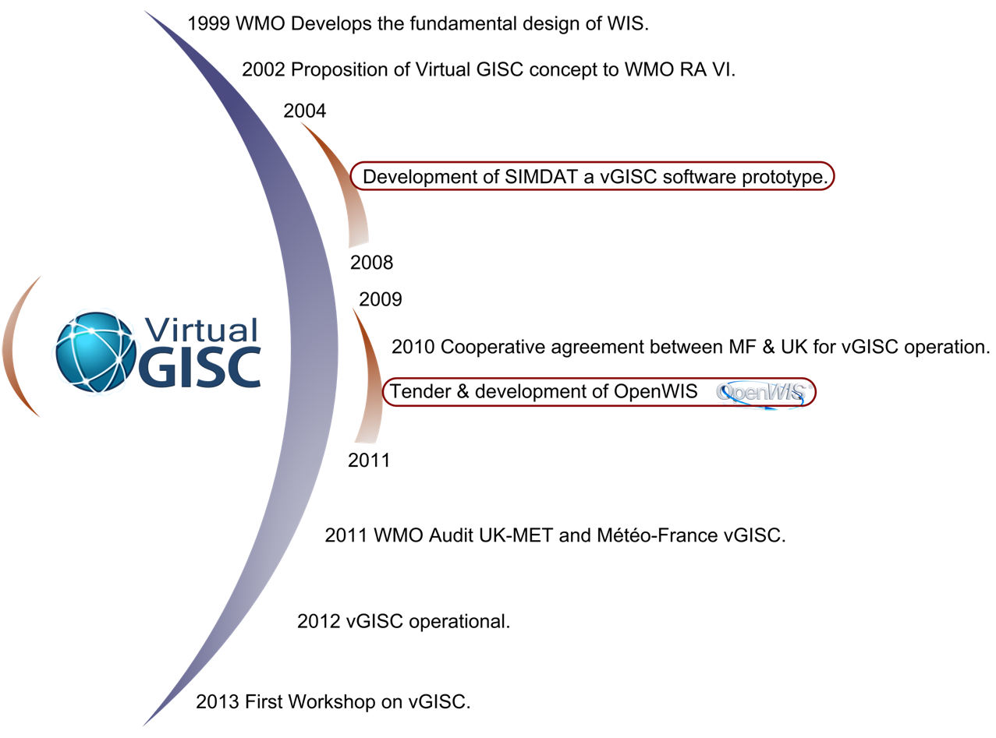

v-GISC Architecture

v-GISC – user perspective
- Users register on one member of the v-GISC and their credentials are recognised by other member of the v-GISC
  - personal information about the user is only available on the component of the VGISC on which they registered
- User subscriptions are transferred between members of the v-GISC so that in the event of a failure, products will still be delivered from the cache of data for global exchange
- Users benefit from a more reliable service as the workload is shared between the centres
- Interactive users are transferred to a back-up within the v-GISC if they attempt to connect to a component that is unavailable
  - This assumes some similarity in the look and feel of the portal
  - Interactive users should always be aware of which centre’s service they are using

vGISC current members
DCPC | NC
ECMWF, | Belgium,
France (7 DCPCs), | France,
Medare The MEditerranean climate DAta REscue , | Ireland,
Netherlands (2 DCPCs : Satellite and Climate), | Netherlands,
United Kingdom (9 DCPCs) | Portugal,
 | Spain,
 | Tanzania,
 | United Kingdom

Meteo France contribution to WIS: DCPCs
RTH Toulouse:Transmet MSS capacity

RTH Toulouse : Monitoring
- The annual Global Monitoring (AGM)
- The integrated WWW Monitoring (IWM)
  - Collect information from Madrid, Lisbon, Rome, Brussels
- Special MTN Monitoring (SMM) IWM
  - Raw data
  - Pre_analysis (AIREP, AMDAR)
- The special Antarctic Monitoring (SAM)

Satellite Dissemination RETIM Via EUMETCAST
- RETIM Europe
  - 2Mb/s
- Retim Africa
  - 256Kb/s
- Number of RETIM receivers held:
  - 700 receivers
- Dissemination program available on WMO volume “C2“

RETIM on EUMETCAST implementation
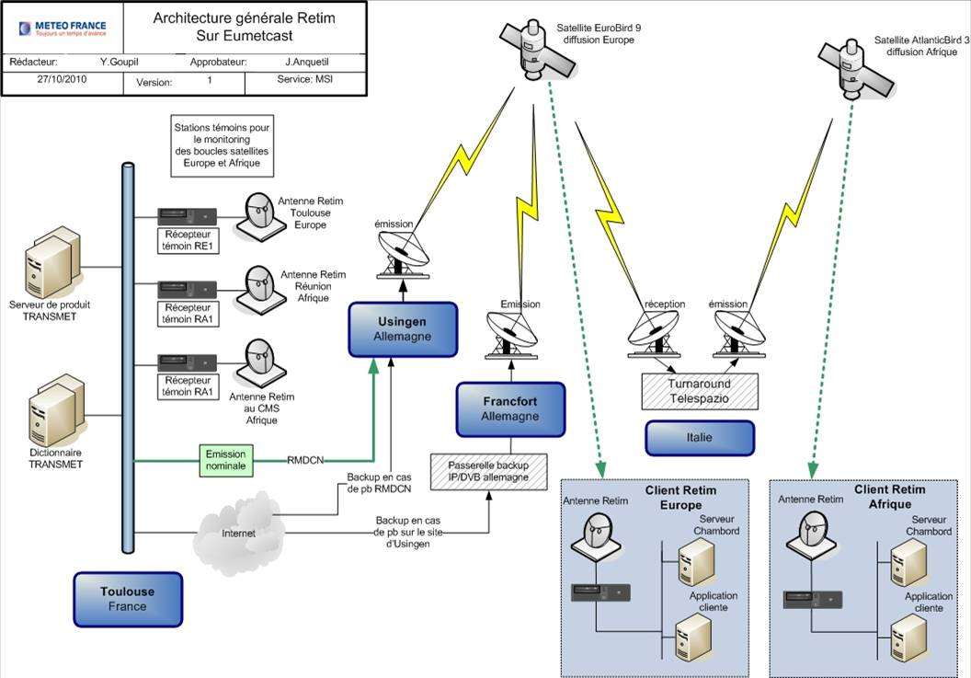

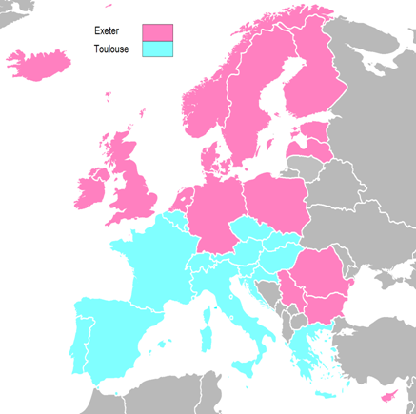
DCPC Odyssey products
- European Radar composites
  - Surface rain-rate
  - Maximum reflectivity
  - Hourly accumulations
  - 2 km x 2 km grid
  - 15 minute updates at DT+15 minutes
- BUFR and HDF5
- Archive data available from Météo France
Odyssey DCPC Overview
- Runs operationally in Toulouse and Exeter
  - Processing the same data
  - Using the same software
- Creating the same products
- Only one centre will disseminate products at any given time
- Routine (Quarterly) switch of operational node
- Simple procedure for Emergency switch (tested with IT Ops in December)

--------------------

