GTS AMDCN Toulouse current status

GTS AMDCN current status

Presentation plan:
- GTS links with Toulouse
- RMDCN Traffic
- Internet
- Plan for next years

GTS links

GTS MSS daily traffic

Toulouse AMDCN links


WMO and AMSS recommendations
- Alpha bulletins files with .a .b > 15K
- All bulletins “Alpha” .a and .b >15K are disseminated with .f or .b
- Other no limits

BUFR migration
- TAC to BUFR migration done (TEMP, CLIMAT and SYNOP)

File naming convention
- WMO file name convention has been integrated
- With PFlag T A W Z in input
- With Pflag T A W in output

Network curent status and evolution
- Internet
  - Speed: 300 Mbps
  - Used by ALADIN community for products delivery
  - Backup for RMDCN in pull mode
- Research link
  - RENATER / GEANT : 1Gbps Research traffic
- RMDCN
  - 10Mbps, will be upgraded to 50Mbps with the next generation of RMDCN

RMDCN daly traffic example July the 08th of 2013

- Input

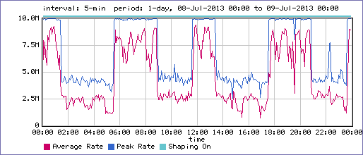

- Output





