5.4 Search (internal and SRU)

Access Analysis of GISC Tokyo’s search pages
Who will access to search pages of GISC Tokyo? What words does people use for query? GISC Tokyo investigated to recognize usage of search pages.
Condition
- Target Page Search and Browse Metadata (http://www.wis-jma.go.jp/meta/search.jsp)
SRU Search (http://www.wis-jma.go.jp/meta/sru.jsp)
- Period 2013/7/1 – 2013/7/8
- Source Apache log files
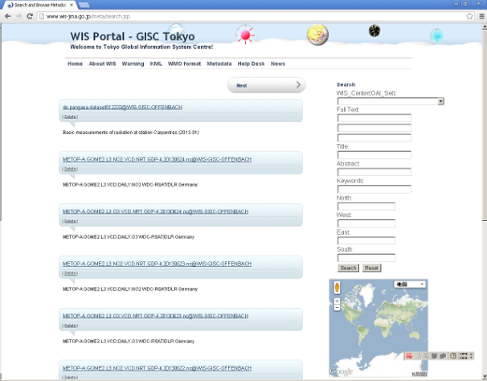  Search and Browse Metadata  (search.jsp) | 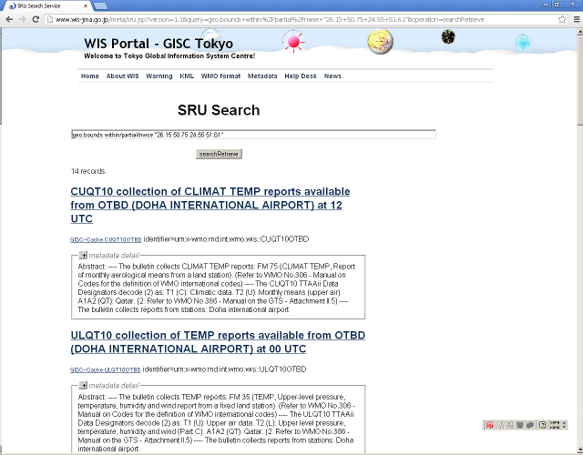  SRU Search  (sru.jsp)

About 70% access to search pages was from Internet BOT by Google, Ahrefs.com, and other. Moreover, the access from BOT by Google, Ahrefs.com was not simple access but with complete query. Also other access was from BOT by msnbot-*.search.msn.com, crawl-*.naver.jp and so on. Regular access was minority.

Access analysis for search pages of GISC Tokyo

Access ratio between “sru.jsp” and “search.jsp”

66.249.74.224 - - [11/Jun/2013:22:56:40 +0000] "GET /meta/sru.jsp?version=1.1&operation=searchRetrieve&query=int.wmo.wis%3A%3AIUAC04VHHH HTTP/1.1" 200 3877
66.249.74.224 - - [11/Jun/2013:23:05:45 +0000] "GET /meta/sru.jsp?version=1.1&operation=searchRetrieve&query=int.wmo.wis%3A%3ASMMZ01FQMA HTTP/1.1" 200 4312
66.249.74.224 - - [11/Jun/2013:23:05:58 +0000] "GET /meta/sru.jsp?version=1.1&operation=searchRetrieve&query=int.wmo.wis%3A%3AHEDK88RJTD HTTP/1.1" 200 2892
66.249.74.224 - - [11/Jun/2013:23:39:50 +0000] "GET /meta/sru.jsp?version=1.1&operation=searchRetrieve&query=int.wmo.wis%3A%3AUKOM10OOMS HTTP/1.1" 200 3932
66.249.74.224 - - [11/Jun/2013:23:47:36 +0000] "GET /meta/sru.jsp?version=1.1&operation=searchRetrieve&query=int.wmo.wis%3A%3AUKMC01GMMC HTTP/1.1" 200 4039
Access from Google BOT
173.199.119.27 - - [11/Jun/2013:22:25:32 +0000] "GET /meta/sru.jsp?version=1.1&operation=searchRetrieve&query=int.wmo.wis%3A%3ACSMK01LYPG HTTP/1.1" 200 3784
173.199.119.27 - - [11/Jun/2013:23:01:04 +0000] "GET /meta/sru.jsp?version=1.1&operation=searchRetrieve&query=int.wmo.wis%3A%3ACSSR01WSSS HTTP/1.1" 200 4013
173.199.119.27 - - [11/Jun/2013:23:07:54 +0000] "GET /meta/sru.jsp?version=1.1&operation=searchRetrieve&query=int.wmo.wis%3A%3ACSAO01GOOY HTTP/1.1" 200 4096
173.199.119.27 - - [11/Jun/2013:23:08:10 +0000] "GET /meta/sru.jsp?version=1.1&operation=searchRetrieve&query=int.wmo.wis%3A%3AUKNU01TNCC HTTP/1.1" 200 4129
173.199.119.27 - - [11/Jun/2013:23:23:41 +0000] "GET /meta/sru.jsp?version=1.1&operation=searchRetrieve&query=int.wmo.wis%3A%3ACSSP02LEMM HTTP/1.1" 200 4216
Access from Ahrefs.com BOT

Search words
Following words was found from access log files as search words. It was seen as often be used in a single word in query.
2.5, ABSTRACT, AGGREGATE, CO2, DOHA, GEO.BOUNDS, GRIB, GRIB2, GSM125C, GSM125J, GSM125L, GSM125P, GWM05N, GWM05S, HEMISPHERE, INDICATOR, INT.WMO.WIS::CCCCTTAAII, JP.GO.JMA.WIS.DCPC-GPC, JP.GO.JMA.WIS.DCPC-SAT, JP.GO.JMA.WIS.DCPC-TCC, JP.GO.JMA.WIS.DCPC-TYPHOON, JP.GO.JMA.WIS.DCPC-WDCGG, OTBD, PRESSURE, RADAR, SMKP01VDPP, SOUTHERN, SURFACE, TEMPERATURE, TEMPRETURE, VHHH, VNNN, WDCGG, WEATHER, WEPS25X
Search words in investigation period (Alphabetical Order) (Search Period : 2013/5/22 – 2013/6/11)

GISC Tokyo started access analysis specialized for search pages. It will be interest to compare with analysis of other GISCs. Such a investigation is necessary for utilization improvement for metadata search function.
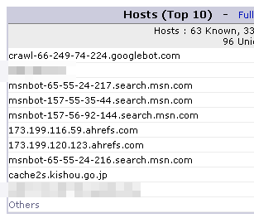
Screen shot of AWSTATS : Hosts
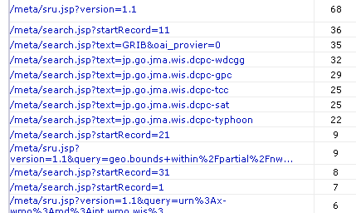
Screen shot of AWSTATS : Search Pages URL

References
- Ahrefs Site Explorer & Backlink Checker https://ahrefs.com/

Recommended Text
Mr. Shigeharu Nishikawa reported the access analysis of GISC Tokyo’s search page. He mentioned that almost access for search page is by internet BOT and regular access is rare. Also he mentioned that analysis for “Search words” is interesting and it will be useful for GISC operation to investigate and share the result.

