User Interface

Background
EC stated in 2003 that “WIS would be used for the collection and sharing of information for all WMO and related international programmes.” Now that several GISCs and DCPCs are operational, it is important to see if that goal has been achieved.
As far as I am concerned, my first impression is that the WIS portals have been designed by experts, for experts, with little concern for the users outside the World Weather Watch. Using them requires quite a lot of specialist knowledge, the usability is often very poor, there is no clear information architecture, and finding data is very challenging.

Basic web-portal usability tests
Disclaimer: the screenshots below are not trying to prove that any WIS portal is better than the others, but they are provided in this document to illustrate that:
- The user experiences are very heterogeneous, and the WIS lacks consistency
- All of the interfaces have serious usability problems
- All interfaces are designed for experts
This paper does not try to compare the different portals/graphical user interface. The main idea is to see what users will see as the entry point to the WIS. Some issues described below are usability issues in the portals, others are due to having poor metadata with (meaningless titles or metadata that refers to non-existent datasets…).

Task 1: Finding data by area
The first task is to find data for Madagascar, using the area search.
Stating with GISC Exeter. The difference between the zooming tool and area selection tool is not obvious
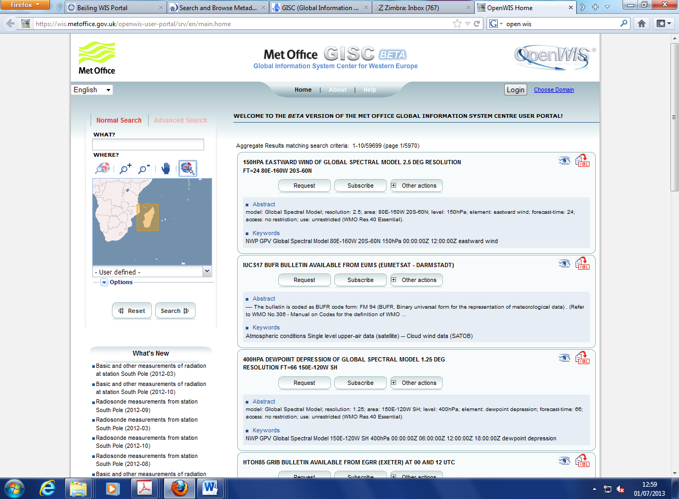
The information returned is minimalistic
The search results are not very good, and the first matching record is a nearly global:
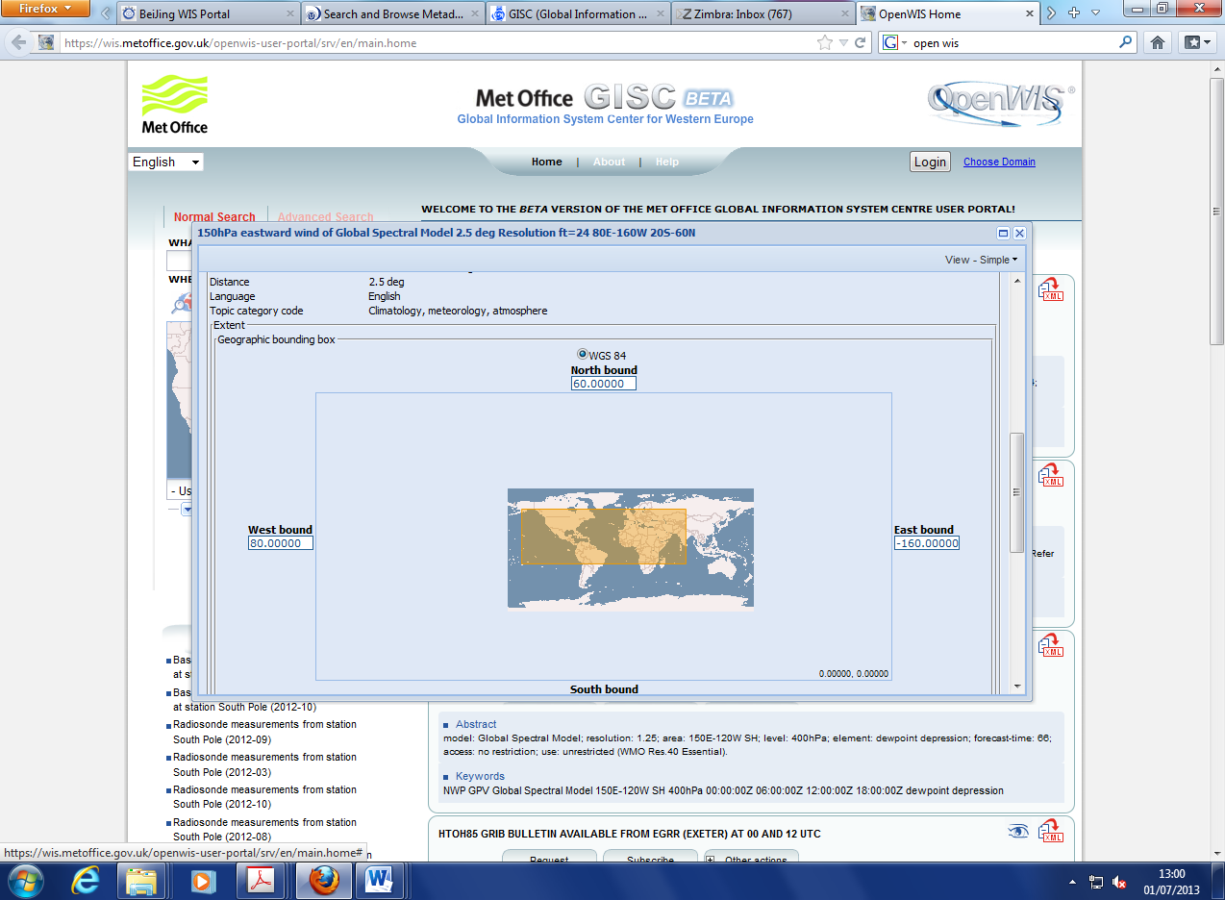
Using the advance search led to no results:
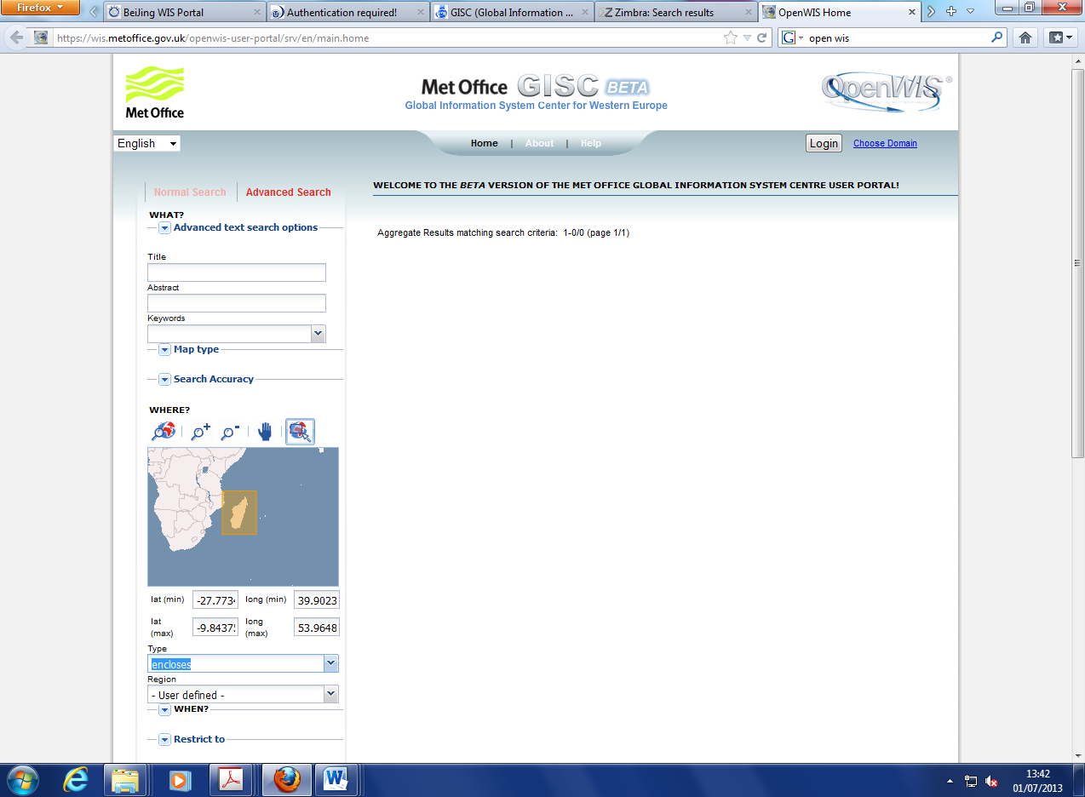
But did on GISC Toulouse portal:
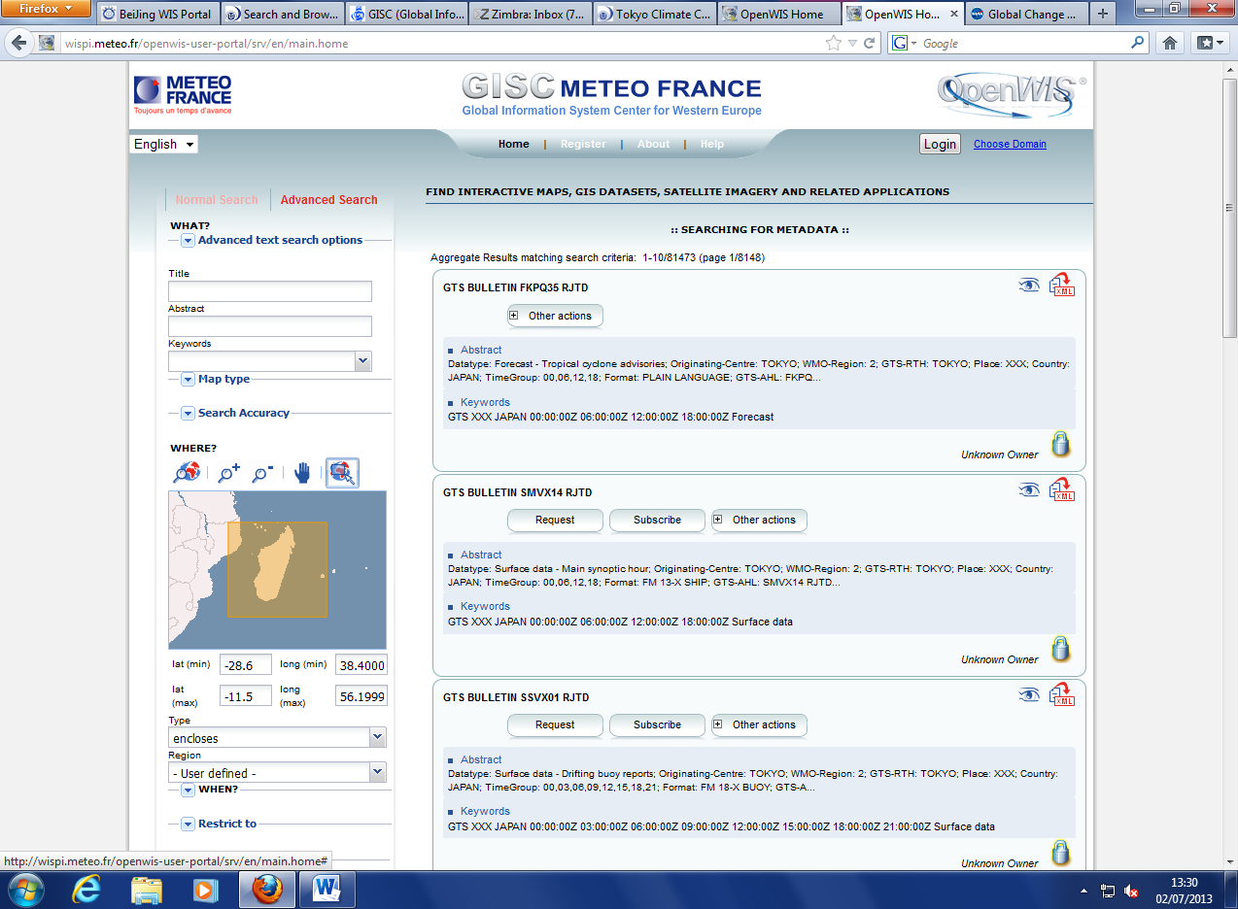
Notice the order of the coordinates
But the first hit was a global field:
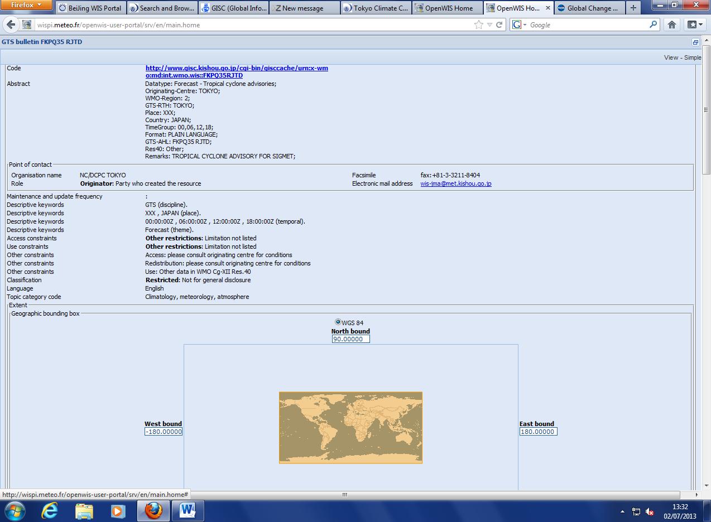
The results on the GISC Tokyo were much better, with data for Antananarivo as the first reply:
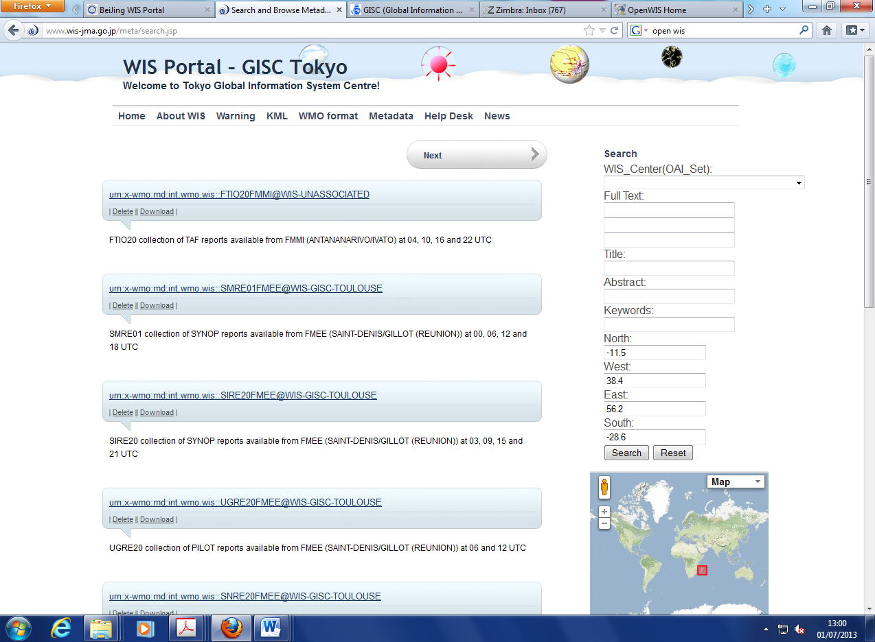
Notice the order of the coordinates
On the GISC Beijing portal the first hit was for a global field
The results only show the IDs
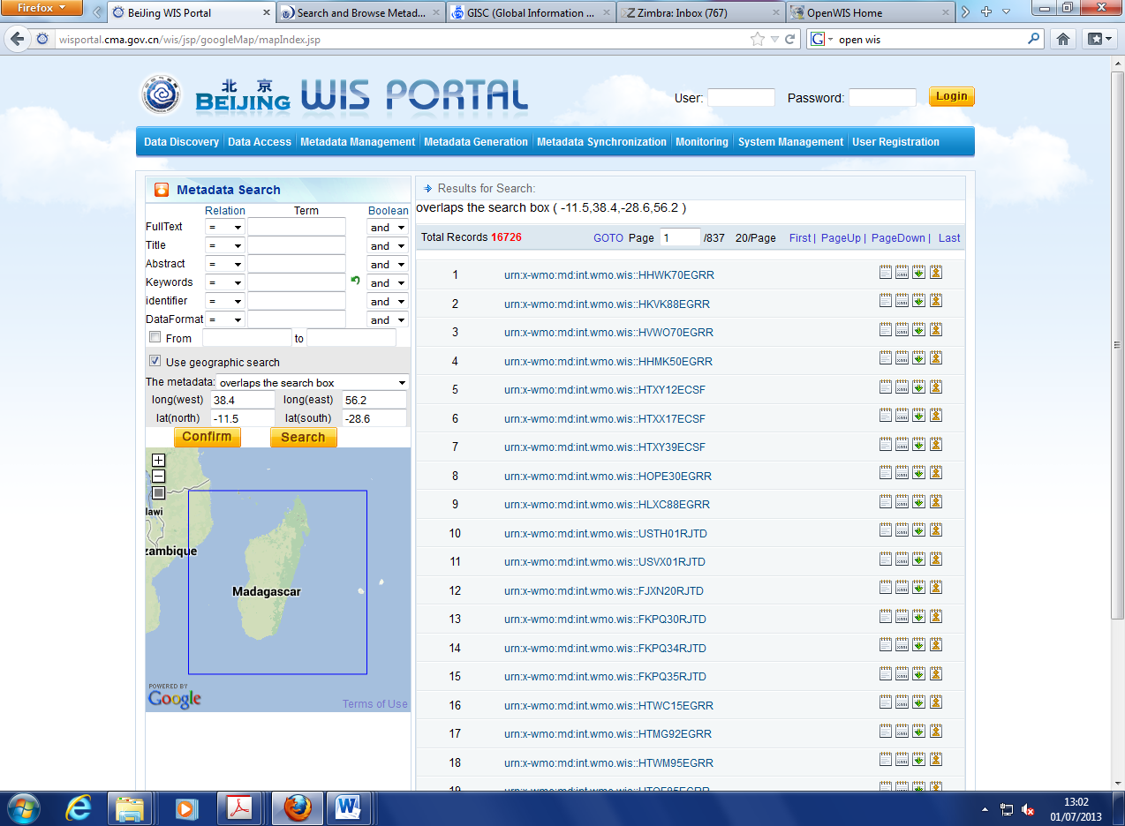
Notice the order of the coordinates
But with no bounding box:
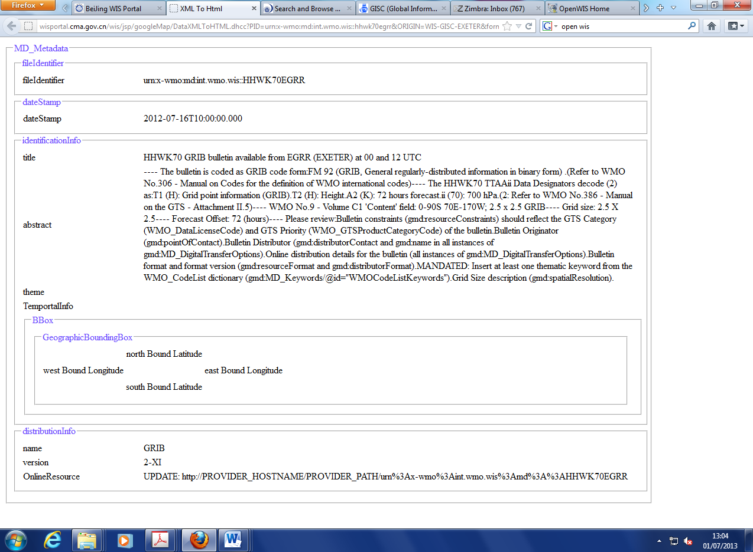
The titles are not useful
On GISC Offenbach portal:
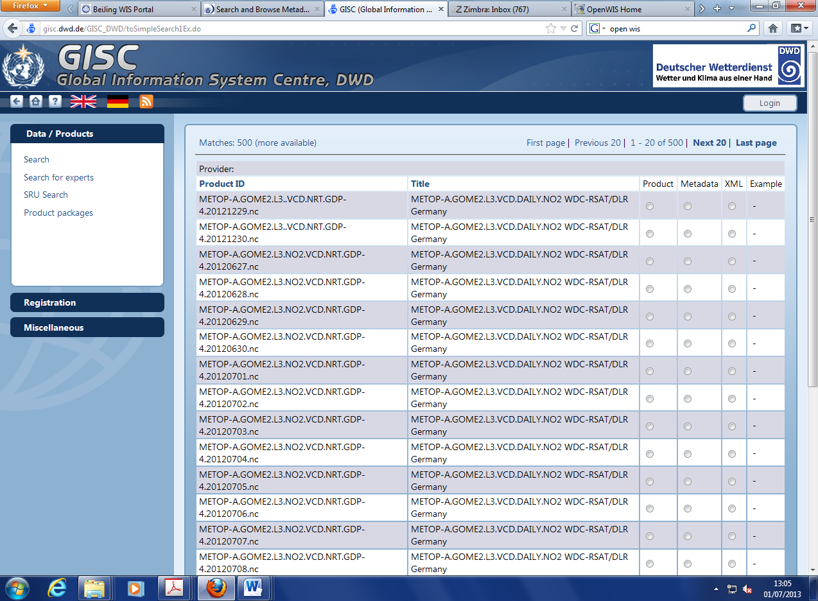
The radio buttons are very confusing
The first hit is a global field:
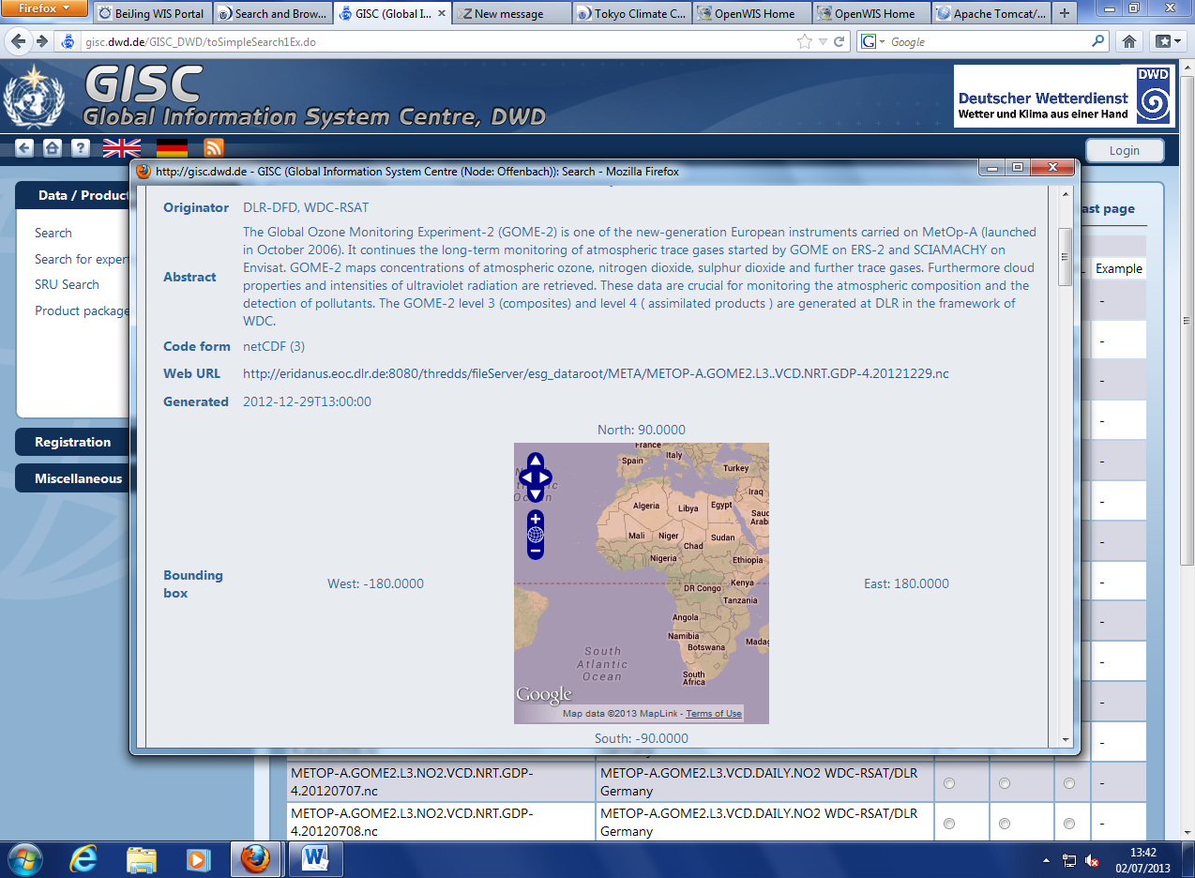
Following the link:
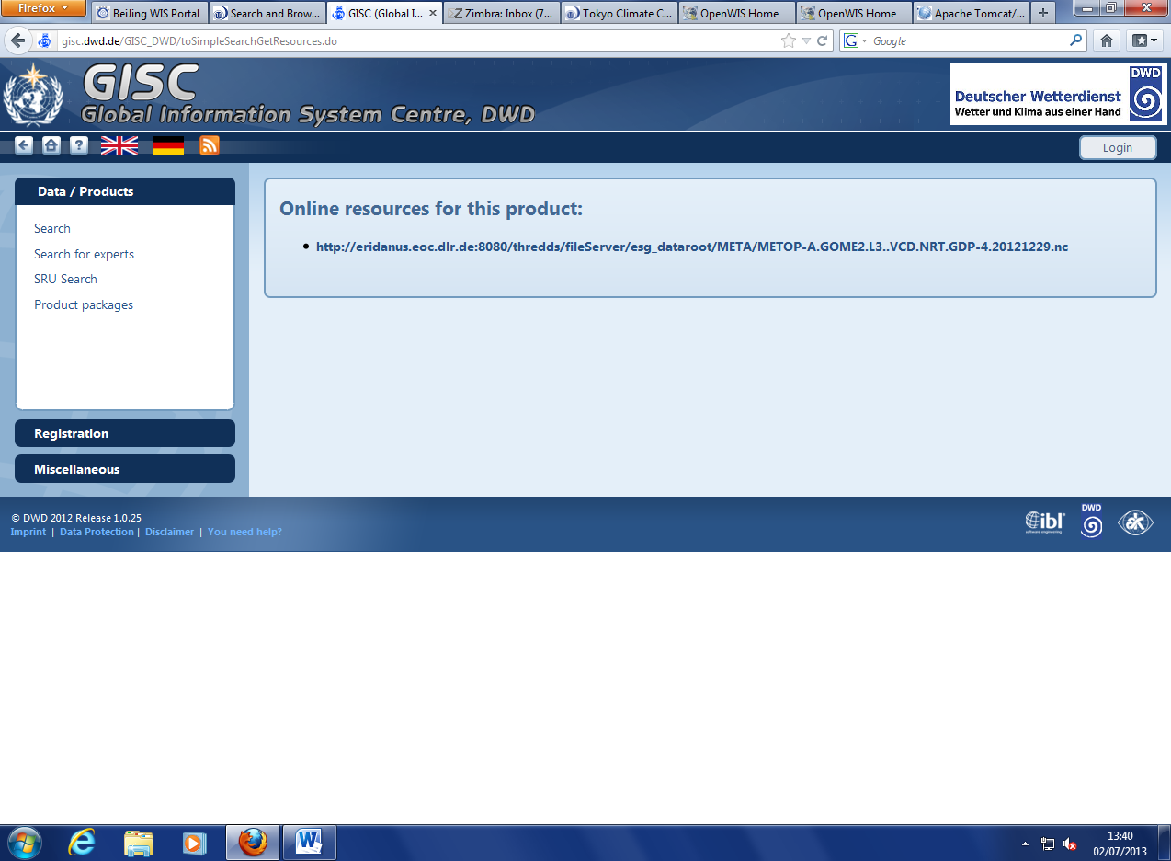
Leads to a missing file:
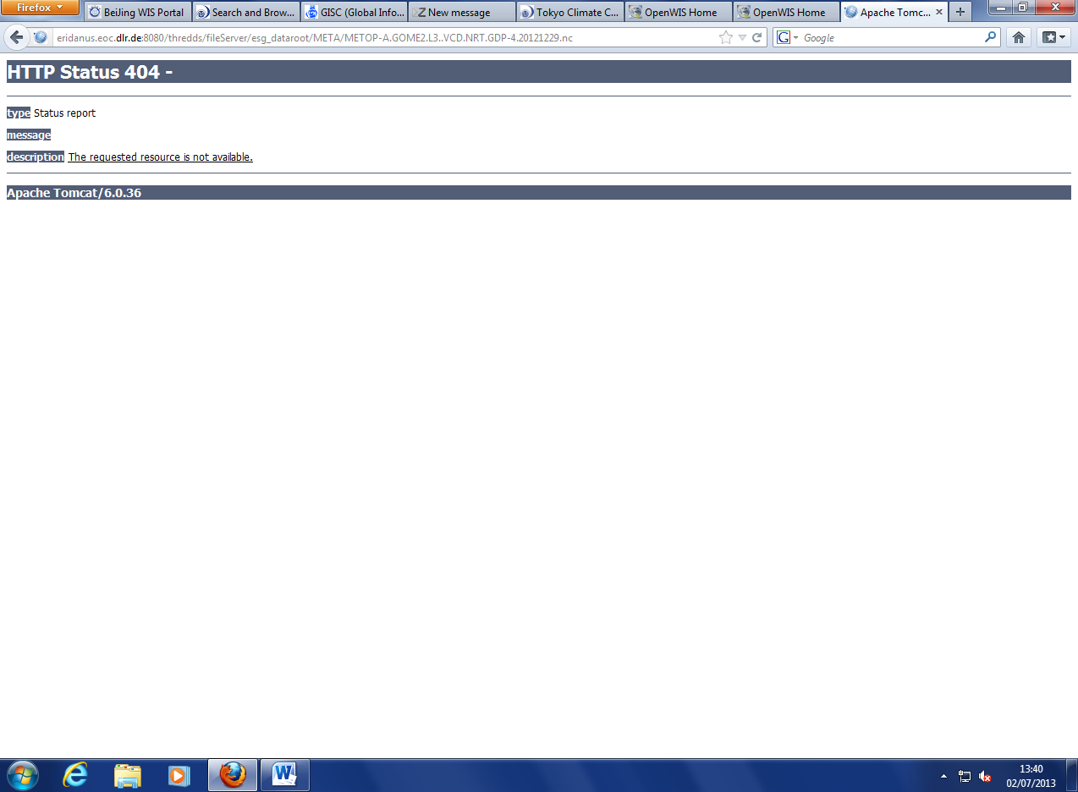
Clicking the “Sort by rank” toggle gives better results: (why is that not on by defaults?)
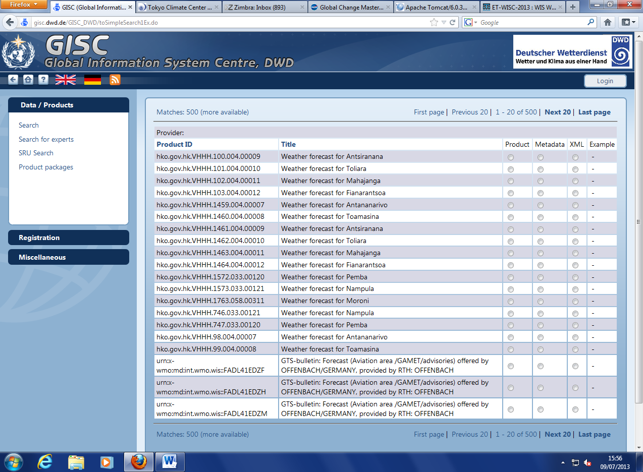

Task 2: Finding data by text search
Searching “metar Canberra”. Starting with WIS Beijing, the first idea is to use “full text” search, but that gives nothing:
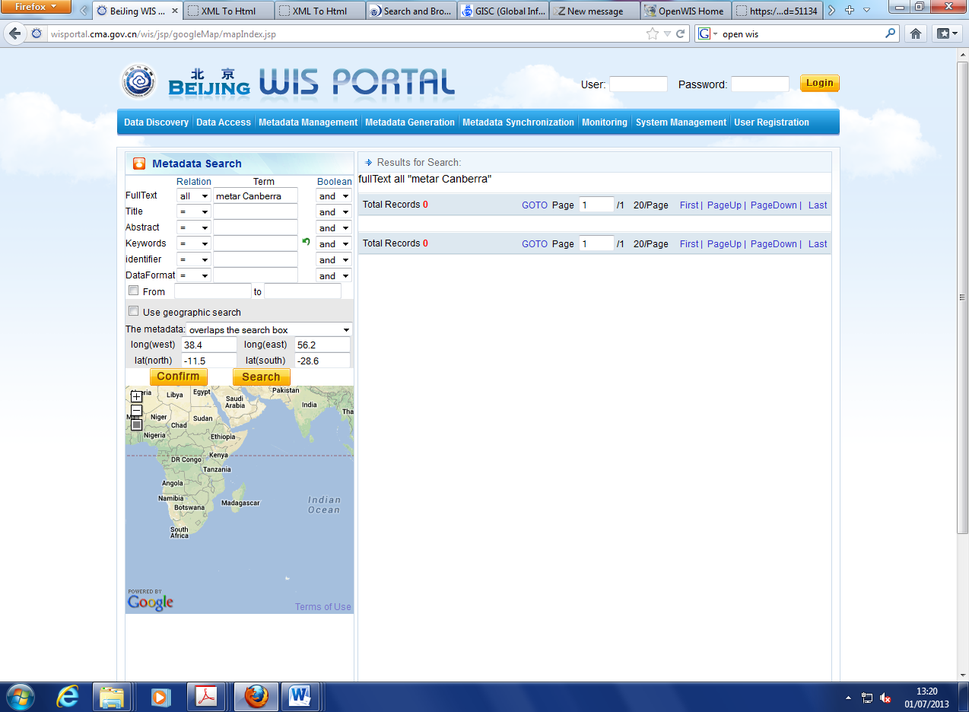
Not clear what “all” means, but does not work with “=”
I was more successful with searching the abstract, but only with “relation” set to “all”:
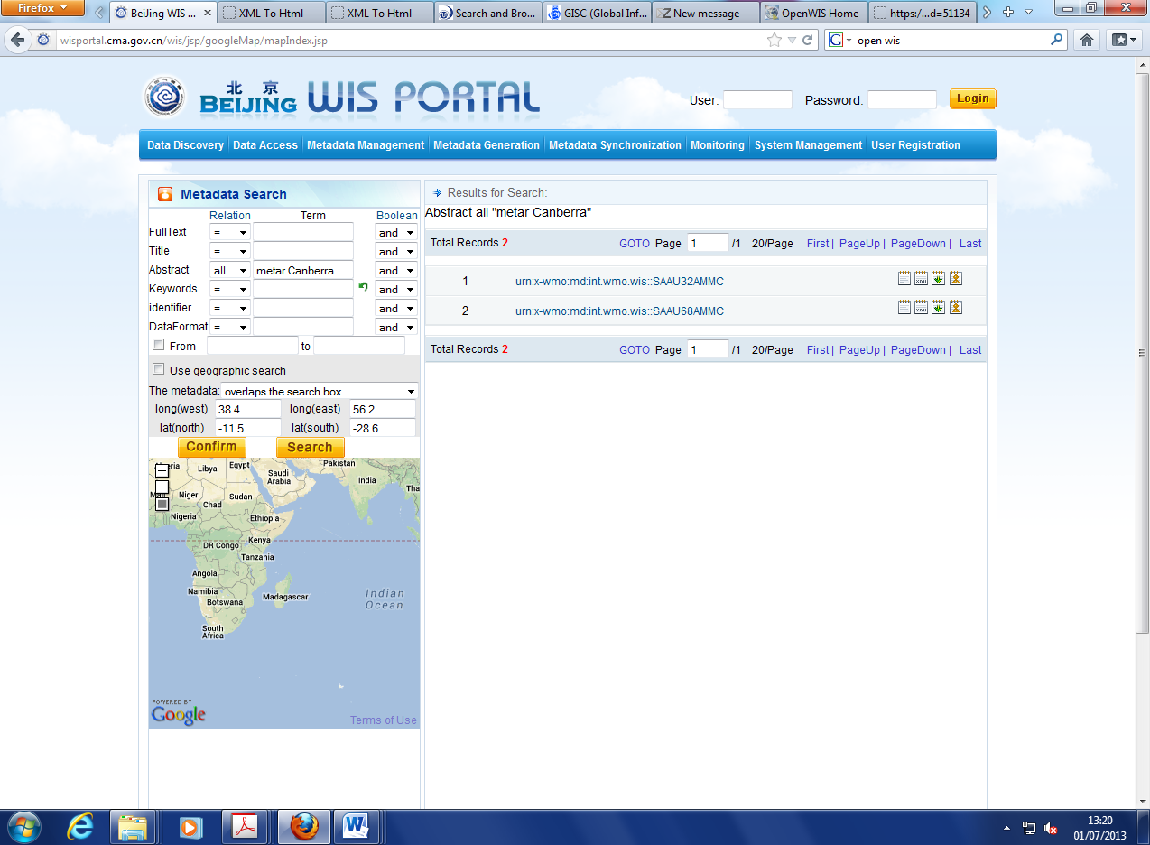
In the case of GISC Tokyo, it worked searching the abstract, but not the full text:
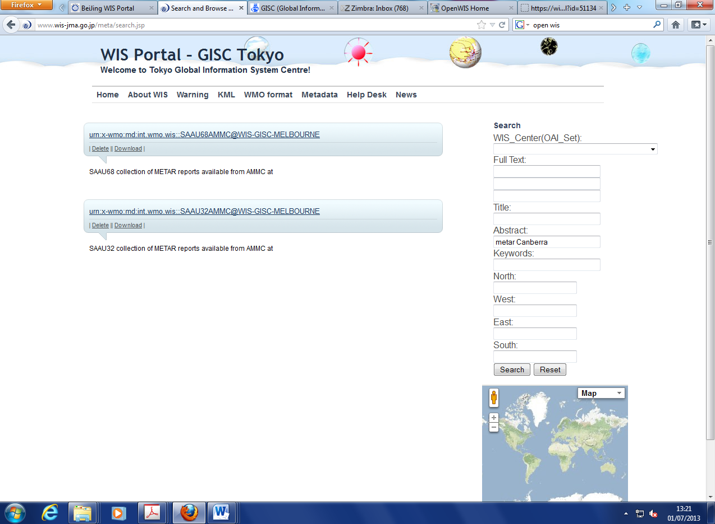
Full text search worked with GISC Offenbach, but only once I understood that I needed to uncheck a checkbox so that I could enter the text to search:
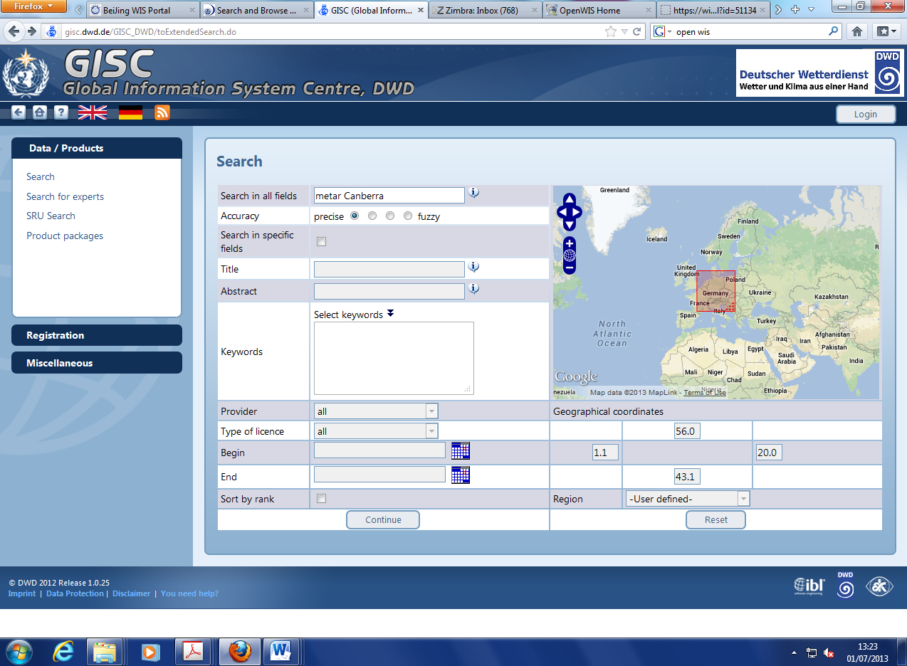
This checkbox (on by default) is very confusing.
The result is OK:
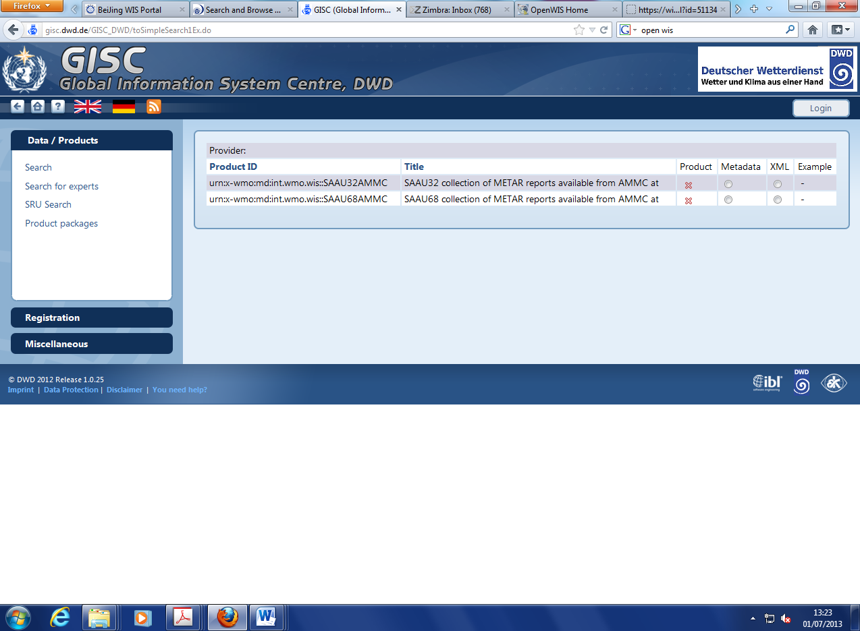
GISC Exeter (and GISC Toulouse) did return the expected results:

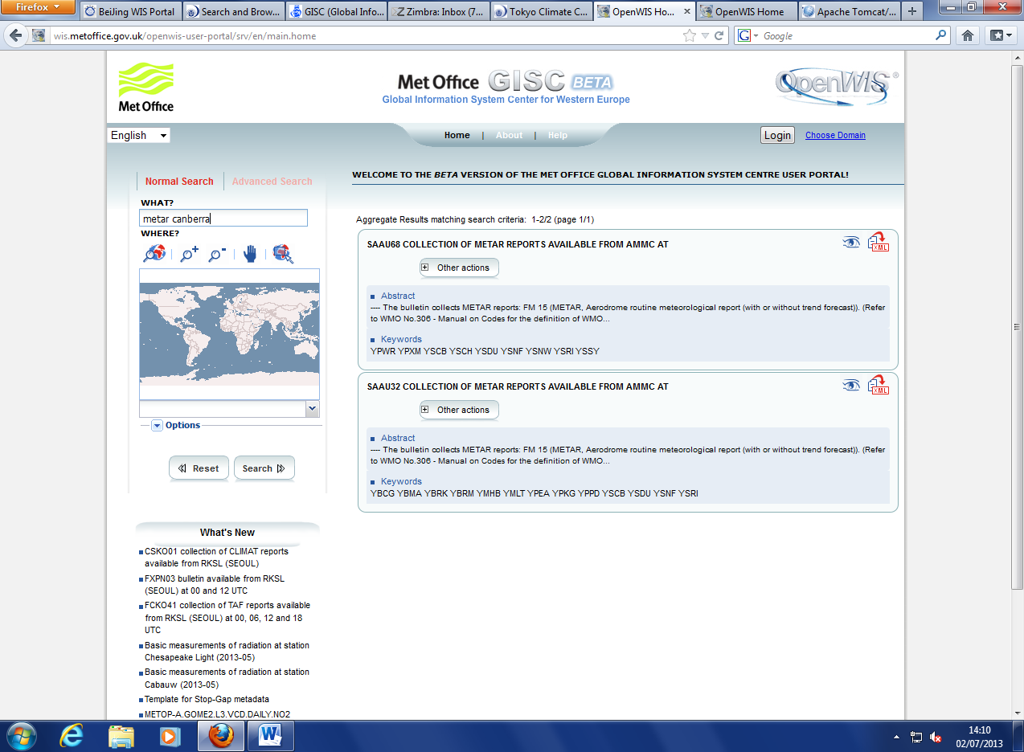

Task 3: Browsing the metadata catalogue
The only GISC that provides browsing of the catalogue in structure manner is GISC Beijing (if the other GISC do, I could not find where).
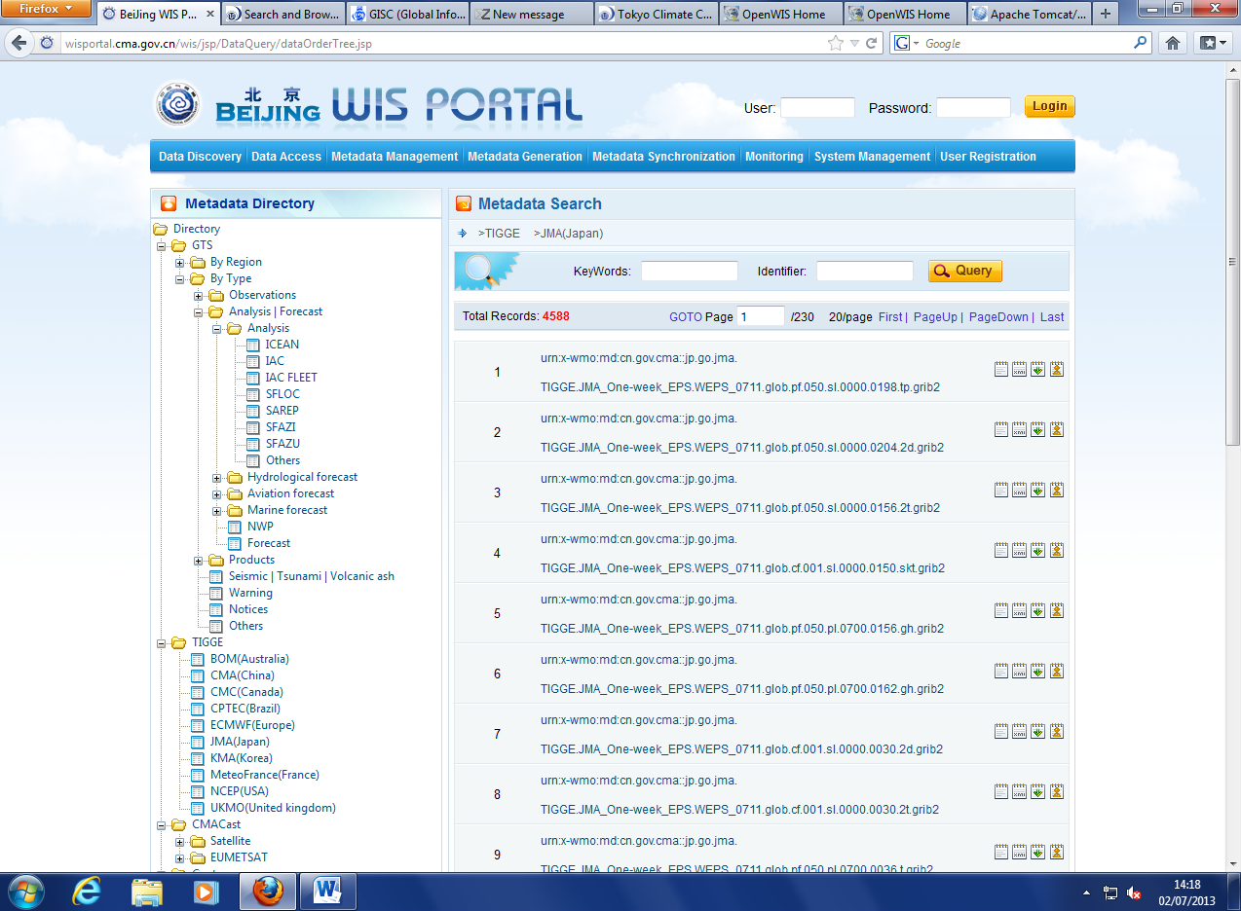

Task 4: Editing metadata
Unfortunately I was only able to have access to the metadata editor from GISC Exeter, no I could not compare them all.
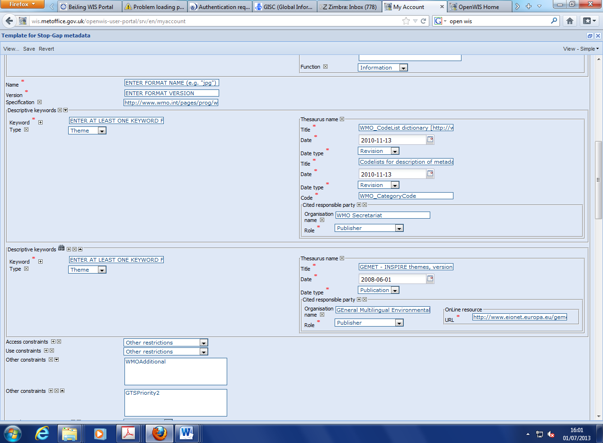
The screenshot represents only 1/6th of the editor.
Filling the form is a daunting, and I counted about 56 fields to provide with “ISO-minimum” set.
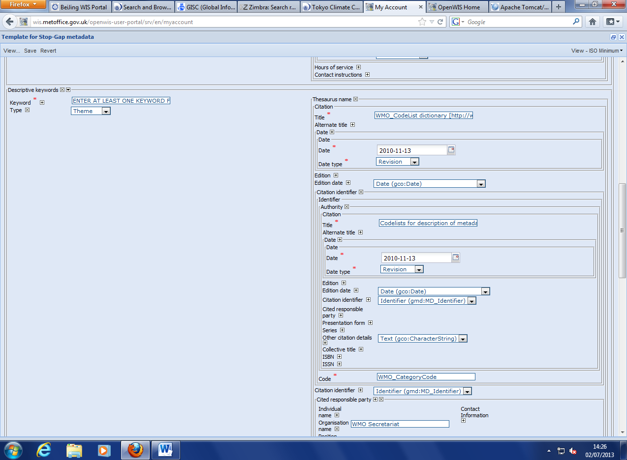
Set to ISO-minimum
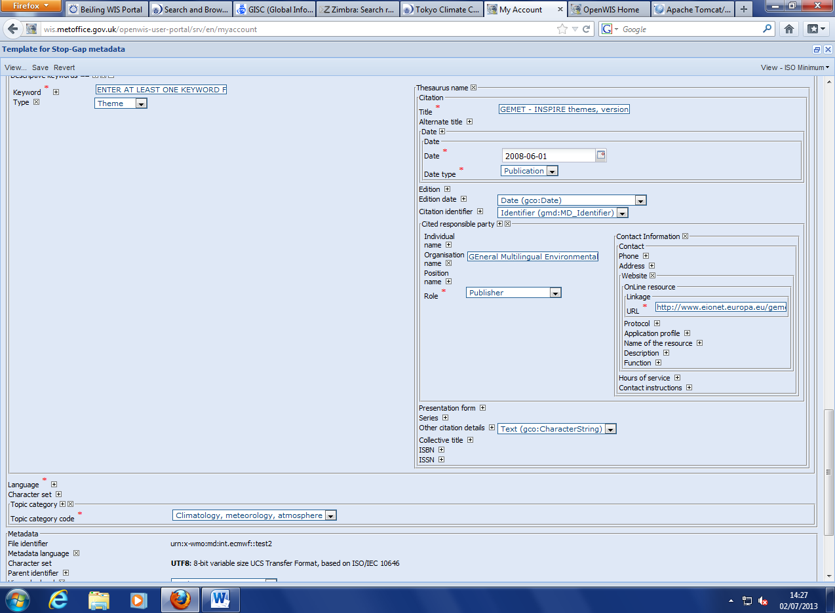
It is clear that no one without training can provide the required information, and even though, the possibility for error is great.

Findings
To summarise my findings:
- The various WIS portals are very different, and there is a lack of overall consistency
- All of the portal are designed for experts
- All but one of the sites only provide searching capabilities, and no browsing of the catalogues
- Most of the portals expect the user to know where to search for text (title, or abstract, or keywords)
- The search results are not ranked properly, especially for area search
- For most of the portal, the search results only show technical information such as the dataset ID, and cannot be understood by users
- Editing metadata can only be done with training, and is error prone
- Most of the metadata records are very poor: their title/abstract are not useful to the users

Some proposal

Text search
By no means should the user be asked to which fields the searched text should be compares, because, is the user is searching, that means he or she does not know in the first place.
Text search should be done against all the text fields, with different weight, e.g. a match in the title scores higher than a match in the keywords, which match higher than a match in the abstract and so on. The number of matching words should be taken into account for the scoring. If two of three searched words match, the score must be higher than of only one match. The proximity of the words in the searched text should also be taken into account (most databases free text search support this feature).
Synonyms must also be considered when searching. We use “precipitations”, the layman will say “rain”. This is something that search engine like Google or Amazon do all the time and users are used to that (and expect that behaviour from a search engine).
Below in an experiment of ontology assisted searching that was implemented by DWDW in the SIMDAT project, where a user searched for “drought” and is given a list of related terms to search on the left hand side :
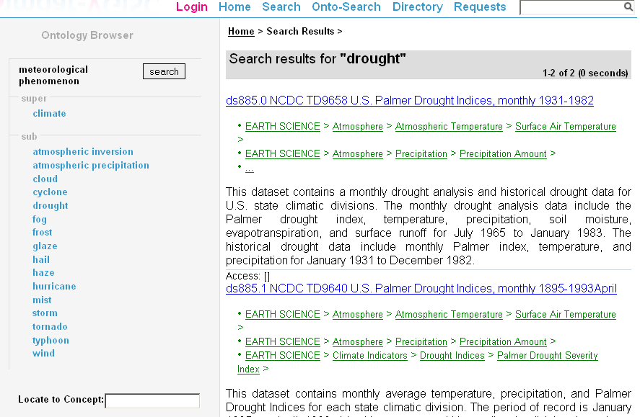
Below was a more specific example, using a multi-language thesaurus:
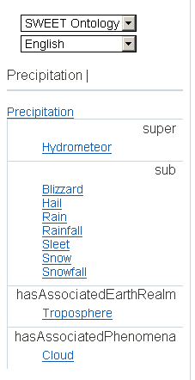
There are several freely available thesaurus/ontologies available to our community:
- American Meteorological Society Glossary (http://amsglossary.allenpress.com/glossary) - about 10,000 terms
- GEMET - GEneral Multilingual Environmental Thesaurus (http://www.eionet.europa.eu/gemet) – used by INSPIRE – more than 5,000 terms in 22 languages
- SWEET - Semantic Web for Earth and Environmental Terminology (http://sweet.jpl.nasa.gov/ontology/)

Area and time search
During the SIMDAT project, it was shown that computing a Jaccard Index between the stored bounding box (A) and the user bounding box (B) will provide a very effecting scoring mechanism:
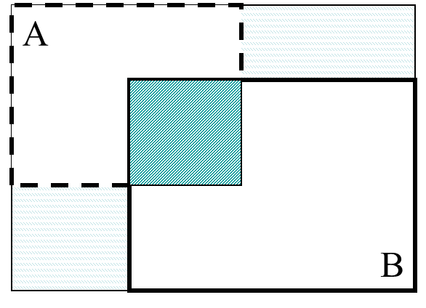
The index is defined as:

If A and B are identical, the index is 1, if there are completely disconnected, the index is 0. If A and B overlap, the larger the overlap the higher the index, but also the more similar the area of A and B are, the higher the index. For example, if someone searches for a bounding box around Crete, and there is a dataset that covers the Aegean Sea, this will be scored higher than a global dataset. The formula is symmetrical, so a dataset for any city of Heraklion (the capital), will also score high.
The same principal can be used for temporal search, the more similar time intervals are the higher the index.

Classification of the metadata (taxonomy) for browsing
NASA’s Global Change Master Directory (GCMD) provides a very comprehensive taxonomy of all environmental sciences. This should be used to create a hierarchies of concepts to which metadata records can be related. Other taxonomies can be created, e.g. by WMO regions, countries …
Browsing by GCMD categories:
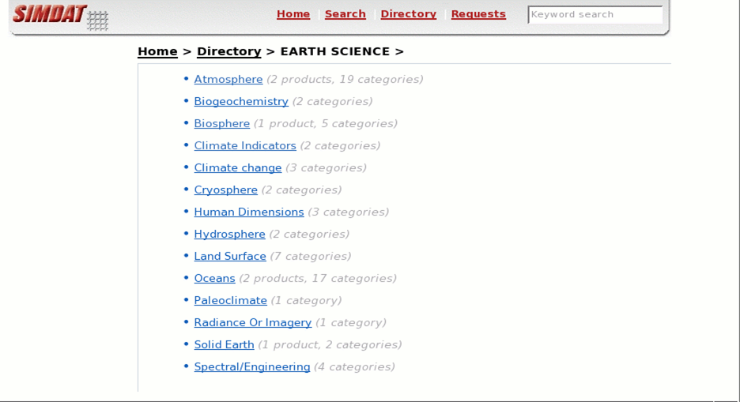

Better search result pages
Search result pages should show the title and the first few lines of the abstract so that the user can easily see which datasets are relevant to him or her at a glance, without having to click on each result one by one. See below for an example:
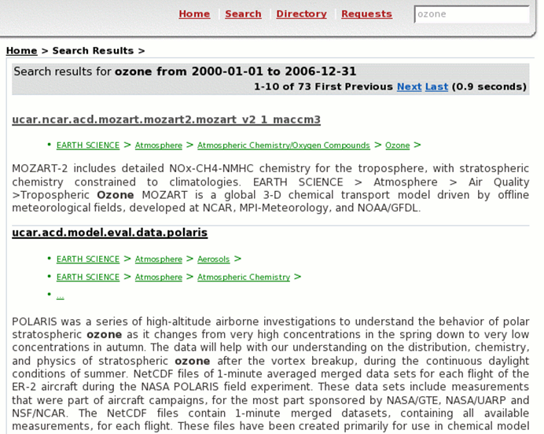
Please note that the record classification is also given, to provide some context to the user. The categories can also be considered in the full text search, to add some weight to the ranking algorithm.

Need for a strong governance on metadata
However good a portal can be, it will only be useful with good quality metadata. There is a need for strong governance on how metadata records should be filled. WMO need to establish a minimum level of “quality”. There are several EU projects tackling this problem (METAFOR, CHARMe).

Conclusion
In these days of Google and other search engines, users expect simple search interfaces and very good ranking system, as well as a readable summary of the search results.
There is a non-negligible risk that the WIS portals, with are the display of the WIS to the outside world, are so complex and so geared towards World-Weather-Watch export users that the uptake by other programmes and other communities will not happen.

Proposal
It is proposed that the ET-WISC initiates:
- a reflection of the issue of WIS portal usability, performance and consistency
- liaise with other ET to provide some guidelines on how to improve the user experience
- establish some metrics to measure how many non-WWW users are making use of the WIS
- define some portal-specific tests to be performed during the recurring audits

http://en.wikipedia.org/wiki/Jaccard_index

