Abstract
The following paper provides an overview about the metadata synchronization in WIS. Currently the whole WIS-CATALOGUE contains roughly 150.000 records where 60.000 records are describing products intended for global exchange and 90.000 products are other products. Last month roughly 5.300 changes in the catalogue took place. GISC Offenbach and GISC Tokyo offer public available OAI Synchronization monitors. The paper highlights the challenges of OAI Monitoring. The authors note that 4 operational GISCs have not implemented one must requirement of the OAI PMH specification which is essential for deeper analysis of monitoring results and that 4 GISCs are not providing the OAI set “WIS-CATALOGUE”.
The authors provide real world examples which show that the synchronization process needs further improvements – especially in the field of WIMMS records.

WIS Catalogue
Currently the whole WIS-CATALOGUE contains roughly 150.000 records where 60.000 records are describing products intended for global exchange and 90.000 products are other products. Last month roughly 5.300 changes in the catalogue took place. In the last 3 month we had roughly 87000 changes, in the last 6 month 88.300 changes, in the last year 113.500 and since operational start 140.500 changes.
Each GISC offers an OAI Set “WIS-GISC-<CITYNAME>” where it offers the records of centres which nominated the GISC as their Principal GISC (in example WIS-GISC-OFFENBACH, for DWD). The other GISCs harvest via OAI-PMH version 2 the records – usually at least once a day. In addition each GISC should offer the entire catalogue as WIS-CATALOGUE (1).
Centres where the Principal GISC is not yet operational, can maintain their metadata in one of the three WIMMS centres offered by CMA, JMA and KMA.
The entire WIS Catalogue is harvested incremental by GEOSS – Euro-GEOSS Broker harvests the OAI set “WIS-CATALOGUE” from GISC Offenbach; GISC Tokyo serves a backup gateway (2).

Metadata Synchronization

OAI Monitor
The GISCs synchronize the WIS-CATALOGUE via harvesting each other. Currently GISC Offenbach and GISC Tokyo provide OAI Synchronization Monitors
- GISC Offenbach: http://oai.dwd.de/oaimonitorgui
- GISC Tokyo: http://toyoda-eizi.net/2011/syncmon/mon.html
The monitors use the “ListIdentifier” request to retrieve the amount of records which each GISC offers in “WIS-GISC-<CITYNAME>” sets every three hours and provide the differences between each set and its authoritative source. Thus the monitors can not recognize if one GISC provides an older version of a record – for an example please refer to Example 1. Furthermore records of centres where the Principal GISC is not operational yet or records of centres which have not nominated a Principal GISC can not be monitored globally because only 3 centres provide a “WIS-CATALOGUE” set.
Nevertheless the monitors provide useful information about the status of synchronization.
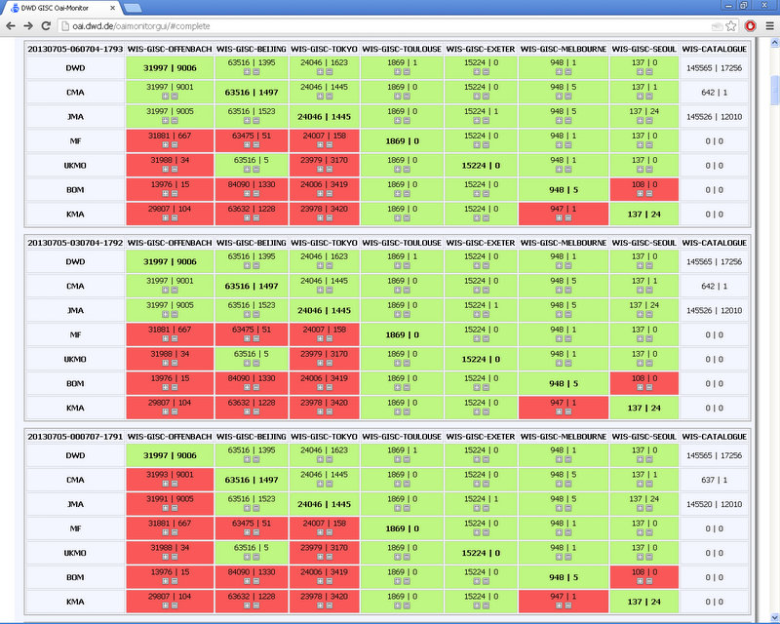

OAI monitoring results
The screen capture above shows two effects:
- If a GISC publishes new records the other GISCs are out of sync for a while and after the next harvesting cycle they are in sync again
- Some differences are permanent
The permanent differences are may be results of one of the following items:
- Metadata of GISC A (set A) appears in GISC B in set C
- For some reasons GISC A missed an update from GISC B. In the next incremental harvesting step GISC A will not retrieve the missed update
- GISC A deleted records without issuing a deleted message
- GISC A is not providing the record
For a deeper analysis of the differences it is essential that each OAI Provider identifies in an OAI request the OAI Set to which a record belongs. This is a must requirement according to the OAI PMH Version 2.0 specification. In paragraph “2.6 set” the specification says:
A set is an optional construct for grouping items for the purpose of selective harvesting. Repositories may organize items into sets. Set organization may be flat, i.e. a simple list, or hierarchical. Multiple hierarchies with distinct, independent top-level nodes are allowed. Hierarchical organization of sets is expressed in the syntax of the setSpec parameter as described below. When a repository defines a set organization it must include set membership information in the headers of items returned in response to the ListIdentifiers , ListRecords and GetRecord requests.
Currently only 3 operational GISCs provide this information.

Real world examples
The following examples were recorded July 5 2013.

Publication of invalid record
On July 4 2013 GISC A published an invalid record – the record was not valid against the ISO 19139 scheme. A brief analysis 24 hours later showed that GISC B harvested and injected the invalid record into its catalogue, GISC C still provides an outdated record from the WMO Baseline date January 20 2012 in the catalogue while 4 GISCs provide the latest valid version dated June 27 2013.
This example illustrates an out of sync status of the GISCs which can not be detected with the current implemented OAI monitors. The case was detected because the invalid record was rejected.
WIMMS records
Bahrain’s CLIMAT record “CSBN10 OBBI” appears in 3 GISCs catalogues out of 7 operational GISCs but in no WIMMS centre – Bahrain’s Principal GISC is not yet operational.
Qatar’s Warning record “WWQT20 OTBD” appears in 3 GISCs catalogues out of 7 operational GISCs - Qatar’s Principal GISC is not yet operational.
Nambia’s CLIMAT record “CSNM01FYWW” appears in 4 GISCs catalogues out of 7 operational GISCs - Nambia’s Principal GISC is not yet operational.
The examples above illustrate that especially the synchronization of WIMMS records needs some improvements. An additional paper suggests a guideline for moving metadata records between GISCs.

References
- OAI-PMH guidelines (reviewed and approved by ET-WISC 2012) http://www.wmo.int/pages/prog/www/WIS/wiswiki/tiki-index.php?page=oai-pmh-guidelines
- ET-WISC 2013, 5.7 WIS GEOSS Interoperability
- The Open Archives Initiative Protocol for Metadata Harvesting Protocol Version 2.0 of 2002-06-14 http://www.openarchives.org/OAI/openarchivesprotocol.html#Set

Recommended Text
Mr. Markus Heene (DWD) presented the paper on metadata synchronization. He highlights that the WIS Catalogue contains roughly 150.000 records where 60.000 records are describing products intended for global exchange and 90.000 products are other products. Last month roughly 5.300 changes in the catalogue took place. GISC Offenbach and GISC Tokyo offer public available OAI Synchronization monitors.
Suggested recommendations and decisions:
ET-WISC encourages the 4 GISCs who have not implemented the must requirement of OAI PMH Spec 2.6 (3) to implement the set membership in the header. Furthermore ET-WISC notes that it is beneficial for monitoring if all GISCs offer an OAI set “WIS-CATALOGUE” as specified in the OAI-PMH guidelines (1) – noting that only 3 of 7 operational GISCs have implemented yet.
ET-WISC suggests two test cases for the re-audit of the GISCs:
- Compliance with OAI PMH version 2 specification
- Implementation of WIS-CATALOGUE at all GISCs
ET-WISC asks all GISCs to check their synchronization status of the catalogues and to work on the identified findings. The presented guideline for moving metadata records between GISCs were reviewed and approved by ET-WISC.
--------------------

