3.5 Report on GTS and AMDCN

GTS
In October 2012, GISC Tokyo established circuit from Tokyo to Offenbach on RMDCN. Current protocol is TCP/IP(FTP) and disseminate data of AN, AN urgent, BIN, File. Current status is as following tables…
Circuit connected with | Type of circuit | Circuit speed (bps) |  | Protocol | Data types
Circuit connected with | Type of circuit | Tokyo side | NMHS side | Protocol | Data types
WMC Melbourne | MPLS | 10M | 2M | TCP/IP  (Socket, FTP) | AN, BIN, FAX, File
WMC Washington | MPLS | 10M | 1M | TCP/IP  (Socket, FTP) | AN, BIN, FAX, File
RTH Beijing | MPLS | 10M | 4M | TCP/IP  (FTP) | AN, AN urgent, BIN,  FAX, File
RTH Offenbach | MPLS | 10M | 8M | TCP/IP  (FTP) | AN, AN urgent, BIN,  File
RTH Exeter | MPLS | 10M | 2M | TCP/IP  (Socket, FTP) | AN, BIN, FAX,  File
RTH New Delhi | MPLS | 10M | 1M | TCP/IP  (Socket) | AN, BIN
RTH Khabarovsk | Dedicated (digital) | 64k | 64k | TCP/IP  (Socket) | AN, BIN, FAX
RTH Bangkok | MPLS | 2M | 128k | TCP/IP  (Socket) | AN, BIN
NMC Hong Kong | MPLS | 2M | 1M | TCP/IP  (Socket, FTP) | AN, BIN, File
NMC Manila | MPLS | 2M | 64k | TCP/IP  (Socket) | AN, BIN
NMC Seoul | Dedicated (digital) | 128k | 128k | TCP/IP  (Socket, FTP) | AN, BIN, FAX,  File
Current Status of GTS Circuits Connected with RTH Tokyo

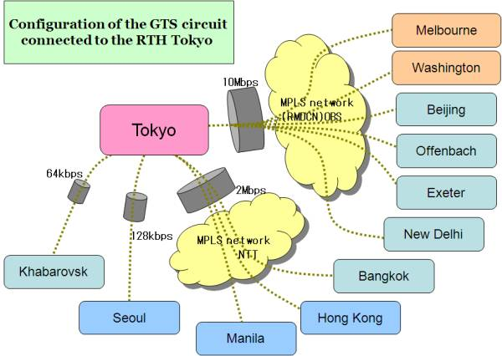

GTS traffic volume
Daily traffic volume on the GTS at Tokyo is increasing year by year.
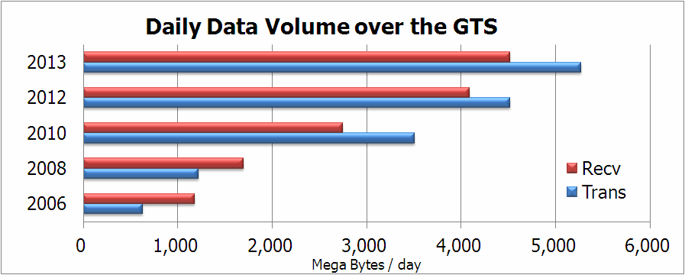

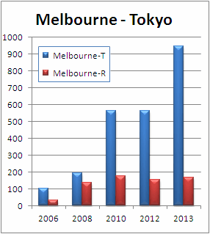
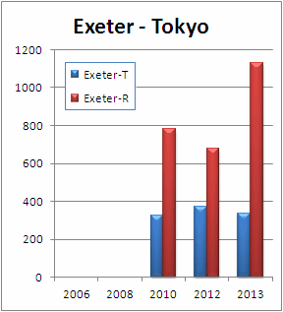
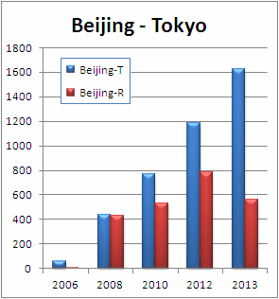
Daily traffic volume on each GTS link (Mega Bytes/day).

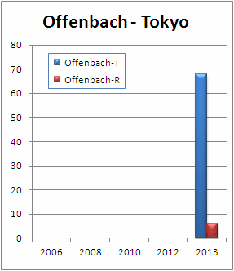
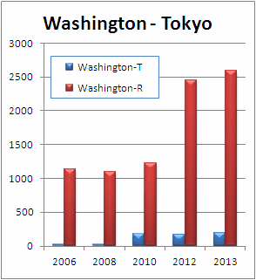
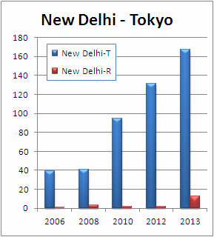

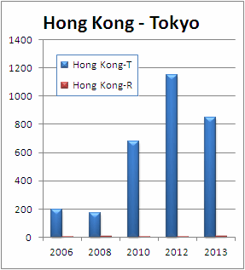
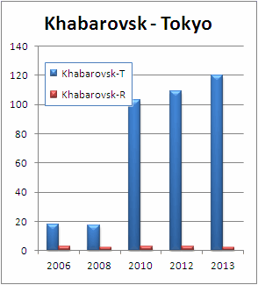
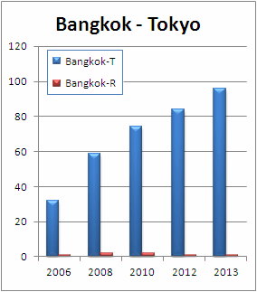

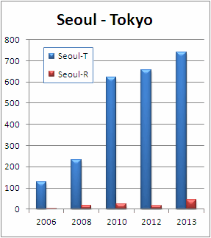
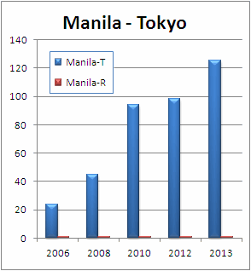

Migration to new MSS
GISC Tokyo will migrate our MSS in October 2013, and GISC Tokyo has been arranging with neighboring GTS centers and EUMETSAT for this migration of MSS. In this migration, there is no need to change IP address and protocols at any centers.

Next Generation of RMDCN
In February 2013, JMA signed Accession Agreement and Order form. JMA had completed contract for procurement. Installation work started in March and finished at middle of April. Currently, JMA is now in Implementation of the circuit line.

AMDCN
According to the Manual on WIS, WIS Core network is based on the Main Telecommunication Network (MTN). Follow the philosophy of WIS core network, AMDCN can be based on an RMTN (Regional Meteorological Telecommunication Network). All six Regional Associations have an RMTN to exchange meteorological data and products stably and reliably and each RMTN has been constructed from various types of telecommunication infrastructures, for example dedicated leased line, MPLS network, Internet, satellite communication and so on.
To establish AMDCN, each GISC should consider the conditions of telecommunication infrastructure in its area/zone/region of coverage of responsibility and cost effectiveness.
According to the survey in 2012, in RA-II, 81 GTS circuits are in operation. The number of operational circuits of each type is as follows;
- Dedicated leased line (35)
- Internet (23)
- MPLS (20)
- Other (3)
Taking into account the current structure of the RMTN, all the GISCs in RA-II should support at least top three communication infrastructures, “dedicated leased line”, “Internet” and “MPLS”. This will be a fast way to establish an AMDCN and accelerate WIS implementation.
AMDCN of GISC Tokyo consists of above major three network infrastructures, direct connects to Bangkok and Manila through the MPLS network, and dedicated leased line and internet via RTH Bangkok. The data and metadata expected for regional exchange between NMHSs are exchanged/managed by RHT Bangkok and data and metadata expected for Global exchange are exchanged/managed by GISC Tokyo.
NMHS | Connection | Bandwidth | Type
Cambodia | Via Bangkok(128Kbps) | Best effort | Internet
Lao PDR | Via Bangkok(128Kbps) | 64Kbps | Dedicated
Myanmar | Via Bangkok(128Kbps) | Best effort | Internet
Philippines | Direct | 64Kbps | MPLS
Thailand | Direct | 128Kbps | MPLS
Vietnam | Via Bangkok(128Kbps) | 64Kbps | Dedicated
Current Status of AMDCN of GISC Tokyo
As a fastest/easiest/cost-effectiveness backup way, GISC Tokyo has been providing users with subscription manager (application) based on the DAR service. Users can get their preferable set of data automatically and near-real time (every 30 second) with a few times mouse click and without any configuration at GISC side. Users can change target data anytime without any arrangement at GISC side.

