Development of a WIS Competence Framework

Background
- The ET-WISC fifth session of ET-WISC in Melbourne in March 2012agreed to establish a capacity building sub group consisting of Ms. La’Tanya Burton, Dr. Weiqing Qu and Dr. Sunghoi Huh to take into consideration planned activity and the requirements identified by Congress XVI to develop a capacity building component of the ET-WISC action plan and capacity building guidelines for Members. The 5th session stated that guidelines should identify extra-budgetary funding opportunities and partnerships that could be used to further WIS implementation and a guide for Members on how to access and support training on and for WIS. The capacity building guidelines should be available for CBS-Ext.(2014). Unfortunately, Ms Burton who was to lead this activity left so the group needs to be reformed if actions are to be completed by CBS 2014.
- EC-65 para 4.4(2)8 stated that “it is now essential to develop a structured training package for WIS and to investigate the feasibility of a competence framework for those with responsibilities for operating and managing WIS centres”.
- It should be noted that a competency framework is essential in order to develop a structured training package. Thus, in response to EC’s request and to support the role of ET-WISC capacity building group, a WIS training Workshop has been scheduled for 1-4 October 2013 in Geneva. It will undertake a study to identify the required competencies and subsequent, training goals and needs. The scope will include WIS users as well as Centre operators and managers. This is the first major work package in establishing Competencies and a suitable Curriculum for WIS.

Competency and Curriculum Development Workshop
- Identifying competencies is not necessarily a straight forward process. There are many models, with one example being that used by the World Health Organization (WHO) for developing their tuberculosis training program shown in figure 1. Although this is not necessarily the model that ET-WISC will choose, it can be used here to help clarify what is expected of the workshop. Broadly speaking one aim of a workshop would be to address something akin to WHO’s steps 1 to 7, focusing on the first four, with later steps to be completed after the workshop with an aim to developing a suitable set of competencies and an outline of a curriculum for consideration by ET-WISC and other OPAG ISS teams early in 2014 for presentation to CBS-14. The longer term aim is to identify the competencies required by WIS providers and users in order to facilitate Members in identifying what skills are needed in their organizations, for individuals and collectively, what skills are specialized to WIS, and what are general skills, etc. For instance, Cisco network management skills and data management skills might be something to look for in recruiting, but Members will need to train these experts in GTS requirements and in WMO Metadata Profile respectively. Also, in this example, these skills may be across several people or just a couple.
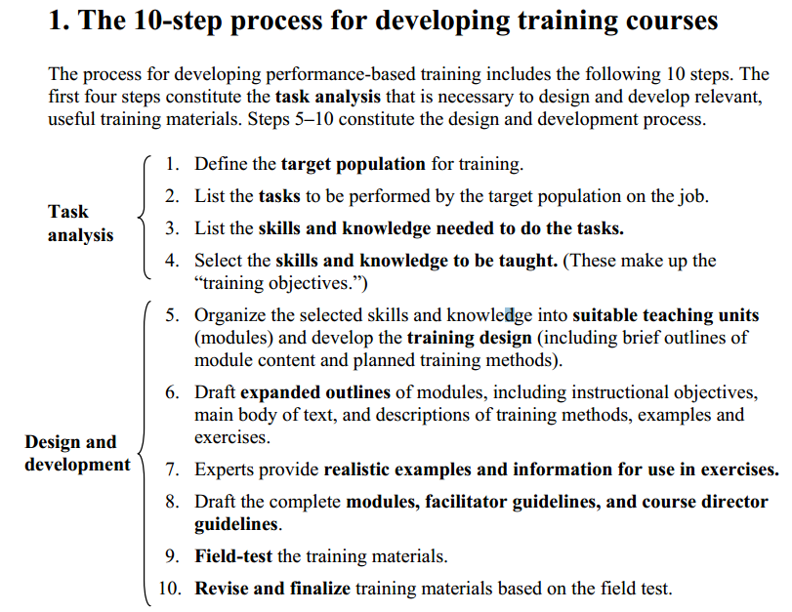
Figure 1 WHO Model for developing training courses (http://whqlibdoc.who.int/hq/2005/WHO_HTM_TB_2005.354_part1_eng.pdf)
- It is anticipated that the output of the workshop will be report that includes an analysis of Job Tasks, Competencies, Training needs and a draft Curriculum for consideration of CBS OPAG-ISS Expert Teams under the leadership of ET-WISC; and, a draft workplan for consideration of ET-WISC and other OPAG-ISS groups for the implementation of the workshop findings with an aim for final consideration at CBS 2014.
- The workshop is expected to be held in WMO Headquarters and participants are expected to include experts from ET-WISC, ET-CTS, IPET-DRMM and IPET-MDRD with an aim to representing all expertise used by WIS and GTS support staff in our NMHSs. The WIS secretariat is arranging for support from Education and Training Department and support of an expert in professional studies that has been involved in similar activities under other WMO programmes.

References
- Final Report on ET-WISC 5th session 2012 (FReport-ET-WISC2012.doc)
- Report on Congress XVI (WMO No 1077)
- Report on CBS-XV(WMO No 1101)
- WIS text for the Report on EC-65 (EC-65-d04-4(2)-REV1-WIS-approved_en.doc)

Suggested text for inclusion in the report
The meeting noted EC-65 statement that “it is now essential to develop a structured training package for WIS and to investigate the feasibility of a competence framework for those with responsibilities for operating and managing WIS centres”. It agreed that the identification of WIS related tasks and the skills needed to benefit from WIS by centres should be undertaken as soon as possible in order to meet this request from EC-65 and for the benefit of Members hoping to benefit from WIS. It agreed to the need for a workshop for the purposes of development of WIS competencies and curriculum. Participants should include representatives of all the OPAG ISS expert teams and ICT-ISS chair and co-chair. It expects that the workshop will be in Geneva from 1 to 4 October 2013. Outputs of the workshop should be made available to ET-WISC for review by February 2014. Outputs should include an analysis of Job Tasks, Competencies, Training needs and a draft Curriculum for consideration of CBS OPAG-ISS Expert Teams under the leadership of ET-WISC; and, a draft workplan for consideration of ET-WISC and other OPAG-ISS groups for the implementation of the workshop findings with an aim for final consideration at CBS 2014.
--------------------

