6.3 WIS System and Performance Monitoring

System and Performance Monitoring of GISC Tokyo

Overview
In addition to WIS Part A monitoring (WWW monitoring), GISC Tokyo has been watching system status and performance with information from suppliers, using open source software and self developing tools. Also GISC Tokyo check metadata exchange status. The monitoring result page has own URL and so GISC Tokyo prepared the portal page collected links. These are our initiative of monitoring focused to WIS Part B.
Current check point for system and performance monitoring

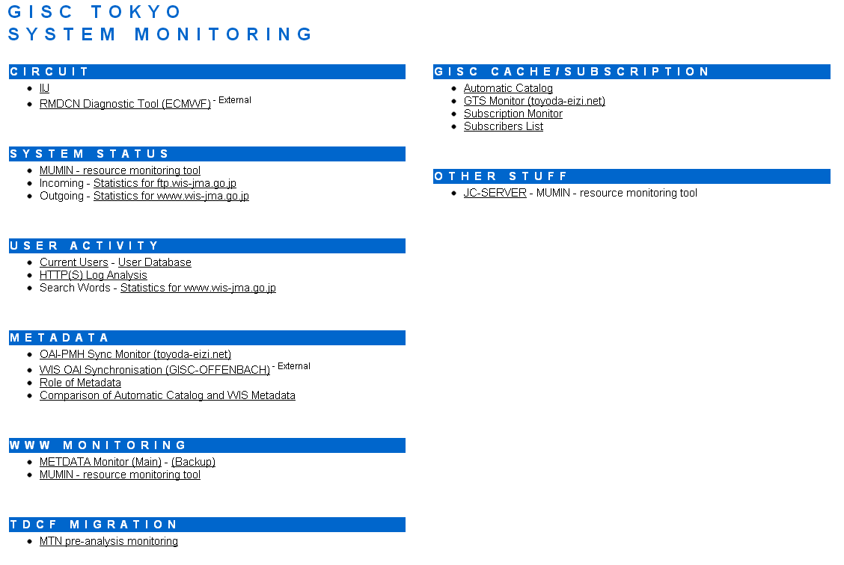
GISC Tokyo’s System Monitoring portal page

Network Monitoring
External (internet) network status can be checked from supplier website. It shows us real time traffic graph, logs, and periodical report. GISC Tokyo recognized that circuit’s status and remaining of bandwidth.
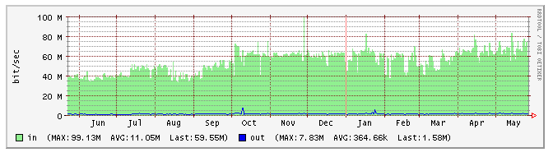
Internet traffic graph : Monthly
Network status of Internal side can be checked using with MUNIN.
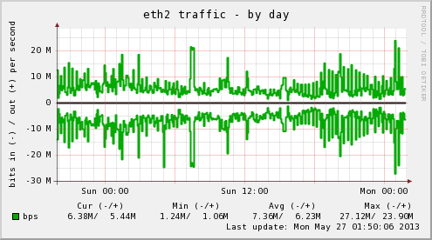
Screenshot of MUNIN monitor : Network

System Monitoring
GISC Tokyo uses open source resource monitoring tool, MUMIN for our system monitoring and server status e.g. Disk, Apache, MYSQL, Network, NFS, Processes, can be checked with this tool. It helps us to find problem of systems and networking. When we install new or modified programs, we check especially processes and disk information carefully.
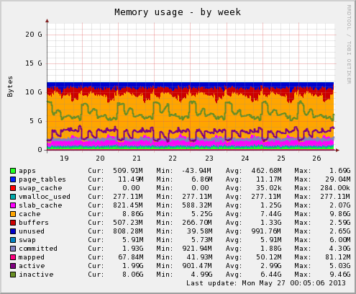
Screenshot of MUNIN monitor : Memory

ftp, www Monitoring
Also GISC Tokyo uses open source log file analysis software, AWSTATS. The ftp log (incoming to system) and http log (outgoing from system) can be analyzed with this tool . GISC Tokyo can realize amount of data size both of in and out.

ftp log analysis
GISC cache of GISC Tokyo is built from data files coming from MSS and super computer. GISC Tokyo analyze ftp log files with AWSTATS. We already know that how much data files we receive from MSS a day by this monitoring, and can compare amount of data files with this value in our everyday checking.
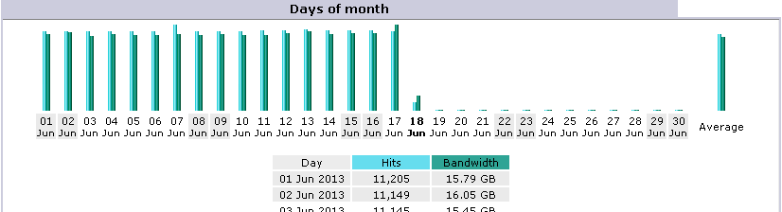
Screenshot of ftp analysis : Daily

http log analysis
GISC Tokyo analyze http log file using with AWSTATS. We can see the general result of log analysis with this tool.

Metadata Monitoring
GISC Tokyo has been exchanging metadata with other operational GISCs, so we must check our operation. For this matter, GISC Tokyo developed monitoring tools, “OAI-PMH Sync Monitor” and monitor current status of exchange with this tool. Also GISC Tokyo has been checking status of metadata exchange with useful DWD’s “WIS OAI Synchronization” page.

Comparison on Actual data catalog and WIS Metadata
For effective DAR service, the enrich of metadata is essential. But it is also true that there is data without metadata. GISC Tokyo has been checking the message which received at GISC Tokyo and registering message’s property to database as actual data catalog (we call it, “Automatic Catalog”) since our official operation. Now GISC Tokyo is developing the comparison software to find out data without metadata, using Automatic catalog of GISC Tokyo and WIS Metadata.

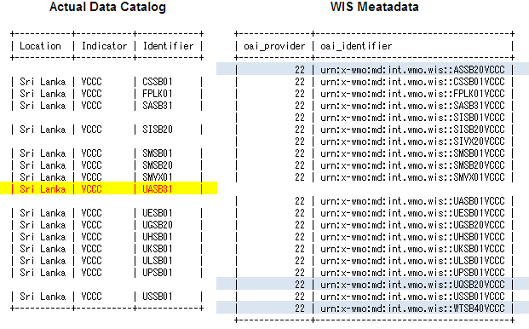
We want to find this record!
Actual data catalog and WIS Metadata

Both of automatic catalog and WIS metadata can be stored on the RDB. If we make a common item as the view, e.g. “CCCCTTAAii”, we be able to compare the difference. For automatic catalog, the view is made from Location Indicator and Identifier. For WIS Metadata, the view is made from OAI identifier. By checking difference of these views, we can find out data without metadata. The result is outputted to text file. GISC Tokyo is planning to provide this information from GISC Tokyo portal.
VBRRUKBM01
VBRRULBM01
VBRRUSBM01
VCCCUASB31
VDPPCSKP01
VDPPISMC01
VGDCISCC01

Process Diagram
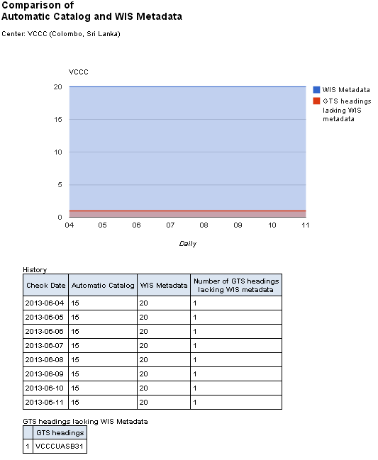
Result Pages (e.g. VCCC : Sri Lanka)
This software can extract difference between automatic catalogue and WIS metadata and correct daily status for area of responsibility and WIMMS. Using this software and result, GISC Tokyo will be able to help create/maintain WIS metadata effectively.

Subscription Monitoring
As overall checking, GISC Tokyo has been subscribing from our GISC cache with same way of users of GISC Tokyo particularly. Currently, GISC Tokyo is subscribing 3 items following…
- Alphanumeric SYNOP (It comes from batched FTP)
- Satellite BUFR (It comes from file FTP)
- High-Resolution GSM (It comes from Super Computer)
By examining the three items, it can help us to determine where system failed. If/when GISC Tokyo has some problem of subscription (it means no download from GISC cache) , email of notification send automatically and GISC Tokyo can start to investigate problem immediately.
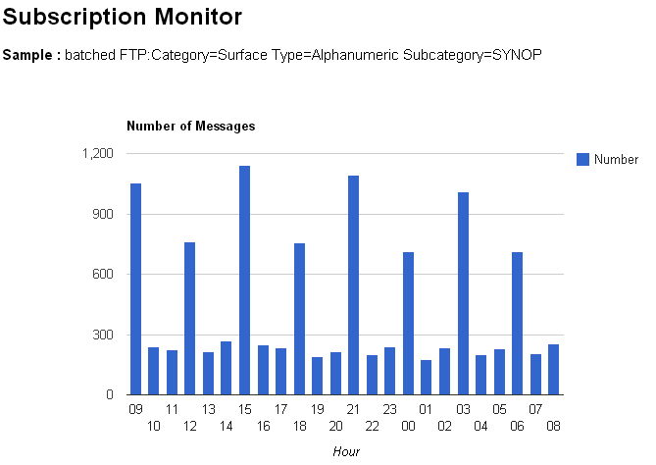
Result Page (e.g. SYNOP, Alphanumeric)

User activity Monitoring
GISC Tokyo developed user database. We can list, search, modify user information easily with using this database. It is easy to list up all email address of users when GISC Tokyo need to send information from GISC Tokyo, or create account graph like below.

Using data from GISC Tokyo user database: IDs

Since official operation, GISC Tokyo has been analyzing apache web sever logs with self developing tool. Relation of IP address and user ID can be analyze from https log file. So GISC Tokyo can analyze http log file using with this relationship. Using both of https and http logs, GISC Tokyo can find user activity.
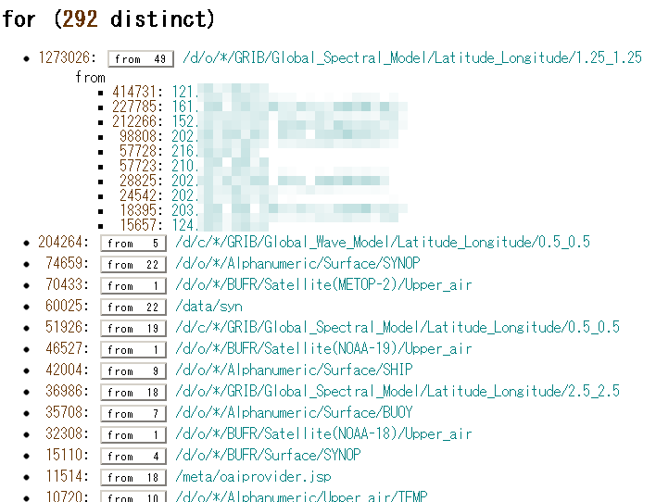
Result Page of “Access log analysis”

Reference
- MUNIN http://munin-monitoring.org/
- AWSTATS http://awstats.sourceforge.net/
- OAI-PMH Sync Monitor http://toyoda-eizi.net/2011/syncmon/mon.html
- DWD’s “WIS OAI Synchronization” http://oai.dwd.de/oaimonitorgui/

Recommended Text
Mr. Shigeharu NISHIKAWA reported initiative of GISC Tokyo’s system and performance monitoring including MUNIN, AWSTAT, and self developing tools. He mentioned that "Comparison on Actual data catalog and WIS Metadata" and "Subscription Monitoring" is useful performance monitoring for GISC’s operation and it helps for users.

