3.7 WIS implementation solutions and applications

RA-II/V WIS Application Pilot Project
In February 2012, CMA and JMA held meeting in Tokyo and updated the future plan of VPN PP. The two sides agreed to reform the VPN PP into the next stage. The reformed VPN PP will focus on applications of WIS in every Member’s operations, and will be renamed to RA-II/V WIS Application Pilot Project. The WIS Application Pilot Project starts with following themes;
- Web data ingest (led by CMA) ,
- WWW Monitoring Results Display (led by CMA) ,
- Visualization of near-real time monitoring results (led by CMA and JMA) ,
- Automatic data acquisition software (led by JMA) ,
- Evaluation of visualization techniques (led by JMA),
- Metadata Creation with Microsoft Excel (led by JMA).
JMA established a new website, RA-II/V WIS Application Pilot Project website, in Nov 2012 for this project ^{[1]}.

Metadata Creation with Microsoft Excel
“Metadata Creation with Microsoft Excel” supports NC’s migration from GTS bulletin catalogue into WIS discovery metadata by developing an MS-Excel based tool which creates WIS metadata. With using this tool, users can make metadata files to upload to GISC easily. The step is so simple;
- Download an MS-Excel based metadata creation tool from the Pilot Project website,
- Fill in columns based on Observing Stations (WMO Publication No.9 Volume A) and GTS bulletin catalogue (WMO Publication No.9 Volume C1),
- Create WIS metadata by clicking Export.
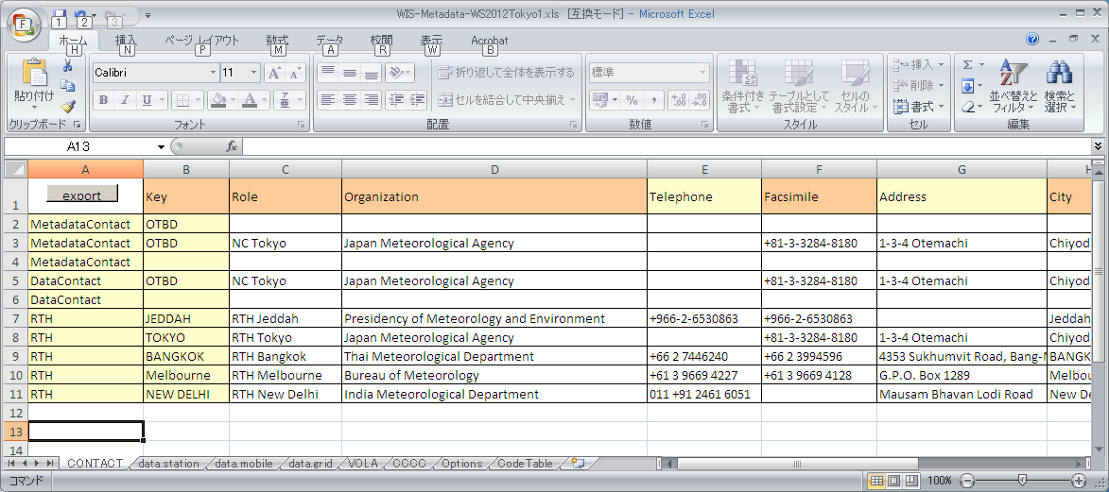
Screen shot of Metadata creation tool

Subscription Manager
GISC Tokyo has been developing “GISC Tokyo Subscription Manager” for this project. This is automatic data acquisition software for GISC cache of GISC Tokyo running on Microsoft Windows. This software is developed for ordinary PC users and features are …
- Easy setup.
- Easy download setting with simple GUI.
- No additional program.
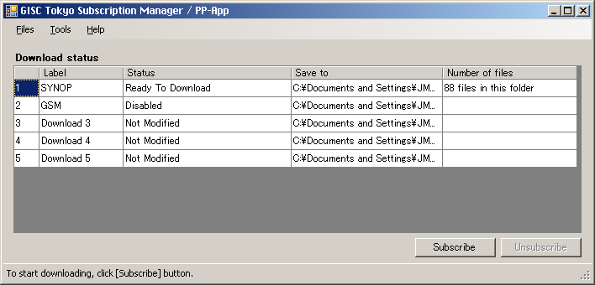
Screen shot of Subscription Manager : “Main Window”

Issuing the news letter of this project
GISC Tokyo issued the first news letter, “WIS Application Pilot Project Newsletter – Volume 1, May 2013” ^{[2]} on May 15th, including
- About WIS Application website,
- Introducing developing software of JMA,
- Collect ideas for software.
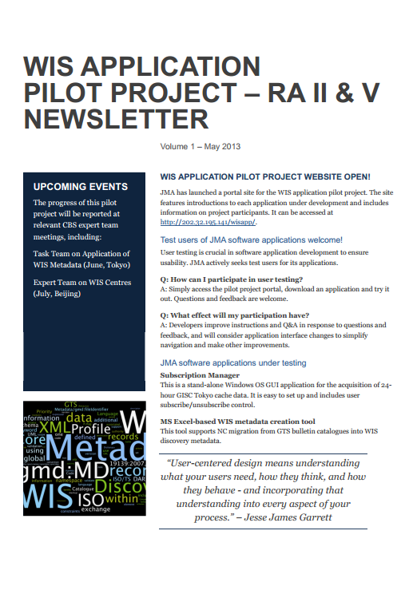

Reference
[1] RA-II/V WIS Application Pilot Project website
http://202.32.195.141/wisapp/
[2] WIS Application Pilot Project Newsletter
http://www.wis-jma.go.jp/cms/wp-content/uploads/2013/05/WIS_PP-App_Newsletter_Volume1_May2013.pdf

