Status report on ET-CTS activities

Introduction

Following last year CBS meeting, the working group was renamed as Expert Team on Telecommunications Infrastructure, however its acronym (ET-CTS) was kept. In the following document we will use the acronym. At the same time, the Terms of Reference were reviewed. They are now the following:

Terms of Reference for Expert Team on Telecommunications Infrastructure (ET-CTS)
Last updated: 01/02/2013
(a) | Maintain and develop recommended practices and technical guidance material for data communication techniques and procedures for use in the WIS, with a view to ensuring efficient and safe operations of information systems, and inform members of recent developments in standards bodies, in particular ITU and ISO;
(b) | Review and further develop the organization and design principles for the WIS data communication and access structure, and coordinate related pilot and implementation projects;
(c) | Review and amend as required the telecommunications components of the Manual on WIS (WMO-No 1060), the Manual on the GTS (WMO-No 386), their associated Guides and other guidance material;
(d) | Provide guidance on the technical, operational, administrative and contractual aspects of data communications services for WIS implementation at national, regional and global levels, including among others satellite telecommunications, managed data communications network services and the Internet and co-ordinating cooperation with other organizations where appropriate to obtain operational benefits;
(e) | Review and further develop guidance and practices for planning, implementation and operation of data collection systems for observing systems for NMHSs, including interfaces with observation platforms, methods and data communications protocols;
(f) | Monitor the effectiveness of data exchange on the WIS in relation to the expected standards, and take follow-up action, including capacity-building activities, to address issues identified;
(g) | Facilitate the interaction between Members and International Organizations on telecommunications issues, including ensuring remote communities and areas with limited access to modern communication systems are properly catered for;
(h) | Advise the technical commissions on data communications issues, especially in respect of the WIS;
(i) | Identify implementation issues requiring the urgent consideration of the OPAG on ISS.
Based on these terms of reference, the working group with WMO and ICT-ISS support has defined the following objectives.

Objectives for Expert Team on Telecommunications Infrastructure (ET-CTS)

CTS/a/1 | WMO IPv6 Initiative | WMO IPv6 Initiative
CTS/a/2 | Multicast for the GISC | Multicast for the GISC
CTS/a/3 | Design principles for the WIS data communication structure | Design principles for the WIS data communication structure
CTS/a/4 | Pilot revision of WMO No. 386, Vol II, sections B.I-1 to B.I-15 | Pilot revision of WMO No. 386, Vol II, sections B.I-1 to B.I-15
CTS/a/5 | Contribute to the development of WIS educational requirements an capacity building led by ET-WISC | Contribute to the development of WIS educational requirements an capacty building led by ET-WISC
CTS/a/6 | Contribute to the development of WIS monitoring requirements led by ET-WISC | Contribute to the development of WIS monitoring requirements led by ET-WISC
CTS/a/7 | Development and maintenance of WIS Core Network | Development and maintenance of WIS Core Network
CTS/a/8 | Develop a coordination mechanism for users and suppliers of satellite data collection systems (Satcom) | Develop a coordination mechanism for users and suppliers of satellite data collection systems (Satcom)
Figure 1 : Agreed list of objectives for ET-CTS

This report will focus on three of these objectives:
- CTS/a/1
- CTS/a/2
- CTS/a/7

Objective CTS/a/1 - WMO IPv6 initiative
The task is lead jointly by I.Gloser (Co-Chair of ET-CTS, DWD) and T.Proeschold (WMO). The team has defined a 4-year plan to facilitate the use of IPv6 within WMO Members and for the exchange of data between members. Late 2012, early 2013, the group launched a survey for toward all WMO members to assess their readiness toward IPv6. The plan is to reissue the same survey each year to assess the progress of IPv6 awareness. For 2013, the main task of the team is to work on a pilot network involving 6 to 8 countries for exchanging data over the Internet using IPv6. At the moment, the potential sites are working on enabling (if it is not already done) the IPv6 connectivity over the Internet. Then, ECMWF will make available an appliance with numerous IPv6 enabled tools to facilitate the exchange of data. The task is progressing well and a number of actions have already been identified for the coming month and years. Ultimately, ET-CTS will have to work on an update of the attachment II-15 to standardize the exchange of data using IPv6. IPv4 will remain the preferred protocol for many years. However, having the standard ready for IPv6 usage is key to facilitate the transition of the GTS and the WIS toward IPv6.

Objective CTS/a/2 - Multicast for the GISCs
In its 2012 session, the Working Group reviewed various papers produced by Australia, EUMETSAT and ECMWF on the usage of multicast on terrestrial network. The various reports illustrated the two challenges of the usage of multicast for the exchange between GISCs:
- A common application must be used by all sites. There is no standard application for file transfer using multicast. EUMETSAT is using a commercial proprietary software and Australia and ECMWF have evaluated MFTP (an open source solution)
- The underlying network must support multicast traffic. To make things more complicated, in the case of GISCs, the network must be able to support up to 15 sources. The meeting also noted that the Internet (using multiple ISP as it is the case between the GISCs) does not support multicast traffic.
The study will now continue. At its next meeting (Q1-2014), ET-CTS should be in a position to conclude on the subject of using Multicast for data exchange between the GISCs.

Objective CTS/a/7 - Development and maintenance of WIS Core Network
WMO Executive Council has decided that the RMDCN will be used as the WIS Core Network. Also,i In the resolution 4.4(2)/1 EC-65:
(see https://docs.google.com/a/wmo.int/uc?id=0B8DhC1GSWSmxMUFISlA3WGVkTUk&export=download) on page 7 that EC requested "all operational GISCs to connect to the WIS core network and transmit information collected from their area to all other operational GISCs".
As a consequence, ECMWF, the project manager of the RMDCN, has contacted all the GISCs for establishing their connection to the RMDCN Next Generation. For the migration project, July 1st 2013 is a very important milestone. This was the date were all countries must have signed the relevant contractual documents and agreed on the required configuration.
The table below summarizes the situation for each GISCs.
Country name | Site Type | Bandwidth (Mbps) | Comment
Australia | Platinum | 4 | Because of various Governance requirements, the Bureau wasn’t in apposition to meet the deadline.
China | Platinum | 8 | Ordered
France | Platinum | 50 | Ordered
Germany | Platinum | 50 | Ordered
India | Platinum | 4 | Ordered
Japan | Platinum | 10 | Delivered (was a Pilot Site)
Morocco | Bronze | 2 | Ordered
Russia | Platinum | 10 | Ordered
South Africa | Bronze | 2 | Ordered
South Korea | Platinum | 4 | Ordered
United Kingdom | Platinum | 20 | Ordered
United States of America | Platinum | 50 | Ordered
Brazil | Platinum | 2 | For internal regulation reasons, INMET cannot sign the order directly with Interoute. A 3rd party (for invoicing purposes) needs to be used. The order is delayed. It is not yet sure if Brazil will be part of the Initial Deployment.
Iran | - | - | Despite a lot of effort from IRIMO, ECMWF, WMO and Interoute, it wasn’t possible to overcome all the legal/technical/financial difficulties on time. The work is continuing with IRIMO for a connection after the Initial Deployment phase.
Saudi Arabia | - | - | From Saad Mohammed : “Regarding GISC Jeddah connection to RMDCN, unfortunately, the final decision is not taken yet and I think it will take some time.”
Figure 2 : Status of the RMDCN Next Generation for the GISCSs
So, 11 or 12 GISCs will be part of the Initial Deployment.
All those GISCs will have a redundant solution. With a PLATINUM configuration, the primary and the backup connection will be the same. Morocco and South-Africa will be using, for the backup connection, an IPSec VPN access.
For the other connected countries, all except Lebanon confirmed their intention to connect to the RMDCN Next Generation as part of the Initial Deployment.
During the migration phase, as the primary aim is to ensure that connectivity is maintained between all sites at all times, it was decided that a “big-bang” approach - i.e. an instantaneous switch-over from the old network to the new - would be far too risky. Instead there will be a designated period of one month, during which all sites will be switched over.
During this period, ECMWF will act as a gateway between the current OBS network and the new Interoute network, thus enabling all RMDCN sites to continue to inter-communicate during the migration, whether they are on the OBS network or have already migrated to Interoute. However, in order to minimise the overhead of running parallel networks, ECMWF will cease its connection to OBS in early May 2014. Sites not part of the Initial Deployment will not be connected to the new RMDCN network until after the end of the one-month migration window (February 2014), on a business-as-usual basis. There is a possibility that of a site doesn’t order its connection on time, it could be isolated from the other sites after the end of the gateway period.
EVENT | DUE DATE (LATEST)
Contract Signature | 11 December 2012
PILOT NETWORK PHASE
ECMWF submits order forms for all Pilot Sites | 4 February 2013
Interoute hands over all Pilot Sites | 26 May 2013
Successful completion of Pilot Network Reliability Acceptance Test  Formal acceptance of Pilot Network | 30 June 2013
INITIAL DEPLOYMENT PHASE
Order forms for a minimum of 17 sites to be submitted, comprising at least the remaining ECMWF Member States.  All these User Sites plus the five Pilot Sites are part of the Initial Deployment | 1 July 2013
Start of Site and Network Reliability Acceptance Tests | 20 November 2013
Successful completion of Global Network Reliability Acceptance Test  Formally acceptance of new network | 20 December 2013
Network Migration starts (for all sites part of the Initial Deployment) | 6 January 2014
Network Migration finishes | 6 February 2014
Figure 3 : Planned timeline of the migration to RMDCN - Next Generation

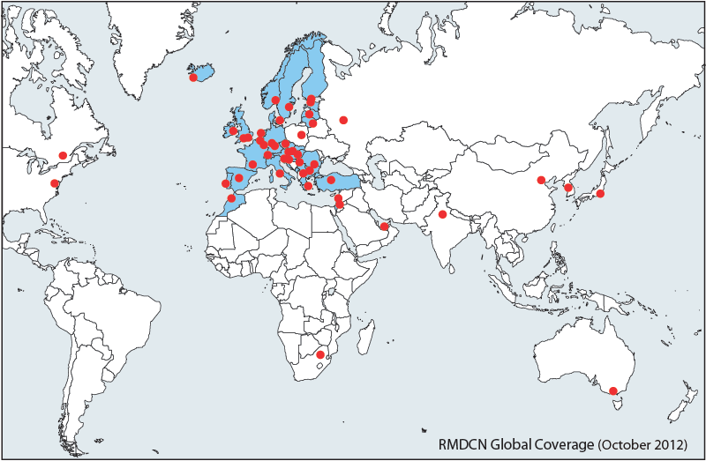
Figure 4 : The global coverage of the current RMDCN
There are 50 sites (46 National Meteorological Centres, ECMWF, 2 EUMETSAT sites and one disaster recovery site in the Netherlands) connected to the network. The shaded countries indicate ECMWF Member States and Co-operating States.
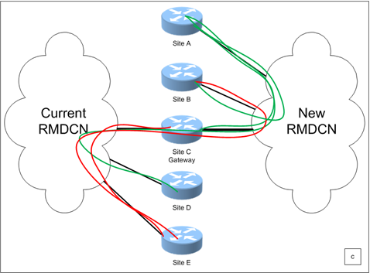
Figure 5 : A graphical representation of a point during the migration from the current RMDCN to the new RMDCN

