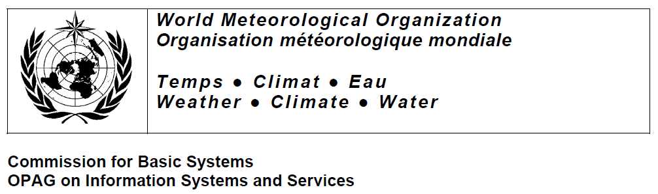

WMO Core Metadata Profile version 1.2
Guidelines on the use of Metadata for WIS
Document version: 0.4 (DRAFT)
Author: Jeremy Tandy (IPET-MDI)
Date: xx February 2011

Change history:
- Initial version (0.1) published for review [12-Nov-2010]
- Amendments included from IPET-MDI team review [xx-Dec-2010]
- Amendments included from IPET-MDI team review [xx-Feb-2011]
- Amendments included from IPET-MDI team review [xx-Feb-2011]

References and attributions

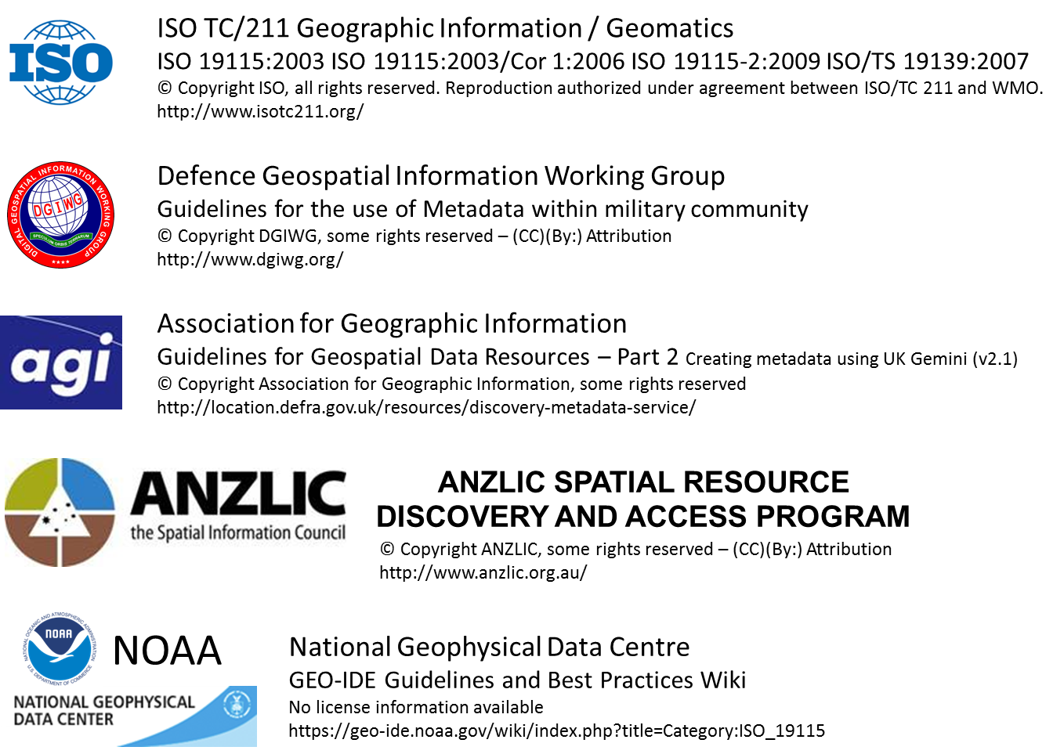

Introduction
Organisations providing information must enable its discovery, evaluation and use. In today’s environment this is accomplished typically through a set of web services, which may interface with multiple networks to allow discovery and retrieval of the information.
Metadata is data about data. It provides additional information about the data resource, to enable it to be better understood and used to good effect.
A world without metadata would be like a world without labels - imagine walking down your supermarket shopping aisle looking for a specific can of food but there were no labels on the products:

- Could you find what you were looking for?

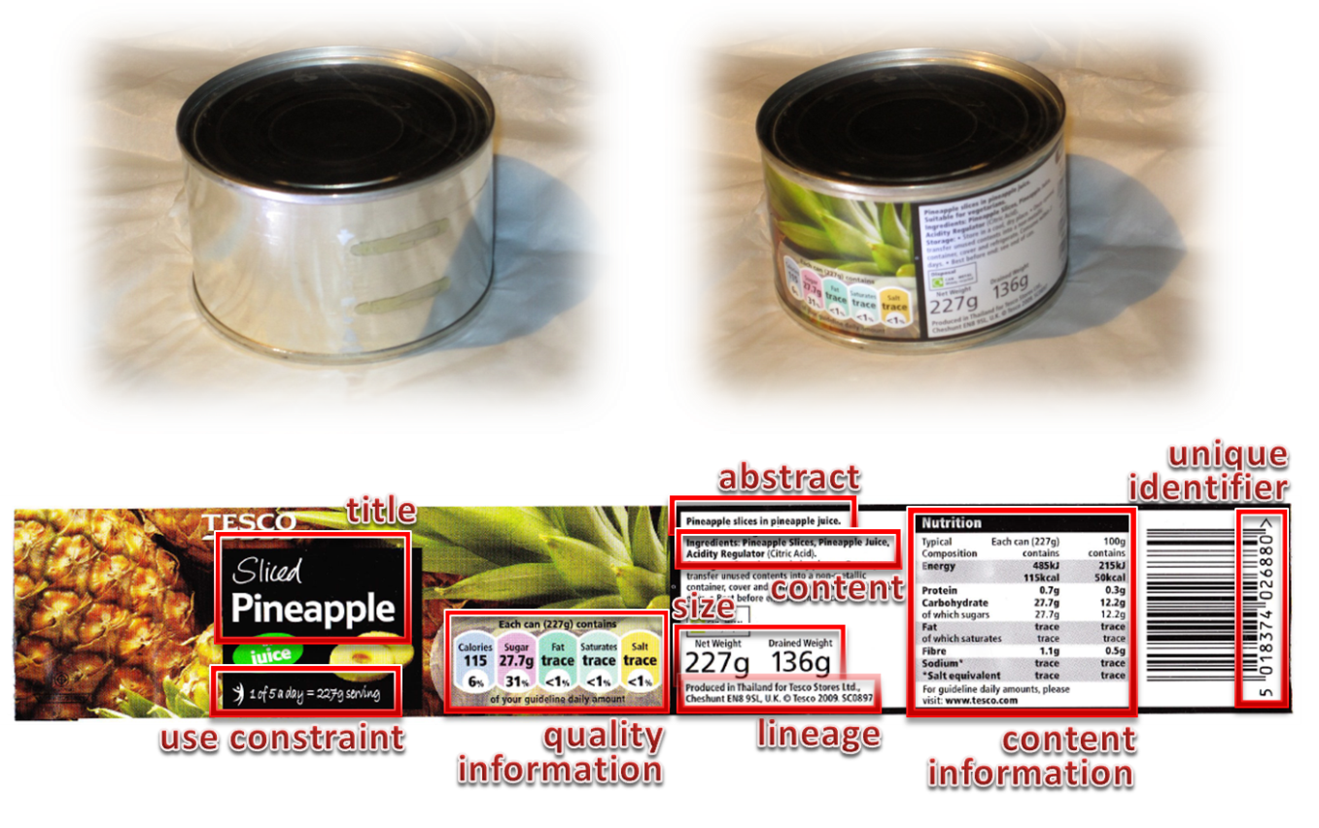
Successful discovery of geospatial data resources, that is data containing a positional or locational element relative to the Earth, depends on matching the search criteria to the metadata.
The WMO Information System (WIS) provides a variety of search mechanisms ranging from structure menus to free text fields. A successful ‘search’ will depend as much on the metadata as on the specific functions provided by the Global Information System Centres (GISC), Data Collection and Production Centres (DCPC) and National Centres (NC) that comprise the WIS.
Geospatial metadata describes geospatial data; that is data containing a positional or locational element relative to the Earth. It describes resources in terms of certain well-defined attributes, such as resource topic category, resource title, or geographic extent of the resource. This description allows users to search for keywords, names and phrases in particular contexts or in structured searches. For example, an organisation’s name might be associated with a specific role with regard to the data, such as ‘responsible party’ or ‘distributor’. Such associations, combined with the use of ‘controlled vocabularies’ (i.e. standardised lists of terms, such as abbreviations for countries or code lists for categories) and standardised formats for values (e.g. for dates or geographic extents) can greatly improve the efficiency of discovery.

About metadata
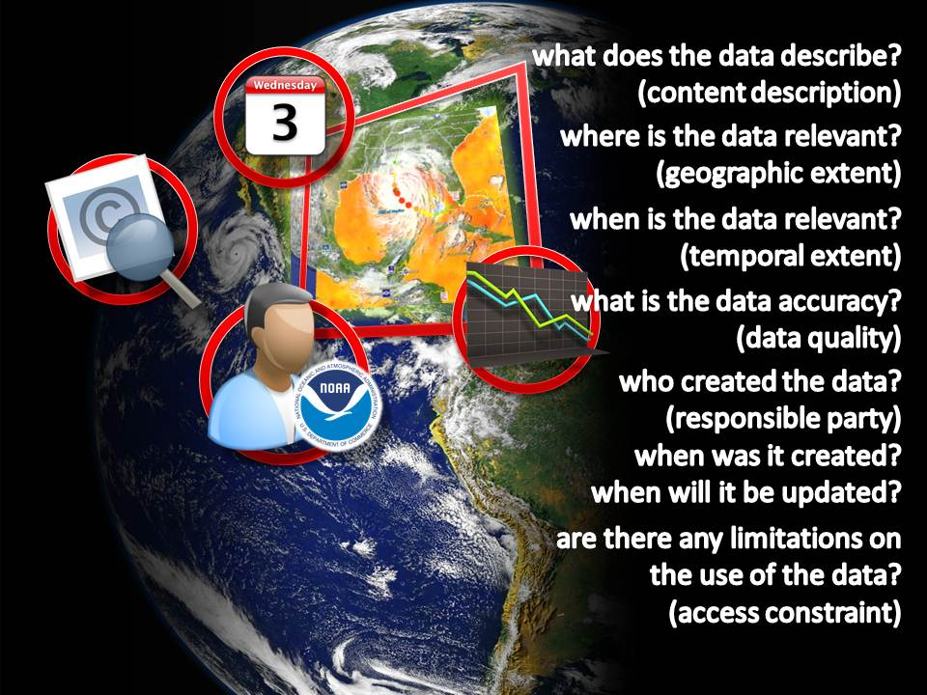
What is commonly understood as metadata comprises:
- Identification information, i.e. information to uniquely identify the resource such as:
  - Title, abstract, reference dates, version, purpose, responsible parties, …
  - Data extent,
  - Browse graphics (overview, thumbnail, …),
  - Possible usage;
- Legal and security constraints;
- Distribution information, i.e. information about the distributor of, and options for obtaining the resource;
- Reference system information, i.e. identification of the spatial and temporal system(s) used in the resource data;
- Quality and validity information, i.e. a general assessment of the quality of the resource data including:
  - quality measures related to the geometric, temporal and semantic accuracy, the completeness or the logical consistency of the data;
  - lineage information including the description of the sources and processes applied to the sources;
  - validity information related to the range of space and time pertinent to the data; to whether the data has been checked to a measurement or performance standard or to what extent the data is fit for purpose.
- Maintenance information, i.e. information about the scope and frequency of updating of the resource data.
“Metadata applied in a standard way ensures that a minimum amount of consistent information is given about each dataset.
… it documents the procedures that were used to create and update the dataset and, more importantly, is an opportunity to state what the data are not. It also provides contact information, so that questions associated with the data can be fielded appropriately.
Metadata can be used to describe an object so that it can be located when needed. It can help organize electronic records, facilitate interoperability across systems, provide digital identification, and support both archiving and preservation.”
Metadata is the starting point for access as it provides the means for ‘discovery’ of spatial information.

Using metadata
Metadata is a document, file, or record that is associated with a dataset (or catalogue) and provides background information about that record that is “computer readable”.
Metadata can be used to describe an object so that it can be located when needed by a search engine, database or application. It can help organize electronic records, facilitate interoperability across systems, provide digital identification, and support both archiving and preservation.
Metadata can be shared with others, without sharing the actual resource described by the metadata.
Metadata applied in a standard way ensures that a minimum amount of consistent information is given about each dataset.
As metadata documents the procedures that were used to create and update the dataset and, more importantly, is an opportunity to state what the data are not. It also provides contact information, so that questions associated with the data can be fielded appropriately.
“Metadata serves data discovery at multiple levels: – initial identification by query of keywords, location, time, and attributes – assessment once located by use and access constraints; data quality measures of positional and attribute accuracy and sources used; and statements as to data availability, format and pricing – access the data, once deemed useful, using distribution URLs, standard order process instructions and individuals to contact. This is very useful when dealing with very large resources – e.g. ABS Census data for Australia or the Bathemetry of Australia.”¹
A general scenario well describes a typical user’s interaction with metadata covering discovery, evaluation and use of the associated data. This is applicable to a wide range of meteorological concerns:
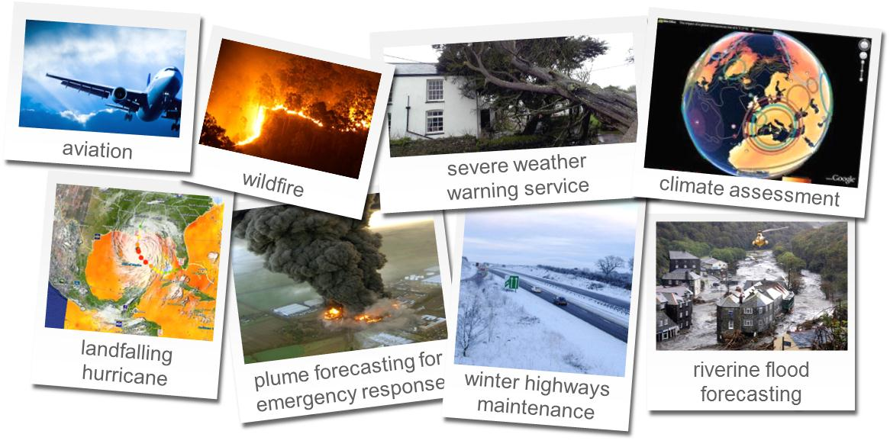
The WIS Metadata Use Case creates a general context associating existing and upcoming metadata based solutions around three base user activities:
1. The discovery of resources. The user expects to identify a set of resources satisfying a basic set of search criteria. The user interacts with a Search Engine connected to a set of metadata repositories which contain metadata about available data resources. The Search Engine transfers the search criteria to the metadata repository and expects a minimum set of metadata related to the matching resources. It consolidates the answers and provides them to the user through an adapted interface.
2. The evaluation of the authority, validation, curation, or other attributes of discovered resources. When the user has identified a candidate resource, potentially as a result of the discovery activity, and wants to determine whether this resource satisfies his/her requirements or not. For this purpose, it may use a Metadata Browser to examine more detailed metadata about the resource.
3. The use of identified resources. When the user has chosen a resource and has also has obtained appropriate access and use rights the resource can be accessed and used through a series of dedicated tools. Metadata supports the user in fully understanding the data and using it properly which results in more reliable analysis and more confidence in the results.
Different kinds of users may be involved in different activities: some experts may evaluate the resources while operators may use them. There are cases where the user may be a software system performing automated searches.
A prerequisite of delivering these outcomes is the establishment of effective maintenance for metadata, i.e. the overall management of the metadata resources. This guidance document seeks to provide would-be metadata authors with sufficient information to create metadata that conforms to the WMO Core Metadata Profile and meets the expectations of the user community.
In terms of discovery, it is important to have sufficient information in the response so that a user is able to recognize the data and determine its source (authority and address). The metadata should refer to coherent sets or collections of data and datasets, and not to a range of nearly identical component datasets.

General principles of metadata
This section describes some general high-level rules that apply to the creation of metadata. Whilst the focus of this guidance material is the WMO Core Metadata Profile, these principles are generally applicable to a wide range of metadata specifications.

Free text
The aim of a discovery metadata specification such as the WMO Core Metadata Profile is to define metadata in a form that provides easily understood information for potential users of the data resource, and is searchable in a computerised discovery metadata service such as that being developed for the WIS. It is difficult to carry out searches on free text, since the same thing can be written in different ways, for example ―WIS, ―WMO Information System, ― Système d'information de l'Organisation météorologique mondiale. Hence, free text entries are discouraged where the metadata is searchable.
By way of example, a Google search for the term ‘ANZLIC’ returns About 19,200 results (0.14 seconds). A semi-structured search for the term ‘ANZLIC metadata profile site:au’ returns About 2,320 results (0.20 seconds).This is better; it’s still a considerable effort to sift through these results.
Encoding the metadata with specific keywords (a controlled vocabulary) and providing that structure to the users significantly improves the ability to locate the target resource.
Where only a limited number of options are available, code lists are specified. For some metadata elements, such as TopicCategory, these may not correspond exactly to the theme of the dataset, and the nearest option should be chosen. Where code lists are used, input and output facilities in a metadata service should identify the corresponding element value. Where simple code lists are insufficient a wide range of controlled vocabularies can be used, ranging from ‘flat’ vocabularies with no structure (very similar to simple code lists), through multi-level vocabularies (taxonomies) and relational vocabularies (ontologies). These schemes all provide a fixed domain of terms for a user to choose from, but can offer significant utility in understanding that domain.

Obligation
As with other metadata specifications, elements in the WMO Core Metadata Profile are given as mandatory, conditional or optional. Mandatory elements must be completed, and most software tools do not allow the metadata to be entered if any mandatory elements are missing. Conditional elements have a condition associated with them, and should be supplied when that condition is fulfilled. Such conditions usually define the applicability of the element. Optional elements may not always be completed. This can be for a number of reasons, for example if the element is not relevant or its value is not known. In practice, optional elements are really conditional, and there is a set of circumstances in which a value should be given, roughly corresponding to ―is it relevant? and ―is its value known? Optional elements should not be ignored.

Element domains
Each metadata element has a range of allowable values, called its domain. These may be values in a given range (e.g. positive integers) or a set of code values chosen from a list. Specifying the domain helps with both the initial creation of data and quality checking. In some cases, default values may be used, for example for elements relating to the metadata itself.

Spatial references
By definition, geographic data contains some form of spatial reference. The spatial reference identifies the position of the object of interest in the real world. Spatial references can be given in a number of forms, not just as Grid References. They can take the form of the name or identifier of a geographic location which can be described in a gazetteer. Examples are property addresses, postcodes and census areas. These spatial references are a key means of searching the data by location, not only within the data resource, but also positioning the data resource in the world (e.g. data for Scotland). A consistent set of spatial references enables spatial searches to be made for datasets in a metadata service.

Date fields
Metadata can contain a multitude of dates identifying the different stages in the life cycle of the data. Key dates are included in metadata. To enable searches to be carried out (e.g. date relating to the period 1990 to 1999), these dates need to be recorded in standardised form. Time and date fields are recommended to be based on ISO 8601, using the extended format (YYYY-MM-DD) defined in this standard. ISO 8601 also has rich mechanisms to describe date-time, periods, durations etc.

Metadata standards for spatial resources
A (metadata) standard establishes:
- common terms;
- common definitions;
- common structure (whether an element is mandatory, conditional on another element, or optional); and
- methods for extending the profile to address specialized or custom needs.
The International Standards Organisation Technical Committee for Geographic Information / Geomatics (ISO TC/211) is responsible for creating a suite of standards associated with geographic information, including several relating explicitly to metadata.
Other metadata standards are in usage around the world, such as Dublin Core [http://www.dublincore.org/] and US Federal Geographic Data Committee’s metadata standard (eponymously termed FGDC) [http://www.fgdc.gov/metadata/geospatial-metadata-standards]. However, the WMO policy is to employ the geographic information standards from ISO TC/211. This is reflected in the WIS Technical Regulations WMO-No. 49:
5.2.1 This specification requires that each metadata record uploaded shall be represented in compliance with the WMO Core Metadata Profile of ISO 19115 […]
ISO 19115 specifies a conceptual schema for geospatial information metadata; it is the foundation for the WMO Core Metadata Profile. A set of minor inconsistencies related directly to the original ISO 19115:2003 version are resolved in ISO 19115:2003/Cor. 1:2006. ISO 19115/Cor.1 supersedes ISO 19115.
ISO 19115-2:2009 extends ISO 19115 to support imagery and gridded data specific requirements.
ISO/TS 19139 defines a set of encoding rules, which can generally be applied to any of the spatial conceptual standards. It proposes an XML Schema Implementation of ISO 19115 and the parts of the conceptual foundation standards involved when implementing ISO 19115.
An XML Schema implementation of ISO 19115-2 has been proposed by France to ISO/TC 211 as a new project ISO 19139-2, and is awaiting final publication from ISO TC/211. The target date for ISO/TS 19139-2 is October 2012, with a Committee Draft specification expected in July 2011.
These ISO/TS 19139 based XML schemas implementations are applicable to interchanges of metadata and related information by transfer. They are also applicable more generally for a local or remote storage of information when they are not accessed via a standard service. It is also recommended that XML schemas implementations based on ISO/TS 19139 encoding rules should be adopted when no standard XML schema Implementation are available.

A short primer to XML conventions
The WIS metadata will be encoded in XML according to the schema implementation defined in ISO/TS 19139. To illustrate examples, this document contains fragments of XML code.
It is our aim to provide tooling for metadata authors that enables them to create metadata records without seeing a single <XML> angle bracket! However, for the purpose of this guide, XML is used to illustrate how metadata may be encoded. In the fullness of time, when tools are available, it is XML that will be created behind the scenes. In the interim, it will be helpful for metadata authors to have some familiarity with the ‘raw’ metadata record.
Some familiarity with XML is assumed; such as understanding the concept of namespaces, attributes and schemas. Detailed knowledge is not a pre-requisite. If some additional insight is required on XML and the associated technologies, the Internet is full of material to discover.
As a starting point, the specifications at the World Wide Web Consortium (W3C) are available here: http://www.w3.org/TR/REC-xml/. XML.com [http://www.xml.com/] is also a great resource.
The examples are considered fragments in that they are not complete XML documents. The following conventions are used:
- The root element when shown shall be gmd:MD_Metadata
- XML element tags will generally be shown on a single line
- XML will be tabbed in where possible to aid reading
- Where an XML element, including the start tag, end tag and content, is too long to show on a single line, it shall break across more than one line automatically (i.e. under the control of the word processing justification and formatting)
- In some cases it might be possible and expedient to express an XML element on a single line but in doing so the tabbing order is broken down
- Missing XML content, removed while forming the fragment, shall be represented by an ellipsis (...)
The schemas used for the WMO Core Metadata Profile are specified ISO/TS 19139 and ISO/TC 19136.
These schemas, along with associated resources such as Code List dictionaries, are hosted by ISO at the following address: http://standards.iso.org/ittf/PubliclyAvailableStandards/ISO_19139_Schemas/
ISO 19139 incorporates modules from other ISO TC/211 Geographic Information standards, and further breaks the metadata schemas into a number of packages for easier management. The result is that a metadata record encoded in ISO 19139 will incorporate multiple namespaces.
- The namespace identifier for gmd (geospatial metadata) shall be: http://www.isotc211.org/2005/gmd
- The namespace identifier for gco (basic types) shall be: http://www.isotc211.org/2005/gco
- The namespace identifier for gmx (metadata extensions) shall be: http://www.isotc211.org/2005/gmx
- The namespace identifier for gsr (spatial referencing schemas) shall be: http://www.isotc211.org/2005/gsr
- The namespace identifier for gss (geometry schemas) shall be: http://www.isotc211.org/2005/gss
- The namespace identifier for gts (temporal schemas) shall be: http://www.isotc211.org/2005/gts
- The namespace identifier for srv shall be: http://www.isotc211.org/2005/srv
- The namespace identifier for gml (geography markup language) shall be: http://www.opengis.net/gml
- The namespace identifier for xlink shall be: http://www.w3.org/1999/xlink
- The namespace identifier for xsi shall be: http://www.w3.org/2001/XMLSchema-instance
The WMO Core Metadata Profile introduces an additional namespace ‘wcmp’ for the extensions defined within the profile:
- The namespace identifier for wcmp (WMO Core Metadata Profile) shall be: http://wis.wmo.int/2010/metadata/version_1-2/wcmp
If elements from ISO19115-2 are required within the metadata record, the ‘gmi’ namespace shall be included:
- The namespace identifier for gmi (geospatial metadata - images) shall be: http://www.isotc211.org/2005/gmi
The root element, and in fact any element in an XML instance, may have an attribute called xsi:schemaLocation which contains a value or set of values hinting at the physical location of schemas which may be used for validation. Since this attribute provides only a hint validating parsers are allowed to ignore it and use other means of locating the relevant schemas.
Currently, the WMO Core Metadata Profile is unable to use ISO’s officially hosted schemas as they (correctly) refer to the gml/3.2 namespace (which is associated with GML 3.2.1 from ISO 19136). Unfortunately, the GML 3.2.0 (from the DRAFT ISO 19136) is the commonly adopted schema within the WIS implementation community. Whilst very similar, the differences cause validation errors for content using the gml/3.2 namespace.
This issue is expected to be resolved by the next release of the WMO Core Metadata Profile. Changes are expected to be invisible to users.
In the interim, the WMO Core Metadata Profile version 1.2 makes use of the schemas hosted at NOAA’s National Geophysical Data Center (NGDC).
An example of the complete namespace declaration for WMO Core Metadata Profile version 1.2 is shown below:

<?xml version="1.0" encoding="UTF-8"?>
<gmd:MD_Metadata xmlns:xsi="http://www.w3.org/2001/XMLSchema-instance"
xmlns:wcmp="http://wis.wmo.int/2010/metadata/version_1-2/wcmp"
xmlns:gmd="http://www.isotc211.org/2005/gmd"
xmlns:gmi="http://www.isotc211.org/2005/gmi"
xmlns:gco="http://www.isotc211.org/2005/gco"
xmlns:gts="http://www.isotc211.org/2005/gts"
xmlns:gsr="http://www.isotc211.org/2005/gsr"
xmlns:gss="http://www.isotc211.org/2005/gss"
xmlns:gmx="http://www.isotc211.org/2005/gmx"
xmlns:srv="http://www.isotc211.org/2005/srv"
xmlns:gml="http://www.opengis.net/gml"
xmlns:xlink="http://www.w3.org/1999/xlink"
xsi:schemaLocation="
http://wis.wmo.int/2010/metadata/version_1-2/wcmp http://wis.wmo.int/2010/metadata/version_1-2/wcmp.xsd
http://www.isotc211.org/2005/gmd http://www.ngdc.noaa.gov/metadata/published/xsd/schema/gmd/gmd.xsd
http://www.isotc211.org/2005/gmi http://www.ngdc.noaa.gov/metadata/published/xsd/schema/gmi/gmi.xsd
http://www.isotc211.org/2005/gco http://www.ngdc.noaa.gov/metadata/published/xsd/schema/gco/gco.xsd
http://www.isotc211.org/2005/gts http://www.ngdc.noaa.gov/metadata/published/xsd/schema/gts/gts.xsd
http://www.isotc211.org/2005/gsr http://www.ngdc.noaa.gov/metadata/published/xsd/schema/gsr/gsr.xsd
http://www.isotc211.org/2005/gss http://www.ngdc.noaa.gov/metadata/published/xsd/schema/gss/gss.xsd
http://www.isotc211.org/2005/gmx http://www.ngdc.noaa.gov/metadata/published/xsd/schema/gmx/gmx.xsd
http://www.isotc211.org/2005/srv http://www.ngdc.noaa.gov/metadata/published/xsd/schema/srv/srv.xsd
http://www.opengis.net/gml http://www.ngdc.noaa.gov/metadata/published/xsd/schema/gml/gml.xsd
http://www.w3.org/1999/xlink http://www.ngdc.noaa.gov/metadata/published/xsd/schema/xlink/xlinks.xsd">
...
</gmd:MD_Metadata>

All namespaces in the example are defined explicitly. The use of a default namespace is currently customary in XML records and is an acceptable construction in metadata XML for WIS.
Including explicit namespace prefixes for all elements in an XML record is the recommended and preferred practice in metadata XML for WIS – but this is not mandatory. In this practice all namespaces should be declared with a prefix and each element in the XML record should explicitly include its namespace prefix.

Default namespace declaration:
<MD_Metadata xmlns="http://www.isotc211.org/2005/gmd" … >
<fileIdentifier>
<gco:CharacterString>urn:x-wmo:md:no.met::HIRLAM12</gco:CharacterString>
</fileIdentifier>
…
</MD_Metadata>
Preferred practice – explicit namespace declaration:
<gmd:MD_Metadata xmlns:gmd="http://www.isotc211.org/2005/gmd" … >
<gmd:fileIdentifier>
<gco:CharacterString>urn:x-wmo:md:no.met::HIRLAM12</gco:CharacterString>
</gmd:fileIdentifier>
…
</MD_Metadata>
Use of explicit namespace declarations simplifies the process of incorporating XML fragments from multiple sources to create a single metadata record.

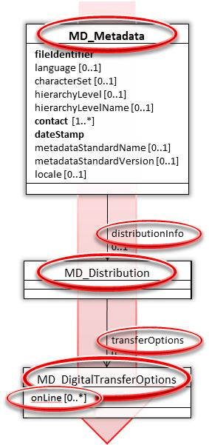
Another convention that is used within this guidance document is use of XPath [http://www.w3.org/TR/xpath/] to describe the traversal of the XML structures.
The figure (left) provides a UML excerpt from the WMO Core Metadata Profile.
To fully describe the ‘onLine’ element at the bottom we have to traverse the ‘path’ from the root element MD_Metadata within the gmd namespace, starting with a ‘/’ to indicate that we are starting from the root:
/gmd:MD_Metadata/gmd:distributionInfo/gmd:MD_Distribution/
↘ gmd:transferOptions/gmd:MD_DigitalTransferOptions/gmd:online
This can be abbreviated to:
//gmd:distributionInfo//gmd:transferOptions//gmd:online
In this case elements with names beginning with capital letters are abbreviated. They represent only parent classes. Roles are identifiable by elements lowercase names.

Profiling ISO 19115
ISO 19115 provides a built-in mechanism to modify the standard to suit the needs of a particular community. The diagram below (known as the ‘fried-egg diagram’) which illustrates the relationship between standard ISO 19115 elements and the profile element set defined by a user community.
If additional requirements for that community cannot be satisfied within the standard, that community are free to extend the standard as is needed to express additional metadata elements; this is called a ‘category-2’] profile which is illustrated by the (dashed line in the figure below). Clearly, those extensions (the shaded area in the diagram), will not be interoperable outside their community. This can be mitigated to some extent by mapping the extensions to standard elements so that a generalist can still use the specialist data, albeit without the specific semantics intended by the specialist’s community.
[ET: When all requirements for the community can be implemented using the elements defined in the ISO 19115 standard, the community profile has no extension. This is known as a ‘category-1’ profile. The WMO Core Metadata Profile is ‘category-1’ profile.]
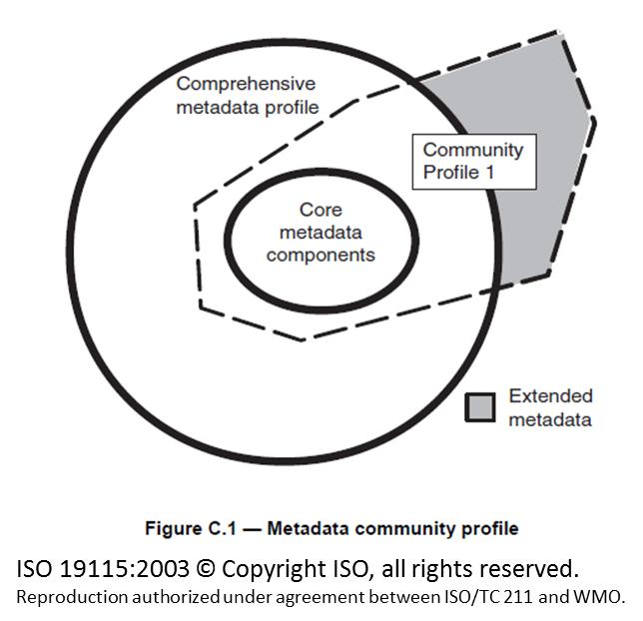
The benefits of developing a community profile are that one achieves further standardisation within that community; all participants agree to use the same terms and mechanisms to describe their content. This is especially important with ISO 19115 as it contains 400+ elements and explicitly states that you should not try to use it all!
For reference, a UML representation of the full metadata model from ISO 19115:2003 can be found at Annex C of this document.
Examining for a moment a community that has established a working example of a profile, in Australia and New Zealand, the ANZLIC Metadata Profile has been created. This profile provides the structure to describe resources by defining metadata elements and establishing a common set of metadata terminology, definitions and extension procedures, which assists organisations to access and share its data. These metadata are compliant with the ISO 19100 series.
The ANZLIC Metadata Profile promotes interoperability between information communities in Australia and New Zealand, as well as the rest of the world.
Their benefits are cited as being able to:
- Provide data producers with appropriate information to characterise their geographic data and associated resources.
- Facilitate the organisation and management of metadata for geographic data and associated resources.
- Enable users to apply geographic data in the most efficient way by knowing its basic characteristics.
- Facilitate data discovery, retrieval and re-use. Users and applications will be better able to locate, access, evaluate, purchase and utilise geographic data.
- Enable users to assess whether geographic data are suitable for their intended purpose.
- Leverage off existing software developed by major vendors and the global spatial community.
- Enable transactions by web services using metadata about specific feature types, features, attribute types or specific attributes.
The WMO Core Metadata Profile seeks to provide similar benefits for the WMO community. At this stage it is heavily focused on supporting WIS by enabling common and consistent metadata records to be published to the WIS Discovery-Access-Retrieval (DAR) catalogue. However, elements of ISO 19115 that are NOT included in the WMO Core Metadata Profile and are required to meet local needs can simply be added without impacting interoperability.

To create a valid profile, one has to understand the needs of the community. Within WMO, this is simplified by the provision of the Manual on WIS [5.9 WIS-TechSpec-8: DAR Catalogue Search and Retrieval] which outlines the mechanisms by which WIS DAR Catalogue content may be searched according to indexed metadata attributes. At a minimum, for text-based searches, these include:
- abstract
- title
- author
- keywords
- format
- identifier
- type
- crs (coordinate reference system)
For date-based searches, these include:
- creationDate
- modificationDate
- publicationDate
- beginningDate
- endingDate
The user is also able to search according to location or geographical extent (bounding box is specified in decimal degrees, north, west, south and east).
The fields defined for use in search is important to understand when preparing metadata records that are intended to be discovered by the user community.

Managing metadata and catalogues

8.1 WMO Technical Regulations
The WIS Technical Regulations WMO-No. 49 (paragraph A.3.3) states:
A.3.3.4 WIS functions and operation shall be based on catalogues that contain metadata describing data and products available across WMO, plus metadata describing dissemination and access options. These catalogues shall be maintained by WIS Centres.
A.3.3.5 Through collaboration across all GISCs, each GISC shall provide comprehensive search across catalogues. [...]
A.3.3.6 […] DCPCs shall maintain catalogues of their holdings and services, and provide appropriate parts of these catalogues to the GISCs to ensure a comprehensive catalogue of WIS holdings.
A.3.3.7 […] NCs shall provide associated metadata to other WIS Centres to become part of the comprehensive catalogue of WIS holdings.
More information on the WIS data management and information exchange functions are described in the practices, procedures and specifications set out in Annex VII (Manual on the WMO Information System (WMO No. 1060)). Relevant excerpts from the ‘Manual on WIS’ are provided below:
Para 2.3 [Interaction among WIS Centres]
[...] Data, products and metadata shall flow to a GISC from DCPCs and from NCs within its area of responsibility. [...]
Para 2.5 [Discovery, Access and Retrieval Function] indicates metadata responsibilities of participants …
As required per WMO No. 49, Vol. I, A.3, WIS shall be based on catalogues that contain metadata describing the full set of data and products available across WMO and how these may be retrieved. The Discovery, Access and Retrieval (DAR) function of WIS shall be the primary realization of the WIS comprehensive catalogue, maintained collaboratively by all WIS Centres.
The Technical Specification [5.2 WIS-TechSpec-1: Uploading of Metadata for Data and Products] mandates the use of WMO Core Metadata Profile of ISO 19115:
5.2.1 This specification requires that each metadata record uploaded shall be represented in compliance with the WMO Core Metadata Profile of ISO 19115 with a unique identifier.

8.2 Metadata management

8.2.1 Obligations
WIS Technical Regulations WMO-No. 49 mandates the responsibility for maintaining catalogues (of metadata) within the WIS. This is further expanded in Annex VII (Manual on the WMO Information System (WMO No. 1060)):
Para 2.1.1 indicates the types Centres operated within WIS. Participants will be affiliated to one of these types of Centre.
2.1.1 In keeping with WMO No. 49, Vol I, A.3, Centres operated by WMO Members and their collaborating organizations shall be categorized as one of the three types of WIS Centres forming the core infrastructure of WIS:
- Global Information System Centres (GISCs),
- Data Collection or Production Centres (DCPCs),
- National Centres (NCs).
[...]
Para 2.3 [Interaction among WIS Centres]
[...] Data, products and metadata shall flow to a GISC from DCPCs and from NCs within its area of responsibility. [...]
Para 2.5 [Discovery, Access and Retrieval Function] indicates metadata responsibilities of participants …
As required per WMO No. 49, Vol. I, A.3, WIS shall be based on catalogues that contain metadata describing the full set of data and products available across WMO and how these may be retrieved. The Discovery, Access and Retrieval (DAR) function of WIS shall be the primary realization of the WIS comprehensive catalogue, maintained collaboratively by all WIS Centres.
Para 4 further illustrates the functional requirements for DCPCs and NCs, indicating that they:
[…] shall provide metadata describing the information it makes available through the WIS comprehensive catalogue […]
Clearly, the responsibility for metadata creation and maintenance lies with the Members operating NCs and DCPCs.

8.2.2 Initial WIS deployment – a ‘baseline’ metadata catalogue
To support initial deployment of WIS, Météo France will create reference (or baseline) metadata for the initial population of the WIS DAR catalogue on behalf of Members. This ‘baseline’ metadata set will only describe those products routinely exchanged on via the GTS. Météo France provide a software tooling to automate the process of creating WMO Core Profile records from Volume C1 and the ‘Additional Data’ catalogue. Météo France will ensure that their metadata generation tools comply with the conformance tests for the WMO Core Metadata Profile. These ‘baseline’ metadata records will be marked as DRAFT. Tooling will be provided to help review & correction of these metadata records.
Members are required to review the automatically generated WMO Core Profile records that describe data products for they are responsible, amending the records as necessary. Once editing is complete, Members must provide their final set of WMO Core Profile metadata records to Météo-France, for insertion in the reference set and upload to the WIS DAR catalogue.
Météo France has agreed to continue maintenance of the reference WIS DAR catalogue on behalf of Members who are unable to provide their WMO Core Profile metadata records to the WIS DAR catalogue via a GISC; for example, if their GISC is not yet fully functional. Météo France will collate amendments (perhaps using METNO bulletins) and re-publish the amended metadata records to the WIS DAR catalogue. The duration of this service awaits agreement with Météo France.
Météo France ‘baseline’ metadata will be marked as DRAFT using the following scheme:
- gmd:MD_Metadata/gmd:metadataMaintenance//gmd:contact//gmd:organisationName = "Meteo France (on behalf of «NC or DCPC» by interim agreement with ICG-WIS)"
- gmd:MD_Metadata/gmd:metadataMaintenance//gmd:contact//gmd:contactInfo//gmd:address//gmd:electronicMailAddress = "«quelqu-un»@meteo.fr"

where «quelqu-un» can be any valid name as email address.

- Additionally, NCAR will support initial deployment by creating records from the Community Data Portal collections, which will provide a wide variety of external datasets and data types that may not be covered in the basic WIS data types.

8.2.3 Procedures
Metadata records describing GTS products intended for global exchange will emulate the practices established to populate Vol C1. Of particular note: metadata ownership resides with the data-provider organization. Only the data-provided organization has the authority to create or update metadata for their products they provide.
Each data-provider is responsible for the accuracy of their metadata. Note that data that does not have a corresponding metadata record will not be visible in the catalogue: the implication is that it will not be discoverable!
The maintenance schedule for metadata will be identical to those in the Manual on GTS for maintaining Volume C1.
Each NC or DCPC will be affiliated with a specific GISC. NC or DCPCs must agree a mechanism to publish (& delete) metadata records with their affiliated GISC. Bi-lateral agreement between NC / DCPC and their affiliated GISC must include information on metadata exchange and deletion mechanisms.
GISCs do not create any original metadata – they only publish content from NCs and DCPCs. However, it is the GISC’s responsibility to ensure that their affiliated NCs or DCPCs are complying with the metadata management policies. The WMO Secretariat currently maintains a list of additional data separately from Volume C1 on the basis on the information provided by the Permanent Representatives.

8.2.4 Uploading metadata to the WIS DAR catalogue
The Technical Specification [5.2 WIS-TechSpec-1: Uploading of Metadata for Data and Products] identifies the mechanisms provided by GISCs to enable uploading metadata to the WIS DAR catalogue:
5.2.5 For updating the DAR Metadata Catalogue, WIS Centres should support two kinds of maintenance facilities: a file upload facility for batch updating (add, replace, or delete metadata records treated as separate files); and an online form for changing metadata entries in the DAR Metadata Catalogue (add, change, or delete of elements in a record as well as whole records).
The mechanism for uploading metadata to the WIS DAR catalogue must defined according to bi-lateral agreement between NC / DCPC and their affiliated GISC.

8.2.5 Deleting metadata from the WIS DAR catalogue
Only the data-owner has the authority to delete metadata records. The circumstances allowing deletion of metadata records include:
- When incorrect metadata is mistakenly or maliciously published; or
- When product or information is no longer available the metadata record must be removed from the DAR catalogue.
When a GISC is requested to delete a metadata record, it must remove the record from the DAR catalogue (so that it can no longer be discovered), but stores the record temporarily for a period of time prior to purging. The recommended ‘grace period’ is 7-days.
Notifying an affiliated GISC regarding the deletion of metadata records is a subject to local agreement; bi-lateral agreement between NC / DCPC and their affiliated GISC must include information on metadata exchange and deletion mechanisms.
Potential mechanisms include:
- If OAI-PMH harvesting used to publish metadata to the GISC, use the OAI-PMH protocol; or
- Publication of a service message (format to be agreed bi-laterally) to GISC requesting deletion of record (using gmd:MD_Metadata/gmd:fileIdentifier as primary key); or
- GISCs may provide metadata editor to allow data originator to delete the record themselves.
Note that an NC or DCPC may choose to maintain a historical archive of metadata records, even if the dataset is no longer available.
Note to implementers:
OAI-PMH is the mandatory mechanism for GISC-to-GISC synchronization of DAR catalogues OAI-PMH can (optionally) support propagation of deletion. The OAI-PMH protocol will be used to achieve GISC-to-GISC synchronization of deleted records.

8.2.6 Harvesting metadata from external providers
It is desirable for the WIS to expose information in its comprehensive catalogue from external communities. To do this, a WIS centre may choose to harvest metadata from external providers. These external providers are not necessarily under the jurisdiction of WMO, so are not bound by WMO Technical Regulations. However, the WIS centre harvesting the external resource has a responsibility to ensure content that it makes available within WIS is compliant with the operating procedures, such as the provision of (globally) unique identifier for each metadata record.
Modifying the unique identifier for a metadata record (gmd:MD_Metadata/gmd:fileIdentifier) may cause issues with harvesting processes used by systems such a Geonetwork [http://geonetwork-opensource.org/] that are used to implement some parts of the WIS DAR catalogue; the unique identifier is used as a primary key to identify records for harvesting. Changing this primary key may result in the record appearing twice. To avoid needing to change the identifier dynamically during harvest, it is envisaged that the addition of a WMO Core Profile compliant identifier will be added to the metadata record by the external data provider according to bi-lateral arrangement a priori. Also, those data custodians may choose to create new metadata records specifically for the WIS community.
If the external data-provider is able to guarantee global uniqueness of their original gmd:MD_Metadata/gmd:fileIdentifier this will remain acceptable as a primary key within WIS and there is no requirement to add a WMO Core Profile compliant identifier.
WIS Centers should not modify gmd:MD_Metadata/gmd:fileIdentifer (as well as any other content) when receiving metadata from external data provider, as far as they guarantee global uniqueness of the fileIdentifier. UUID (Universal Unique Identifier) is considered globally unique in this respect. However, a WIS Center may agree with the data provider to give a fileIdentifier compliant to the WMO Core Profile. In that case previously given fileIdentifier is preserved in:
- //gmd:dataQualityInfo//gmd:lineage//gmd:source//gmd:sourceCitation//gmd:identifier//gmd:code

8.2.7 Metadata files and file-naming conventions
File-naming conventions are explicitly referenced in Annex VII (Manual on the WMO Information System (WMO No. 1060)) Para 5.1.6.
5.1.6 The WMO file naming convention shall be used for files and the associated metadata record whenever it is necessary. The WMO file naming convention is documented in GTS Manual (WMO No. 386, Vol. 1, Part II, Attachment II-15).
Each metadata file must contain one, and only one, record. Valid root elements are:
- DS_Aggregate (implying all concrete sub-classes)
- MI_Metadata
- MD_Metadata
The relationships between metadata, datasets and aggregations are shown in the figure below:
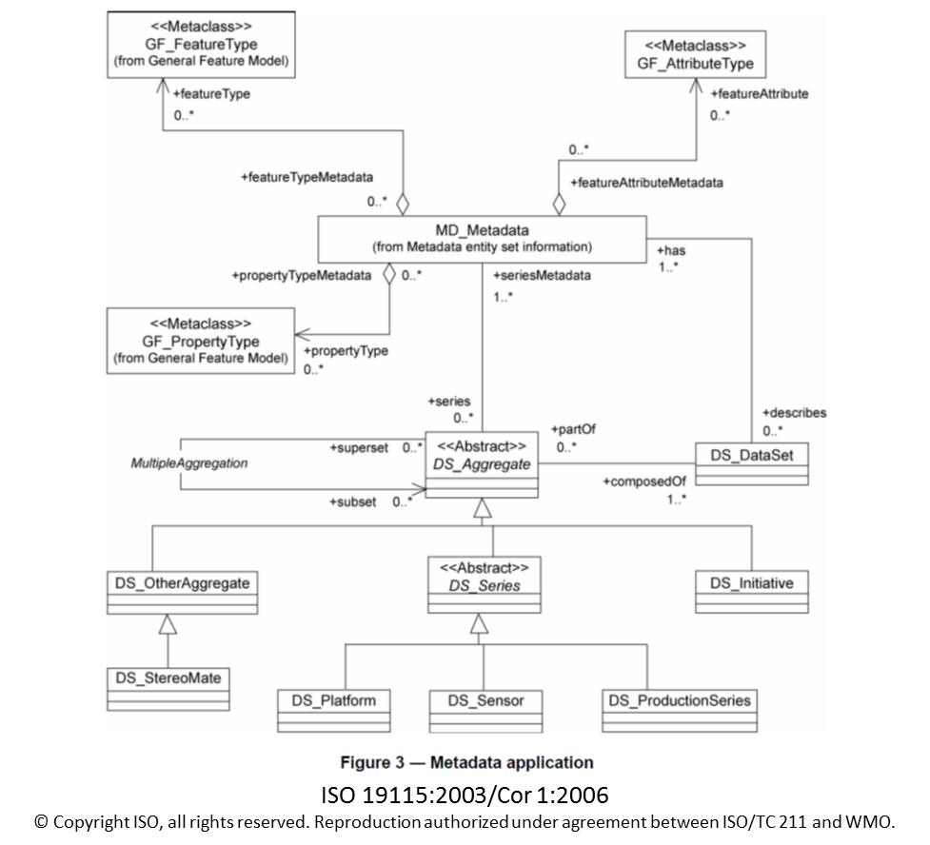
MI_Metadata (from ISO 19115-2) is an extensionof the main MD_Metadata class from ISO 19115. It includes optional elements to describe the acquisition of imagery and gridded data (MI_AcquisitionInformation). This information is important within the WMO community. As such there is a desire to use MI_Metadata as the default root element.
However, the use of MI_Metadata involves XML namespace “gmi:” and may cause validation errors in some WIS system implementations (see Section 6 for definition of namespaces). For the WMO Core Metadata Profile version 1.2 the preferred root element is MD_Metadata. This limitation is expected to be resolved in version 1.2.1 after survey among WIS implementers.
Metadata will be encoded in XML according to the schema implementation defined in ISO/TS 19139. Section 6 of these guidelines provides more information on the XML encoding of metadata.
Each metadata file must be comprised of well-formed XML. [http://www.w3.org/TR/REC-xml/#sec-well-formed]
Metadata files must be encoded in UTF-8 [RFC3626, http://en.wikipedia.org/wiki/UTF-8]
The guidance on what information should be provided in a single metadata file (i.e. which datasets the metadata seeks to describe) is based on a number of concerns:
- The granularity level described by each metadata record;
- The need to accommodate a simple solution for GTS datasets intended for global exchange; and
- The association of metadata files and data-files (or groups of data-files)
Two cases are used below to illustrate the varying approaches:
A. Metadata record A describes a dataset of bulletins which are stored in the 24-hour cache of the GISC. The metadata record is equivalent (although more informative) to a record in WMO vol C1 & describes the normal contents of this type of bulletin; for example SYNOPS from several observation stations; including 91291 (Mauna Loa [Strip Road], Hawaii).
B. Metadata record B describes a long-term climate record from station 91291 which is comprised of a collection of SYNOPTIC observations from, say, 1954.
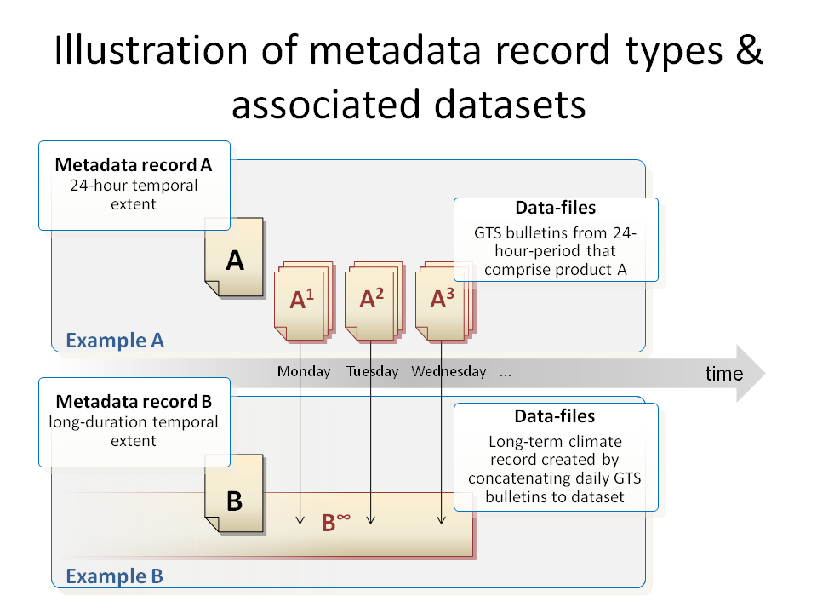
Whilst both datasets are continually changing, both metadata records are ‘quasi-static’; only needing to be changed when the observation regime changes (i.e. a new instrument is deployed or the exact observation location changes). The critical differences between records A & B in this example are:
- Temporal extent: A has a relative temporal extent in any 24-hour period, whilst B has a temporal extent from 1954 to (almost) present day;
- Citation authority: authority for A is int.wmo.wis, whilst B is gov.noaa
- Quality control: the dataset described by B may have undergone additional quality control to validate the observation record for inclusion in a long-term archive
Whilst there may be significant overlap between A and B, one cannot assume that overlap exists. Metadata records A and B describe entirely different products!
For efficiency, some Regional Transportation Hubs (RTH) ‘batch’ bulletins into a file for efficient transfer. This is not visible to the end users, hence the content of a transport-level GTS message is not required to be described by a metadata record. The user/consumer is interested in the discrete bulletins which are currently catalogued in Volume C1 and will be exposed via the WIS Discovery Access and Retrieval (DAR)-metadata catalogue.
All files (including metadata) exchanged via the GTS must conform to the WMO file-naming-convention (see Attachment II-15 to the Manual on the GTS).
There are two types of data transfer in the GTS: file transfer and legacy bulletin. Legacy bulletins are solely identified by their abbreviated heading line (AHL), not by the filename of their transfer container file (a.k.a. message).
Whilst OAI-PMH has been agreed as the protocol for GISC-GISC metadata harvesting, the WIS functional architecture indicates that the default mechanism for National Centres (NC) and DCPCs to pass their metadata records to their affiliated GISC is via sending of files. The meeting noted that the Internet connectivity is not always available and transfer via GTS is necessary in such case.
Therefore, filenames of all metadata files transferred via the GTS must conform to the endorsed file-naming-convention.
The file-naming-convention is summarized as:
«productPart»_«originatorPart»_«YYYYMMDDhhmmss»[_«additionalPart»].«type».[«compression»]
- where «productPart» is «pflag»_«productidentifier», and «pflag» describes the format of «productidentifier»,
- «originatorPart» is C_«CCCC», where «CCCC» is 4-letter code for the originating telecommunications centre, and
- «type» is general format type from fixed acceptable list.
There are four types of «productPart» (hence values of «pflag») defined:
- T_«TTAAii» and A_«TTAAii»«CCCC»«YYGGgg»[«BBB»] are provided for mapping bulletins into file transfer. The latter (A_ form) gives all AHL information, while the former (T_ form) is sufficient for bulletins not using «BBB» for amendment/correction (ex. NWP output). «YYGGgg» is day-in-month, hour, and minute in UTC.
- Routing of bulletins between RTHs is specified using «TTAAii» and «CCCC».
- The file-naming-convention is designed in order to resolve the limitations of too narrow namespace «TTAAii», and following two «pflag»s are prepared for that purpose.
- W_«WMO Product Identifier» is globally unique identifier of the product, where «WMO Product Identifier» is a comma-separated list of data properties, including originating centre, data category, and other information, optionally followed by varying date and «BBB». Invariant string is intended to be used in routing control.
- Z_«local product identifier» is a effectively a free-form identifier type, which is unique only within the originating centre.
Note: W_«WMO Product Identifier» scheme employs commas (,) to separate elements – this may create problems if these file-names are ever integrated into other lists or URLs as the comma is commonly used as a list delimiter in software systems.
Eventually bulletins and T_ and A_ product-identifiers will be phased out in favour of file transfer with W_ and Z_ identifiers. However, currently Volume C1 and the Routing Catalogue only covers bulletins, which have to be mapped to either T_ or A_ types of filename.
As a DAR metadata record is considered to be quasi-static (i.e. it is unlikely to change over the period of days or months) certain instance-specific elements of the data-filename must be excluded from the name of any associated metadata-identifier. For example, an ‘A_’ type product-identifier ‘«TTAAii»«CCCC»«YYGGgg»[«BBB»]’ would be truncated to ‘«TTAAii»«CCCC»’ to provide a unique identifier that does not vary over time.
The WMO file-naming convention «pflag» has been modified to enable specific designation of metadata files. New «pflag»s are:
- TM
- WM
- ZM
There is no requirement for «pflag» = AM. For example, see these two data filenames that could represent the same data content:
- A_SMJP01RJTD271200_C_RJTD_201009271232.txt
- T_SMJP01_C_RJTD_201009271232.txt
For filename (a), the [CCCC] "RJTD" and [YYGGgg] "271200" are duplicate information. Because WIS metadata does not describe data instances, we will NEVER include the [BBB] in the metadata file-name. Given these points, filenames created according to the «pflag»s TM and AM rules would carry the same information. «pflag» = TM should always be used for the metadata file that describes instances of files with «pflag» = T OR «pflag» = A.
The metadata filename relating the example data file-names above would be the same irrespective of whether the filename is «pflag» = T or «pflag» = A:
- TM_SMJP01_C_RJTD_201009271232.txt
Resulting from these constraints, the rules for metadata filenames are:
- must comply with the WMO file-naming-convention;
- must use «pflag» TM, WM or ZM as appropriate;
- should truncate W_ product identifiers to form an invariant string; i.e. the date and amendment / correction code will be excluded
- must ensure that Z_ product identifier are globally unique within the WIS
- must use the «YYYYMMDDhhmmss» element from the top-level structure of WMO file-naming convention to express the metadata publication / update date-time (this must represent the same date-time as the MD_Metadata/dateStamp element); and
- use an ‘.xml’ extension.
Examples:
- TM_FCUK31_C_EGRR_20100310180000.xml
- TM_HHXA05_C_BABJ_20100427083000.xml
- WM_FR-meteofrance-toulouse,GRIB,ARPEGE-75N10N-60W65E_C_LFPW_20100428115800.xml
The '.met' file extension previously allocated to metadata will be deprecated.

8.2.8 Metadata versioning
The sequence (time-order) of metadata files with the same fileIdentifier will be assessed according to the metadata date-time stamp. Thus, WIS implementers will identify a specific version of a metadata record using only the fileIdentifier element and metadata creation date-time stamps:
- gmd:MD_Metadata/gmd:fileIdentifier
- gmd:MD_Metadata/gmd:dateStamp

Multi-lingual metadata
The core entities of the WIS, GISCs, will always operate on the primary English metadata.
At a minimum, metadata will be published in English. The abstract must primarily be in English; noting that alternative language versions may be provided.
Where a 3rd party wishes add translation to a metadata record, they must propose changes to the metadata custodian (data-owner) for the record. Only the metadata custodian (or their delegated agent) has the authority to update the metadata. Updates will be propagated via the WIS via the normal mechanism.

The default language and character set of the metadata record is identified in the gmd:MD_Metadata/gmd:language and gmd:MD_Metadata/gmd:characterSet elements:
<gmd:language>
<gmd:LanguageCode codeList="http://standards.iso.org/ittf/PubliclyAvailableStandards/ISO_19139_Schemas/resources/Codelist/gmxCodelists.xml#LanguageCode" codeListValue="eng">eng</gmd:LanguageCode>
</gmd:language>
<gmd:characterSet>
<gmd:MD_CharacterSetCode codeList="http://standards.iso.org/ittf/PubliclyAvailableStandards/ISO_19139_Schemas/resources/Codelist/gmxCodelists.xml#MD_CharacterSetCode" codeListValue="utf8">UTF-8</gmd:MD_CharacterSetCode>
</gmd:characterSet>
Each alternate language for the metadata is defined via a gmd:MD_Metadata/gmd:locale element:
<gmd:locale>
<gmd:PT_Locale id="locale-fr">
<gmd:languageCode>
<gmd:LanguageCode codeList="http://standards.iso.org/ittf/PubliclyAvailableStandards/ISO_19139_Schemas/resources/Codelist/gmxCodelists.xml#LanguageCode" codeListValue="fra"/>fra
</gmd:languageCode>
<gmd:characterEncoding>
<gmd:MD_CharacterSetCode codeList="http://standards.iso.org/ittf/PubliclyAvailableStandards/ISO_19139_Schemas/resources/Codelist/gmxCodelists.xml#MD_CharacterSetCode" codeListValue="utf8"/>UTF-8
</gmd:characterEncoding>
</gmd:PT_Locale>
</gmd:locale>
Each metadata element with a CharacterString type and free text domain can be instantiated with a gmd:PT_FreeText_PropertyType type:
<gmd:abstract xsi:type="gmd:PT_FreeText_PropertyType">
<gco:CharacterString>Abstract in english</gco:CharacterString>
<gmd:PT_FreeText>
<gmd:textGroup>
<gmd:LocalisedCharacterString locale="#locale-fr">Résumé en français</gmd:LocalisedCharacterString>
</gmd:textGroup>
<gmd:textGroup>
<gmd:LocalisedCharacterString locale="#locale-es">Resumen en espanol</gmd:LocalisedCharacterString>
</gmd:textGroup>
</gmd:PT_FreeText>
</gmd:abstract>
This example assumes that an additional Spanish locale “locale-es” was also defined. Also note the use of an abbreviated XPointer version of a URI to refer to the location of an explicitly identified element within the same XML document:
<gmd:LocalisedCharacterString locale="#locale-fr">Résumé en français</gmd:LocalisedCharacterString>
refers to
<gmd:PT_Locale id="locale-fr"> … </gmd:PT_Locale>
The abstract element is provided in the default language with a common gco:CharacterString element. An additional gmd:PT_FreeText element is present, containing possibly a gmd:textGroup element for every alternate translation.
Translations may be defined in translation files instead of being embedded in the metadata record. In this case, it is simpler to group in a single file the definition of one alternate language and the associated translations, each translated string identified by a unique id attribute. Here is an example translation file (named “translation-fr.xml”):
<gmd:PT_LocaleContainer … >
<gmd:description>
<gco:CharacterString>This file contains all the French translations for my metadata record(s)</gco:CharacterString>
</gmd:description>
<gmd:locale>
<gmd:PT_Locale id="locale-fr">
<gmd:languageCode>
<gmd:LanguageCode codeList="http://standards.iso.org/ittf/PubliclyAvailableStandards/ISO_19139_Schemas/resources/Codelist/gmxCodelists.xml#LanguageCode" codeListValue="fra"/>fra
</gmd:languageCode>
<gmd:characterEncoding>
<gmd:MD_CharacterSetCode codeList="http://standards.iso.org/ittf/PubliclyAvailableStandards/ISO_19139_Schemas/resources/Codelist/gmxCodelists.xml#MD_CharacterSetCode" codeListValue="utf8"/>UTF-8
</gmd:characterEncoding>
</gmd:PT_Locale>
</gmd:locale>
<gmd:date>
<!-- gmd:CI_Date element not shown -->
</gmd:date>
<gmd:responsibleParty>
<!-- gmd:CI_ResponsibleParty element not shown -->
</gmd:responsibleParty>
<gmd:localisedString>
<gmd:LocalisedCharacterString locale="#locale-fr" id="abstractfr">Résumé en français</gmd:LocalisedCharacterString>
</gmd:localisedString>
<!-- other gmd:localisedString elements not shown -->
</gmd:PT_LocaleContainer>
The translated values of textual metadata elements are then referenced in the multi-lingual metadata as follows:
<gmd:abstract xsi:type="gmd:PT_FreeText_PropertyType">
<gco:CharacterString>Abstract in english</gco:CharacterString>
<gmd:PT_FreeText>
<gmd:textGroup xlink:href="translation-fr.xml#abstractfr"/>
</gmd:PT_FreeText>
</gmd:abstract>

Multi-lingual Code Lists and other controlled vocabularies
ISO 19139 also provides mechanisms for multi-lingual reference data, such as Code Lists and other dictionaries. Please refer to ISO/TS 19139 for more information.
It is anticipated that a future release of the WMO Core Metadata Profile will include multi-lingual versions of the reference data.
Where controlled vocabularies sufficiently complex that they cannot be easily accommodated within a Code List, alternative mechanisms such as the Simple Knowledge Organisation System (SKOS) [http://www.w3.org/TR/2009/NOTE-skos-primer-20090818/] can be used.
For information, an example of a multi-lingual SKOS vocabulary is provided at Annex F of this document.

WMO Core Metadata Profile – UML models
Some familiarity with UML Class models is assumed. Note that the default multiplicity for element is one [1] – i.e. a mandatory element. Other multiplicities are:
- [0..1] zero or one (optional)
- [0..*] zero to many (optional)
- [1..*] one to many (mandatory)
The data dictionary describing the elements of the WMO Core Metadata Profile can be found at Annex A. The data dictionary provides detailed advice and examples on the usage of the WMO Core Metadata Profile elements.
The figure below describes the MINIMUM metadata record that is compliant to the WMO Core Metadata Profile. It contains only the MANDATORY elements.
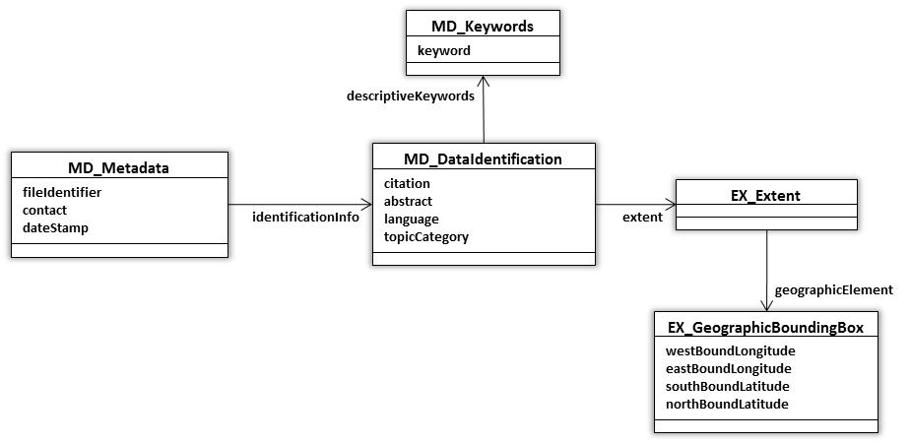

The figure below describes the CORE metadata record and includes all the OPTIONAL elements of the WMO Core Metadata Profile.
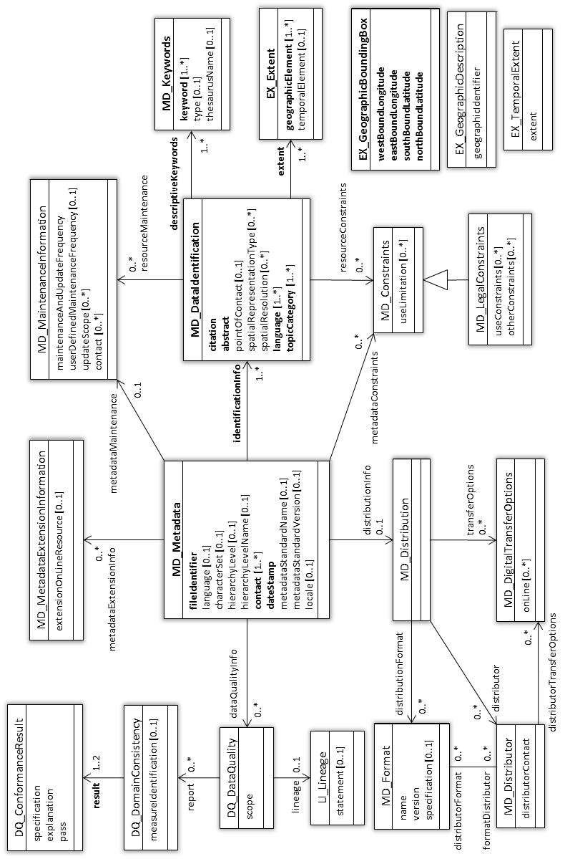
The figure below describes the «DataTypes» included in the WMO Core Metadata Profile.
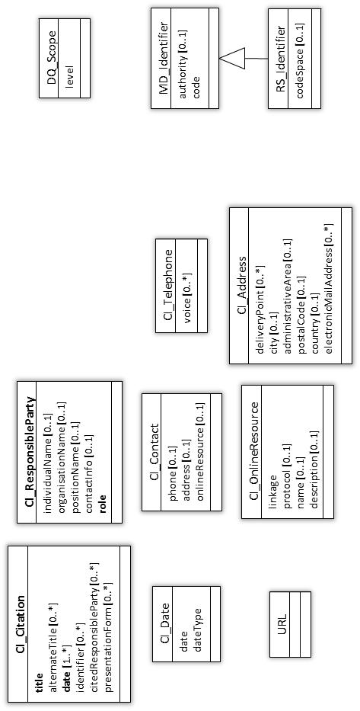

WMO Core Metadata Profile – extensions to ISO 19115
The WMO Core Metadata Profile is a ‘category-1’ profile. This implies it only RESTRICTS the original standard and adds / amends Code Lists.

Additional Restrictions
Please refer to the data dictionary (Annex A) for more information on these restrictions.
 | Target element(s) | Description
1 | MD_Metadata/fileIdentifier | - MANDATORY obligation  - If metadata record describes data exchanged via the GTS, the strict convention for constructing the unique identifier shall be applied
2 | MD_Metadata/hierarchyLevel | - Multiplicity limited to zero or one [0..1]
3 | MD_Metadata/hierarchyLevelName | - Multiplicity limited to zero or one [0..1]
4 | MD_Metadata/identificationInfo/  ↘MD_Identification/descriptiveKeywords | - MANDATORY obligation; a minimum of one descriptive keyword must be supplied referencing the WMO_CategoryCode «CodeList». The MD_Keywords/type for this entry shall be “theme” (from MD_KeywordTypeCode «CodeList»)  - All keyword elements sourced from a particular thesaurus shall grouped into a single instance of the MD_Keywords class.
5 | MD_Metadata/identificationInfo/  ↘MD_DataIdentification/topicCategory | - MANDATORY obligation
6 | MD_Metadata/identificationInfo/  ↘MD_DataIdentification/extent/  ↘EX_Extent/geographicExtent/ | - MANDATORY obligation; a minimum of one instance of EX_GeographicBoundingBox shall be supplied

For compliance with the INSPIRE implementing rules [http://inspire.jrc.ec.europa.eu/] some additional restrictions should be observed. These are not part of the WMO Core Metadata Profile, but are included for completion.
 | Target element(s) | Description
8 | MD_Metadata/identificationInfo/  ↘MD_Identification/resourceConstraints/  ↘MD_Constraints/useLimitation | - MANDATORY obligation; if no conditions apply, then a phrase such as “No conditions apply” should be recorded
2 | MD_Metadata/dataQualityInfo/  ↘DQ_DataQuality/report | - MANDATORY obligation; used to indicate conformance with INSPIRE Implementing Rules

Amendments to Code Lists / new Code Lists
Please refer to Annex B for more information on the Code List extensions. An XML encoding of these CodeLists is provided in Annex G.
 | Target Code List | Change | Description
1 | CI_DateTypeCode | amendment | Additional term «reference» [004]
2 | WMO_DataLicenseCode | new | WMO Data License applied to the data resource – derived from WMO Resolution 25 and Resolution 40 (http://www.wmo.int/pages/about/exchangingdata_en.html)
3 | WMO_GTSProductCategoryCode | new | Product category used for prioritising messages on the WMO Global Telecommunications System (GTS)
4 | WMO_CategoryCode | new | Additional topic categories for WMO community

WMO Core Metadata Profile version 1.2
Annex A – Data Dictionary & usage guidance notes

Note: items in the data dictionary marked in RED are amendments to ISO 19115 required to comply with the WMO Core Metadata Profile

A Metadata Package data dictionaries

A.1 Metadata entity set information
 | Name / Role name | Definition | Obligation / Condition | Maximum occurrence | Data type | Domain
1 | MD_Metadata | root entity which defines metadata  about a resource or resources | M | 1 | Class | Lines 2-17
2 | fileIdentifier | unique identifier for this metadata  file | M | 1 | CharacterString | URN – structure defined below (A.1.2)
3 | language | language used for documenting  metadata | O | 1 | CharacterString | ISO 639-2 recommended
4 | characterSet | full name of the character coding  standard used for the metadata set | O | 1 | Class | MD_CharacterSetCode «CodeList»  UTF-8 recommended
5 | hierarchyLevel | scope to which the metadata  applies | O | 1 | Class | MD_ScopeCode «CodeList»
6 | hierarchyLevelName | name of the hierarchy levels for  which the metadata is provided | O | 1 | CharacterString | Free text
7 | contact | party responsible for the metadata  information | M | N | Class | CI_ResponsibleParty  «DataType» A.9.3
8 | dateStamp | date that the metadata was created | M | 1 | Class | Date
9 | metadataStandardName | name of the metadata standard (including profile name) used | O | 1 | CharacterString | See below (A.1.7)
10 | metadataStandardVersion | version of the metadata standard (version of the profile) used | O | 1 | CharacterString | See below (A.1.7)
11 | locale | provides information about alternative localisations for linguistic extension | O | N | Class | PT_Locale (from ISO 19139)
12 | Role name:  metadataExtensionInfo | information describing metadata  extensions | O | N | Association | MD_ExtensionInformation A.8
13 | Role name:  metadataMaintenance | provides information about the  frequency of metadata updates,  and the scope of those updates | O | 1 | Association | MD_MaintenanceInfomation A.6
14 | Role name:  identificationInfo | basic information about the  resource(s) to which the metadata  applies | M | N | Association | MD_DataIdentification A.2
15 | Role name:  metadataConstraints | provides restrictions on the access  and use of metadata | O | N | Association | MD_Constraints A.4
16 | Role name:  distributionInfo | provides information about the  distributor of and options for  obtaining the resource(s) | O | 1 | Association | MD_Distribution A.7
17 | Role name:  dataQualityInfo | provides overall assessment of  quality of a resource(s) | O | N | Association | DQ_DataQuality A.5

A.1.1 gmd:MD_Metadata
19115 metadata is structured with one class gmd:MD_Metadata providing general information on the metadata, and several association classes (identification info, quality info, maintenance info, etc…) providing information on the resource itself. The multiplicity of these association classes is not restrained to 1 in 19115, which enable in theory to describe several resources within the same instance of gmd:MD_Metadata.
It is however strongly recommended to describe only one resource for each instance of gmd:MD_Metadata, to simplify the structure of the file.

A.1.2 gmd:MD_Metadata/gmd:fileIdentifier
gmd:MD_Metadata/gmd:fileIdentifier is commonly used to provide a sort of identifier of the metadata set. The name of the property implies that the metadata set is stored in a dedicated file, which is not necessarily the case. However, in the case of metadata records published to the WIS Data Access and Retrieval (DAR) Catalogue each metadata record will be encoded within a file.
Metadata identifiers do not need to explicitly match the filenames of the datasets they describe.
The WMO Core Metadata Profile recommends that gmd:MD_Metadata/gmd:fileIdentifier is a URI (Universal Resource Identifier) structured as follows:
- fixed string "urn:x-wmo:md:"
- citation authority
Examples:
- "int.wmo.wis"
- "gov.noaa"
- "edu.ucar.ncar"
- "uk.gov.metoffice"
Citation authority "int.wmo.wis" is used for all datasets intended for global exchange
Citation authority for other datasets remains with the dataset provider, expressed using a reverse-DNS name
A register of citation authorities will be developed and maintained by WMO secretariat to support the WIS function.
- separator colon ‘:’
- empty string, reserved for future extension
- separator colon ‘:’
- unique identifier:
  - if a GTS «TTAAii» and «CCCC» is allocated for the product (i.e. where the datasets described by the metadata record employ the WMO file-naming convention P-flag = “T” or P-flag=”A”) use «TTAAii»«CCCC» for the unique identifier;
  - else if a WMO Product Identifier is allocated for the product (i.e. WMO file-naming convention P-flag=”W”) use a truncated WMO product identifier field of the associated data-files, excluding the date-stamp and any other varying elements as necessary; or
  - else use a locally-unique identifier for the citation authority (not recommended for data and products intended for global exchange).
Examples:
- urn:x-wmo:md:int.wmo.wis::FCUK31EGRR
- urn:x-wmo:md:cn.gov.cma::NMC.NWP.HCXA05BABJ
- urn:x-wmo:md:int.wmo.wis::FR-meteofrance-toulouse,GRIB,ARPEGE-75N10N-60W65E_C_LFPW
The structure is mandatory for metadata records that describe products exchanged via the GTS.
If an external data-provider is able to guarantee global uniqueness of their original gmd:MD_Metadata/gmd:fileIdentifier this will remain acceptable as a primary key within WIS and there is no requirement to add a WMO Core Profile compliant identifier.
Note: gmd:MD_Metadata/gmd:fileIdentifier elements are treated as CASE-INSENSITIVE when assessing metadata records for duplication.
- Best practice amongst OGC & others indicates that they are beginning to favour persistent URLs over URNs as they are resolvable; an example would be: "http://wisportal.cma.gov.cn/md/HCXA20BABJ.NMC.NWP". This change may be reflected in future versions of this WMO Core Metadata Profile.
Where possible, the metadata identifier should map onto the invariant elements of the data-filename to help a human reader infer the connection. Examples:
- Data-filename instance: “A_SMCI01BABJ281200_C_BABJ_20100428120000.txt”
- gmd:MD_Metadata/gmd:fileIdentifier=”urn:x-wmo:md:int.wmo.wis::SMCI01BABJ”
- Data-filename instance: “W_FR-meteofrance-toulouse,GRIB,ARPEGE-75N10N-60W65E_C_LFPW_20061001000000.bin”
- gmd:MD_Metadata/gmd:fileIdentifier=”urn:x-wmo:md:int.wmo.wis::FR-meteofrance-toulouse,GRIB,ARPEGE-75N10N-60W65E_C_LFPW”
As WIS will assess the uniqueness of a metadata record using only the fileIdentifier element (gmd:MD_Metadata/gmd:fileIdentifier) and metadata creation date-time stamp (gmd:MD_Metadata/gmd:dateStamp) version numbering or date-stamps are explicitly forbidden from the gmd.fileIdentifier element. The gmd:MD_Metadata/gmd:dateStamp is the correct place for this information. It may also optionally appear in the metadata filename (see Section 8.2.7). Changing the gmd:fileIdentifier element in any way will appear to be a new product to the WIS! In other words, implementers please be advised the gmd:fileIdentifier element is used to contain a typically invariant WIS product identifier.
Note to implementers:
- The gmd:dateStamp within the metadata record should be distinguished from the datestamp in OAI-PMH wrapper XML, which appears as oai:header/oai:datestamp. Note that the OAI-PMH Implementation Guideline mandates that the OAI-PMH Aggregators (i.e. a WIS Centre that provides metadata harvested from somewhere else) must use local harvesting time as oai:datestamp. In other words, OAI-PMH providers of GISCs and RTH-type of DCPCs must not use gmd:dateStamp as oai:datestamp, because a GISC that is attempting to harvest an archive cannot use incremental harvesting to harvest only changed records. In some implementations the timestamp of metadata files are given as oai:datestamp, and the operator can cause re-synchronization by changing metadata file time stamps (such as touch(1) command). This is intended behaviour, and developers should follow this methodology so as not to disable this functionality.
- OAI-PMH requires the identifier must comply with generic URI syntax (RFC2396, now obsoleted by RFC3986). The naming convention defined in Recommendation 2 above is compliant to URN scheme of URI. The namespace identifier of URN (i.e. "x-wmo") begins with "x-", which indicates an experimental namespace not registered to IANA (cf. RFC3406). In the long term, the WIS community may wish to apply to IANA for registration of formal namespace "wmo" under URN, or namespace under "info:" URI scheme if the review process for URN does not work (http://info-uri.info/registry/docs/misc/faq.html#use_urn describes such high burden).

Example XML encoding:
<gmd:fileIdentifier>
<gco:CharacterString>urn:x-wmo:md:no.met::HIRLAM12</gco:CharacterString>
</gmd:fileIdentifier>

A.1.3 gmd:MD_Metadata/gmd:language and gmd:MD_Metadata/gmd:characterSet
It is recommended to select a value from the ISO 639-2 controlled vocabulary which uses three-letter primary tags with optional subtags.
The Library of Congress (US) maintains a resource providing more information on this vocabulary: http://www.loc.gov/standards/iso639-2/
The CodeList itself can be located here: http://www.loc.gov/standards/iso639-2/php/code_list.php
The WMO Core Metadata Profile strongly recommends that metadata files should be encoded in UTF-8 [RFC3626, http://en.wikipedia.org/wiki/UTF-8]
Example XML encoding:
<gmd:language>
<gmd:LanguageCode codeList="http://standards.iso.org/ittf/PubliclyAvailableStandards/ISO_19139_Schemas/resources/Codelist/gmxCodelists.xml#LanguageCode" codeListValue="eng">eng</gmd:LanguageCode>
</gmd:language>
- <gmd:characterSet>
<gmd:MD_CharacterSetCode codeList="http://standards.iso.org/ittf/PubliclyAvailableStandards/ISO_19139_Schemas/resources/Codelist/gmxCodelists.xml#MD_CharacterSetCode" codeListValue="utf8">UTF-8</gmd:MD_CharacterSetCode>
</gmd:characterSet>

A.1.4 gmd:MD_Metadata/gmd:hierarchyLevel and gmd:MD_Metadata/gmd:hierarchyLevelName
Fundamental to ISO19115 are the concepts of dataset (DS_DataSet) and aggregations (DS_Aggregate). The hierarchy level is described in each metadata record via the gmd:hierarchyLevel element; selecting the appropriate value from the MD_ScopeCode «CodeList».
Aggregations, or collections, of datasets can be of many types including series, platforms & sensors etc. Every type of aggregation can include subsets and/or discrete datasets. The relationships permitted within the ISO19115 conceptual model allow one to create a hierarchy of related aggregations and datasets. This enables data providers to structure their metadata for improved clarity & browsing.
NCAR’s Community Data Portal, the THREDDS (Thematic Realtime Environmental Distributed Data Services) Project and NOAA’s National Geophysical Data Centre [http://www.ngdc.noaa.gov/] have gained experience from structuring datasets within hierarchies. These dataset hierarchies can be used to structure a browsable network of related datasets. Such browsable networks can be used to supplement other browse-hierarchies inferred from the categorization of metadata records using structured taxonomies etc. Reference information can be found at here: http://www.unidata.ucar.edu/projects/THREDDS
Referring to the needs of WIS, the main focus is to enable the discovery of datasets. Building a browse-hierarchy from a network of related metadata records will add value in the long-term. However, this does not offset the additional complexity & risk of implementation during the development-phase of the WIS.
In order to maintain simple GISC implementation, discrete metadata records will be used to describe GTS products intended for global exchange, defining the hierarchy level as «dataset». DCPCs and NCs may choose to describe their dataset at whichever level in the ‘hierarchy’ is deemed appropriate. For example, a single TIGGE metadata record may describe 10000 data-files or more, thus avoiding the need to create many hundreds or thousands of metadata records (TIGGE reference: http://tigge.ecmwf.int/).
More information regarding the use of hierarchy levels to structure WMO Core Metadata will be provided in future releases of this guidance. For reference, ISO 19115:2003 Annex H provides more information about metadata hierarchy levels.
The element hierarchy level name may be used to provide an alternative name for this hierarchical level within a particular organisation, to give more details, or to provide the level in another language.
For example, within French IGN, the code gmd:MD_HierarchyLevel = “dataset” correspond to the term “lot”, provided within the gmd:hierarchyLevelName field.
- These elements have a multiplicity of 0..* in 19115. This means that a single metadata record may appear at multiple levels of hierarchy, depending on different views. In order to avoid such complexity before having enough experience, the multiplicity in the WMO Core Metadata Profile is limited to 0..1.
Example XML encoding:
<gmd:hierarchyLevel>
<gmd:MD_ScopeCode codeList="http://standards.iso.org/ittf/PubliclyAvailableStandards/ISO_19139_Schemas/resources/Codelist/gmxCodelists.xml#MD_ScopeCode" codeListValue="dataset">dataset</gmd:MD_ScopeCode>
</gmd:hierarchyLevel>
<gmd:hierarchyLevelName>
<gco:CharacterString>Basic HIRLAM Model Output</gco:CharacterString>
</gmd:hierarchyLevelName>
Side note:
Best practice recommends that the CodeList term is repeated as free-text, thus aiding readability and simplifying XSL styling derived from the codeList term:
<gmd:MD_ScopeCode codeList="http://standards.iso.org/ittf/PubliclyAvailableStandards/ISO_19139_Schemas/resources/Codelist/gmxCodelists.xml#MD_ScopeCode" codeListValue="dataset">dataset</gmd:MD_ScopeCode>
- Side note:
As implementation experience with WIS increases, IPET-MDI (WMO Inter Programme Expert Team – Metadata and Data Interoperability) will continue to review the value of structured dataset-hierarchies against the potential cost and risk of implementation. This may lead to updated recommendations that positively endorse the use of dataset-hierarchies for DCPCs or NCs dataset aggregations and perhaps even products intended for global exchange served by the GISCs. The current recommendations imply that NMHSs such as JMA will be required to create and maintain many thousands of metadata records to describe their GRIB bulletins (approx. 21000 products). It is recognized that the query service at the GISC is likely to return large numbers of positive hits to any query for JMA GRIB data, which is not particularly helpful for the user. However, there is nothing to stop JMA from exposing a richer, more sophisticated service interface(s) as a DCPC that provides higher levels of control to the user. These interfaces would likely be described by fewer, more coarse-grained metadata records, thus returning fewer positive hits to an initial query in the DAR catalogue. In this case, the user experience is likely to be significantly improved.

A.1.5 gmd:MD_Metadata/gmd:contact
The metadata point of Contact provides information on the person or organisation responsible for the content of the metadata. (not for the organisation who set up the structure of the metadata).
- Current practice seems to be shifting toward organizations setting up support email addresses that connect to a listserv or some other email distribution system, rather than a person’s email or a postal mailing address. As it is more likely that this email would be more persistent than the alternatives, a group support email address is the recommended entry in this field, if available.
It is recommended to provide (or require) a least a name and an e-mail address.

<gmd:contact>
<gmd:CI_ResponsibleParty>
<gmd:organisationName>
<gco:CharacterString> The Community Data Portal, National Center for Atmospheric Research </gco:CharacterString>
</gmd:organisationName>
<gmd:contactInfo>
<gmd:CI_Contact>
<gmd:address>
<gmd:CI_Address>
<gmd:electronicMailAddress>
<gco:CharacterString> cdp@ucar.edu </gco:CharacterString>
</gmd:electronicMailAddress>
</gmd:CI_Address>
</gmd:address>
<gmd:onlineResource>
<gmd:CI_OnlineResource>
<gmd:linkage>
<gmd:URL> http://cdp.ucar.edu/ </gmd:URL>
</gmd:linkage>
</gmd:CI_OnlineResource>
</gmd:onlineResource>
</gmd:CI_Contact>
</gmd:contactInfo>
<gmd:role>
<gmd:CI_RoleCode codeList=".resources/CodeList.xml#CI_RoleCode" codeListValue="custodian">custodian</ gmd:CI_RoleCode >
</gmd:role>
</gmd:CI_ResponsibleParty>
</gmd:contact>

A.1.6 gmd:MD_Metadata/gmd:dateStamp
Where the WMO file-naming convention is used for the metadata record, the gmd:MD_Metadata/gmd:dateStamp element shall match the dateStamp used within the filename.
Use a single date as specified by ISO 8601 in the extended date format (YYYY-MM-DD), where YYYY is the year, MM is the month and DD is the day. Time (HH:MM:SS, where HH is the hour, MM the minutes and SS the seconds) may be added if required, separated from the day by “T”. Refer to Wikipedia for more information on ISO 8601: http://en.wikipedia.org/wiki/ISO_8601
This should be updated whenever the metadata is updated due to a change in the dataset, or when it is reviewed and confirmed as wholly correct.
In combination with the gmd:MD_Metadata/gmd:fileIdentifier element, the gmd:MD_Metadata/gmd:dateStamp element shall be used to identify a version of a metadata record. The dateStamp serves as a mechanism to discriminate between versions of metadata records with the same fileIdentifier. The WIS will always choose the file with the most recent dateStamp when selecting the appropriate metadata record.
Example XML encoding:
<gmd:dateStamp>
<gco:DateTime>2010-11-08T09:44:24.165</gco:DateTime>
</gmd:dateStamp>

A.1.7 gmd:MD_Metadata/gmd:metadataStandardName and gmd:MD_Metadata/gmd:metadataStandardVersion
gmd:MD_Metadata/gmd:metadataStandardName must always use the following text:
<gmd:metadataStandardName>
<gco:CharacterString>ISO 19115-2 Geographic information — Metadata — Part 2: Extensions for imagery and gridded data</gco:CharacterString>
</gmd:metadataStandardName>
<gmd:metadataStandardVersion>
<gco:CharacterString>ISO 19115-2:2009-02-15</gco:CharacterString>
</gmd:metadataStandardVersion>
This describes the full title and short-name used to unambiguously identify the ISO19115-2 Geographic Information Metadata standard. Software developer is advised to use gmd:metadataStandardVersion if there is any need to automatically detect the version of the metadata standard; gmd:metadataStandardName contains EM-DASH letter which is often mistaken as other dashes or hyphens.

A.2 Identification information
 | Name / Role name | Definition | Obligation / Condition | Maximum occurrence | Data type | Domain
18 | MD_DataIdentification | basic information required to  uniquely identify a dataset | M | 1 | Specialised Class  (MD_Identification) | Lines 19-29
19 | Citation | citation data for the resource(s) | M | 1 | Class | CI_Citation «DataType» A.9.3
20 | Abstract | brief narrative summary of the  content of the resource(s) | M | 1 | CharacterString | Free text
21 | pointOfContact | identification of, and means of  communication with, person(s) and  organization(s) associated with the  resource(s) | O | 1 | Class | CI_ResponsibleParty «DataType» A.9.3
22 | spatialRepresentationType | method used to spatially represent  geographic information | O | N | Class | MD_SpatialRepresentation  TypeCode «CodeList»
23 | spatialResolution | factor which provides a general  understanding of the density of  spatial data in the dataset | O | N | Class | MD_Resolution «union»  See below (A.2.6)
24 | Language | language(s) used within the  dataset | M | N | CharacterString | ISO 639-2 recommended
25 | topicCategory | main theme(s) of the dataset | M | N | Class | MD_TopicCategoryCode «Enumeration»
26 | Role name:  resourceMaintenance | provides information about the  frequency of resource updates,  and the scope of those updates | O | N | Association | MD_MaintenanceInformation A.8
27 | Role name:  descriptiveKeywords | provides category keywords, their  type, and reference source | M | N | Association | MD_Keywords A.3
28 | Role name:  Extent | extent information including the  bounding box, bounding polygon,  vertical, and temporal extent of the  dataset | M | N | Association | EX_Extent «DataType» A.9.1
29 | Role name:  resourceConstraints | provides information about  constraints which apply to the  resource(s) | O | N | Association | MD_Constraints A.4

A.2.1 gmd:MD_DataIdentification
The WMO Core Metadata Profile is currently focused on data discovery to support WIS. As such, the profile ignores the SV_ServiceIdentification class and conflates the «abstract» MD_Identification with its concrete sub-type MD_DataIdentification.

A.2.2 gmd:MD_Identification/gmd:citation
See A.9.3 for details on CI_Citation.
It is mandatory to provide the //gmd:identificationInfo//gmd:citation//gmd:title and //gmd:identificationInfo//gmd:citation//gmd:date.
The dataset title is one of the key elements for the discovery of a dataset. The usual name on which the dataset is identified should be provided here. If this usual name is an acronym, the complete name may be provided as an alternativeTitle.

A.2.3 gmd:MD_Identification/gmd:abstract
The abstract should provide a clear and concise statement that enables the reader to understand the content of the dataset.
For guidance when completing the abstract, consider these points:
1. State what the “things” are that are recorded.
2. State the key aspects recorded about these things.
3. State what form the data takes.
4. State any other limiting information, such as time period of validity of the data.
5. Add purpose of data resource where relevant (e.g. for survey data).
6. Aim to be understood by non-experts.
7. Do not include general background information.
8. Avoid jargon and unexplained abbreviations.
Example XML encoding:
<gmd:abstract>
<gco:CharacterString>
Products from the METNO Numerical Weather Prediction model. METNO is running the HIRLAM model. Check out http://www.hirlam.org/ for details.
The model output has been subsetted, reprojected and reformatted using FIMEX (http://wiki.met.no/fimex/).
Contained fields: Potential temperature [K], Geopotential height [m**2 s**-2], U velocity [m s**-1], V velocity [m s**-1], Vertical velocity [Pa s**-1] and Relative humidity [%]
Levels [hPa]: 1000, 925, 850, 700, 500, 400, 300, 250, 200, 150, 100, 70, 50, 30 and 10
Forecast Offset Times [Hours]: 0, 3, 6, 9, 12, 15, 18, 21, 24, 30, 36, 42, 48, 54, 60 and 66
Grid resolution [degrees]: 0.216 X 0.216
</gco:CharacterString>
</gmd:abstract>

A.2.4 gmd:MD_Identification/gmd:pointOfContact
See A.9.3 for more information on CI_ResponsibleParty.
It is recommended to provide (or require) a least a name and an e-mail address.
- Note that gmd:MD_Metadata/gmd:identificationInfo//gmd:pointOfContact describes the contact details of the party responsible for the dataset or resource which the metadata record describes, whereas gmd:MD_Metadata/gmd:contact describes the contact details of the party responsible for the metadata record.

A.2.5 gmd:MD_Identification/gmd:resourceFormat
One question regarding the format is whether it is wanted to express the format of the resource or the format in which the data may be distributed. The distribution format (see A.7) is the one defined in the ISO Core, but when data is interchange by transfer, the resource format is relevant. Yet, in that case, the resource format is also a distribution format (it is the format in which the data is effectively distributed). In order to follow the ISO Core, it is consequently recommended to use the distribution format because it is relevant when distributing the data both by transfer or transmission.
For this reason, gmd:MD_Identification/gmd:resourceFormat is not described explicitly in the WMO Core Metadata Profile.

A.2.6 gmd:MD_DataIdentification/gmd:spatialResolution
The purpose of this element is to provide an indication of how detailed the spatial data is. It is equivalent to the ground sample distance. It should not be confused with the scale of a map which is purely a display attribute (the spatial resolution should be defined in the specification of the data resource).
The domain of this element is MD_Resolution «union»; which is comprised of two elements:
- equivalentScale (type MD_RepresentativeFraction); and
- distance (type Distance).
The WMO Core Metadata Profile recommends the use of the simpler distance measure. Example:
<gmd:spatialResolution>
<gmd:MD_Resolution>
<gmd:distance>
<gco:Distance uom="http://standards.iso.org/ittf/PubliclyAvailableStandards/ISO_19139_Schemas/resources/uom/ML_gmxUom.xml#deg">1</gco:Distance>
</gmd:distance>
</gmd:MD_Resolution>
</gmd:spatialResolution>
This example describes a 1° x 1° resolution. The unitsOfMeasure dictionary referenced also includes meters (m) and radians (rad).

A.2.7 gmd:MD_DataIdentification/gmd:language
Refer to guidance above: A.1.3
If there is no textual information in the data resource, then it is recommended that a nil value should be recorded.

A.2.8 gmd:MD_DataIdentification/gmd:topicCategory
The purpose of this element is to provide a basic classification for the data resource for use in initial searches.
The CodeList provided by ISO 19115 for this element is large. It may appear useless for the needs of one specific community, but it is mandatory in 19115 to facilitate the discovery of information within a catalogue where data from multiple communities are stored.
Select one or more categories that most closely represent the topic of the data resource. If in doubt, go by the topic categories rather than the examples. It is not necessary to include all categories which may be applicable, but only a limited number of most relevant should be chosen (e.g. topographic maps should not be classified as farming).
The MD_TopicCategory «Enumeration» is listed here for reference:
Name | Domain code | Definition
farming | 001 | rearing of animals and/or cultivation of plants  Examples: agriculture, plantations, herding, pests and diseases affecting crops and livestock
biota | 002 | flora and/or fauna in natural environment  Examples: wildlife, vegetation, biological sciences, ecology, sea-life, habitat
boundaries | 003 | legal land descriptions  Examples: political and administrative boundaries
climatologyMeteorologyAtmosphere | 004 | processes and phenomena of the atmosphere  Examples: weather, climate, atmospheric conditions, climate change, precipitation
economy | 005 | economic activities, conditions and employment  Examples: production, labour, revenue, commerce, industry, tourism and ecotourism, forestry, fisheries, commercial or subsistence hunting, exploration and exploitation of resources such as minerals, oil and gas
elevation | 006 | height above or below sea level  Examples: altitude, bathymetry, digital elevation models, slope, derived products
environment | 007 | environmental resources, protection and conservation  Examples: environmental pollution, waste storage and treatment, environmental impact assessment, monitoring environmental risk, nature reserves, landscape
geoscientificInformation | 008 | information pertaining to earth sciences  Examples: geophysical features and processes, geology, minerals, sciences dealing with the composition, structure and origin of the earth’s rocks, risks of earthquakes, volcanic activity, landslides, gravity information, soils, permafrost, hydrogeology, erosion
health | 009 | health, health services, human ecology, and safety  Examples: disease and illness, factors affecting health, hygiene, substance abuse, mental and physical health, health services
imageryBaseMapsEarthCover | 010 | base maps  Examples: land cover, topographic maps, imagery, unclassified images, annotations
intelligenceMilitary | 011 | military bases, structures, activities  Examples: barracks, training grounds, military transportation, information collection
inlandWaters | 012 | inland water features, drainage systems and their characteristics  Examples: rivers and glaciers, salt lakes, water utilization plans, dams, currents, floods, water quality, hydrographic charts
location | 013 | positional information and services  Examples: addresses, geodetic networks, control points, postal zones and services, place names
oceans | 014 | features and characteristics of salt water bodies (excluding inland waters)  Examples: tides, tidal waves, coastal information, reefs
planningCadastre | 015 | information used for appropriate actions for future use of the land  Examples: land use maps, zoning maps, cadastral surveys, land ownership
society | 016 | characteristics of society and cultures  Examples: settlements, anthropology, archaeology, education, traditional beliefs, manners and customs, demographic data, recreational areas and activities, social impact assessments, crime and justice, census information
structure | 017 | man-made construction  Examples: buildings, museums, churches, factories, housing, monuments, shops, towers
transportation | 018 | means and aids for conveying persons and/or goods  Examples: roads, airports/airstrips, shipping routes, tunnels, nautical charts, vehicle or vessel location, aeronautical charts, railways
utilitiesCommunication | 019 | energy, water and waste systems and communications infrastructure and services  Examples: hydroelectricity, geothermal, solar and nuclear sources of energy, water purification and distribution, sewage collection and disposal, electricity and gas distribution, data communication, telecommunication, radio, communication  Networks

As with all «Enumeration»s, this list cannot be extended.
The most appropriate category for the WMO Core Metadata Profile is climatologyMeteorologyAtmosphere.
As the WMO Core Metadata Profile is concerned (at this stage) only with datasets, the element is MANDATORY.
Example XML encoding:
<gmd:topicCategory>
<gmd:MD_TopicCategoryCode>climatologyMeteorologyAtmosphere</gmd:MD_TopicCategoryCode>
</gmd:topicCategory>

A.3 Keywords information
 | Name / Role name | Definition | Obligation / Condition | Maximum occurrence | Data type | Domain
30 | MD_Keywords | Keywords, their type and reference source | M | N | Aggregated Class (MD_Identification) | Lines 31-33
31 | keyword | commonly used word(s) or  formalised word(s) or phrase(s)  used to describe the subject | M | N | CharacterString | Free text
32 | type | subject matter used to group  similar keywords | O | 1 | Class | MD_KeywordTypeCode «CodeList»
33 | thesaurusName | name of the formally registered  thesaurus or a similar authoritative  source of keywords | O | 1 | Class | CI_Citation «DataType» A.9.3

A.3.1 gmd:MD_Keywords
The purpose of this element is to indicate the general subject area of the data resource using keywords. This enables searches to eliminate resources that are of no interest. Ideally, a standardised set of keywords should be used, so that resources can be identified in any search. This element is similar to Topic, which has a coded list of high-level categories; whereas Keyword allows more appropriate terms to describe the data resource.
Keyword values should if possible be taken from a list of standard subject categories, and terms covering the subject of the data resource should be selected.
Place-names (such as observation stations and other static sensor platforms) will be expressed as both keyword (type=place) and geographicIdentifiers:
- gmd:MD_Metadata/ gmd:identificationInfo// gmd:descriptiveKeywords// gmd:keyword
- gmd:MD_Metadata/ gmd:identificationInfo// gmd:descriptiveKeywords// gmd:type = "place"
- gmd:MD_Metadata/ gmd:identificationInfo// gmd:extent// gmd:geographicElement// gmd:geographicIdentifier/ gmd:MD_Identifier
Example XML encoding of a known geographic location use as a keyword:
<gmd:descriptiveKeywords>
<gmd:MD_Keywords>
<gmd:keyword>
<gco:CharacterString>http://wis.wmo.int/WMOVolumeAGazeteer.xml#ESSW</gco:CharacterString>
</gmd:keyword>
<gmd:keyword>
<gco:CharacterString>http://wis.wmo.int/WMOVolumeAGazeteer.xml#ESSB</gco:CharacterString>
</gmd:keyword>
…
<gmd:type>
<gmd:MD_KeywordTypeCode codeList=" http://standards.iso.org/ittf/PubliclyAvailableStandards/ISO_19139_Schemas/resources/Codelist/gmxCodelists.xml #MD_KeywordTypeCode" codeListValue="place"/>
</gmd:type>
<gmd:thesaurusName>
<gmd:CI_Citation>
<gmd:title><gco:CharacterString>WMO Publication No. 9, Volume A, Observing Stations and WMO Catalogue of Radiosondes</gco:CharacterString></gmd:title>
…
</gmd:CI_Citation>
</gmd:thesaurusName>
</gmd:MD_Keywords>
</gmd:descriptiveKeywords>
Currently, the International Meteorological Vocabulary (WMO-No. 182), NASA Global Change Master Directory (GCMD) vocabulary and the WMO_CategoryCode «CodeList» are the recommended choices for specifying thematic keywords.
Example XML encoding of International Meteorological Vocabulary thematic keywords:
<gmd:descriptiveKeywords>
<gmd:MD_Keywords>
…
<gmd:keyword>
<gco:CharacterString>Wind -- direction -- pressure level</gco:CharacterString>
</gmd:keyword>
<gmd:keyword>
<gco:CharacterString>Humidity -- pressure level</gco:CharacterString>
</gmd:keyword>
<gmd:type>
<gmd:MD_KeywordTypeCode codeList="http://standards.iso.org/ittf/PubliclyAvailableStandards/ISO_19139_Schemas/resources/Codelist/gmxCodelists.xml#MD_KeywordTypeCode" codeListValue="theme">theme</gmd:MD_KeywordTypeCode>
</gmd:type>
<gmd:thesaurusName>
<gmd:CI_Citation>
<gmd:title>
<gmx:Anchor xlink:href="http://www.wmo.int/pages/prog/www/WDM/IPET-MDI-I/documents/doc2-1-2-IR4.doc">
MODIFIED WMO No. 182, International Meteorological Vocabulary
</gmx:Anchor>
</gmd:title>
…
</gmd:CI_Citation>
</gmd:thesaurusName>
</gmd:MD_Keywords>
</gmd:descriptiveKeywords>
Note the recommended use of double-hyphens (--) to delimit the flattened keyword structure. Such a practice would not be necessary if a more sophisticated vocabulary that provisions a unique identifier to every term within the multi-level hierarchies were used.
Example XML encoding of NASA GCMD keywords:
<gmd:descriptiveKeywords>
<gmd:MD_Keywords>
<gmd:keyword>
<gco:CharacterString>Atmosphere &gt; Altitude &gt; Geopotential Height</gco:CharacterString>
</gmd:keyword>
<gmd:keyword>
<gco:CharacterString>Atmosphere &gt; Atmospheric Water Vapor &gt; Humidity</gco:CharacterString>
</gmd:keyword>
<gmd:type>
<gmd:MD_KeywordTypeCode codeList="http://standards.iso.org/ittf/PubliclyAvailableStandards/ISO_19139_Schemas/resources/Codelist/gmxCodelists.xml#MD_KeywordTypeCode" codeListValue="theme">theme</gmd:MD_KeywordTypeCode>
</gmd:type>
<gmd:thesaurusName>
<gmd:CI_Citation>
<gmd:title>
<gco:CharacterString>Global Change Master Directory (GCMD) Scientific Keywords, Version 6.0.0.0.0</gco:CharacterString>
</gmd:title>
</gmd:CI_Citation>
</gmd:thesaurusName>
</gmd:MD_Keywords>
</gmd:descriptiveKeywords>
Note the use of ‘&gt;’ to represent the angle bracket ‘>’ normally used to delimit the GCMD keyword structure. Angle brackets do not mix well with XML!
Other recommended thematic vocabularies include:
- CF Standard Names [http://cf-pcmdi.llnl.gov/documents/cf-standard-names/]
- GEMET Thesaurus [http://www.eionet.europa.eu/gemet]
- INSPIRE Spatial Data Themes [http://www.eionet.europa.eu/gemet/inspire_themes]

WMO maintains a large number of resources that are candidates for reference as keyword thesauri. The majority of these are specified in relation to the WMO Table Driven Code Forms (BUFR and GRIB). Information regarding these resources can be found here: http://www.wmo.int/pages/prog/www/WMOCodes/TDCFtables.html
Categories and parameters:
- WMO BUFR Table A – Data Category
- WMO Common Code Table C-13: Data sub-categories of categories defined by entries in BUFR Table A
- WMO Common Code Table C-14: Atmospheric chemical or physical constituent type
- WMO GRIB Code Table 0.0 Discipline of processed data
- WMO GRIB Code Table 1.3 Production status of data
- WMO GRIB Code Table 1.4 Type of data
- Multi-level parameter dictionary:
  - WMO GRIB Code Table 4.0 Product ‘type’
  - WMO GRIB Code Table 4.1 Parameter category by product discipline
  - WMO GRIB Code Table 4.2 Parameter number by product discipline and parameter category
WMO GRIB Code tables 4.201 (Precipitation type) to 4.223 (Fire detection indicator) provide Code List domains for many of the GRIB parameters.
Geographic identifiers:
- ISO 3166 3-numeric country codes
- WMO Code Tables and Flag Tables Associated with BUFR/CREX Table B
  - Code table 0 01 003: WMO Region number/geographical area
  - Code table 0 01 101: State identifier
- WMO Common Code Table C-11: Originating / generating centres
- WMO Common Code Table C-12: Sub-centres of originating centres defined by entries in Common Table C-11
- WMO Volume A Observing Station Gazetteer
- ICAO Location Indicator (ICAO Doc.7910)
Note that each station in the Volume A gazetteer shall be assigned a unique identifier to supplement the (mostly unique) WMO Station Code.

Instrument and Process types (that may be used in specifying the lineage of the resource):
- WMO Common Code Table C-2 Radiosonde/sounding system used
- WMO Common Code Table C-3 Instrument make and type for water temperature profile measurement […]
- WMO Common Code Table C-4 Water temperature profile recorder types
- WMO Common Code Table C-5 Satellite identifier
- WMO Common Code Table C-8 Satellite instruments
- WMO GRIB Code Table 4.3 – Type of generating process
- WMO GRIB Code Table 4.6 – Type of ensemble forecast
- WMO GRIB Code Table 4.7 – Derived forecast
- WMO GRIB Code Table 4.10 – Type of statistical processing
Other miscellaneous controlled vocabularies managed by WMO include:
- WMO GRIB Code Table 3.1 – Grid definition template number … a list of projections used in the coordinate reference systems in common usage
- WMO GRIB Code Table 3.15 – Physical meaning of vertical coordinates … a list of parameters used in specifying vertical coordinate reference systems
- WMO GRIB Code Table 4.4 – Indicator of unit time range … a list of commonly used durations of forecast or time range statistics, in conjunction with appropriate number given in the Section 4 of the GRIB codeform
- WMO GRIB Code Table 4.5 – Fixed surface types and units … a list of common vertical levels such as ‘Isobaric surface’, ‘Cloud base level’ and ‘Mean sea level’.
- WMO Common Code Table C-6: List of units for Table Driven Code Forms … a ‘units of measure’ dictionary
It is anticipated that (at least) a sub-set of these resources will be provided as web-accessible resources to support future releases of the WMO Core Metadata Profile.

A.4 Constraint information (includes legal)
 | Name / Role name | Definition | Obligation / Condition | Maximum occurrence | Data type | Domain
34 | MD_Constraints | restrictions on the access and use  of a resource or metadata | Use obligation from  referencing object | Use  maximum  occurrence  from  referencing  object | Aggregated Class  (MD_Metadata and MD_Identification) | Line 35
35 | useLimitation | limitation affecting the fitness for  use of the resource or metadata.  Example, “not to be used for  navigation” | O | N | CharacterString | Free text
36 | MD_LegalConstraints | restrictions and legal prerequisites  for accessing and using the  resource or metadata | Use obligation from  referencing object | N | Specialised Class  (MD_Constraints) | Lines 37-38
37 | useConstraints | constraints applied to assure the  protection of privacy or intellectual  property, and any special  restrictions or limitations or  warnings on using the resource or  metadata | O | N | Class | MD_RestrictionCode «CodeList»
38 | otherConstraints | other restrictions and legal  prerequisites for accessing and  using the resource or metadata | C / accessConstraints  or useConstraints  equal  “otherRestrictions”? | N | CharacterString | Free text

A.4.1 Usage constraints
PROPOSAL: workflow for accept / reject metadata based on presence of data policy >>>
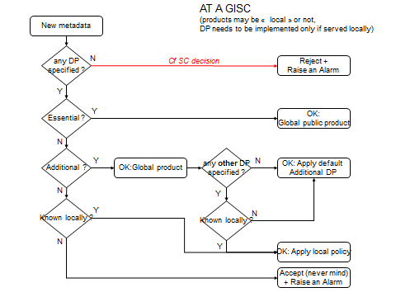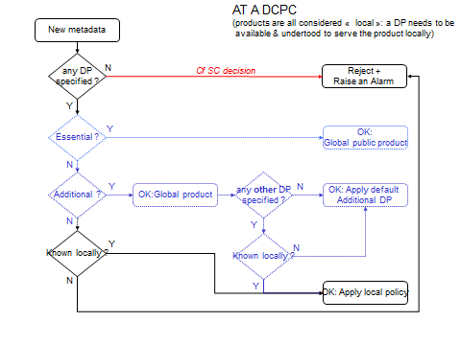
<<<
The purpose of this element is to describe any restrictions on usage of the data. Use constraints are different from restrictions on public access which describes limitations on access to the data. A data resource can have open access (e.g. to look at it), but restricted use.
Multiple entries are permitted to express a multitude of usage license conditions. A separate MD_Constraints element should be used to express each set of constraints. Related constraints may be grouped.
Any known constraints should be identified. If no conditions apply, then it is strongly recommended that “No conditions apply” should be recorded for */resourceConstraints/MD_Constraints/useLimitation.
Best practice suggests that the absence of the //gmd:identificationInfo//gmd:resourceConstraints/gmd:MD_LegalConstraints/gmd:useConstraints element means unrestricted usage. Data providers must be aware of this convention when providing metadata. However, as indicated above, it is strongly recommended that this lack of restriction be explicitly stated.
Within the WMO context, Resolution 40 and Resolution 25 Essential Data states ‘free and un-restricted’ usage. Whilst this is very similar to ‘no constraints apply’ it is useful to explicitly to indicate that data-providers are sharing this dataset under WMO Resolution 40 or Resolution 25.
Custom use constraints from NCs or DCPCs can be expressed as follows:
<gmd:resourceConstraints>
<gmd:MD_LegalConstraints>
<gmd:accessConstraints>
<gmd:MD_RestrictionCode codeList="http://standards.iso.org/ittf/PubliclyAvailableStandards/ISO_19139_Schemas/resources/Codelist/gmxCodelists.xml#MD_RestrictionCode" codeListValue="otherRestrictions">otherRestrictions</gmd:MD_RestrictionCode>
</gmd:accessConstraints>
<gmd:otherConstraints>
<gmx:Anchor xlink:href="http://www.ordnancesurvey.co.uk/oswebsite/opendata/licence/docs/licence.pdf">OS OpenData licence</gmx:Anchor>
</gmd:otherConstraints>
</gmd:MD_LegalConstraints>
</gmd:resourceConstraints>
This method uses gmx:Anchor extend the standard free-text field, providing both an xLink to the URL of the data license and a human readable version.
The same mechanism can be used to explicitly cite WMO Resolution 25 and Resolution 40 (WMO Resolution 40 and Resolution 25 are described online here: http://www.wmo.int/pages/about/exchangingdata_en.html). Thus Essential Data can be marked as:
- <gmx:Anchor xlink:href="http://www.wmo.int/pages/about/exchangingdata_en.html">WMO Essential</gmx:Anchor>
Whilst Additional data is marked:
- <gmx:Anchor xlink:href="http://www.wmo.int/pages/about/exchangingdata_en.html">WMO Additional</gmx:Anchor>
To express WMO Resolution 25 and WMO Resolution 40 the new CodeList WMO_DataLicenseCode «CodeList» should be referenced. It is included here for reference:
 | Name | Domain Code | Definition
1. | WMO_DataLicenseCode | WMO_DatLicCd | WMO Data License applied to the data resource – derived from WMO Resolution 25 and Resolution 40 (http://www.wmo.int/pages/about/exchangingdata_en.html)
2. | WMO Essential | 001 | WMO Essential Data: free and unrestricted international exchange of basic meteorological data and products
3. | WMO Additional | 002 | WMO Additional Data: free and unrestricted access to data and products exchanged under the auspices of WMO to the research and education communities for non-commercial activities

To express the legal validity of a Terminal Aerodrome Forecast (TAF), we must define a period of valid usage. The recommended method is:
- gmd:MD_LegalConstraints/gmd:useLimitations/gmd:CharacterString="PT12H"
- gmd:MD_LegalConstrains/gmd:useConstraints/gmd:MD_RestrictionCode="otherRestrictions"
- gmd:MD_LegalConstraints/gmd:otherConstraints/gmd:CharacterString="Valid usage period after issue"
In this case, we will need to ensure that MD_LegalConstraints/useLimitations/CharacterString shall be an ISO 8601 compliant PERIOD definition.
Delivery priorities for GTS Products have been enumerated in a new WMO_GTSProductCategoryCode «CodeList»
 | Name | Domain Code | Definition
1. | WMO_GTS_ProductCategoryCode | WMO_GTSCatCd | Product category used for prioritising messages on the WMO Global Telecommunications System (GTS)
2. | GTS Priority 1 | 001 | GTS Priority 1 – highest priority products
3. | GTS Priority 2 | 002 | GTS Priority 2
4. | GTS Priority 3 | 003 | GTS Priority 3
5. | GTS Priority 4 | 004 | GTS Priority 4

GTS priority can be expressed as follows:
- gmd:MD_Constraints/gmd:useLimitation/gco:CharacterString="GTS Priority 1"
Within WIS the primary focus is to provide metadata guidance for authors describing datasets routinely exchanged and freely accessible via the GTS so that these data resources can be discovered in the WIS DAR catalogue. For this reason, limitations on access have been ignored within this metadata profile.
Should data providers / custodians need to express access constraints, please follow the guidance supplied for the base ISO 19115 standard.

A.5 Data quality information (includes lineage)
 | Name / Role name | Definition | Obligation / Condition | Maximum occurrence | Data type | Domain
39 | DQ_DataQuality | quality information for the data  specified by a data quality scope | Use obligation from  referencing object | Use  maximum  occurrence  from  referencing  object | Aggregated Class (MD_Metadata) | Lines 40-42
40 | scope | the specific data to which the data  quality information applies | M | 1 | Class | DQ_Scope A.9.7
41 | Role name:  report | quantitative quality information for  the data specified by the scope | C /  lineage not provided? | N | Association | DQ_Element «Abstract»  Use specific concrete sub-class DQ_DomainConsistency
42 | Role name:  lineage | non-quantitative quality information  about the lineage of the data  specified by the scope | C /  report not provided? | 1 | Association | LI_Lineage
43 | Intentionally left blank
44 | Intentionally left blank
45 | DQ_DomainConsistency | adherence of values to the value  domains | Use obligation from  referencing object | Use  maximum  occurrence  from  referencing  object | Specialised Class  (DQ_Element) | Lines 46-47
46 | measureIdentification | code identifying a registered  standard procedure | O | 1 | Class | MD_Identifier «DataType» A.9.2
47 | result | value (or set of values) obtained  from applying a data quality  measure or the outcome of  evaluating the obtained value (or  set of values) against a specified  acceptable conformance quality  level | M | 2 | Class | DQ_Result «Abstract»  Use specific concrete sub-class DQ_ConformanceResult
48 | DQ_ConformanceResult | Information about the outcome of  evaluating the obtained value (or  set of values) against a specified  acceptable conformance quality  level | Use obligation from  referencing object | Use  maximum  occurrence  from  referencing  object | Specialised Class  (DQ_Result) | Lines 49-51
49 | specification | citation of product specification or  user requirement against which  data is being evaluated | M | 1 | Class | CI_Citation «DataType» A.9.3
50 | explanation | explanation of the meaning of  conformance for this result | M | 1 | CharacterString | Free text
51 | pass | indication of the conformance  result where 0 = fail and 1 = pass | M | 1 | Boolean | 1 = yes  0 = no
52 | LI_Lineage | information about the events or  source data used in constructing  the data specified by the scope or  lack of knowledge about lineage | Use obligation from  referencing object | Use  maximum  occurrence  from  referencing  object | Aggregated Class  (DQ_DataQuality) | Line 53
53 | statement | general explanation of the data  producer’s knowledge about the  lineage of a dataset | C /  (DQ_DataQuality.sco  pe.DQ_Scope.level =  “dataset” or “series”)? | 1 | CharacterString | Free text

A.5.1 gmd:DQ_Quality/gmd:report
The purpose of this is to record the conformity to a specification, such as the INSPIRE implementing rules. It describes degree of conformity with the product specification or user requirement against which the data is being evaluated.
This element is MANDATORY if claiming to be INSPIRE compliance. In this case, the author must assess the conformity of the data resource against its product specification or the INSPIRE thematic data specification. If these have not been finalised, then the data resource’s own specification should be used.
- Specification: citation of the product specification or user requirements against which the data resource is evaluated. A title and a reference date have to be provided: e.g. D2.8.I.5 INSPIRE Data Specification on Addresses – Guidelines, publication, 2010-04-26
- Degree (pass): degree of conformity with the specification. This is Boolean (true or false) depending on the conformity
- Explanation: meaning of conformance for this result. For example, include a statement about which aspects of the specification the data resource conforms and any exceptions.

A.5.2 gmd:LI_Lineage
The purpose of this element is to give an indication of how the data resource was created. It is useful in determining its fitness for purpose.
Where possible, include statements on the following:
- source material;
- process used to create the data, including resolution of measurement;
- method of updating; and
- any quality control processes.
As a minimum, it is recommended that a general statement is made about the provenance of the dataset. For example:
- High data quality controlled according to the procedures of the GTS

A.5.3 candidate controlled vocabularies for data quality and lineage
WMO maintains a large number of resources that are candidates for controlled vocabularies. The majority of these are specified in relation to the WMO Table Driven Code Forms (BUFR and GRIB).
Quality control:
- WMO GRIB Code Table 4.12 – Operating mode … a list of operating modes for instruments such as ‘maintenance mode’
- WMO GRIB Code Table 4.13 – Quality Control Indicator … a Boolean flag indicating the application of quality control procedures (or not!)
- WMO GRIB Code Table 4.14 – Clutter filter indicator
- … etc.
Instrument and Process types (that may be used in specifying the lineage of the resource):
- WMO Common Code Table C-2 Radiosonde/sounding system used
- WMO Common Code Table C-3 Instrument make and type for water temperature profile measurement […]
- WMO Common Code Table C-4 Water temperature profile recorder types
- WMO Common Code Table C-5 Satellite identifier
- WMO Common Code Table C-8 Satellite instruments
- WMO GRIB Code Table 4.3 – Type of generating process
- WMO GRIB Code Table 4.6 – Type of ensemble forecast
- WMO GRIB Code Table 4.7 – Derived forecast
- WMO GRIB Code Table 4.10 – Type of statistical processing

A.6 Maintenance information
 | Name / Role name | Definition | Obligation / Condition | Maximum occurrence | Data type | Domain
54 | MD_MaintenanceInformation | information about the scope and  frequency of updating | Use obligation from  referencing object | Use  maximum  occurrence  from  referencing  object | Aggregated Class  (MD_Metadata and MD_Identification) | Lines 55-58
55 | maintenanceAndUpdate  Frequency | frequency with which changes and  additions are made to the resource  after the initial resource is  completed | M | 1 | Class | MD_MaintenanceFrequency «CodeList»
56 | userDefinedMaintenance  Frequency | maintenance period other than  those defined | O | 1 | Class | TM_PeriodDuration
57 | updateScope | scope of data to which  maintenance is applied | O | N | Class | MD_ScopeCode «CodeList»
58 | contact | identification of, and means of communicating with, person(s) and organization(s) with responsibility for maintaining the resource | O | N | Class | CI_ResponsibleParty «DataType» A.9.3

A.6.1 gmd:MD_MaintenanceInformation/gmd:maintenanceAndUpdateFrequency
This identifies how often the updated data resource, or the associated metadata, is made available to the user (for instance a data resource may be updated continuously, but released to the user only monthly).
The choices are listed in CodeList MD_MaintenanceFrequencyCode. However, if is often more appropriate to provide a user-defined frequency of update:
- */gmd:MD_MaintenanceInformation/gmd:maintenanceAndUpdateFrequency = “continual”
- */gmd:MD_MaintenanceInformation/gmd:userDefinedMaintenanceFrequency = «ISO8801-compliant duration»

Wikipedia provides a useful resource on ISO 8601: http://en.wikipedia.org/wiki/ISO_8601.

A.6.2 Marking metadata as DRAFT
Météo France ‘baseline’ metadata (created for initial deployment of WIS) will be marked as DRAFT using the following scheme:
- gmd:MD_Metadata/gmd:metadataMaintenance//gmd:contact//gmd:organisationName = "Meteo France (on behalf of «NC or DCPC» by interim agreement with ICG-WIS)"
- gmd:MD_Metadata/gmd:metadataMaintenance//gmd:contact//gmd:contactInfo//gmd:address//gmd:electronicMailAddress = "«quelqu-un»@meteo.fr"

When necessary, computer-based detection of this draft status may be done by searching text “by interim agreement with ICG-WIS” in gmd:organisationName. Data providing agency must make sure to set appropriate name of WIS centre or organisation when publishing updated metadata derived from such draft.

A.7 Distribution information
 | Name / Role name | Definition | Obligation / Condition | Maximum occurrence | Data type | Domain
59 | MD_Distribution | information about the distributor of  and options for obtaining the  resource | Use obligation from  referencing object | Use  maximum  occurrence  from  referencing  object | Aggregated Class  (MD_Metadata) | Lines 60-62
60 | Role name:  distributionFormat | provides a description of the  format of the data to be distributed | C / MD_Distributor.  distibutorFormat not  documented? | N | Association | MD_Format
61 | Role name:  distributor | provides information about the  distributor | O | N | Association | MD_Distributor
62 | Role name:  transferOptions | provides information about  technical means and media by  which a resource is obtained from  the distributor | O | N | Association | MD_DigitalTransferOptions
63 | MD_Format | description of the computer  language construct that specifies  the representation of data objects  in a record, file, message, storage  device or transmission channel | Use obligation from  referencing object | Use  maximum  occurrence  from  referencing  object | Aggregated Class  (MD_Distribution,  MD_Identification, and  MD_Distributor) | Lines 64-67
64 | name | name of the data transfer format(s) | M | 1 | CharacterString | Free text
65 | version | version of the format (date,  number, etc.) | M | 1 | CharacterString | Free text
66 | specification | name of a subset, profile, or  product specification of the format | O | 1 | CharacterString | Free text
67 | Blank
68 | MD_Distributor | information about the distributor | Use obligation from  referencing object | Use  maximum  occurrence  from  referencing  object | Aggregated Class  (MD_Distribution and  MD_Format) | Lines 69-71
69 | distributorContact | party from whom the resource may  be obtained. This list need not be  exhaustive | M | 1 | Class | CI_ResponsibleParty «DataType» A.9.3
70 | Role name:  distributorFormat | provides information about the  format used by the distributor | C / MD_Distribution.  distributionFormat not  documented? | N | Association | MD_Format
71 | Role name:  distributorTransferOptions | provides information about the  technical means and media used  by the distributor | O | N | Association | MD_DigitalTransferOptions
72 | MD_DigitalTransferOptions | technical means and media by  which a resource is obtained from  the distributor | Use obligation from  referencing object | Use  maximum  occurrence  from  referencing  object | Aggregated Class  (MD_Distribution and  MD_Distributor) | Line 73
73 | online | Information about online sources from which the resource can be obtained | O | N | Class | CI_OnlineResource «DataType» A.9.5

A.7.1 gmd:MD_Format

The purpose of this element is to identify the various options for data formats that may be provided. Entries should be recognised formats for data transfer, either standard or proprietary.

A.7.2 online distribution information for GTS products

For GTS products intended for global exchange, the onlineResource attribute of the MD_Distributor object should conform to the following syntax: http://«hostname»/«path»/«MD_Metadata/fileIdentifier»
- «hostname»/«path»/ refers to the location of the web-service that serves the GTS product on behalf of the data-owner. This will normally be the NC or DCPC who is responsible for publishing the product, but may be a GISC node who has agreed to serve the ‘source’ data-files on their behalf
- «MD_Metadata/fileIdentifier» is the globally unique identifier of the metadata record that describes the product being served.

Example implementation of such web service is available at
- http://www.gisc.kishou.go.jp/cgi-bin/gisccache

The onlineResource for SMJP02 RJTD would be defined as:
- http://www.gisc.kishou.go.jp/cgi-bin/gisccache/urn:x-wmo:md:int.wmo.wis::SMJP02RJTD

A.7.3 online distribution information for the WIS 24-hour cache

GISCs will be able to identify GTS products (for global exchange) using the citation authority in the mandatory «MD_Metadata/fileIdentifier», being "int.wmo.wis", irrespective of the approach used to specify the online resource.

Each GISCs will maintain a 24-hour cache of the globally exchanged GTS products, and serve those products to users from their local (or preferred) GISC node. GISCs will need to amend the metadata returned to a user in response to a search query to (additionally) indicate their 24-hour product cache as an onlineResource that the user may choose to access.

Metadata authors do not need to know how GISC systems achieve this amendment. The following schematics describe the process for information purposes only.

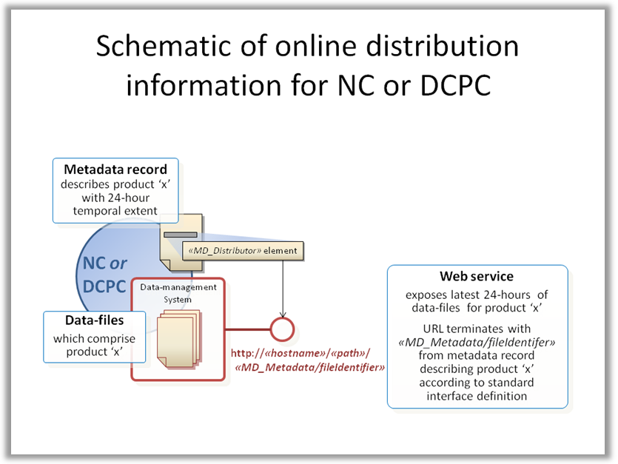

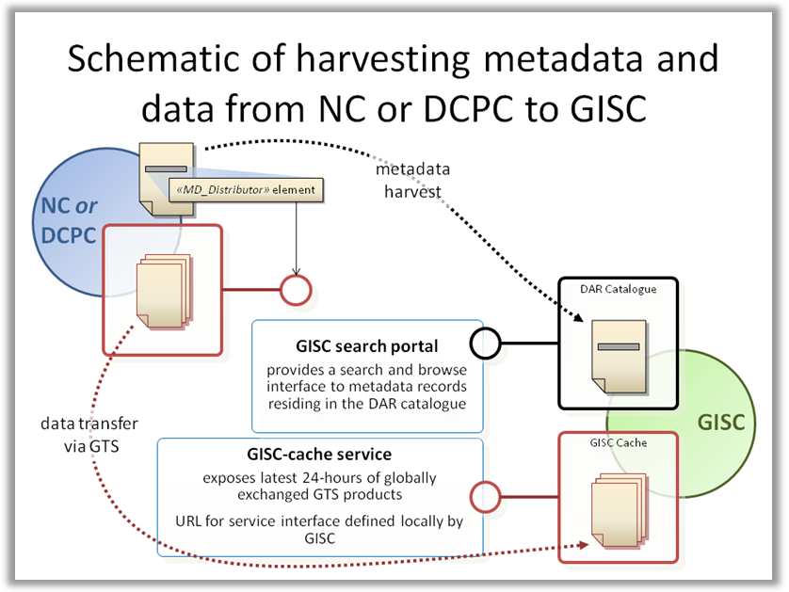

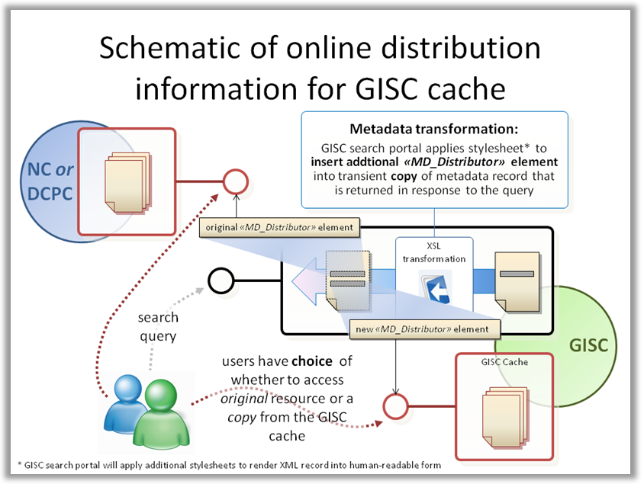

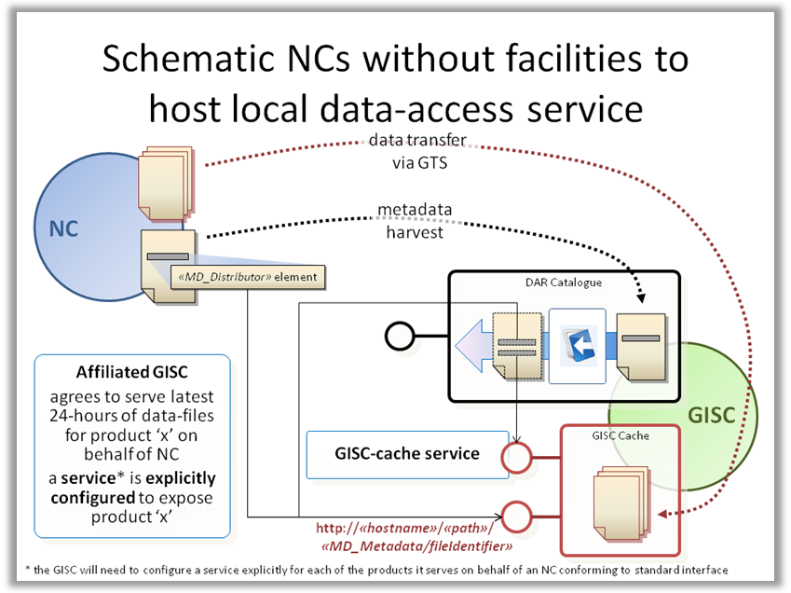

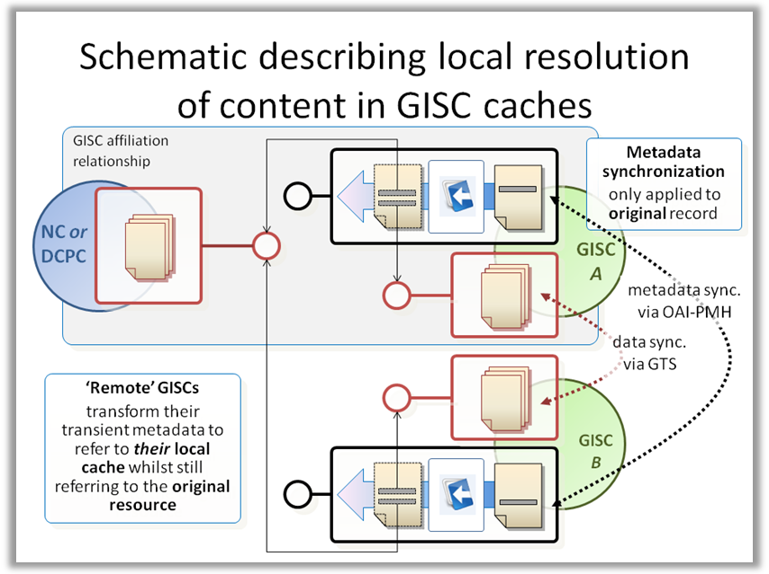

A.7.4 use of gmd:formatDistributor

The WMO Core Metadata Profile prohibits the use of gmd:formatDistributor within MD_Format. This role is useful only in the unlikely case that the data distributors are sorted by their only single data format. Careless schema definition allows endless recursion such as gmd:formatDistributor//gmd:distributionFormat//gmd:formatDistributor//gmd:distributorFormat/... thus making it very difficult to implement generic software to handle it.

A.8 Metadata extension information
 | Name / Role name | Definition | Obligation / Condition | Maximum occurrence | Data type | Domain
74 | MD_MetadataExtension  Information | information describing metadata  extensions | Use obligation from  referencing object | Use  maximum  occurrence  from  referencing  object | Aggregated Class  (MD_Metadata) | Line 75
75 | extensionOnLineResource | information about on-line sources  containing the community profile  name and the extended metadata  elements. Information for all new  metadata elements | M | 1 | Class | CI_OnlineResource «DataType» A.9.5

A.8.1 Extension metadata

Example XML encoding:

<gmd:metadataExtensionInfo>
<gmd:MD_MetadataExtensionInformation>
<gmd:extensionOnLineResource>
<gmd:CI_OnlineResource>
<gmd:linkage>
<!-- this refers to the ad-hoc guidance relating to WMO Core Metadata Profile -->
<gmd:URL>http://www.wmo.int/pages/prog/www/WDM/IPET-MDI-I/report/Report_IPETMDI_I_20100503.htm</gmd:URL>
</gmd:linkage>
<gmd:name>
<gco:CharacterString>WMO Core Profile of ISO 19115, v1.2, IPET-MDI I implementing guidelines</gco:CharacterString>
</gmd:name>
</gmd:CI_OnlineResource>
</gmd:extensionOnLineResource>
</gmd:MD_MetadataExtensionInformation>
</gmd:metadataExtensionInfo>

A.9 «DataType» definitions

A.9.1 Extent information
 | Name / Role name | Definition | Obligation / Condition | Maximum occurrence | Data type | Domain
76 | EX_Extent | information about horizontal,  vertical, and temporal extent | M | Use  maximum  occurrence  from  referencing  object | Class «DataType» | Lines 77-78
77 | Role name:  geographicElement | provides geographic component of  the extent of the referring object | M | N | Association | EX_GeographicExtent «Abstract»
78 | Role name:  temporalElement | provides temporal component of  the extent of the referring object | O | N | Association | EX_TemporalExtent
79 | EX_GeographicBoundingBox | geographic position of the dataset  NOTE This is only an approximate  reference so specifying the  coordinate reference system is  unnecessary | M | Use  maximum  occurrence  from  referencing  object | Specialised Class  (EX_GeographicExtent) | Lines 80-83
80 | westBoundLongitude | western-most coordinate of the  limit of the dataset extent,  expressed in longitude in decimal  degrees (positive east) | M | 1 | Class | Angle  -180,0 <= West Bounding  Longitude  Value <= 180,0
81 | eastBoundLongitude | eastern-most coordinate of the  limit of the dataset extent,  expressed in longitude in decimal  degrees (positive east) | M | 1 | Class | Angle  -180,0 <= East Bounding  Longitude  Value <= 180,0
82 | southBoundLatitude | southern-most coordinate of the  limit of the dataset extent,  expressed in latitude in decimal  degrees (positive north) | M | 1 | Class | Angle  -90,0 <= South Bounding  Latitude  Value <= 90,0; South  Bounding Latitude Value <=  North bounding Latitude  Value
83 | northBoundLatitude | northern-most, coordinate of the  limit of the dataset extent  expressed in latitude in decimal  degrees (positive north) | M | 1 | Class | Angle  -90,0 <= North Bounding  Latitude  Value <= 90,0; North  Bounding Latitude Value >=  South Bounding Latitude  Value
84 | EX_GeographicDescription | description of the geographic area  using identifiers | Use obligation from  referencing object | Use  maximum  occurrence  from  referencing  object | Specialised Class  (EX_GeographicExtent) | Line 85
85 | geographicIdentifier | identifier used to represent a  geographic area | M | 1 | Class | MD_Identifier «DataType»
86 | EX_TemporalExtent | time period covered by the content  of the dataset | Use obligation from  referencing object | Use  maximum  occurrence  from  referencing  object | Aggregated Class  (EX_Extent) | Line 87
87 | Extent | date and time for the content of the  dataset | M | 1 | Class | TM_Primitive

A.9.1.1 gmd:EX_GeographicExtent and subclasses
This element defines the geographical extent of coverage of the data resource. Noting that Extent is the overall coverage of the data resource, not the individual objects in the data resource; i.e. the boundary of the extent is strongly recommended to enclose all objects described by the data resource.
ISO 19115 allows one to document the geographicalExtent of a resource as a BoudingBox, a BoundingPolygon or a Geographic Description.
However, the WMO Core Metadata Profile mandates the provision of a GeographicBoundingBox as a minimum. More geographical extents may also be provided as appropriate.
The GeographicBoundingBox is determined by four coordinates.
- West bounding longitude: western-most limit of the data resource extent, expressed in longitude in decimal degrees (positive east, acceptable range -180 to 180)
- East bounding longitude: eastern-most limit of the data resource extent, expressed in longitude in decimal degrees (positive east, acceptable range -180 to 180)
- North bounding latitude: northern-most limit of the data resource extent, expressed in latitude in decimal degrees (positive north, acceptable range -90 to 90)
- South bounding latitude: southern-most limit of the data resource extent, expressed in longitude in decimal degrees (positive north, acceptable range -90 to 90)
Longitude and latitude shall be recorded in a coordinate reference system that has the same axes, units and prime meridian as WGS84.
Where the sensor platform is mobile (e.g. AMDAR, ships or bouys) the bounding box will describe the maximum reasonable extent within which the platform may operate, potentially a global extent. However, it should be noted that GTS practices (tables C1, C2 & C3 of the Manual on GTS) keep the extent of the bulletin fixed and require that the data from mobile platforms is allocated to the appropriate bulletin based on the location of the platform.
Note:
Acceptable range shown above is given by ISO 19115. Specifying datasets that overlap the 180th meridian may be difficult using the geographic bounding box. INSPIRE Implementing Rule states “If the bounding box crosses the 180 meridian, then the value of the westBoundLongitude will be greater than the eastBoundLongitude value.”
The BoundingPolygon is a GML Object (GM_Object).
The GeographicDescription provides an identifier of the area, and should then point on a well-known identifier, based on a published standard. For example: ISO 3166-3:1999 provides codes for the representation of names of countries and their subdivisions.

Place-names (such as observation stations and other static sensor platforms) will be expressed as both keyword (type=place) and geographicIdentifiers:
- gmd:MD_Metadata/gmd:identificationInfo//gmd:descriptiveKeywords//gmd:keyword
- gmd:MD_Metadata/gmd:identificationInfo//gmd:descriptiveKeywords//gmd:type = "place"
- gmd:MD_Metadata/gmd:identificationInfo//gmd:extent//gmd:geographicElement//gmd:geographicIdentifier/gmd:MD_Identifier
Example XML encoding of geographic identifier using a WMO station gazetteer:
<gmd:geographicIdentifier>
<gmd:MD_Identifier>
<gmd:authority>
<gmd:CI_Citation id="volAgazeteer">
<gmd:title><gco:CharacterString>Vol A Gazeteer</gco:CharacterString></gmd:title>
…
</gmd:CI_Citation>
</gmd:authority>
<gmd:code>
<gco:CharacterString>http://wis.wmo.int/WMOVolumeAGazeteer.xml#91291</gco:CharacterString>
</gmd:code>
</gmd:MD_Identifier>
</gmd:geographicIdentifier>
There are a number of gazetteers managed by WMO and other authorities that are candidates for reference as geographicIdentifiers:
- ISO 3166 3-numeric country codes
- WMO Code Tables and Flag Tables Associated with BUFR/CREX Table B
  - Code table 0 01 003: WMO Region number/geographical area
  - Code table 0 01 101: State identifier
- WMO Common Code Table C-11: Originating / generating centres
- WMO Common Code Table C-12: Sub-centres of originating centres defined by entries in Common Table C-11
- WMO Volume A Observing Station Gazetteer
- ICAO [Location Identifier][Aerodrome Gazetteer [?]
Note that each station in the Volume A gazetteer shall be assigned a unique identifier to supplement the (mostly unique) WMO Station Code.
It is anticipated that (at least) a sub-set of these resources will be provided as web-accessible resources to support future releases of the WMO Core Metadata Profile.

A.9.1.2 gmd:EX_TemporalExtent
This is the date or date range that identifies the currency of the data. It may refer to the period of collection, or the date at which it is deemed to be current.
This element should not be confused with Dataset reference date which is an identifying date for the data resource.
Provide a date, or two dates defining the duration of the period, as defined by ISO 8601. Periods are recorded as (from-date/to-date). Either from-date or to-date (but not both) may be left blank to indicate uncertainty. The extended date format (YYYY-MM-DD) should be used, where YYYY is the year, MM is the month and DD is the day. Time (HH:MM:SS, where HH is the hour, MM the minutes and SS the seconds) may be added if required, separated from the day by “T”.
Examples:
- 2001-01-01
- 2009-05-02T09:10:01
- 1939/1945
- /2003-03-31
- 2000/
- 19
More information relating to ISO 8601 can be found on Wikipedia: http://en.wikipedia.org/wiki/ISO_8601.
Within the WMO Core Metadata Profile, the choice has been made to not use combined spatio-temporal extents (EX_SpatialTemporalExtent). Maintaining the separate extent objects results in simpler management of the metadata components.

A.9.2.3 Vertical Extents
Currently, the WMO Core Metadata Profile does not provide any guidance on the use of vertical extents. It is anticipated that this will be added in later releases.

A.9.2.4 Tagging Extent elements for quick identification and indexing
Following best-practice developed at NOAA’s National Geophysical Data Centre (NGDC), boundingExtent, boundingBoxExtent, boundingTemporalExtent, and boundingVerticalExtent elements should be tagged using common terms for identification and easy re-use within the metadata record:
- <gmd:EX_Extent id="boundingExtent">
- <gmd:EX_GeographicBoundingBox id="boundingGeographicBoundingBox">
- <gmd:EX_TemporalExtent id="boundingTemporalExtent">
- <gmd:EX_VerticalExtent id="boundingVerticalExtent">

A.9.2 Identifier information
 | Name / Role name | Definition | Obligation / Condition | Maximum occurrence | Data type | Domain
88 | MD_Identifier | value uniquely identifying an object  within a namespace | Use  obligation/condition  from referencing  object | Use  maximum  occurrence  from  referencing  object | Class «DataType» | Lines 89-90
89 | Authority | person or party responsible for  maintenance of the namespace | O | 1 | Class | CI_Citation «DataType»
90 | Code | alphanumeric value identifying an  instance in the namespace | M | 1 | CharacterString | Free text
91 | RS_Identifier | identifier used for reference  systems | Use  obligation/condition  from referencing  object | Use  maximum  occurrence  from  referencing  object | Specialised Class  (MD_Identifier) | Lines 92-93
92 | codeSpace | name or identifier of the person or  organization responsible for  namespace | O | 1 | CharacterString | Free text
93 | Version | version identifier for the  namespace | O | 1 | CharacterString | Free text

A.9.3 Citation and responsible party information
 | Name / Role name | Definition | Obligation / Condition | Maximum occurrence | Data type | Domain
94 | CI_Citation | standardized resource reference | Use  obligation/condition  from referencing  object | Use  maximum  occurrence  from  referencing  object | Class «DataType» | Lines 95-100
95 | Title | name by which the cited resource  is known | M | 1 | CharacterString | Free text
96 | alternativeTitle | short name or other language  name by which the cited  information is known. Example:  "DCW" as an alternative title for  "Digital Chart of the World” | O | N | CharacterString | Free text
97 | Date | reference date for the cited  resource | M | N | Class | CI_Date «DataType»
98 | Identifier | value uniquely identifying an object  within a namespace | O | N | Class | MD_Identifier «DataType»
99 | citedResponsibleParty | name and position information for  an individual or organization that is  responsible for the resource | O | N | Class | CI_ResponsibleParty «DataType»
100 | presentationForm | mode in which the resource is  represented | O | N | Class | CI_PresentationFormCode «CodeList»
101 | CI_ResponsibleParty | identification of, and means of  communication with, person(s) and  organizations associated with the  dataset | Use  obligation/condition  from referencing  object | Use  maximum  occurrence  from  referencing  object | Class «DataType» | Lines 102-106
102 | individualName | name of the responsible personsurname,  given name, title  separated by a delimiter | C / organisationName  and positionName not  documented? | 1 | CharacterString | Free text
103 | organisationName | name of the responsible  organization | C / individualName  and positionName not  documented? | 1 | CharacterString | Free text
104 | positionName | role or position of the responsible  person | C / individualName  and  organisationName not  documented? | 1 | CharacterString | Free text
105 | contactInfo | address of the responsible party | O | 1 | Class | CI_Contact «DataType»
106 | Role | function performed by the  responsible party | M | 1 | Class | CI_RoleCode «CodeList»
107 | CI_Address | location of the responsible  individual or organization | Use  obligation/condition  from referencing  object | Use  maximum  occurrence  from  referencing  object | Class «DataType» | Lines 108-113
108 | deliveryPoint | address line for the location (as  described in ISO 11180, Annex A) | O | N | CharacterString | Free text
109 | City | city of the location | O | 1 | CharacterString | Free text
110 | administrativeArea | state, province of the location | O | 1 | CharacterString | Free text
111 | postalCode | ZIP or other postal code | O | 1 | CharacterString | Free text
112 | Country | country of the physical address | O | 1 | CharacterString | ISO 3166-3, other parts may  be used
113 | electronicMailAddress | address of the electronic mailbox  of the responsible organization or  individual | O | N | CharacterString | Free text
114 | CI_Contact | information required to enable  contact with the responsible  person and/or organization | Use  obligation/condition  from referencing  object | Use  maximum  occurrence  from  referencing  object | Class «DataType» | Lines 115-117
115 | Phone | telephone numbers at which the  organization or individual may be  contacted | O | 1 | Class | CI_Telephone «DataType»
116 | Address | physical and email address at  which the organization or individual  may be contacted | O | 1 | Class | CI_Address «DataType»
117 | onlineResource | on-line information that can be  used to contact the individual or  organization | O | 1 | Class | CI_OnlineResource «DataType»

A.9.3.1 gmd:CI_Citation/gmd:title
The purpose of this element is to provide a readily recognisable name for the data resource.
1. The title should be the formal or product name for the data resource, if existing.
2. If no name exists, then a title should be created that is short, encapsulates the subject, temporal and spatial coverage of the data resource, and does not contain terms or jargon that make it incomprehensible.

A.9.3.2 gmd:CI_Citation/gmd:alternativeTitle
The purpose of this element is to record any alternative titles by which the data resource is known.
1. There is no need to fill in this entry unless there are other names used for the dataset, for example historic names.
2. Commonly used abbreviations or acronyms should be recorded.
3. Other language equivalents should be recorded where they exist, for example the Welsh language title (although this title may refer to a different data resource).
Note: refer to section 9 for how to specify language.
4. Entries should be short and concise.

A.9.3.3 gmd:CI_ResponsibleParty
This informs the user about who is responsible for the data resource. This class comprises multiple elements relating to the responsible organisation distributed amongst several discrete «DataTypes»:
- contact position
- organisation name
- full postal address
- telephone number
- facsimile number
- email address
- web address
- responsible party role

The responsible party roles are listed below:
Code | Name | Definition
1 | resource provider | party that supplies the resource
2 | custodian | party that accepts accountability and responsibility for the data and ensures appropriate care and maintenance of the resource
3 | owner | party that owns the resource
4 | user | party who uses the resource
5 | distributor | party who distributes the resource
6 | originator | party who created the resource
7 | point of contact | party who can be contacted for acquiring knowledge about or acquisition of the resource
8 | principal investigator | key party responsible for gathering information about or acquisition of the resource
9 | processor | party who has processed the data in a manner such that the resource has been modified
10 | publisher | party who published the resource
11 | author | party who authored the resource

Where there are, say, several distributors, then a separate entry should be given for each.

A.9.4 Date information
 | Name / Role name | Definition | Obligation / Condition | Maximum occurrence | Data type | Domain
118 | CI_Date | reference date and event used to  describe it | Use  obligation/condition  from referencing  object | Use  maximum  occurrence  from  referencing  object | Class «DataType» | Lines 119-120
119 | date |  | M | 1 | Class | Date
120 | dateType |  | M | 1 | Class | CI_DateTypeCode «CodeList»

A.9.5 Online resource information
 | Name / Role name | Definition | Obligation / Condition | Maximum occurrence | Data type | Domain
121 | CI_OnlineResource | information about on-line sources  from which the dataset,  specification, or community profile  name and extended metadata  elements can be obtained | Use  obligation/condition  from referencing  object | Use  maximum  occurrence  from  referencing  object | Class «DataType» | Lines 122-125
122 | linkage | location (address) for on-line  access using a Uniform Resource  Locator address or similar  addressing scheme such as  http://www.statkart.no/isotc211 | M | 1 | Class | URL  (IETF RFC1738  IETF RFC 2056)
123 | protocol | connection protocol to be used | O | 1 | CharacterString | Free text
124 | name | name of the online resource | O | 1 | CharacterString | Free text
125 | description | detailed text description of what  the online resource is/does | O | 1 | CharacterString | Free text

A.9.4.1 gmd:CI_Date
The ISO 19115 element CI_Date requires providing a date type: publication, creation or revision associated with the date itself. At least one date is required in 19115, with no conditions on the type of this date.
Provide a date as defined by ISO 8601. The extended date format (YYYY-MM-DD) should be used, where YYYY is the year, MM is the month and DD is the day. Time (HH:MM:SS, where HH is the hour, MM the minutes and SS the seconds) may be added if required, separated from the day by “T”.
Examples:
- 2001-01-01
- 2010-11-11T21.09:18
- 19
More information relating to ISO 8601 can be found on Wikipedia: http://en.wikipedia.org/wiki/ISO_8601.
The date should be completed to a resolution sufficient to identify the version. Thus if the data resource is updated annually, only a year is required, whilst if it is updated weekly, a day is required. Metadata authors should identify whether date refers to creation, last revision or publication.

A.9.5.1 gmd:CI_OnlineResource
The purpose of this element is to point to where the dataset may be downloaded. This may be different from where it may be ordered online, which should be included in the web address of the distributor.

A.9.6 Telephone information
 | Name / Role name | Definition | Obligation / Condition | Maximum occurrence | Data type | Domain
126 | CI_Telephone | telephone numbers for contacting  the responsible individual or  organization | Use  obligation/condition  from referencing  object | Use  maximum  occurrence  from  referencing  object | Class «DataType» | Line 127
127 | voice | telephone number by which  individuals can speak to the  responsible organization or  individual | O | N | CharecterString | Free text

A.9.7 Data quality scope information
 | Name / Role name | Definition | Obligation / Condition | Maximum occurrence | Data type | Domain
128 | DQ_Scope | extent of characteristic(s) of the  data for which quality information  is reported | Use obligation from  referencing object | Use  maximum  occurrence  from  referencing  object | Class  «DataType» | Line 129
129 | level | hierarchical level of the data  specified by the scope | M | 1 | Class | MD_ScopeCode «CodeList»

WMO Core Metadata Profile version 1.2
Annex B – CodeList extensions

B.5.2 CI_DateTypeCode «CodeList»
Amendment only: additional term «reference» [004]
 | Name | Domain Code | Definition
1. | CI_DateTypeCode | DateTypCd | identification of when a given event occurred
2. | creation | 001 | date identifies when the resource was brought into existence
3. | publication | 002 | date identifies when the resource was used
4. | revision | 003 | date identifies when the resource was examined or re-examined and improved or amended
5. | reference | 004 | date identifies when the resource was referenced or accessed

WMO_DataLicenseCode «CodeList»
New CodeList for WMO Core Metadata Profile.
 | Name | Domain Code | Definition
1. | WMO_DataLicenseCode | WMO_DatLicCd | WMO Data License applied to the data resource – derived from WMO Resolution 25 and Resolution 40 (http://www.wmo.int/pages/about/exchangingdata_en.html)
2. | WMO Essential | 001 | WMO Essential Data: free and unrestricted international exchange of basic meteorological data and products
3. | WMO Additional | 002 | WMO Additional Data: free and unrestricted access to data and products exchanged under the auspices of WMO to the research and education communities for non-commercial activities

WMO_GTSProductCategoryCode «CodeList»
New CodeList for WMO Core Metadata Profile.
 | Name | Domain Code | Definition
1. | WMO_GTS_ProductCategoryCode | WMO_GTSCatCd | Product category used for prioritising messages on the WMO Global Telecommunications System (GTS)
2. | GTS Priority 1 | 001 | GTS Priority 1 – highest priority products
3. | GTS Priority 2 | 002 | GTS Priority 2
4. | GTS Priority 3 | 003 | GTS Priority 3
5. | GTS Priority 4 | 004 | GTS Priority 4

WMO_CategoryCode «CodeList»
New CodeList for WMO Core Metadata Profile.
 | Name | Domain Code | Definition
1. | WMO_CategoryCode | WMOCatCd | Additional topic categories for WMO community
2. | weatherObservations | 001 | weather observations
3. | weatherForecasts | 002 | weather forecasts
4. | meteorology | 003 | Meteorology
5. | hydrology | 004 | Hydrology
6. | climatology | 005 | Climatology
7. | landMeteorologyClimate | 006 | land meteorology climate
8. | synopticMeteorology | 007 | synoptic meteorology
9. | marineMeteorology | 008 | marine meteorology
10. | agriculturalMeteorology | 009 | agricultural meteorology
11. | aerology | 010 | Aerology
12. | marineAerology | 011 | marine aerology
13. | oceanography | 012 | oceanography
14. | landHydrology | 013 | land hydrology
15. | rocketSounding | 014 | rocket sounding
16. | pollution | 015 | pollution
17. | waterPollution | 016 | water pollution
18. | landWaterPollution | 017 | land water pollution
19. | seaPollution | 018 | sea pollution
20. | landPollution | 019 | land pollution
21. | airPollution | 020 | air pollution
22. | glaciology | 021 | Glaciology
23. | actinometry | 022 | actinometry
24. | satelliteObservation | 023 | satellite observation
25. | airplaneObservation | 024 | airplane observation
26. | observationPlatform | 025 | observation platform

It is noted that WMO provides and maintains a number of vocabularies that describe categories of WMO products and activities:
- GRIB Code table 0.0 – Discipline of processed data in the GRIB message
- GRIB Code table 4.0 – Product definition
- BUFR Table A – Data Category
- Common Code Table C-13 – Data sub-categories
- International Meteorological Vocabulary (WMO-No. 182)
[http://www.wmo.int/pages/prog/www/WMOCodes/TDCFtables.html].
It is anticipated that these resources will be provided as a web-accessible vocabularies to support future releases of the WMO Core Metadata Profile and related standards.
As this CodeList provides a significant overlap with these resources, additional maintenance should be avoided, suggesting the need to reconcile the TDCF Code Tables and WMO_CategoryCode «CodeList» in future releases of the WMO Core Metadata Profile.
Deprecated CodeList extensions
WMO Core Metadata Profile version 1.1 identified a number of CodeList extensions that have been deprecated (i.e. no longer in valid use). These are listed below, along with the reasons for deprecation:
B.5.10 MD_CharacterSetCode «CodeList»
 | Name | Domain Code | Definition
1. | MD_CharacterSetCode | CharSetCd | name of the character coding standard used for the resource
«deprecated»
31. | CP1251 | 030 | Cyrillic code set

Advice from the Russian Institute for Hydrometeorological Information indicates that ISO 8859 code is in common use for the Cyrillic alphabet.
B.5.10 MD_MaintenanceFrequncyCode «CodeList»
 | Name | Domain Code | Definition
1. | MD_MaintenanceFrequencyCode | MaintFreqCd | frequency with which modifications and deletions are made to the data after it is first produced
«deprecated»
14. | Hourly | 013 | data is updated hourly
15. | 3-hourly | 014 | data is updated every 3-hours
16. | 6-hourly | 015 | data is updated every 6-hours
17. | 12-hourly | 015 | data is updated every 12-hours

Recommendation 29 from IPET-MDI-1 [http://www.wmo.int/pages/prog/www/WDM/IPET-MDI-I/report/Report_IPETMDI_I_20100503.htm] states:
Use of bespoke extensions to the MD_MaintenanceFrequencyCode code-list will be prohibited. As an alternative the following must be used:
- */MD_MaintenanceInformation/maintenanceAndUpdateFrequency = “continual”
- */MD_MaintenanceInformation/userDefinedMaintenanceFrequency = «ISO8801-compliant duration»
This applies to both data and metadata maintenance.
Wikipedia provides a useful resource on ISO 8601: http://en.wikipedia.org/wiki/ISO_8601
Additionally, it is noted that WMO provides and maintains a vocabulary of ‘time ranges’ in GRIB Code table 4.4 – Indicator of unit time range [http://www.wmo.int/pages/prog/www/WMOCodes/TDCFtables.html].
It is anticipated that this will be provided as a web-accessible vocabulary to support future releases of the WMO Core Metadata Profile and related standards.
B.5.18 MD_SpatialRepresentationTypeCode «CodeList»
 | Name | Domain Code | Definition
1. | MD_SpatialRepresentationTypeCode | SpatRepTypCd | method used to represent geographic information in the dataset
«deprecated»
8. | bitmap | 007
9. | irregularPoints | 008 | irregularly-spaced points, such as meteorological stations

Review of common usage of these CodeList entries indicates a mapping to common parlance used in GIS systems. Given that understanding:
- «bitmap» [007] shall be described using «grid» [002]; and
- «irregularPoints» [008] shall be described using «vector» [001]
WMO_DataFrequencyCode «CodeList»
 | Name | Domain Code | Definition
1. | WMO_DataFrequencyCode | WMODataFreqCd | Supplemental CodeList to MD_MaintenanceFrequencyCode reflecting WMO timescales
«deprecated»
2. | continuous | 001 | data is observed, measured or forecasted continuously
3. | 1-minute | 002 | data is observed, measured or forecasted every minute
4. | 5-minute | 003 | data is observed, measured or forecasted every 5 minutes
5. | 10-minute | 004 | data is observed, measured or forecasted every 10 minutes
6. | 30-minute | 005 | data is observed, measured or forecasted every 30 minutes
7. | Hourly | 006 | data is observed, measured or forecasted every hour
8. | 3-hourly | 007 | data is observed, measured or forecasted every 3 hours
9. | 6-hourly | 008 | data is observed, measured or forecasted every 6 hours
10. | 8-hourly | 009 | data is observed, measured or forecasted every 8 hours
11. | 12-hourly | 010 | data is observed, measured or forecasted every 12 hours
12. | daily | 011 | data is observed, measured or forecasted every day
13. | weekly | 012 | data is observed, measured or forecasted every week
14. | 10-daily | 013 | data is observed, measured or forecasted every 10 days
15. | fortnightly | 014 | data is observed, measured or forecasted every 2 weeks
16. | monthly | 015 | data is observed, measured or forecasted every month
17. | quarterly | 016 | data is observed, measured or forecasted every 3 months
18. | biannually | 017 | data is observed, measured or forecasted twice each year
19. | annually | 018 | data is observed, measured or forecasted every year
20. | decadally | 019 | data is observed, measured or forecasted every decade
21. | Irregularly | 020 | data is observed, measured or forecasted irregularly

WMO provides and maintains a vocabulary of ‘time ranges’ in GRIB Code table 4.4 – Indicator of unit time range [http://www.wmo.int/pages/prog/www/WMOCodes/TDCFtables.html]. As this CodeList provides a significant overlap with this resource, additional maintenance shall be avoided. The TDCF Code Tables will take priority.
It is anticipated that GRIB Code table 4.4 – Indicator of unit time range will be provided as a web-accessible vocabulary to support future releases of the WMO Core Metadata Profile and related standards.
Where durations are not covered by GRIB Code table 4.4 – Indicator of unit time range, an ISO 8601-compliant duration should be used. Wikipedia provides a useful resource on this subject: http://en.wikipedia.org/wiki/ISO_8601.

Franks, P. Kunde, N. (Jan 2006) Why Metadata Matters, The Information Management Journal, Sept/Oct 2006 issue, pp55-61
Excerpts are sourced from Draft 5; minor amendments may have occurred for the final published version
The exact title of the Code Table is ‘Product definition template number’
Note: this is sometimes similar to the deprecated Code List WMO_DataFrequencyCode (see Annex B)

