  World Meteorological Organization  COMMISSION FOR BASIC SYSTEMS  Implementation Coordination Team on Information Systems and Services  15-17 October 2019, Geneva | ICT-ISS-2019
18.10.2019
Submitted by:
Secretariat

Final report OF THE Meeting of the Implementation Coordination Team on Information Systems and Services

15-17 October 2019
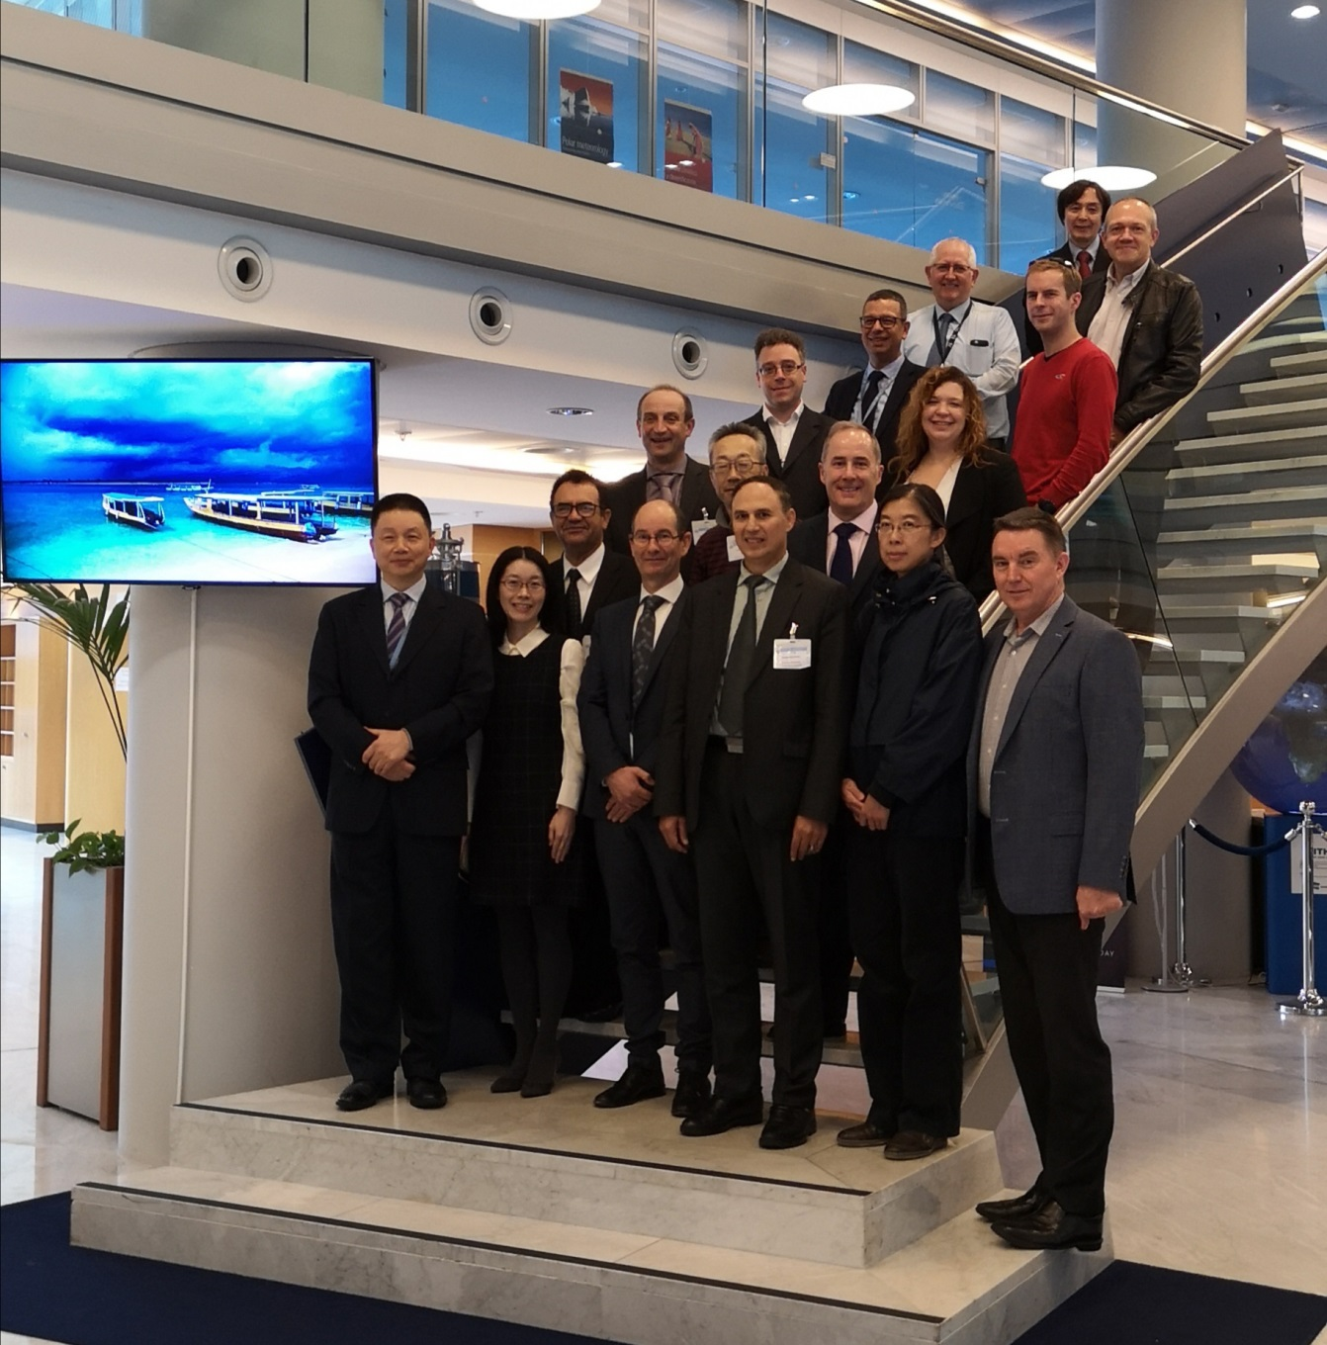

DISCLAIMER
Regulation 43
Recommendations of working groups shall have no status within the Organization until they have been approved by the responsible constituent body. In the case of joint working groups the recommendations must be concurred with by the presidents of the constituent bodies concerned before being submitted to the designated constituent body.
Regulation 44
In the case of a recommendation made by a working group between sessions of the responsible constituent body, either in a session of a working group or by correspondence, the president of the body may, as an exceptional measure, approve the recommendation on behalf of the constituent body when the matter is, in his opinion, urgent, and does not appear to imply new obligations for Members. He may then submit this recommendation for adoption by the Executive Council or to the President of the Organization for action in accordance with Regulation 9(5).
© World Meteorological Organization, 2018
The right of publication in print, electronic and any other form and in any language is reserved by WMO. Short extracts from WMO publications may be reproduced without authorization, provided that the complete source is clearly indicated. Editorial correspondence and requests to publish, reproduce or translate this publication in part or in whole should be addressed to:
Chairperson, Publications Board
World Meteorological Organization (WMO)
7 bis, avenue de la Paix Tel.: +41 (0)22 730 84 03
P.O. Box No. 2300 Fax: +41 (0)22 730 80 40
CH-1211 Geneva 2, Switzerland E-mail: Publications@wmo.int
NOTE:
The designations employed in WMO publications and the presentation of material in this publication do not imply the expression of any opinion whatsoever on the part of WMO concerning the legal status of any country, territory, city or area, or of its authorities, or concerning the delimitation of its frontiers or boundaries.
The mention of specific companies or products does not imply that they are endorsed or recommended by WMO in preference to others of a similar nature which are not mentioned or advertised.
This document (or report) is not an official publication of WMO and has not been subjected to its standard editorial procedures. The views expressed herein do not necessarily reflect those of WMO or its Members.

1 Executive Summary

The Implementation Coordination Team on Information Systems and Services (ICT-ISS) met in Geneva from 15 to 17 October 2019. The main focus of the meeting was around WMO reform and the new Standing Committee on Information Management and Technology (SC-IMT).
The team reviewed the decisions of Cg-18 and EC-71, the status and work plans of Expert Teams and Task Teams, discussed the terms of reference of SC-IMT, a transition plan, reviewed the list of competencies required by SC-IMT and its Expert Teams, and proposed a structure of SC-IMT.

1.1 Terms of reference of SC-IMT
IT-ISS discussed at length the terms of reference of SC-IMT. The Team agreed that the requirement to cover all the activity areas of WMO based on the Earth System approach and the need to better serve Members needs by engaging them in activities and gathering their requirements where the key elements to be considered in the review of the ToR of SC-IMT.
The text drafted by the team for the Terms of Reference of SC-IMT is the following.

Responding to the WMO Convention, article 2(b), which states that a primary purpose of the organization shall be “to promote the establishment and maintenance of systems for the rapid exchange of meteorological and related information”, the Standing Committee will focus on the normative work and technical systems required to achieve Objective 2.2 of the WMO Strategic Plan: “{to} Improve and increase access to, exchange and management of current and past Earth system observation data and derived products through the WMO Information System”

The activities of the Standing Committee will include the following:

A. To develop and update regulatory and guidance material relating to exchange of observations and other meteorological and related data and information, information life-cycle management, information and telecommunication technology, cybersecurity, operations management, data and metadata standards, working with national and international standard bodies and communities where appropriate;
B. To lead the development of WIS to support efficient and effective exchange of data and information between WMO Members and partners;
C. With the Regional Associations, monitor and review the performance and use of WIS and coordinate the provision of technical support and interaction between WIS centres;
D. To drive and promote unified practices to information management and use of technology across all disciplines and WMO application areas;
E. To coordinate all activities related to information management and technology, by providing technical regulations, recommendations and guidance for production, documentation, discoverability, access, exchange and preservation of data and products derived from current and past observations as well as from all-timescale Earth system predictions;
F. To monitor the evolution of technology that may contribute to the effective and secure operation of WIS;
G. With the Regional Associations gather and review requirements of all user programmes, assess and advise on gaps and solutions for meeting user needs in new information and communication technologies for all disciplines and WMO application areas, and make proposals on implementation, planning and operational management of WIS;
H. To monitor compliance with information management, cybersecurity and technology standards and practices in WIS and promote a culture of compliance with standards and relevant regulatory material among all Members;
I. To develop and promote education and training material and recommend competency based training events on telecommunications, information management, operations management, and cyber security;
J. To contribute to the development and implementation planning of infrastructure of partner organizations;

1.2 Transition plan towards SC-IMT
The Secretariat explained the timeline toward the formation of the SC-IMT and its substructures. CBS, ICT-ISS, current ETs and TTs will cease their formal work at the beginning of the new year. The Technical Commissions are going to discuss the formation of SC-IMT during the first joint session planned for 30 March 2020. The newly established SC-IMT will have its first meeting after the TCs joint session and will form its substructures. Only after the first meeting of SC-IMT the ET meetings can take place. Therefore from the 1st January to around June or July the current teams won’t be formally supported and any work that is required to the team members during that period is difficult to justify in their organisation and there will also be motivational reasons for which the members are not any more willing to contribute to WMO work.
To avoid stopping activities that are important for the correct operation of Members’ activities coordinated by WMO the Team decided to make a list of critical tasks that need to be performed and Mr. Matteo dell’Acqua (Chair of ICT-ISS) will write to the President of CBS and President of INFCOM to ask to that the teams performing those activities are kept fully functional with a formal communication to the relevant PRs to make sure that those important activities are not stopped causing significant damages and delays during the transition period.
The teams and the critical activities are listed below.

IPET-CM
Activities:
- GRIB and BUFR first fast track 2020
- TAC Aviation Codes approval between sessions by request of ICAO.

IPET-DD
- TT-AvXML
Activities: continuous development of IWXXM to implement ICAO requirements

ET-CTS
- Pub/sub experimentation
- SATCOM organisation
TT-eWIS
- List of WIS 2.0 demonstration projects
- Develop WIS 2.0 specification sufficiently to allow Members budget planning for WIS 2.0 implementation. The work is in coordination with GISCs to gather information on operational costs.

ET-WISC
- TT-GISC operational coordination (GISC watch)
- GISC audit criteria for ET-CAC and review.

1.3 Competencies for SC-IMT and ETs
The Secretariat explained that according to the new Rules of Procedure for Technical Commissions (WMO-No. 1240) a database for a common Expert Network will be established and maintained by the Secretariat and that the members of the standing committee and expert teams are selected from the Expert Network on the basis of their competencies to fulfil the requirements in terms of expertise for each body.
The importance of having a good list of competencies required for the work of SC-IMT and its teams was highlighted and the team was requested to review the existing list of competencies to provide the updated list for SC-IMT.
The result of the work of the team on the list of competencies is reported.

Thematic Experience Areas:
Marine & Ocean, Climate, Agriculture, Hydrology, Weather (WWW, PWS), Aviation, Metrology(?), WIS (?), Atmospheric Composition.

SC-IMT Competencies

E1 - Data management (including processing, storage, archiving or representation as relevant to the topic of the expert team). Metadata, data representation, information management systems, infrastructure
E2 - Internet and telecommunications technologies (with specialization as in the topic of the expert team). Space and terrestrial comms, applications, security,
E3 - Observing systems (with specialization as in the topic of the expert team).
E4 - Observing network design and implementation.
E5 - Use of observations in application systems (with specialization as in the topic of the expert team).
E6 - Data acquisition systems, Modelling systems, automated production systems, Service delivery systems or dissemination systems (with specialization as in the topic of the expert team).
E7 - Manual production systems (with specialization as in the topic of the expert team).
E8 - Use of forecast and other model products for delivering services (with specialization as in the topic of the expert team).
E9 - Service delivery systems, including with particular emphasis on impact-based forecast and warning services, dissemination, communication and innovations in these fields (and with specialization as in the topic of the expert team).
E10 - Radio frequencies in meteorology and radio frequency regulations.
E11 - NMHS National weather-, climate- or water-services management and related infrastructure. (includes management of operational systems)
E12 - WMO Technical Regulations (with specialization as in the topic of the expert team).
E13 - Certification and assurance processes. (Noting the desire to separate QMS management from certification processes)
E14 – Capacity Development and delivery of training.
E15 – Communications and outreach
E16 – Leadership, project and programme management

The following list was also produced with a more detailed view on the expertise needed to complete the more detailed list of tasks that the Team considered to be at the core of the work of the SC-IMT

Sub-area | Publications / deliverables | Competencies
Data Management | - No. 1060, Manual on WIS Part VI Information Management  - No. 1061, Guide to WIS PART VI Information Management  - No. 788, Guide on WWW Data Management (to be retired and integrated in Guide to WIS)  - Manual on High-Quality global data management framework for climate (to be referenced/integrated in Guide to WIS)  - CDMS Reference Specification  - Guide on Data Rescue  - No. 788 – Guide on WWW data management (to be updated to all information management) | - Data management  - Data rescue  - Data archiving  - Large and dynamic data  - Data processing  - Data exchange / sharing
Data standards  TDCF and TAC  Data standards based on data model  - Hydrology XML  - WIGOS metadata  - OGC/ISO related  - CAP?  Aviation XML  Data standards based on CF conventions  - Radar  - Satellite  - Climate  - Marine and Oceanographic | No. 306, Manual on Codes Vol. I.1 and I.2 | - No. 306, Manual on Codes Vol. I.1 and I.2  - GRIB  - BUFR / CREX  - TAC  - Procedure for manuals amendment
 | No. 306, Manual on Codes Vol. I.3 | - No. 306, Manual on Codes Vol. I.3  - OGC/ISO  - XML  - WIGOS metadata  - QMS  - WIS metadata
 | No. 306, Manual on Codes Vol. I.3 IWXXM  (based on requirements from 49 Vol. II and amendments to ICAO Annex 3 to the Convention on International Civil Aviation) | - IWXXM
 | No. 306, Manual on Codes Vol. I.4 (new volume for netCDF data) | - netCDF CF
Metadata  - WIS Metadata GTS routing metadata  - WIS SAR catalogue performance monitoring | - No. 1060, Manual on WIS Part V WIS Discovery Metadata  - No. 1061 Guide to WIS Part V  - No. 386, Manual on GTS | - Discovery Metadata  - Legacy(GTS) headers  - Principles of metadata
Operations  Monitoring  WIS  - Operational (is WIS working?)  - Functional (is WIS effective?)  - Compliance (who is compliant?)  - Quality assurance (certification and continuous improvement)  WIS Infrastructure (Centres and governance)  Information and communication Systems and technology | - No. 1060, Manual on WIS  - No. 1061 Guide to WIS  Guidance on methodology and metrics for monitoring.  Periodic reports on monitoring | - No. 1060, Manual on WIS  - No. 1061 Guide to WIS  - Concepts of monitoring  - QMS
 | - No 49 Vol I. Part II, WIS  - No. 1060, Manual on WIS  - No. 1061, Guide to WIS | - Operations management  - ICT management  - IT security management
 | - No. 1060, Manual on WIS  - No. 1061, Guide to WIS  - No. 1115, Guide to Information Technology Security  - No. 1116, VPN Guide  - No. 1223, Satellite Data Telecommunication Handbook)  - No. 386, Manual on GTS | - ICT management  - IT security  - IT security management  - Communication protocols  - Network technology
Evolution  Evolution of WIS | WIS 2.0 implementation plan | - ICT system design and development  - Internet protocols  - Software development  - Database development  - Data service

ICT-ISS decided that the two lists can be harmonised and merged to accomplish the tasks of providing the membership of SC-IMT and its ETs.

1.4 Expert Teams and proposed structure of SC-IMT

ICT-ISS discussed tasks, deliverables and functions of SC-IMT and agreed on the following structure of the standing committee.

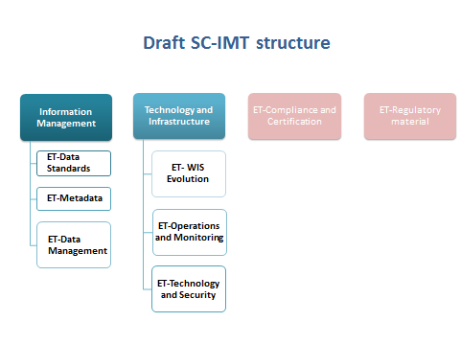

The standing committee is divided in two areas:
- Information Management. Concerning the all information life cycle (create, share, use, preserve, dispose) and including data standards and metadata to enable findability, accessibility, interoperability and re-usability of data. Three teams are included in this area working on data standards (BUFR, GRIB, XML, netCDF-CF), metadata (WIS and WIGOS metadata), data management (with focus on data rescue)
- Technology and Infrastructure. Concerning the technology and infrastructure required to effectively exchange and share data and information in WIS, including
  - monitoring of the current operational activities, effectiveness and compliance, and
  - monitoring of new technologies and gathering of Members needs and requirements to plan for the evolution of WIS.
Three teams are part of this area: operations and monitoring, technology and security, WIS evolution.
The expert team on regulatory material is covering the need for an editorial board overlooking the harmonisation of the regulatory material produced by the other teams.
The expert team on compliance and certification is managed by SC-IMT, but it is serving the needs of other SCs and working at INFCOM level.

