  World Meteorological Organization  COMMISSION FOR BASIC SYSTEMS  Expert Team on WIS Centres  13-17 November 2017, Geneva | ET-WISC2017/Doc-7.3.1
Submitted by:
Ján Osuský
14.11.2017

Report from task team on wis UI
The Joint Meeting of the ET-WISC TT-GISC in Melbourne, April 2016 reviewed report from CGMS about WIS usability and created a task team to investigate the issue further [1]. This document summarises findings related to WIS web user interfaces - the UI for searching (discovery) and the UI for metadata editing.

user interface for searching
- Search criteria
The WIS Manual (WMO publication 1060) in chapter 8.2 currently gives a minimal list of "indexed metadata attributes" which shall be available for query definition and divides these into 3 groups:
  - text-based searches
i. subject, ii. abstract, iii. title, iv. author, v. keywords, vi. format, vii. identifier, viii. type, ix. crs (coordinate reference system)
  - date-based searches
i. creationDate, ii. modificationDate, iii. publicationDate, iv. beginningDate,v. endingDate
  - geographic search
i. bounding box (specified in decimal degrees, north, west, south and east)
This is fairly comprehensible list but the WIS manual does not give any more details. Thus if a GISC implements UI (User Interface) which allows to select exactly one of the above mentioned types of search and enter exactly one word (or number) to look for (e.g. "'wind' in subject" or “'BUFR' in format" without being able to relate this two criteria) it would meet the requirement. This is not what users expect and most probably not what was meant there.
We suggest to provide a clarification which says that users shall be able to freely combine all above mentioned searches as logical "AND", i.e. to search for product with 'wind' in subject AND 'BUFR' format. In extreme case the user should be able to define 15 criteria at once (9 for text fields + 5 for date fields + 1 bounding box or point) and get list containing only such products that satisfy all of them. Of course, we should emphasise that more advanced search criteria definition is welcome - use of OR, NOT etc. User friendliness of the query definition is understood.
- Browsing
The report from CGMS [2] calls for "search by browse category as demonstrated by some interfaces such as Beijing". Several GISCs abandoned this feature for good reasons (to laborious maintenance). We tried several times to evaluate the browsing provided by GISC Beijing but unfortunately it was not working. The concept, if it works well, can help to newcomers. Moreover, it can make the WIS catalogue more search engine friendly. Our tests to find DAR record (description of a particular meteorological product) through google failed. Our DAR metadata are well hidden behind our GISC portals.
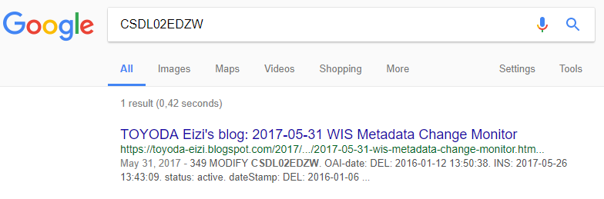
Search for a product identifier or its part should ideally produce a list starting with links to the 15 GISCs and then possibly some other pages. In fact Google found exactly one page which refers to CSDL02EDZW. Bing found none.
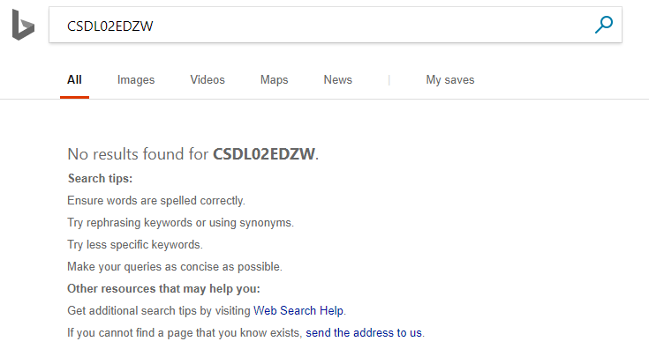
- Ranking (ordering) of matching products
Example of reasonable looking ordering
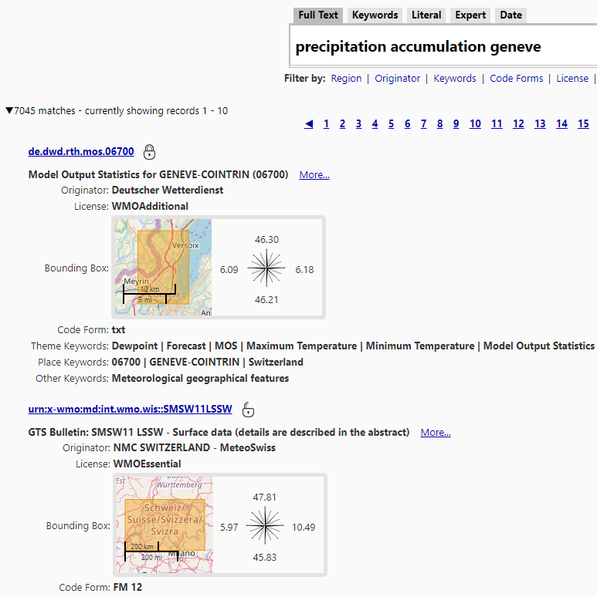

Example of ordering which is counterintuitive
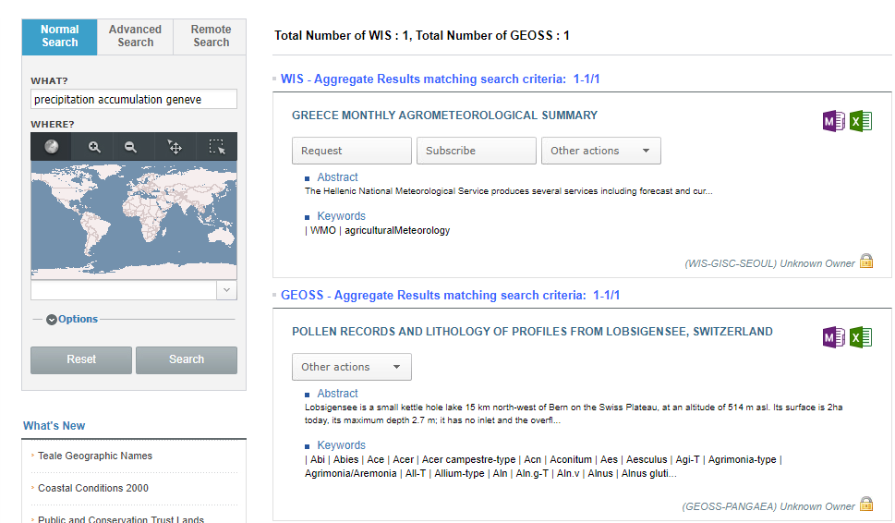

It is not clear if we could define (and get accepted by all GISCs) a ranking formula but I believe that we could:
  - either agree on giving user possibility to define weight for each criteria (with some meaningful defaults); or
  - agree on basic principles like "a match in title weights more than a match in the abstract", "bounding box overlap of 90% is worth more than 5% overlap"

- Presentation of results
Example of result list which is too brief
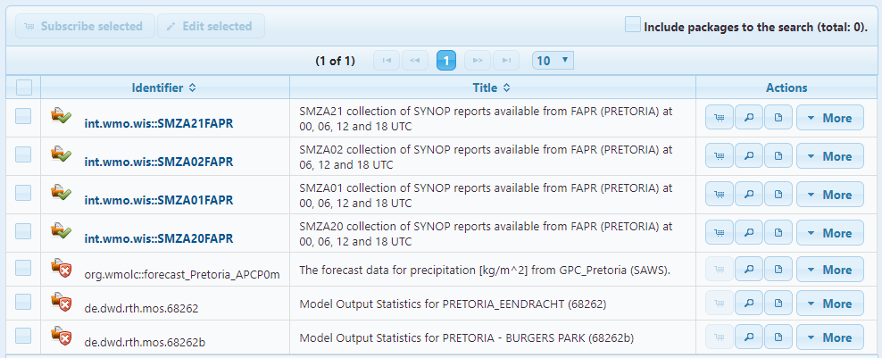
The report from CGMS [2] describes the issue quite well. We propose that the list of matching products (i.e. search result page) shall at least contain following elements for each product:
- title
- abstract (truncated if too long)
- data originator
- license
- data format (Code Form)
- bounding box (preferably as map)

- Access to data
Actual access to the data (product instances) is quite straight forward on all GISCs however we shall emphasise that WIS portals shall not pose any arbitrary obstacles to data distribution. Of course, subscription or other advanced forms of delivery require additional steps (FTP access configuration, file format definition) but these may frighten new or irregular users. Therefore, simple ("single click") download shall be always available at least for the essential data.
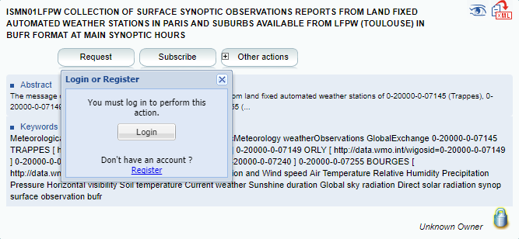

User interface for metadata editing
- Editors for experts only?
The quality of the metadata (product description) is a key factor in the usefulness of the WIS DAR catalogue. It is essential to get each new product described when it appears and update the description when the product changes. We need to bring the editing functionality to the hands of each data producer – this means to a relatively large number of users. We require them to have “metadata knowledge” but the praxis shows that those people have only “data knowledge”. In fact they are scared of XML, GML, ISO-19115, Core profile and all that jargon. Their expertise is elsewhere and trainings efforts are often ineffective. We believe that user-friendliness of the metadata editors became equally important as the user-friendliness of the search UI.
Two examples of metadata editors
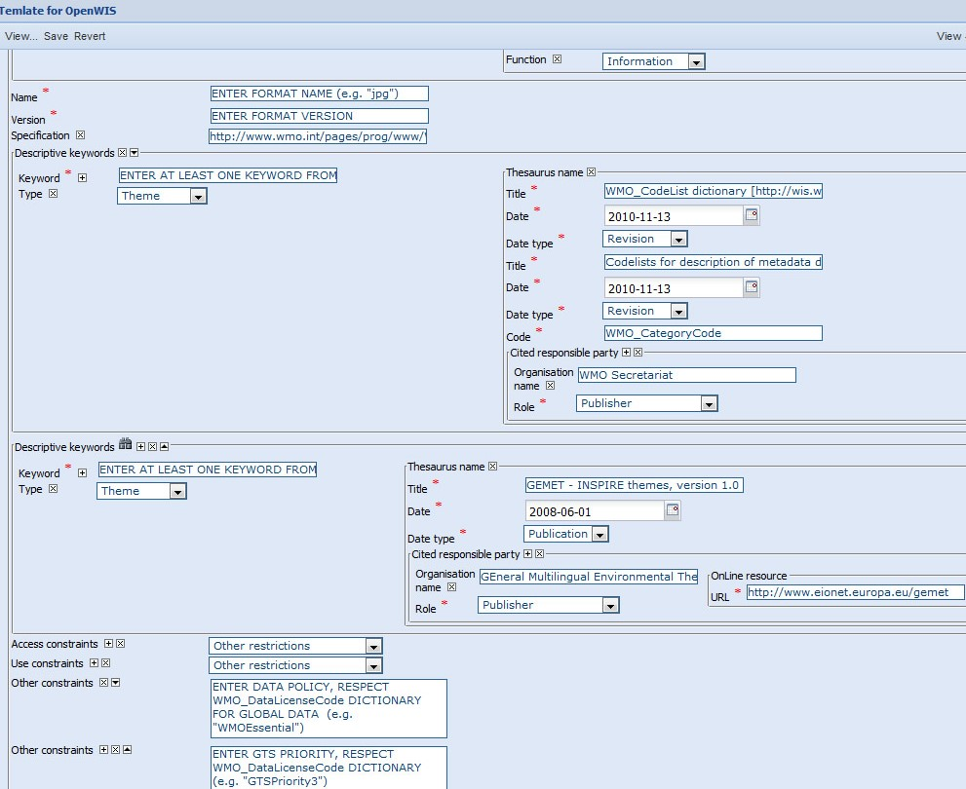
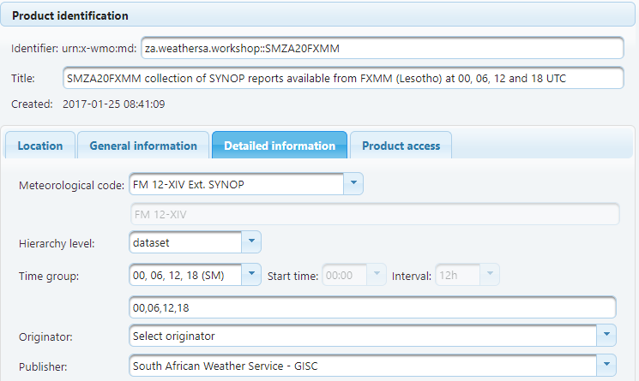
  - The basic principles for the metadata editor UI:
    - Names of fields to be filled by the user shall be in plain language with explanatory tooltip or other documentation of the expected input and its meaning.
    - Layout of the UI should not be governed by the underlying data model but by human understandable logical grouping.
    - User should not be required to repeatedly enter information common for all her/his products such as Organization (data provider) name.
    - Values which are from a controlled vocabulary or otherwise restricted set of values (enumeration) should not be edited in plain text field but rather in a combobox or similar selection widget.

Controversies
The slow uptake of WIS is at least partially caused by the fact that WIS addressed the real problems but not from the perspective of the real users. After 10 years we started to discuss UI issues and we still do not even collect relevant usage data to be able to improve it. We focused too much on creating “search portals” – something which is not in our area of expertise. Perhaps we should concentrate more on defining data formats and protocols (APIs) to publish domain specific data and metadata - and let third parties to build appealing presentation layer (in broad sense).
In past I advocated for improvements of the search algorithms, ranking etc. to get relevant results out of poor (meta)data. I still believe that a good algorithm can find a needle in a hay stack but I doubt that we, WMO experts, should be the ones to design them. Instead I think that we should offer simple services to access the metadata and concentrate on improving its quality and readability.

References
[1] wis.wmo.int/file=2507 (Nov 10, 2017)
[2] CGMS WIS usability report. http://www.cgms-info.org/documents/CGMS-TFMI-WMO-WIS-Portal-Usability-Report.pdf (March 18, 2016)

Recommended Text
- ET-WISC agreed to explore further the possibility to get DAR metadata indexed by search engines (make global catalogue search engine friendly) to make WIS truly discoverable by non-WIS experts. It would be nice to combine it with “by browse category” functionality but is it proves unfeasible then the two should be explored separately.
- ET-WISC agreed to add clarification on support for search criteria that combine multiple search terms to the manual on WIS.
- ET-WISC agreed to specify in the manual on WIS that the list of matching products (search result), as presented by GISC UI to the end user, must contain at least following elements for each product: title, abstract (truncated if too long), data originator, license, data format (Code Form), bounding box (preferably as map).
- ET-WISC noted that download shall be always available for the essential data and requested all GISCs and DCPCs to double check that their user interface allows it.
- ET-WISC agreed to further analyse usability issues of the metadata editors and create set of recommendations to make them usable by non-metadata-experts.

____________

