  World Meteorological Organization  COMMISSION FOR BASIC SYSTEMS  Task Team GISC  13-17 November 2017, Geneva | TT-GISC2017/Doc -4.1.7
Submitted by:
Weiqing Qu
09.11.2017

GISC Melbourne Status Report
- Area of Responsibility
  - AMDCN connectivity
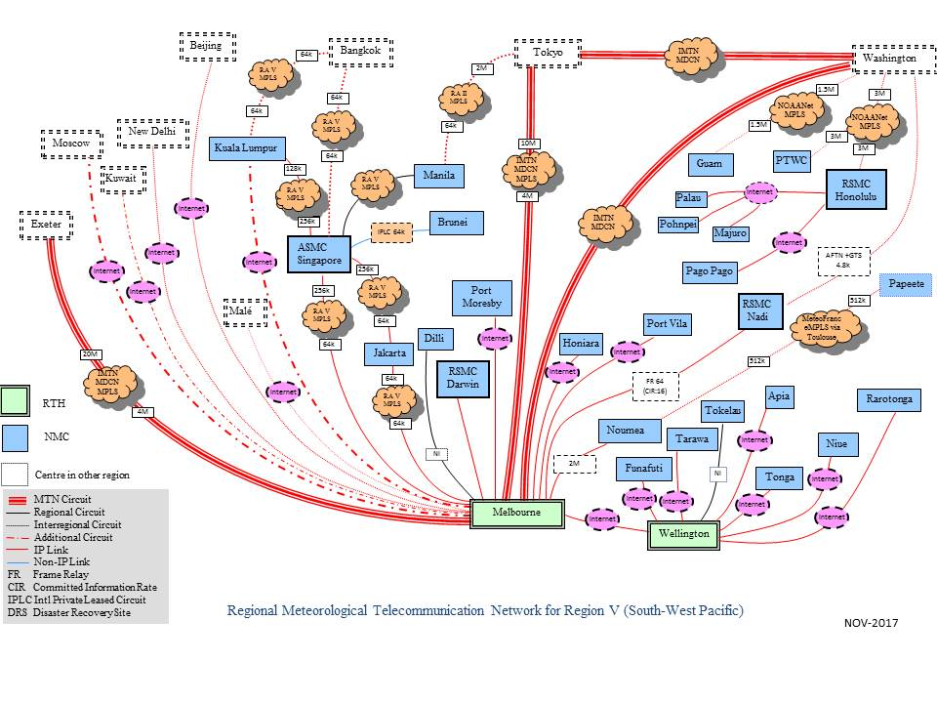
  - DCs WIS compliance

- Training – Capacity building activity
  - RA V WIS Training Workshop 2013
  - On-site WIS training for Pacific Islands Countries 2013/14
  - Some RA V countries (Indonesia, Philippines) participated RA II WIS training workshop in JMA. BoM provided the training on WIS Monitoring to this workshop on the request of JMA.
- Operational issues in last period
  - No operational issues.
- GISC Back up and activities
  - GISC backup with JMA in progress. Backup proposal has been made and discussed. Working on backup procedures.
- Monitoring Activity & volume
  - Cache volume: ~1.8G/day (GTS input)
  - Data dissemination: ~ 6G/day
  - Uptime: 99.99%
  - Active user registration: 30 (WIS system only, excluding MSS, FTP users)
- Changes in GISC, including new features since last meeting
  - A major OpenWIS system upgrade carried out in October 2017.
- Progress on action items

- Outlook (planned changes/improvements)
  - Scheduled maintenance only.
  - Link to Fiji will change from Frame Relay to the internet.
  - Link to Manila will be established in form of VPN via internet.
- Any other issues of interest
  - None
- Summary (Text for report)
WIS/GTS operation of GISC Melbourne and centres in its AoR has been functioning as expected.

