  World Meteorological Organization  COMMISSION FOR BASIC SYSTEMS  Task Team GISC  13-17 November 2017, Geneva | TT-GISC2017/Doc -XX
Submitted by:
Shigeharu NISHIKAWA
13.11.2017

WCD development and demonstration status (WP1)

Summary
“JSON Message Specifications and Guidelines” was published and participating GISCs has been providing JSON files. CMA, and JMA cooperation with INMET were completed to develop WIS Common Dashboard (WCD) and have been providing their WCD as demonstration. The working package 1 of WIS Monitoring Project Team was successfully completed.

History

Sep 2014, CBS-Ext
CBS-Ext encouraged ICT-ISS to proceed with a pilot implementation so that the interim guidance can be tested and updated with the aim of producing a standard practice for inclusion in Guide to WIS (WMO-No. 1061) at CBS‑16.

April 2015, Established “WIS Monitoring Project Team”

Mar 2015, Remy Giraud and Weiqing Qu take the lead.
Project team was divided into 3 working packages:
- wp1 : Development (JSON format & Dashboard) Lead:JMA
- wp2 : GISC requirement
- wp3 : DCPC/NC requirement
Project team wp1 worked on pilot having Web and face-2-face meetings. June 2015, Demonstration at Cg-17

June 2016, CG17, WIS monitoring demonstration.
- GISC Casablanca and GISC Tokyo demonstrated WIS monitoring at the side event of CG17.

Nov 2016, CBS-16, Decision 26 adopted.

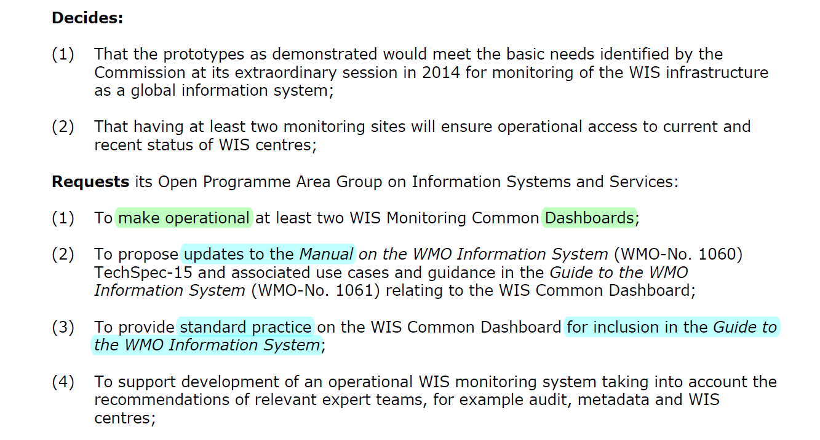
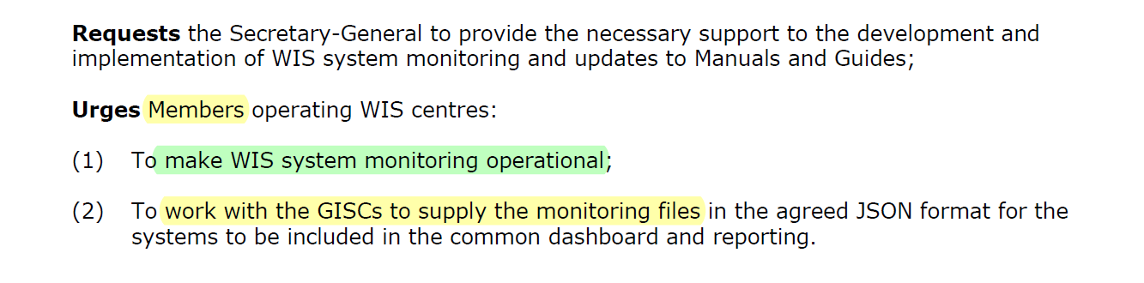

Nov 2016, WCD was demonstrated.
GISC Beijing, GISC Brasilia, and GISC Tokyo introduced and explained their WCD at the side event of CBS-16.

Current status OF JMA
JMA had finished developing the WCD (for demonstrating) and now providing it on following URL:
- JMA’s WCD http://www.wis-jma.go.jp/wcd/v1/top.html
Toward operational stage of WIS monitoring, JMA is ready to provide this WCD (as is) to users as “WIS Common Dashboard Centre”, if other GISCs does not provide WCD.

Keys from now on
It will be so difficult to arrange and develop to expand WIS monitoring to DCPC’s and NC’s more than ever. So before we start, we have to remind initial purpose of WIS monitoring, why we monitor our operation / how to use this monitoring result to improve WIS operation.

Interim guidance
- should be updated based on the previous pilot.
- should be used for inclusion WIS Guide and Manual.

Procedure for moving toward operation
- CBS-16 decides to have at least 2 dashboards, not specifying CMA’s and JMA’s.

How to operate
Dashboards are ready. But, how do we utilize it for improving WIS operation?

DCPC monitoring, NC monitoring
After updating the interim guidance in which requirements of DCPC and NC are mixed up.
- NC monitoring
Data-receiving-at-GISC information has been implemented already.
Data-sending-at-NC information would be the other target to work on.
- DCPC monitoring
Requirement should be clearly defined based on need of DCPCs collectively.

References
- WIS-Monitoring
https://wiswiki.wmo.int/tiki-index.php?page=WIS-Monitoring
- WIS-Status (Link to WCDs)
https://wiswiki.wmo.int/tiki-index.php?page=WIS-Status
- (Link to) Interim Guide
https://wiswiki.wmo.int/tiki-index.php?page=wis-monitor
- JSON Message Specifications and Guidelines
ET-WISC-Doc09

Recommended Text
Mr Shigeharu NISHIKAWA, JMA reported the history of development of WIS Monitoring Pilot Team briefly. He also reported that JSON format of WIS monitoring was published and some GISCs have been providing JSON files. And also CMA and JMA have been providing WCD as demonstration. So WP1 were successfully completed. He explained JMA’s current status that JMA is ready to provide WCD as “WIS Common Dashboard Centre” toward operation of WIS Monitoring.

