  World Meteorological Organization  COMMISSION FOR BASIC SYSTEMS  Task Team GISC  13-17 November 2017, Geneva | TT-GISC2017/Doc -XX
Submitted by:
Kai WIRT
03.11.2017

Status Report GISC Offenbach

Introduction

GISC Offenbach covers an Area of Responsibility (AoR) of 27 countries. All NCs and DCPCs send the data for global exchange to GISC Offenbach and to both Backup GISC Moscow and Tokyo. Details on Backup Topics are given below.

GISC Offenbach is connected to the internet via two ISPs with an overall bandwidth of 7.5GB/s as well as a backup access point in Berlin. GISC Offenbach is also connected to the RMDCN. Connection details for GISC – GISC traffic are given in EDZW_network.xlsx

GISC Offenbach is harvesting the following metadata sets:
GISC | Metadata set
Melbourne | WIS-GISC-MELBOURNE
Beijing | WIS-GISC-BEIJING
Brasilia | WIS-GISC-BRASILIA
Tehran | WIS-GISC-TEHRAN
Tokyo | WIS-GISC-TOKYO, WIS-CATALOGUE
Seoul | WIS-GISC-SEOUL
Toulouse | WIS-GISC-TOULOUSE
Jeddah | WIS-GISC-JEDDAH
Moscow | WIS-GISC-MOSCOW
Exeter | WIS-GISC-EXETER
Casablanca (test status) | WIS-GISC-CASABLANCA

Area of responsibility

AMDCN Connectivity

Connection details for GISC Offenbachs AoR are given in EDZW-AMDCN_network.xlsx

DCs WIS Compliance

-

Training – Capacity building activity

In 2017 GISC Offenbach mainly is focussing to provide internal training for DWD staff as well as to provide expertise to users of GISC Offenbach. Secondly we are seeking for suggestions for improvements from our users in order to further improve the usability of our WIS portal and to facilitate the self-management-capabilities of subscriptions with GISC Offenbach.

Operational issues in last period

DWD upgraded its mss system in November 2017.

GISC Back up and activities

All members of the GISC Offenbach AoR are invited to perform quarterly Backup-Test where the completeness of the backup is checked. These tests are considered valuable.
JMA and DWD are currently working on completing the full backup-set. From DWDs AoR there are three countries missing in Backup Tokyo (while they are already backup-ed at Backup Moscow)

Monitoring Activity & volume

GISC Offenbach is monitoring the status of the harvested metadata sets mentioned above.

Traffic size and volumes, uptime etc, user registration

GISC Offenbach has 358 registered users (NCs, DCPCs, GISCs as well as public or other organisations)

Uptime for data transfer has been 100% in 2017
The portal has been offline for 3 days for the update in 2017. This however had no impact on operations.

The data volumes transferred are given in the figures below. The decrease in number of files in February 2016 and April 2017 was caused by model changes in DWD’s NWP.
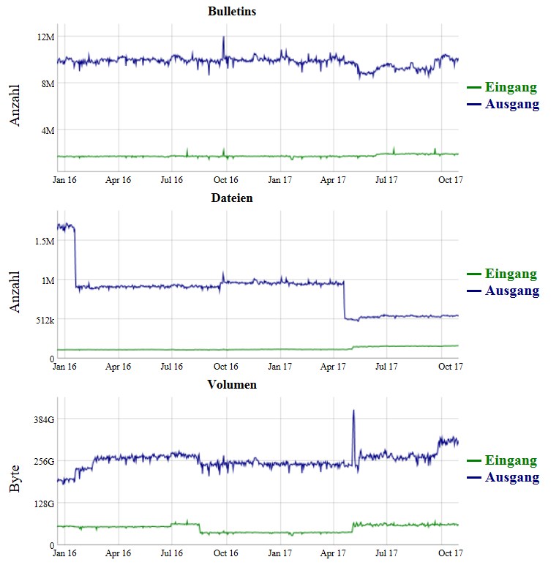

Changes in GISC, including new features since last meeting

DWD updated its GISC Software in 08/2017. The update mainly incorporated bug fixes and improvements in self-service-subscriptions. With this update DWD is now able to provide http staging as data delivery method (besides GTS messaging, ftp and eMail).

Progress on action items

-

Outlook (planned changes/improvements)

DWD is working to further improve the usability of its WIS portal. A planned feature will be the preview of data in the search results page in the portal.

DWD also is working on direct connections with GISC Washington and GISC Casablanca.

Any other issues of interest

In 2017 DWD became accepted as Global-Production-Center for Long-Range-Forecasts (GPC-LRF).
DWD nominated new Focal Points for RTH and WIS (Thorsten BÜßELBERG, Kai WIRT)
Estonia nominated Offenbach as principal GISC

Summary (Text for report)

GISC Offenbach covers an Area of Responsibility (AoR) of 27 countries. All NCs and DCPCs send the data for global exchange to GISC Offenbach and to both Backup GISC Moscow and Tokyo.
In 2017 DWD became accepted as Global-Production-Center for Long-Range-Forecasts (GPC-LRF).
DWD nominated new Focal Points for RTH and WIS (Thorsten BÜßELBERG, Kai WIRT)

