  World Meteorological Organization  COMMISSION FOR BASIC SYSTEMS  Expert Team on Communication Techniques and Systems  13-17 November 2017, Geneva | ET-CTS2017/Doc -5.1(1)
Submitted by:
Secretariat
07.11.2017

Clarifying technical regulation relating to gisc-gisc connectivity

Introduction
The RMDCN (Regional Meteorological Data Communication Network) , procured from Interoute and managed by ECMWF, is the Regional Telecommunication Network for RA VI and forms part of the WIS Core Network. It connects 55 WIS Centres world-wide.

There is a common understanding that the RMDCN service shall be used to implement the WIS Core Network in its entirety; e.g. that all GISCs shall be connected to RMDCN.

After several years of extensive effort, two GISCs remain disconnected from RMDCN (GISC Brasilia, GISC Tehran) and the connection with one GISC will be terminated in December 2017 in favour of Internet-based connectivity (GISC Washington).

This paper provides excerpts from statements of Executive Council, Regional Association VI and technical regulations pertaining to the WIS Core Network in an attempt to clarify the provisions with which Members operating GISCs must comply.

Statements from Executive Council

Sixty fifth session of Executive Council

Resolution 13 (EC-65) Amendments to the Manual on the WMO Information System (WMO-No. 1060)
Requests all operational GISCs to connect to the WIS core network and transmit information
collected from their area to all other operational GISCs;

Sixty sixth session of Executive Council

Cooperation in telecommunication systems
4.4.52 The Council appreciated the leading role played by ECMWF in managing the introduction of the Next Generation RMDCN that, as well as providing the Region VI telecommunications network, will provide the WIS Core Network connecting all GISCs. […]

Statements from Regional Association VI

Twelfth session of Regional Association VI (May 1998, Tel Aviv, Israel)

Proposed Regional Meteorological Data Communication Network (RMDCN)
4.3.9 [The Association] expressed its appreciation for the cooperation and contribution provided by the ECMWF. Considering the overlap between RA VI meteorological data communication requirements and the ECMWF requirements and noting that Member States of ECMWF were also Members of RA VI, the Steering Group recommended a common meteorological data communication network to meet the combined requirements. […]

…

4.3.17 In view of the above, the Association adopted Resolution 4 (XII-RA VI) […]

Resolution 4 (XII-RA VI) Regional Meteorological Data Communication Network (RMDCN)

...

Agrees […] WMO and ECMWF recognize that the RMDCN will be part of the Global Telecommunication System (GTS) or the World Weather Watch as regards RA VI telecommunications requirements. […]

Technical regulation

Manual on GTS (WMO-No. 386)

Part I. Organization of the Global Telecommunication System
Note: changes as proposed in Annex 2 to Recommendation 18 (CBS-16)

1. Functions, Organization and principles of the Global Telecommunication System
1.1 Functions
The functions of the Global Telecommunication System (GTS) as a key component within the WMO information system shall be to facilitate the flow of data and processed products to meet the WWW requirements in a timely, reliable and cost effective way, ensuring that all Members have access to data and products in accordance with approved procedures and within the limits of the agreed WWW system.

Note: It also gives telecommunication support to other programmes as a part of WIS and as decided by the WMO Congress or the Executive Council, within the limits of its primary objectives.

…

1.2 Organizational principles of the GTS
1.2.1 The Global Telecommunication System shall be so organized as to accommodate the volume of meteorological information and its transmission within the required time limits as the core network of WIS and to meet the needs of World, Regional Specialized and National Meteorological Centres, resulting from the implementation of the WWW.

1.2.2 The GTS shall be organized on a three-level basis, namely:
- The Main Telecommunication Network (MTN), linking together the WMCs as well as designated Regional Telecommunication Hubs (RTHs).
- […]
- […]

Note: The components of the MTN connecting the WIS Global Information System Centres is also referred to as the WIS Core Network (See the Manual on the WMO Information System WMO-No. 1060)

…

3. Functions and characteristics of the networks of the Global Telecommunication System
3.1.1 The MTN shall be an integrated system of circuits linking together the GISCs on the WIS Core Network WMCs and designated RTHs. The circuits which directly link WMCs and/or RTHs situated on the MTN may, at the request of Members concerned, be designated as circuits of the MTN.

Attachment I-2. Configuration of the Main Telecommunication Network
Note: updated as proposed in Annex 2 to Recommendation 18 (CBS-16). EC-69 raised concerns over regarding the routeing from RTH Tashkent to GISC Seoul, resulting in Annex 2 to Recommendation 18 (CBS-16) being referred back to CBS. Also note that this WIS routeing diagram shows only the RTH-GISC routeing and does not include GISC-GISC routeing.

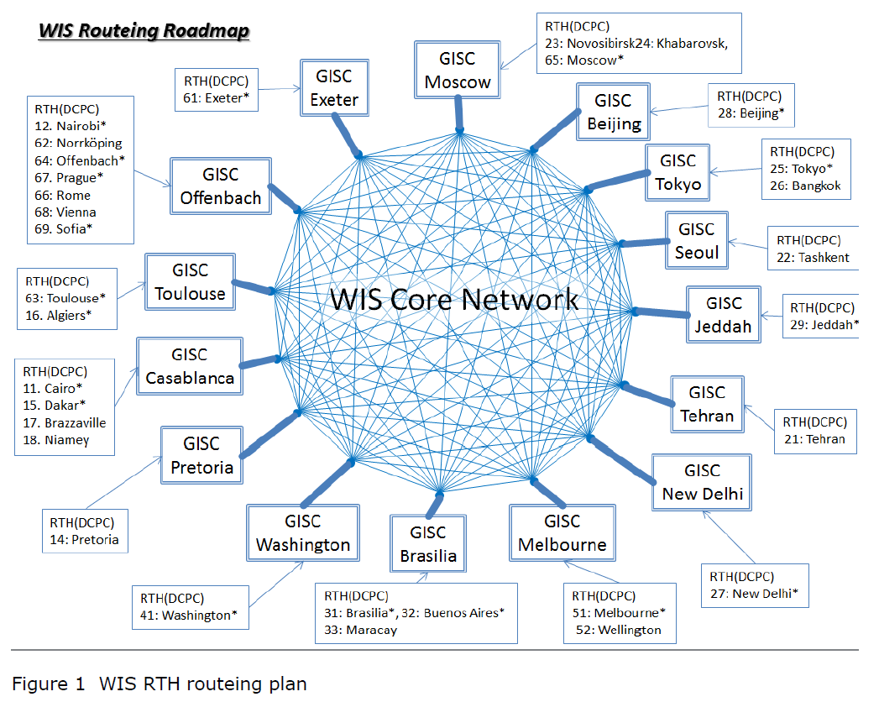

Attachment II-15. Recommended practices and procedures for the implementation, use and application of TCP/IP on the GTS
Note: although Attachment II-15 does not relate to GISC-GISC connectivity, it is relevant when assessing how GISCs transfer data files.

Relationship of the Internet and GTS
The Internet has grown rapidly in capacity, penetration and diversity of applications. Its bandwidth greatly exceeds that of the GTS and it could potentially take over some functions of the GTS. Although day-to-day performance of the Internet used to be a recognized weakness, recent experience shows that in many countries its reliability has reached acceptable levels. It should be noted, however, that the very nature of the Internet will always mean that no one can build a system using the Internet for which specific service levels can be guaranteed. The Internet is the result of the amalgamation of numerous telecommunication systems, for which no operator has complete responsibility.

It is therefore recognized that the Internet can be used:
- As an underlying technology for some components of the GTS in special conditions;
- As a backup to the GTS;
- As a complement to the GTS.

GTS Data Exchange Methods
FTP and SFTP are the two data exchange methods that can be used on the GTS.

Centres are encouraged to choose FTP or SFTP by bilateral agreement. The SFTP is to be preferred on the Internet.

Manual on WIS (WMO-No. 1060)

Part I. Organization and responsibilities

1.3 Interaction among WIS Centres
GISCs shall connect to other GISCs through the WIS Core Network, which is based on the Main Telecommunication Network (MTN). […]

…

1.7 Collection and dissemination services
1.7.2 WIS shall support the WMO virtual all-hazards network, thus ensuring the fast, secure and reliable exchange of alert and warning information […].

…

1.7.3 [The WMO Integrated Global Data Dissemination Service (IGDDS)] shall remain an important component of WIS, mainly for the exchange and dissemination of data and products generated by space-based observing systems.

Part III. Functions of WIS

3.5.3 Exchange information with other GISCs
3.5.3.2 GISCs should employ the MTN and associated collaborative mechanisms to exchange the information efficiently and without detriment to the performance of any GISC.

3.5.7 Data network connectivity of a GISC
Each GISC shall provide around-the-clock connectivity to the public and dedicated communication networks at a capacity that is sufficient to meet its global, regional and AMDCN responsibilities. Each GISC should ensure that every telecommunication facility it employs in support of WIS has the appropriate level of availability and capacity, including, as necessary, routing and back-up arrangements. Each GISC should maintain service level agreements with the suppliers of its communication links and associated hardware.

3.5.8 Coordinate telecommunications in a GISC area
Each GISC shall coordinate with the Centres in its area of responsibility to maintain a WIS telecommunications infrastructure that can meet the WIS requirements for information exchange within the area. In the case of particular global and/or regional agreements, a GISC could also support the exchange of agreed WIS time- and operation-critical information with other AMDCNs. The telecommunications infrastructure shall be implemented through various technologies and services (for example, the Internet, satellite-based data distribution, dedicated data networks) in accordance with capacity and reliability requirements.

Part IV. WIS Technical Specifications

4.4 WIS‑TECHSPEC‑3: Centralization of globally distributed data

4.4.2 Warnings shall be transmitted end-to-end within WIS within two minutes.

Guide to Virtual Private Networks (VPN) via the Internet between GTS Centres (WMO-No. 1116)
Note: changes as proposed in Annex 5 to Recommendation 18 (CBS-16)

4.2 A quick view of the Global Telecommunication System (GTS)

4.2.1 Physical layers
The current GTS is a mix of various technical solutions:
- […]
- An MPLS network such as the RMDCN (as WIS core network) in Region VI is such a network
- Connections using the Internet
- Satellite communication channels

Guide to WIS (WMO-No. 1061)

Part I. Organization and responsibilities

1.3 Interaction among WIS Centres
As required by the Manual on WIS, 1.3, GISCs shall connect to each other through the WIS Core Network. […]

…

1.7 Collection and dissemination services
1.7.3 In addition to satellite‑based data and products, IGDDS should distribute a basic subset of the information intended for global exchange.

Part IV. WIS Technical Specifications

4.2 WIS‑TECHSPEC‑1: Uploading of metadata for data and products
4.2.4 Additional notes
[…] metadata uploaded to a GISC could take up to 24 hours to be synchronized across all GISCs.

4.4 WIS‑TECHSPEC‑3: Centralization of globally distributed data
4.4.4 Additional notes
4.4.4.2 Although the cache of data and products intended for global exchange is required to be current across all GISCs to within 15 minutes, warnings must be current to within two minutes.

Discussion

Historical evolution of WMO global telecommunication

Resolution 4 (XII-RA VI) (May 1998, Tel Aviv, Israel) established the RMDCN as the Regional Telecommunication Network for RA VI.

The original concept of WIS, as endorsed by Cg-XIV, states that WIS will “build on GTS for highly reliable delivery of time-critical data and products and base its core communication network on the IMTN”.

The fourteenth session of the Commission for Basic Systems (CBS-XIV) noted in relation to the Improved MTN project (IMTN) that the “Commission noted that the Improved MTN project (IMTN) implementation had facilitated a progressive and rapid implementation of effective and reliable data-communication network services for the core GTS services towards the core network for WIS.” (para §6.2.18). It also noted that Network I (“Cloud I”) was still using Frame Relay services and that the current contract was due to expire in December 2009, requiring new contractual arrangements (para §6.2.19). In contrast Network II (“Cloud II”) was implemented through the extension of the RMDCN, which had successfully migrated to MPLS-based IPVPN in June 2007, leading to improved cost effectiveness and decisions from RTH Melbourne and RTH Washington to join IMTN Network II (para §6.2.20).

As illustrated in the report on the status of the IMTN provided to ET-CTS2008 (see Figure 3), Beijing, Exeter, Jeddah, Moscow, New Delhi, Offenbach, Tokyo and Toulouse were already connected to IMTN Network II. With the addition of Melbourne and Washington, this made 10 of the 15 current GISCs connected to the IMTN Network II (e.g. the RMDCN).

CBS-XIV also noted that, in relation to the WIS Core Network, the “requirements for the core network are predictability and stability in available throughput (bandwidth and network latency), reliability for continuous operation on 24 x 7 basis without interruption and security against malicious attacks such as intrusion, denial of service, tampering, spoofing and snooping” (para §6.2.16), and consequently that the “Commission agreed that the Improved MTN should evolve into the core WIS network” (para §6.2.17).

So the IMTN became the WIS Core Network. Given the existing connectivity within the RMDCN, the assumption was made that the WIS Core Network would be implemented as part of the RMDCN. Paragraph 4.4.52 of the proceedings from the sixty sixth session of Executive Council states that the “[Executive] Council appreciated the leading role played by ECMWF in managing the introduction of the Next Generation RMDCN that […] will provide the WIS Core Network connecting all GISCs”.

The memorandum of agreement between ECMWF and WMO was updated to include the WIS Core Network in the RMDCN service. However, as of today, the RMDCN service still forms only a part of the WIS Core Network (see ECMWF Website for further details), with some GISCs being connected via other means such as the Internet.

However, after several years of extensive effort, two GISCs remain disconnected from RMDCN (GISC Brasilia, GISC Tehran) and the connection with one GISC will be terminated in December 2017 in favour of Internet-based connectivity (GISC Washington).

Definition and description of WIS Core Network and GISC-GISC data routeing

Manual on WIS (WMO-No. 1060) Part I. 1.3 states that “GISCs shall connect to each other through the WIS Core Network”. This statement is ambiguous in that some read it is “all GISCs connect to all other GISCs through the WIS Core Network”, whereas others may read it as “any connection between GISCs shall use the WIS Core Network”.

Resolution 13 (EC-65) asserts that all operational GISCs must connect to the WIS core network and transmit data from their area to all other operational GISCs. However, the WIS core network is described as the “components of the MTN connecting the WIS Global Information System Centres” and the MTN is described as “an integrated system of circuits linking together the GISCs on the WIS Core Network and designated RTHs” (Manual on GTS WMO-No. 386, Part I. 1.2.2 ‘Note’ and Part 3. 3.1.1).

From these descriptions, there is no definitive statement that the WIS Core Network must be a single [manged] network, such as provided by the RMDCN service.

Manual on WIS (WMO-No. 1060) Part III. 3.5.3.2 states that GISCs should employ the MTN and associated collaborative mechanisms to exchange information efficiently. There is no prescriptive statement about how this must be done.

Furthermore, Resolution 13 (EC-65) asserts that GISCs must transmit their data to all other GISCs. The current method to achieve this data transmission is by GTS routeing; using other WIS Centres to relay messages as required. There is no statement indicating that each GISC must directly route data to all other GISCs.

ET-CTS are invited to consider whether technical regulation should be amended; e.g. to prescribe how GISC interconnectivity is achieved or to require direct transmission of data between all GISCs without relying on intermediate centres to relay those messages.

Performance criteria approach (Service Level Agreements)

The critical concern is one of timeliness. Manual on WIS (WMO-No. 1060) Part IV. 4.4.2 states that warnings shall be transmitted end-to-end within WIS (e.g. from originating WIS Centre to receiving WIS Centre) within 2-minutes.

The Manual on GTS (WMO-No. 386) Part I. 1.2.1 adds that the GTS shall be so organized as to accommodate the volume of meteorological information and its transmission within the required time limits.

Ensuring that warnings are transmitted end-to-end within 2-minutes is a requirement that can only be validated through testing: one is interested in the outcome rather than how that outcome is achieved.

UNESCO IOC IOTWS (Indian Ocean Tsunami Warning System) organizes the Tsunami Communication test every year, monitoring transmission time at Tsunami Warning Centre and the reception time at National Tsunami authority. In this way the real, end-to-end performance of the IOTWS can be verified.

ET-CTS are invited to consider whether the existing technical regulation, in particular the 2-minute end-to-end performance criteria for transmission of warnings, is sufficient.

ET-CTS are invited to consider whether a ‘warning dissemination test’ would be of value in verifying compliance with WIS technical regulation.

Note: the performance of metadata synchronisation between GISCs, exclusively via Internet, using the OAI Sync Monitor provided by Deutscher Wetterdienst.

Use of the Internet for operational data exchange
Manual on GTS (WMO-No. 386), Attachment II-15 Table 1 defines the categories of usage for the GTS (e.g. using managed networks such as the MTN) and the Internet:
- GTS: Delivery of time-critical communication for weather, water and climate operations
- Internet: Communication for less critical requirements and possibly for large volumes of data
Furthermore, the Manual on WIS (WMO-No. 1060) Part I. 1.3 states that “GISCs shall connect to each other through the WIS Core Network”. Given the definitions of the WIS Core Network given above, Internet-based connections do not appear to be consider part of the WIS Core Network / MTN.

ET-CTS are invited to consider whether technical regulation needs to be updated in light of current Internet-based connectivity between GISCs(e.g. GISC Washington, GISC Jeddah).

Recommended Text
[Include here suggested text for inclusion in Report, including any proposed amendments to the Manual or Guide to WIS, Manual on GTS, Manual on Codes or guides.]
____________

Annex 2 to Recommendation 18 (CBS-16) was referred back to CBS by EC-69 to clarify some concerns about RTH routeing (Attachment I-2 Figure 1 and Attachment I-3 Figure 2).
An excerpt from the proceedings of Cg-XIV pertaining to the approval of WIS is provided here: https://wis.wmo.int/page=TT-eWIS%3AWIS-approval-CgXIV-3.1.2
IMTN Network I was provided by BT Ignite
IMTN Network II was provided by Orange Business Services “OBS”, formerly EQUANT
http://www.wmo.int/pages/prog/www/ISS/Meetings/ET-CTS_Toulouse2008/documents/StatusIMTN.doc
https://www.ecmwf.int/en/computing/our-facilities/rmdcn
http://oai-test.dwd.de/oaimonitorgui/#complete

