The Scientific Data Stewardship Maturity Assessment Model Template
Template Version: NCDC-CICS-SMM-0001-Rev.1 v4.0 06/23/2015
Steps for carrying out a self- evaluation of data stewardship maturity of a dataset:
- Download the latest NCEI/CICSNC Scientific Data Stewardship Maturity Matrix (SMM) template file from http://tinyurl.com/DSMMtemplate
- Go over the whole file and read the disclaimer carefully before using the template
- Enter dataset and relevant Point-Of-Contacts (POCs) information in the SMM metadata section
- Read the content of SMM, if in question,
- Review the scope and rationale for each key component of the matrix including examples of community-accepted best practices and standards provided in Peng et al. (2015) – doi:10.2481/dsj.14-049
- Review high-level background information on scientific data stewardship maturity matrix at http://tinyurl.com/DSMMintro
- Go through each key component, identify the stewardship practices applied to the dataset, and document your rating and justifications
- Obtain any additional information if necessary from data, scientific, or tech stewards
- Review the results and fill in the matrix cells with the defined color scheme (provided in Table I)
- Capture the assessment results in the SMM metadata section
Assumptions:
- Datasets are digital Earth Sciences data products that are publicly available online.
- Evaluators who use this template have a basic knowledge of or are able to obtain information about conventions or standards relevant to practices examined in each key component in the community that datasets are produced for or/and provided to.
Creative Commons License – Attribution (BY)-NC (Non-Commercial)
Disclaimer: This template is provided “as is” without any representations or warranties, express or implied. NCEI or CICS-NC makes no representations or warranties in relation to this template or the information and materials provided on this template. Use for the template is intended for use as a preliminary stewardship maturity assessment of a dataset, utilizing the latest NCEI/CICS-NC scientific data stewardship maturity matrix. Examples for each key component are provided only to help users to better understand the meaning of the languages used in the matrix. No endorsement or preference is intended.
NCEI or CICS-NC does not warrant that the template will be constantly available or available at all or the information within the template is complete, true, accurate, adequate or non-misleading. NCEI or CICS-NC will not be liable to you (whether under the law of contract, the law of torts or otherwise) in relation to the contents of, or use of, or otherwise in connection with, this temple for any direct loss, for any indirect, special or consequential loss; or for any business losses, loss of revenue, income, profits or anticipated savings, loss of contracts or business relationships, loss of reputation or goodwill, or loss or corruption of information or data. By using this template, you agree that the limitations of liability set out in this template disclaimer are reasonable. If you do not think they are reasonable, you must not use this template.
The layout or/and content of the matrix and template are subject to change any time without notification.
Stewards who carried out their self-evaluations of the stewardship maturity of their datasets are encouraged to document justifications in detail (with URL links if applicable) and make them available to data users at the dataset web sites to allow transparency and feedback from the data users.
Any opinions or recommendations expressed here are those of the people who have carried out the assessment and do not necessarily reflect the views of NCEI or CICS-NC.
Stewardship Maturity Matrix (SMM) as of <MM/DD/YYYY>
for <Dataset Short Name>
Dataset Title
Dataset Information URL
Data Provider POC (Name; E-mail; Affiliation)
Dataset POC (Name; E-mail; Affiliation)
SMM Version (Document ID and Version Number) | NCDC-CICS-SMM_0001_Rev.1 12/09/2014
SMM POC (Name; E-mail; Affiliation) | Ge Peng; Ge.Peng@noaa.gov; Cooperative Institute for Climate and Satellites, North Carolina (CICS-NC), North Carolina State University (NCSU) & NOAA’s National Centers for Environmental Information (NCEI) ¹
SMM Template Version (Document ID and Version Numbers) | NCDC-CICS-SMM_0001_Rev.1 v4.0 06/23/2015
SMM Template POC (Name; E-mail; Affiliation) | Ge Peng; Ge.Peng@noaa.gov; Cooperative Institute for Climate and Satellites, North Carolina (CICS-NC), North Carolina State University (NCSU) & NOAA’s National Centers for Environmental Information (NCEI)
SMM Assessment Version (v<nn>r<mm>, e.g., v01r00)
SMM Assessment Date (MM/DD/YYYY)
SMM Assessment POC (Name; E-mail; Affiliation)
Stewardship Maturity Ratings (each key component)
(kc1/kc2/kc3/kc4/kc5/kc6/kc7/kc8/kc9)
SMM Original Assessment Date (MM/DD/YYYY)
SMM Original Assessment POC (Name; E-mail; Affiliation)
SMM Last Modified Date (MM/DD/YYYY)
SMM Last Modification POC (Name; E-mail; Affiliation)
SMM Modified Date (MM/DD/YYYY) ²
SMM Modification POC (Name; E-mail; Affiliation)
¹ NCEI includes the organizations previously referred to as National Climatic Data Center (NCDC), National Geophysical Data Center (NGDC), and National Oceanographic Data Center (NODC).
² Repeat these last two lines to capture the SMM modification history
Maturity Scale (across) | Level 1  Ad Hoc  Not Managed | Level 2  Minimal  Managed  Limited | Level 3  Intermediate  Managed  Defined, Partially Implemented | Level 4  Advanced  Managed  Well-Defined, Fully Implemented | Level 5  Optimal  Level 4 +  Measured , Controlled , Audit
Key Component (below) |  |  |  |  |  | Stewardship Maturity Rating  And Justification or Evidence |  |  | Comments
Preservability  (The state of being preservable) | Any storage location  Data only | Non-designated repository  Redundancy  Limited archiving metadata | Designated archive  Redundancy  Community-standard archiving metadata  Conforming to limited archiving standards | Level 3 +  Conforming to community archiving standards | Level 4 +  Archiving process performance controlled, measured, and audited  Future archiving standard changes planned | - Level
Accessibility  (The state of being searchable and accessible publicly) | Not publicly available  Person-to-person | Publicly available  Direct file download (e.g., via anonymous FTP server)  Collection/dataset level searchable online | Level 2 +  Non-standard data service  Limited data server performance  Granule/file level searchable  Limited search metrics | Level 3 +  Community-standard data service  Enhanced data server performance  Conforming to community search metrics  Dissemination report metrics defined and implemented internally | Level 4 +  Dissemination reports available online  Future technology and standard changes planned | - Level
Usability  (The state of being easy to use) | Extensive product-specific knowledge required  No documentation online | Non-standard  data format  Limited documentation (e.g., user’s guide) online | Community standard-based interoperable format & metadata  Documentation (e.g., source code, product algorithm document, processing or/and data flow diagram) online | Level 3 +  Basic capability (e.g., subsetting, aggregating) & data characterization (overall/global, e.g., climatology, error estimates) available online | Level 4 +  Enhanced online capability (e.g., visualization, multiple data formats)  Community metrics of data characterization (regional/cell) online  External ranking | - Level
Production Sustainability  (The state of data production being sustainable and extendable) | Ad Hoc or Not applicable  No obligation or deliverable requirement | Short-term  Individual PI’s commitment (grant obligations) | Medium-term  Institutional commitment (contractual deliverables with specs and schedule defined) | Long-term  Institutional commitment  Product improvement process in place | Level 4 +  National or international commitment  Changes for technology planned | - Level
Data Quality Assurance  (The state of data quality being assured) | Data quality assurance (DQA) procedure unknown or none | Ad Hoc and random  DQA procedure not defined and documented | DQA procedure defined and documented and partially implemented | DQA procedure well documented, fully implemented and available online with master reference data  Limited data quality assurance metadata | Level 4 +  DQA procedure monitored and reported  Conforming to community quality metadata & standards  External review | - Level
Data Quality Control/Monitoring  (The state of data quality being controlled and monitored) | None or  Sampling unknown or spotty  Analysis unknown or random in time | Sampling and analysis are regular  in time and space  Limited product-specific metrics defined & implemented | Level 2+  Sampling and analysis are frequent and systematic but  not automatic  Community metrics defined and partially implemented  Procedure documented and available online | Level 3 +  Anomaly detection procedure well-documented and fully implemented using community metrics, automatic, tracked and reported  Limited quality monitoring metadata | Level 4 +  Cross-validation of temporal & spatial characteristics  Physical consistency check  Conforming to community quality metadata & standards  Dynamic providers/users feedback in place | - Level
Data Quality Assessment  (The state of data quality being assessed) | Algorithm/method/model theoretical basis assessed (methods and results online) | Level 1 +  Research product assessed (methods and results online) | Level 2 +  Operational product assessed (methods and results online) | Level 3 +  Quality metadata assessed  Limited quality assessment metadata | Level 4 +  Assessment performed on a recurring basis  Conforming to community quality metadata & standards  External ranking | - Level
Transparency /Traceability  (The state of being transparent, trackable, and traceable) | Limited product information available  Person-to-person | Product information available in literature | Algorithm Theoretical Basis Document (ATBD) & source code online  Dataset configuration managed (CM)  Unique Object Identifier (OID) assigned (dataset, documentation, source code)  Data citation tracked  (e.g., utilizing Digital Object Identifier (DOI) system) | Level 3 +  Operational Algorithm Description (OAD) online, OID assigned, and under CM | Level 4 +  System information online  Complete data provenance online | - Level
Data Integrity  (The state of data integrity being verifiable) | Unknown or no data ingest integrity check | Data ingest integrity verifiable  (e.g., checksum technology) | Level 2 +  Data archive integrity verifiable | Level 3 +  Data access integrity verifiable  Conforming to community data integrity technology standard | Level 4 +  Data authenticity verifiable  (e.g., data signature technology)  Performance of data integrity check monitored and reported | - Level

Note:
- Datasets that the data stewardship maturity matrix is designed for are digital Earth Sciences data products that are publicly available. It is possible to apply the matrix to other dataset types. However, evaluators are encouraged to clearly state that fact, describe the dataset types, identify and document suitable stewardship practices, especially conventions and standards, in their own local or domain community.
- It is recommended for the evaluator to identify the community as one of the followings: local, domain, national, and international. (Definitions of community are not final and will be improved over time.)
- Local can be one of the following: individual project, group, institution, small multi-groups program (tend to be within the same institute or discipline), or other (define in your own words),
- Domain can be one of the followings: individual discipline, agency, multi-institutions program (tend to be within the same agency or discipline), or other (define in your own words),
- National can be inter-disciplines, inter-agencies, large multi-agencies programs (tend to be within the same country), or other (define in your own words),
- International can be international or large multi-countries programs, or other (define in your own words).
- All criterions need to be completely satisfied at the lower maturity level(s) before moving on to a higher maturity level, even if some practices are satisfied at the higher maturity level.
- Use brown color-coded text to indicate that more information is needed or the evidence may not be true for all data files in a data collection or it may require additional assessment.
- The color scheme for filling-in maturity ratings is provided in Table I.
- An example of data stewardship maturity scoreboard is shown in Figure 1. A recommended way of displaying the stewardship maturity rating is shown in Figure 2. It is encouraged to display the data stewardship maturity rating diagram at the data site with a link to a pdf version of the self-assessment results, preferably using the template provided here.
- A pdf version of the data stewardship maturity matrix can be freely downloaded from http://tinyurl.com/DSMMslide.
Register: Users of the data stewardship maturity matrix or/and the template are encouraged to register to receive e-mail notifications of future updates. To do so, please send an e-mail with your name and affiliation to Maturity.Matrix@gmail.com with a subject line of SDS_MM_Register or register at http://goo.gl/kUW5Qq or at http://tinyurl.com/DSMMregister. Constructive comments and suggestions are encouraged.
Citation for the data stewardship maturity matrix paper:
Peng, G., J.L. Privette, E.J. Kearns, N.A. Ritchey, and S. Ansari, 2015: A unified framework for measuring stewardship practices applied to digital environmental datasets. Data Science Journal, 13, 231 - 253. Doi: 10.2481/dsj.14-049.
Citation for this template:
Peng, G., 2015: The scientific data stewardship maturity assessment model template. Version: NCDC-CICS-SMM-0001-Rev.1 v4.0 06/23/2015. figshare. DOI: http://dx.doi.org/10.6084/m9.figshare.1211954. Date Accessed: mm/dd/yyyy.
Acknowledgement Dan Kowal contributed to the layout of the template. Sophie Hou, Ruth Duerr, and Toni Rosati provided beneficial comments and suggestions on using the previous version of the template (i.e., v3.3 04/03/2015).
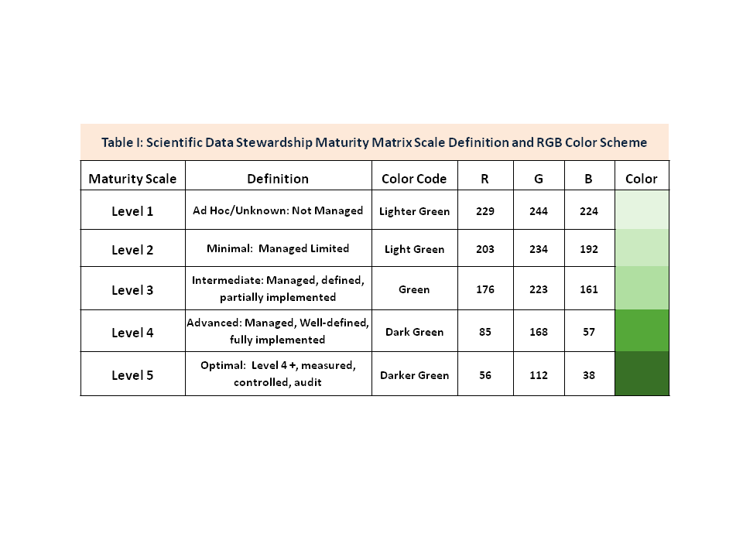
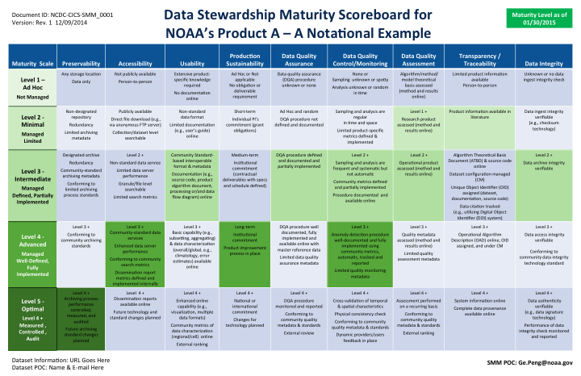
Figure 1: Data stewardship maturity scoreboard: An example of summarizing and displaying the assessment results of your dataset*.
If two cells are filled, it is an indication that only a partial maturity rating at the higher level is satisfied.

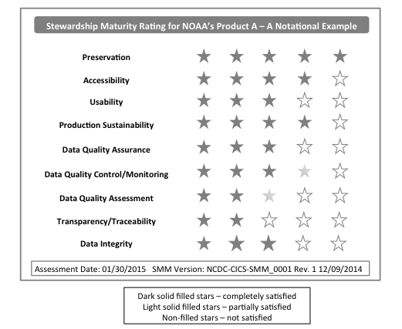
Figure 2: Data stewardship maturity rating diagram: An example of displaying your dataset rating*
*To request an external review of the stewardship maturity assessment for your dataset, send your detailed assessment result utilizing this template to Maturity.Matrix@gmail.com
with a subject line of SDS_MM_Scoreboard. As there is no operational support for this review service at this time, no guarantee will be made on the turn-around time.

