World Meteorological Organization Commission for Basic Systems
Task Team on Aviation XML Meeting 2017

Local Information for Participants

- Date and Venue
The workshop will be held from 13 to 15 October 2017 (Friday to Sunday) at the Conference Hall of the Hong Kong Observatory Headquarters, 134A Nathan Road, Tsim Sha Tsui, Hong Kong.

The meeting will start at 9 am on 13 October 2017 (Friday).

- Working Language and Internet Access
The working language will be English. Free Wi-Fi access is available in the venue.

- Visa Information
A valid passport is necessary for all persons entering Hong Kong. Some countries may need visa. You can apply the visa from the nearest Chinese diplomatic and consular mission. For further information, please visit the website of the Immigration Department of the Hong Kong Special Administrative Region.
http://www.immd.gov.hk/en/services/hk-visas/visit-transit/visit-visa-entry-permit.html

Please contact the local organizer if you require any assistance.

- Accommodation
There are numerous hotels in Hong Kong and maps showing their locations are available in Appendix A for participants’ information. Reservations can be made through their respective websites or online travel agents. As room rate fluctuates, participants are invited to secure their reservations at their earliest convenience.

Hotels | Website
Stanford Hillview Hotel | http://www.stanfordhillview.com/default-en.html
BP International | http://www.bpih.com.hk/
Best Western Grand | http://www.bestwesterngrandhotel.com/en/
Empire Hotel Kowloon | http://www.empirehotelsandresorts.com/en/ehk/overview.aspx
The Kimberly Hotel | http://www.kimberley.hk/eng/home/
The Mira Hong Kong | http://www.themirahotel.com/category/rooms/

- Transportation

From the airport to the hotel:
- Hotel Airport Shuttle
Hotel airport shuttle from and to the airport is available. Please consult the hotel you are staying for the fare of a trip.
- Airport Bus
Take Cityflyer Route A21 from Hong Kong International Airport to Kimberley Road / Miramar Shopping Centre, Nathan Road (Stop 12). Then walk for about 10 – 15 minutes (~500 m) to the hotel (see map below). Note that you need to walk up the slope at the Observatory Road for Stanford Hillview Hotel.

Fare: HKD33 (Approx 70 min)
http://www.nwstbus.com.hk/routes/airport-bus/route/index.aspx
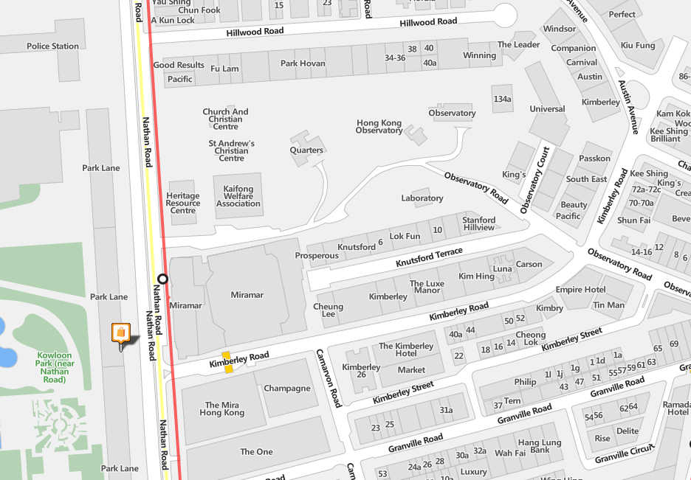

Hotel
Bus Stop

Hotel
Hotel
Hotel

- Taxi
Taxis in Hong Kong are colour-coded according to their operating areas. Please take the red one which serves nearly all the destinations throughout Hong Kong.

Fare: Approx. HKD250-300 from the Airport to Tsim Sha Tsui [depending on traffic] plus baggage charge
http://www.hongkongairport.com/eng/transport/to-from-airport/taxi.html

- Electricity
The standard electrical voltage in Hong Kong is 220 V AC, 50Hz. The majority of electrical outlets in Hong Kong take a three-pronged UK-style plug as shown below.


- Currency
The unit of the currency is Hong Kong Dollar. Coins are in denominations of 0.1, 0.2, 0.5, 1, 2, 5 and 10. Bank notes of 10, 20, 50, 100, 500, 1000 are in circulation. The exchange rate against US dollar is approximately HKD 7.8 ~ USD 1. Credit card use is common in most shops for major purchases and most accept VISA and MasterCard, and some accept American Express as well. ATM machines are also available in Tsim Sha Tsui.

- Climate
For October:
Mean daily maximum temperature | 27.8 ºC
Mean daily minimum temperature | 23.7 ºC
Mean relative humidity | 73 %
Mean rainfall | 100.9 mm

Note: The venue is air-conditioned and you may consider bringing a light jacket if necessary.

- Useful Information
Discover Hong Kong: http://www.discoverhongkong.com/eng/index.jsp
Hong Kong Travel Guide in wikitravel: http://wikitravel.org/en/Hong_Kong
Hong Kong Observatory (for weather information): http://www.hko.gov.hk
Consulates in Hong Kong: http://www.protocol.gov.hk/eng/consular/index.html
In emergency situations, you can contact the local police, ambulance service, fire department and other emergency services by calling 999.

- Local Information
For additional information and assistance concerning the local and logistic arrangements for the meeting, please contact the local organizer as follow:

Mr Boon-leung Choy, Hong Kong Observatory
Email: blchoy@hko.gov.hk
Tel: (+852) 2926 8350

Appendix A
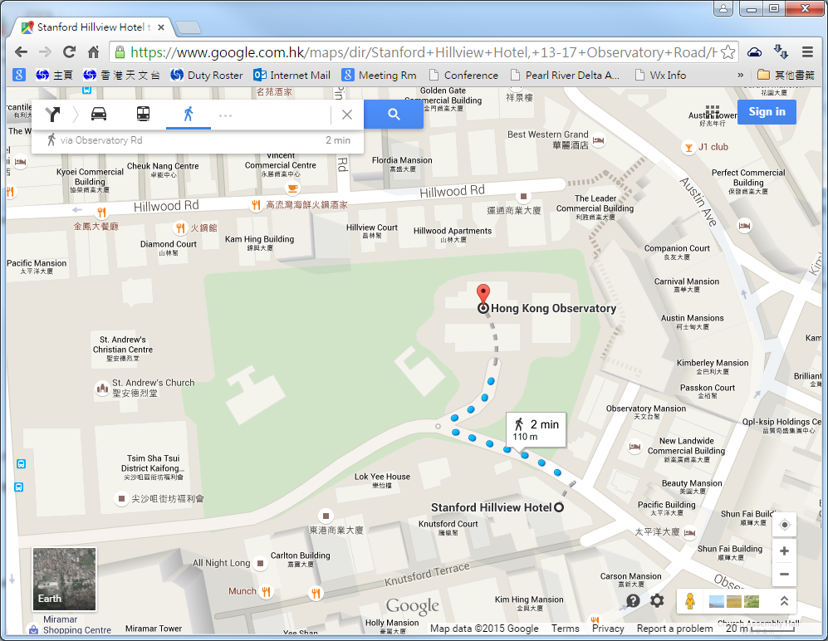
Routes from hotels to the meeting venue
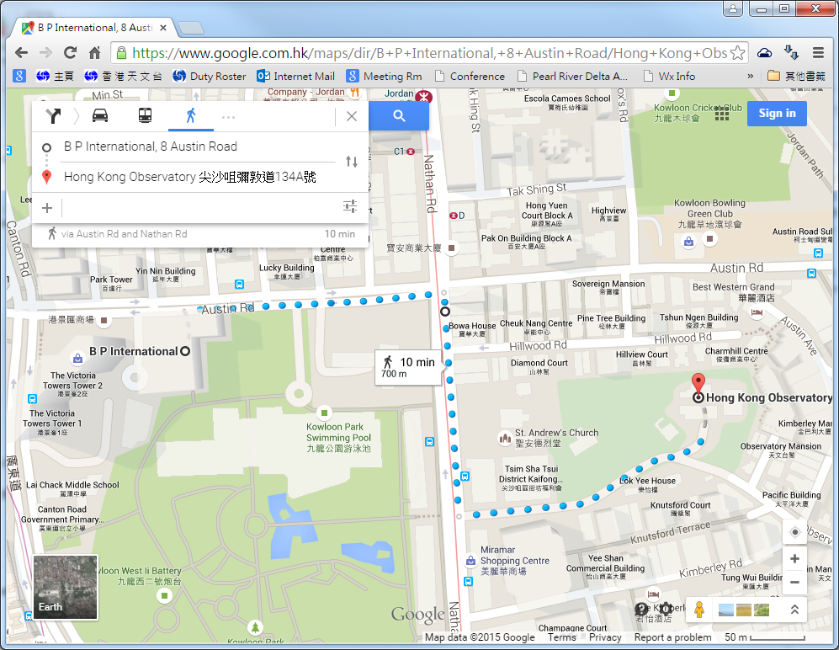
From Stanford Hillview Hotel to Hong Kong Observatory

From BP International to Hong Kong Observatory

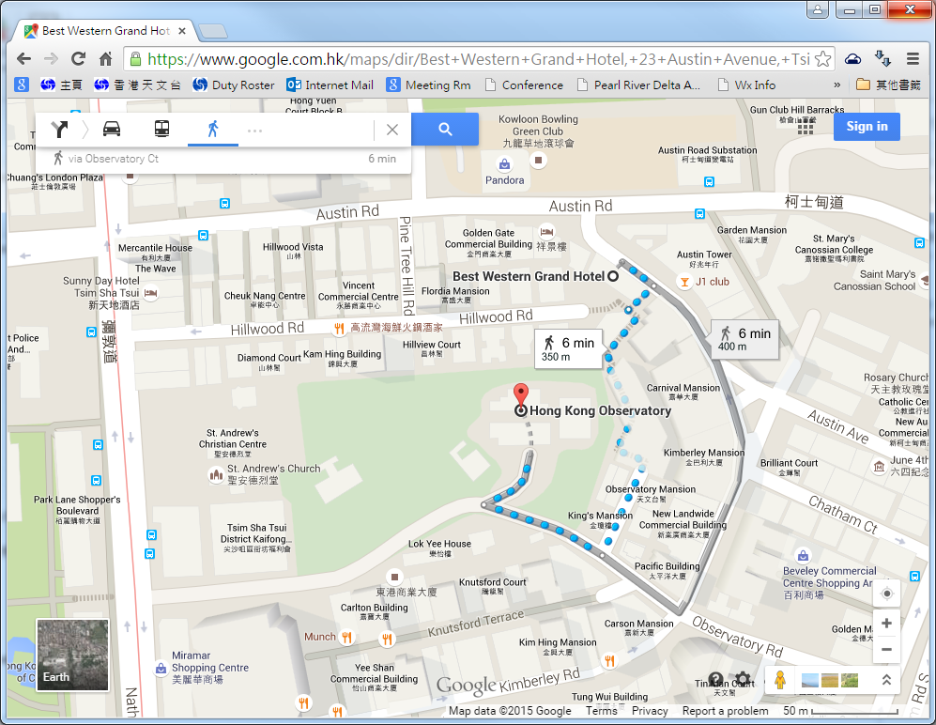
From Best Western Grand Hotel to Hong Kong Observatory

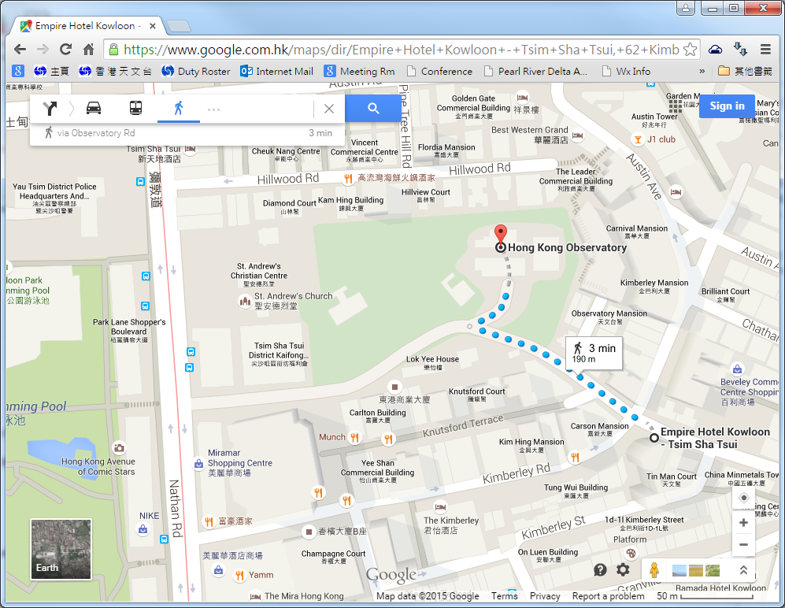
From Empire Hotel Kowloon to Hong Kong Observatory
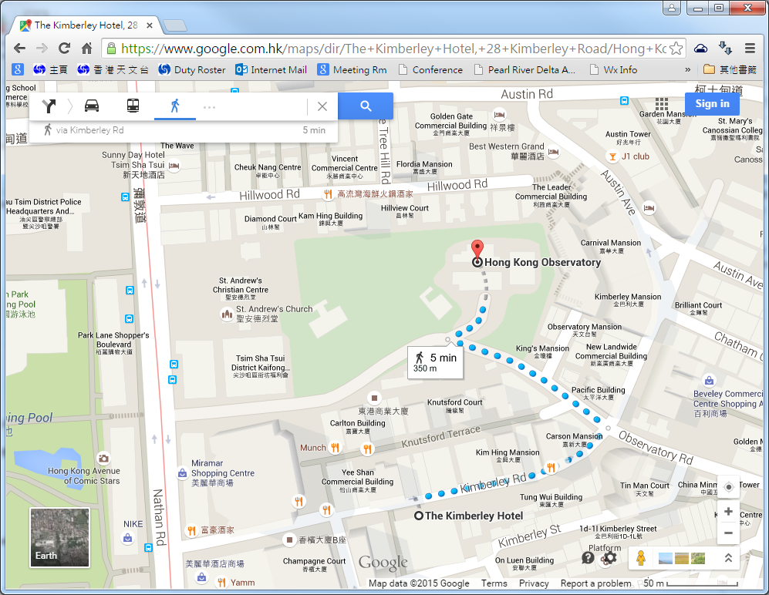

From The Kimberly Hotel to Hong Kong Observatory

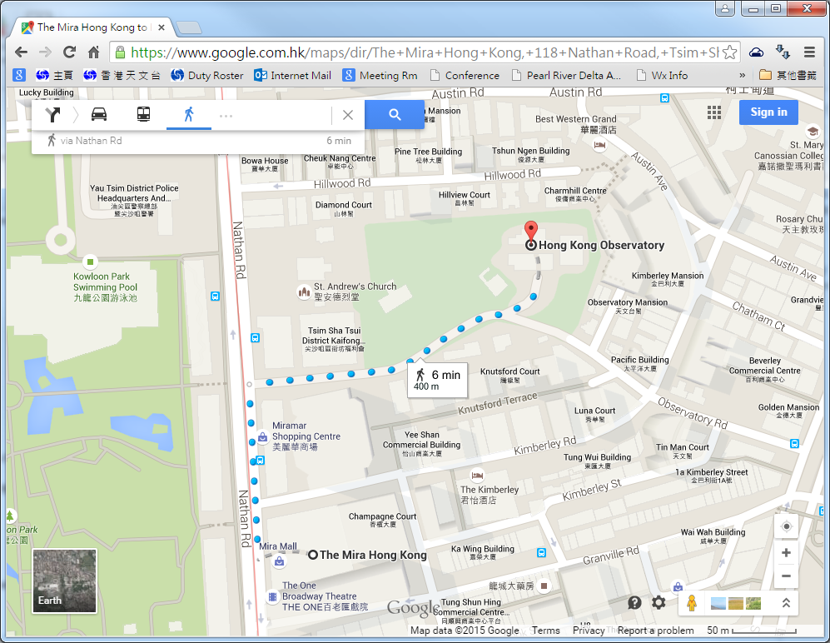

From The Mira Hong Kong to Hong Kong Observatory

