CONCEPT NOTE
COMMON INTERFACE FOR SERVICE DELIVERY

Introduction:

The Executive Council of WMO has requested that the Commission for Basic Systems to develop a Concept Note of a Common Interface for Service Delivery (CISD) “driven by data from NMHSs and emerging sources to enable users to seamlessly access weather and climate information in a way that would ensure attribution to NMHSs as providers of services”.

Why a Common Interface for Service Delivery?

In today’s world of mass travel, global news, and “always on” internet access to information, there is a need to provide one unified and consistent source of authoritative and high-quality weather and climate information, seamless in space and time. Already some of the major global aggregators of information provide such a seamless service of weather information, but typically this is not based on the high-quality information available for many countries through their NMHSs.

While NMHSs, by their nature, have a national remit the need is for a single international one-stop service for authoritative weather and climate information; one that will combine the high quality typically available via the separate websites of each NMHSs together with the convenience of a seamless service of aggregated global information provided to PC, tablets and mobile phones.

While focusing on the authoritative nature of weather and climate information available from NMHSs, there also needs to be a recognition of the high quality of information available through many private sector providers which can amplify and augment the information presented by NMHSs, and in particular provide additional depth of detail relevant to specific user groups. Thus the CISD must make provision for the merging of meteorological information provided from many sources, and presented in many different data formats and protocols, and synthesise these into a unified stream of weather and climate information that can be readily expressed and visualized on internet-connected devices.

The task of developing a CISD is analogous, in some respects, to those tasks already carried out in developing the WMO Integrated Global Observing System, WIGOS, and the WMO Information System, WIS. The CISD will attempt to achieve the same global coordination, but in the area of Service Delivery. The CISD must be built upon agreed technical protocols and standards, but these will need to be developed in close consultation with the users if they are to gain widespread acceptance.

In embarking on the challenge of developing the CISD, WMO must be aware of the need to support and enhance the authoritative voice of Members in providing warnings and other information about severe weather and it’s impacts, and must also keep in view the principle that no Member be left behind. It will be a significant challenge to develop an interface that can accept information from the wide range of technical capabilities of WMO Members and provide a unified output which is compatible with some of the most advanced information and communications technology on earth.

It should be clearly established also what the CISD will not attempt to do. Many NMHSs have, in close cooperation with their users, developed technical interfaces for the delivery of products and services to their own client base. The CISD will not attempt to replicate or improve on these. Rather it will offer meteorological service providers a new route to provide their products and services, in common with products and services from other providers - both public and private sector, to an international user-base.

The interface which is envisaged as the CISD must meet the need for interoperability in the digital world. Meteorological services provided via image and text from nationally-based websites no longer meet the requirements of smooth and seamless operation of a world which has entered the digital age. Standard protocols will be required to provide this interoperability between meteorological services and other information communication systems in the digital world.

This introduces the concept of a Common Interface for Service Delivery (CISD).

Purpose of CISD

- Open Service Delivery system designed for seamless availability of and accessibility to data and products for users, particularly in partnership with the private sector.

- Establishment of a widely accepted standard interface (protocol) for access to data and products for public service delivery;

- Establishment of a mechanism to link user requirements to the meteorological service providers who are registered with the CISD.

- Establishment of a one-stop-shop service of PWS products from WMO members and partners, including private sectors.

Fig 1. More than 100 NWP models/model members are available for each location in earth. How can these be rationalized into one service?

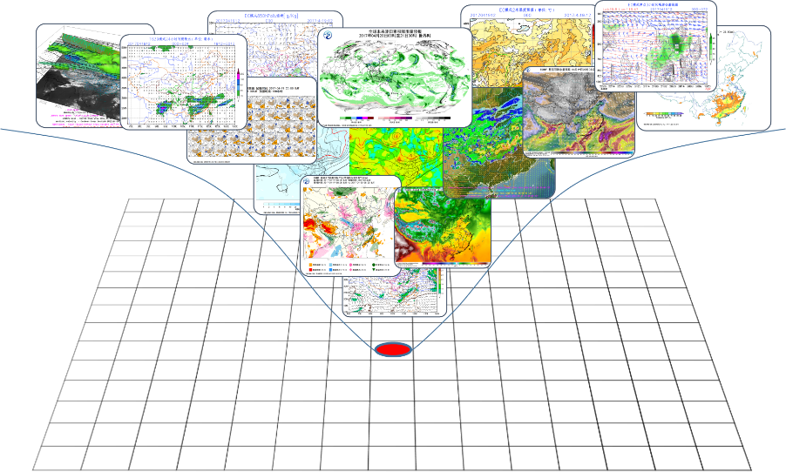

Definition

Protocol: First, the CISD will act as a WMO-defined unified protocol, which will aim to be widely accepted by industry and by UN affiliated organizations, and which will include existing standards such as CAP, to facilitate the provision of meteorological information services.

Proxy: The CISD will act as a WMO proxy to aggregate and release world-wide weather information from either official NMHS (alert and warnings, high impact weather forecasts and regular forecasts) or private sectors (high impact weather and regular forecasts) with source labelling. Proxy here also means partnership between WMO members and other sectors.

Provider: The CISD will act as a WMO service provider delivering the “best” or “optimum” forecast based on the verification and assessment of products from diverse sources, except for weather alerts and warnings which will solely come from NMHSs.

Users of CISD

- WMO Members who receive global met-services and contribute to CISD;
- Other meteorological service providers who will get authoritative products from CISD and contribute their own by service linkage following CISD standards;
- UN-affiliated organisations who need aggregated, authoritative weather and climate information;
- Governmental, inter-governmental and non-governmental organisations active in international humanitarian relief and disaster risk reduction;
- Certified/registered sectors or data aggregators like Google / Facebook;
- Other organization or individuals; CISD should be open to everyone.

Relationships between CISD and other CBS Projects

The CISD will not generate products itself, but will act as a channel through which services can be delivered, or alternatively direct user requests to appropriate product services. So, existing on-line resources such as GDACS / GMAS / WWIS / SWIC can become important inputs for CISD.

WIS 2.0 is a cloud-based information infrastructure and data-exchange platform, which can support the future WMO based functionality of CISD. The relationship between WIS and CISD will be analogous to that between an OS (operating system) and applications. Besides, WIS 2.0 cannot host everything, especially content from private sector providers. The concepts and standards underlying the CISD could also be implemented in other public cloud-based systems such as the Amazon cloud, Google cloud, Alibaba Cloud etc.

Principles in the Implementation of a Common Interface for Service Delivery

NMHS-first and mutual benefits: The CISD will support the authoritative voice of NMHSs, and leave no member behind. The CISD will also monitor and measure the products being used, and product providers/owners can decide whether or not to charge for the usage of the products originating with them. This means that CISD is first and foremost a standard of platform, which can be implemented upon WMO/WIS 2.0, or by other sectors.

Cloud based: The CISD will operate as an online service which will be based on WMO Information System (WIS 2.0) – a cloud infrastructure to handle massive concurrent data access.

De-centralized: The CISD will be connected to nodes on the WIS (WMC, RSMC, NMHS) and to private sectors via the internet. But the CISD will not aim for long-term storage of products from diverse sources, but will cache them for real time access, and for the greater efficiency of the data service.

Integrated: Alerts and warnings from NMHSs will go directly via the CISD to enhance the authoritative voice of the NMHSs of WMO Member. Other meteorological service provider information will be carried on the CISD with the source-label provided for user choice. With the help of Seamless GDPFS common platform, products (other than alerts and warnings) can be evaluated and integrated as “best” or “optimum” products, before being distributed via the CISD.

User oriented: A thorough investigation of user needs, user application and user scenarios will be essential if the CISD is to be widely accepted. The CISD should have a user-friendly Web application UI to facilitate location-based and on-demand meteorological services. The CISD should also include a set of APIs to assist with the collection of user feedback. This means that CISD registered users will have more privileges in getting access to more valuable data, products and feedback than ordinary visitors.

Components

Implementation of CISD will be through an alliance of internet nodes that follow the protocols and standards of CISD; the WMO node will be a starting point based on the architecture and cloud infrastructure of WIS2.0. (fig. 3)

WMO CISD Node:

  - Common Interface Service: linked to the services of NMHS (Web service), GDPFS centres (GDPFS common platform), WMO projects (e.g. MHEWS), and other sectors, supplying data and products through online interface to users. Other online products could also be registered as one service of WMO Common Interface.
  - WEBGIS UI: Based on backend service, a WEBGIS system established to facilitate exploration and online analysis (temporal and spatial analysis) of WMO-organised PWSD products such as Impact-Based Forecasts, GMAS warning etc. WEBGIS UI could be a support tool for decision makers in United Nation affiliated organisations.

Fig 2. WEBGIS for exploration of PWSD products

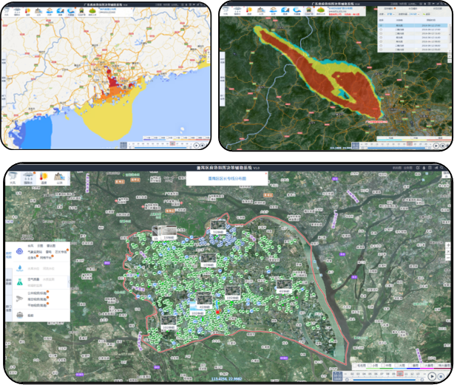

  - Cache data: WMO node doesn’t keep a long-term storage, but caches products for efficiency of delivery.

  - Registration: Products from other sectors who want to join the alliance will need to register and provide the relevant metadata relating to their services and products.

Other CISD Nodes:
Encourage other sectors to join the CISD alliance.
  - Common Interface for Service Delivery: strictly follows the standard of WMO common interface protocol;
  - Entity data centre (optional)
  - WEBGIS UI(optional)

Challenges of a Common interface

  - The first challenge is to solve the authoritative voice issue. Not to jeopardize but enhance the authority of NMHSs while facilitating private sector service provision through the CISD.
  - Not all Members will have the technical capacity to provide products following the CISD standards. Therefore, improving the technical capacity in providing products and services through digital means, and developing an agreement among NMHSs on the use of standard protocols, will be another challenge.
  - It will be essential to work closely with international industry associations and smart phone (wear) manufacturers to ensure their acceptance of CISD standards and protocols, and promotion of weather and climate information provided via the CISD.
  - Workshops and Pilot/demonstration project will certainly be needed to fully test the CISD concept at various stages in its development.

Fig. 3 Conceptual Diagram for Common Interface

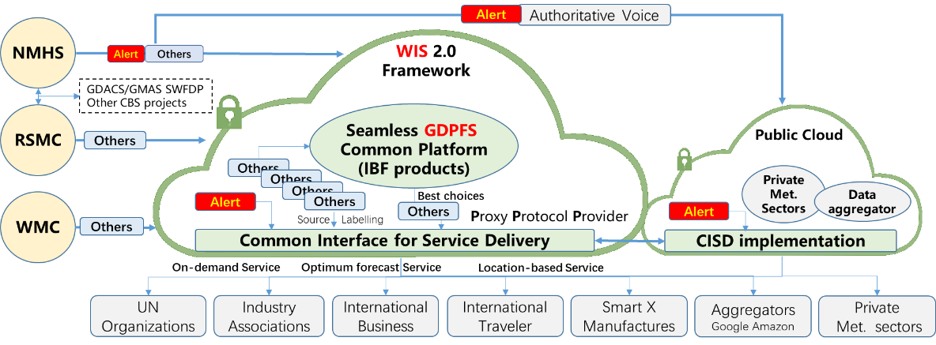

Roles of WMO members, data aggregators and private sectors in CISD could be both users and contributors of the CISD.

