Workshop report

Summary

The meeting started the 5th March at 14:00 following the agenda in Annex 1 and with the participants in Annex 2. After a round of introductions Enrico Fucile made a presentation on the WIS 2.0 strategy.

The 11 principles providing a technical framework for WIS 2.0 were recalled. The list of demonstrator projects was presented with a focus on the projects regarding ocean, cryosphere and hydrology. The aim to integrate systems for these programmes in WIS 2.0 was highlighted and the projects provide the opportunity to analyze the systems and plan their integration.

An introduction on pub/sub solution was presented by David Podeur. The main highlight was on the possibility to eliminate the maintenance of the routing table and the message switching because the pub/sub model is providing a reverse approach where the user is subscribing to the published data rather than asking an RTH to route the data to be able to receive them.

The use of pub/sub in the SEASAR project was presented by Yann Genin. The MET-GATE project was launched within SESAR programme in 2012. The introduction of AMQP in the project was based on the need to deliver MET information to the users as soon as it is available. The users subscribe to MET products via a Webservice, they get notification via AMQP queue.
Messages have very different sizes. From the few bites of TAC to GBs of model output. Two options were considered: WS-Notification (SOAP), AMQP. The use of AMQP was chosen for its flexibility reasons and because it is simpler to implement compared to SOAP. The first implementation used ActiveMQ. Now the implementation has changed and it is using RabbitMQ. It is based on METWORK framework and it is more a Meteo France project. It is still following the SESAR SWIM guidance for pub-sub implementation. The notification format is XML and includes the data if the size is small enough (not clear definition of small). There is 1 queue per user and messages are duplicated for each subscribing user.

Marcos Mera made a presentation on the use of RabbitMQ at ECMWF for forecast charts services (ecCharts, WMS) and archive data (webmars/api) services. ECMWF is using RabbitMQ since many years with two main usages:
- Distribute user policies
  - In combination with durable queues allows for zero-downtime upgrades.
  - Used by many consumer applications. Atlassian, ECPDS, ecChara, WebMARS.
- Manager distributed loads on WebMARS, ecCharts. Very efficient, reliable and stable. ecCharts/RabbitMQ performance:
  - Up to 15k messages per second (durable queues, no replicated).
  - ~6k connections.
  - It uses ~2 Gb of memory.
  - CPU usage 40-50% (8 CPUs each instance).

Peter Silva presented Met.px-Sarracenia: An open source data distribution mechanism based on pub/sub.

David Podeur presented Météo-France contribution to WIS2 demonstrator project.

Tiago Quintino presented Aviso, a notification system for ECMWF real-time NWP products and dissemination. Aviso is using a pub/sub framework to allow subscribed users to receive notifications that products are available in the mars archive. The notification message has a domain specific semantics that is already know to the users because adopted in the mars archive. Retrieval of the data can be performed submitting the mars request received in the notification message or through a URL in the message.

Antje Schremmer provided a short overview of DWD's test environment and first experiences.

During the second day of the meeting Enrico Fucile provide a presentation on the progress of the WMO reform explaining the next steps of the reform.

The remaining of the meeting was devoted to a brainstorm session that produced the following list of actions.

Actions

Integrate openGTS, WHOS and GCW in WIS 2.0. (Secretariat to plan workshop)
- How can WIS 2.0 support the needs of LDCs and SIDSs? (Enrico and Jeremy + workshop to be planned)
- Publish the latest version of topic structure and message format. ( Enrico, Peter, Remy (+ Jeremy?) )
- Finalise topic structure (David, Peter, Antje):
  - Centre name (in codes.wmo.int)
  - From TTAAii to data type
  - Data format ?
  - Post ?
- Metadata for WIS2 catalogue. There is an attempt by Antje. We need to involve the TT-WISMD to have an update on the WMCP. (Secretariat to start)
- Which protocol(s)? Consider the feasibility of using AMQP 1.0. Requirement is that the same client can access using the chosen protocol different brokers (e.g. rabbitMQ, QPID, …). We are going to limit the protocol choice between. AMQP 1.0, AMQP 0.9.1, MQTT 3.1.1, MQTT 5.0. (group effort. Who is the lead?)
- How to standardise authentication and authorization? Simple ssl, user/passwd ?
- Do we need to have explicit access rights in the message? (Kate, Jan, Benjamin)
- Message can deliver a payload or only a notification if the payload is big. Estimate the max size for which only notification is used. (Kate, Jan, Benjamin)
- The project to finalise the exchange mechanisms will be run by France, Germany, Jan, Japan, Canada, Brazil.

Annex 1: Agenda
Thursday 5 March 2020
Time |  |  |  | Presented By |  |  | Session/title
14:00 |  | 14:20 |  | All |  |  | Welcome and introduction of participants
14:20 |  | 18:15 |  | What happened so far ?
14:20 |  | 14:35 |  | WMO |  |  | A summary of WIS2 Strategy
14:35 |  | 14:45 |  | D.Podeur (France) |  |  | A brief introduction to pub/sub solutions
14:45 |  | 15:15 |  | Y.Génin (France) |  |  | The use of pub/sub in the SESAR Project
15:15 |  | 15:30 |  | Coffee Break
15:30 |  | 15:50 |  | M.Mera (ECMWF) |  |  | How RabbitMQ is used as a service broker that underpins ECMWF Forecast charts (eccharts/WMS) and archive data (webmars/api) services.
15:50 |  | 16:10 |  | P.Silva  (Environnement Canada) |  |  | Met.px-Sarracenia: An open source data distribution mechanism based on pub/sub
16:10 |  | 16:30 |  | D.Podeur (France) |  |  | Météo-France contribution to WIS2 demonstrator project (Canada, France,…)
16:30 |  | 16:50 |  | T.Quintino  (ECMWF) |  |  | Aviso - A notification system for ECMWF real-time NWP products and dissemination
16:50 |  | 17:20 |  | A.Schremmer (Germany) |  |  | A short overview of DWD's test environment and first experiences
17:20 |  | 18:15 |  | All |  |  | Other experiences and open discussion
18:15 |  |  |  |  |  |  | End of day 1
20:00 |  |  |  |  |  |  | Diner
 | Friday 6 March 2020
 | Time |  |  |  | Presented By | Session/title
 | 9:00 |  | 13:45 |  | Let’s talk about the future…
 | 9:00 |  | 9:15 |  | WMO | The Joint Session of INFCOM/SERCOM(JS-TC-1) : Geneva 04-08 April : What will happen next ?
 | 9:15 |  | 10:15 |  | Participants WMO-Mesh | Evolution of message format, hashing, security…  The WIS2 demonstrator project next phases: new countries
 | 10:15 |  | 10:30 |  | Coffee Break
 | 10:30 |  | 12:30 |  |  | Brainstorming session:  Use of a pilot to obtain a reference design and implementation  What is missing in the current demonstrator project? (E.g. set of keywords for topic?, licence?)  Which protocol(s) to use?  Which broker(s)?  Exchange of views on a potential pub/sub architecture for WIS2
 | 12:30 |  | 13:30 |  |  | Conclusion and next steps
 | 13:30 |  |  |  |  | Closure of the meeting

Annex 2: Participants

Baudouin Raoult | ECMWF (remote)
Stephan Siemen | ECMWF (remote)
Tiago Quintino | ECMWF (remote)
Andrew Brady | ECMWF (remote)
Marcos Mera | ECMWF (remote)
Manuel Martins | ECMWF (remote)
Cesar Lombao | ECMWF (remote)
W. Petsuwan | TMD (remote)
Peter Silva | Environnement Canada
Antje Schremmer | DWD
Jens Kuscherka | DWD (remote)
Ján Osuský | HMEI
Renan Rodrigues | INMET
Enrico Fucile | WMO
Timo Proescholdt | WMO
Steve Olson | NOAA (remote)
Kari Sheets | NOAA (remote)
Frank Guibert | MFI
Yoritsugi Yuge | JMA (remote)
Jeyoung Ryu | KMA
Kate Roberts | BOM (remote)
Sungsoo Do | KMA (remote)
El Garrai Chems Eddine | Maroc Météo
Ennaji El Mahfoud | Maroc Météo
Kuldeep Srivastava | IMD
Jeremy Tandy | UKMO (remote)
Rémy Giraud | Météo-France
Benjamin Saclier | Météo-France
David Podeur | Météo-France
Erwan Favennec | Météo-France
Yann Génin | Météo-France
Ludovic Stemberger | Météo-France
Fabien Marty | Météo-France

Annex 3: BlueJeans chat

Marcos Hermida (ECMWF)
Hi, so basically the question is if it has some sort of clustering

Kate
Seems very neat!

Jeremy Tandy
Bonjour - Jeremy has now joined the conference

Jeremy Tandy
At Met Office we use Campbell Scientific data loggers - we’ve worked with Campbell Scientific to amend the data logger software to talk directly to the AWS IoT platform, which uses messaging protocols … assume could deploy an MQ client (AMQP or MQTT) directly on the data logger

Jeremy Tandy
Sensor to data logger is still RS232 etc

Eventually the NEW sensors will talk directly to the message server
… data loggers is a transitional step

Peter Silva
CRAP - Certified Reliable Appliances in Place

Jeremy Tandy
AWS = amazon web services … not automatic weather station 😄

Yoritsugi YUGE
What is JMS?

Renan Rodrigues
https://en.wikipedia.org/wiki/Java_Message_Service
Java Message Service

Jeremy Tandy
Although the URL might be longer than a TAC message (TAF, METAR etc.) I think that architecturally, it’s easy to treat ALL messages the same; i.e. every message says “this data is available” and the receiving client then needs to retrieve the data by, for example, https
S/easy/easier/

JanO
In WMO mesh we have option to embed the data.
(gzipped and base64 encoded to fit into JSON 😄

Renan Rodrigues
from IT and system archteture point of view, I agree too it would be easier to treat and setup

Jeremy Tandy
Thanks JanO for info … Renan, I agree - it makes the applications simpler & easier to maintain … less work for humans; computers can make 2 requests without building up a sweat!
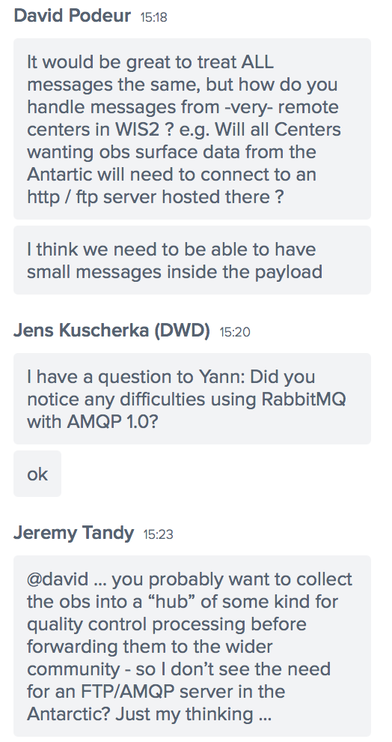
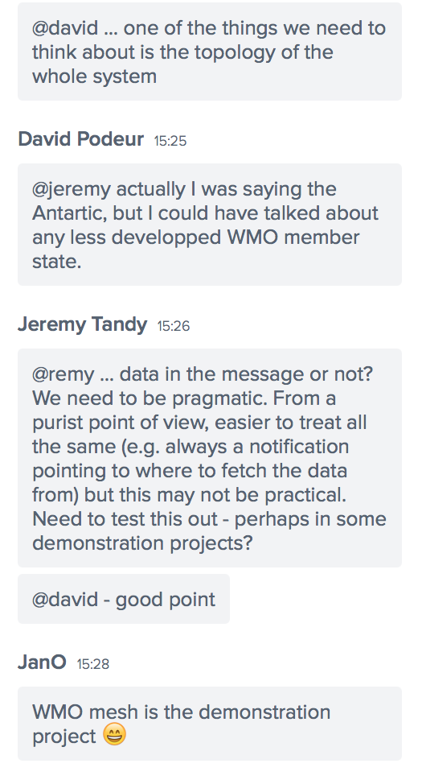

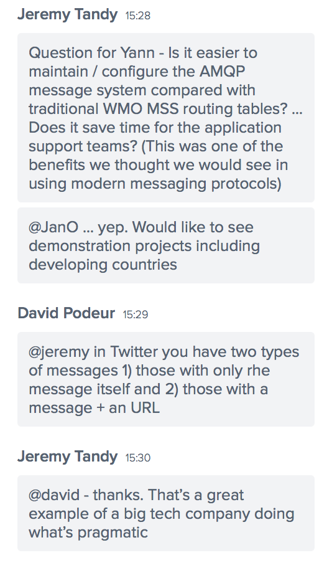
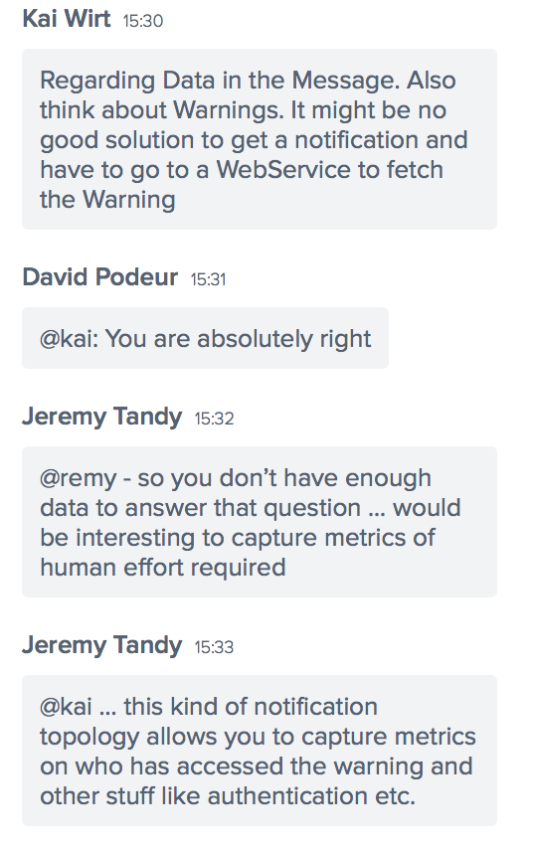

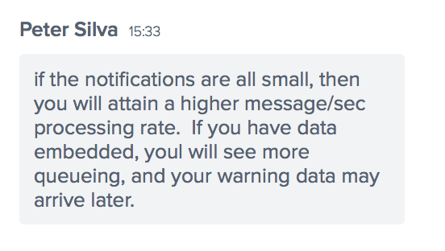

March 5th, 2020

Yann Genin Presentation

Remy Giraud
@Jeremy: Yes, you are right. We don't know yet the effort required.

Peter Silva
also in CAP, there is no hard limit on data size. there have been discussions around embedding video... can of worms.
CAP - Common Alerting Protocol ... XML dialect for warnings

Jeremy Tandy
@remy - will this chat be saved too? This Q&A will be a useful resource

Bob Bunge
Unless the message is a pointer to the data stored else where... the tweet with a URL

Remy Giraud
#jeremy, I don't know if I can save the chat... Need to check.

Jeremy Tandy
@remy – thanks!

<chat about sound quality>

Erwan Favennec
Chat can not be recorded ; I will manage to do it manually :)
https://support.bluejeans.com/s/article/Recording-and-Playback-instructions

Marcos Mera Presentation

Jeremy Tandy
@marcos - thanks for the presentation

Peter Silva Presentation

Jeremy Tandy
@peter - those are really useful metrics on how subscriptions saves config effort vs. routing tables

David Podeur Presentation

Remy Giraud
There were multiple reference to ET-CTS Buenos-Aires meeting. Here is the report http://wiswiki.wmo.int/tiki-download_file.php?fileId=5461
In the annex of the report you will find the structure of the pub/sub messages

JanO
https://github.com/MetPX/wmo_mesh
https://github.com/MetPX/wmo_mesh/blob/master/message-schema.json

Peter Silva
@jeremy thanks!

Jeremy Tandy
@remy ... would prefer to say that we're getting rid of point to point routing and routing tables ... rather than the GTS ... the GTS will _evolve_ to include these new pub/sub protocols
... and that the Internet is seen as the default netwokr
... network choice
I agree with @timo .... the messaging topology is simpler - there's no interim routing hubs required

Tiago Quintino Presentation

Jeremy Tandy
could you talk a bit more about cloudevents

Yoritsugi Yuge
what protocol does aviso uses to distribute data? https only?

ECMWF
cloudevents can also be used natively by cloud provider APIs to schedule starting of VMs etc.

Yoritsugi Yuge
Ok, thanks

Claudio Lacopino (ECMWF)
cloudEvent data field can contain string, JSON or binary according to the spec

A. Schremmer Presentation

Jan Osusky presentation

------------------------------------------------------------------------------------------

March 6th, 2020

Claudio Lacopino (ECMWF)
Good morning, sorry I'm not set up with a microphone, I will use the chat if I need to give some input

Enrico xxx presentation

Jeremy Tandy
What's the liklihood that the JTC meeting will actually happen 4-8 April? #coronavirus

W. Petsuwan (TMD)
Due to the ongoing COVID-19 public health emergency of international concern, does WMO plan to postpone the Joint Session of INFCOM/SERCOM (JS-TC-1)?

<Enrico : it could be postponed but no decision has been taken yet>

Jeremy Tandy
OK - thanks @enrico

W. Petsuwan (TMD)
Thank you @enrico

Jeremy Tandy
@enrico - do you have a list of suggested developing countries?

<Enrico : not yet>

<chat about whiteboard visibility>

A. Schremmer Presentation

Kai Wirt
In services you also don't necessarily have date. My first thought thus also was to remove date. However if you are interested specifically in a certain run then it consequently makes sense to not only have time but also date imho
There is no need for 1:1 mapping

Kate
The person mentioned the date as indicating the retention policy. Can we hear more on this,, and how it can be expressed /interpreted?

Kate
ah
yes, thx

Kai Wirt
We don't need to discuss the GTS tree here. To me it is sufficient to setup a WIS tree. If there are other trees in parallel that doesn't matter. Evetnuelly we will move to WIS

Jeremy Tandy
I agree with @enrico ... it is a complicated thing
we WILL need metadata
but we can figure this out
WCMP? probably not ...
Or at least not in its current form
@remy – exactly

Kate
you can achieve Google indexing while also using xml/WMCP

Yoritsugi Yuge
JMA is using MetPX software to test for WIS2 demonstration. also we have own software developed by JMA staff.
MetPX is AMQP 0.9.1 and our .own software is MQTT 3.1.1

Remy
Thanks

Kai Wirt
Why not put the burden on ICAO? If we decide other protocols are better for our purposes, than we can also ask ICAO to invent a gateway or so

Yoritsugi Yuge
Brokers are RabbitMQ and Mosquite.

Kai Wirt
The interface between LDC and Pub/Sub might be http or sftp from LDC to GISC

Jeremy Tandy
is ok

Yoritsugi Yuge
Sorry, I have to leave now. Please share the presentation on this workshop. Thank you.

<coffee break>

Discussion about authentication

Kai Wirt
We can only solve the problem for the Brokers. Data access is out of scope, because access to data is mantained by the data producers.
Maybe we can link this to licence code by saying WMOEssential must be downloadable without authentication.

Remy
Yes, but it covers only a small (hopefully) subset of wis2. I am looking at a larger scope.

Kai Wirt
I would also want to add sftp
I agree with Jan, we should not put everything from the Metadata also in the messages

Karl Sheets
US would likely want sftp as well

Kate
2 separate nodes (public and private) seems a good idea
At the top level, that separation could remove just SOME of the inappropriate/disappoint subscritions; but ther is more info needed somewhere (message) about type of restriction, or similar?
sorry -too much echo to explain on phone
did the group consider adding a licence flag to the topic?

Jeremy Tandy
@remy - I think we need to be pragmatic here ... AMQP 0.9 can be considered a de facto standard
isnt there the same case with the s/ftp protocol (?) or something similar ... there really isn't a standard, but everyone seems to be able to work together anyway
ah yes ... ssh
can we make it an RFC?
Nope
:-)

<chat about sound quality>

Peter Silva
http://www.amqp.org/specification/0-9-1/amqp-org-download

Kai Wirt
I'm thinking about Warnings, NOXX and NPXX replacements

Kate
for endusers, isnt it better to be consistent?
re: data in the message, or not .. especially for data types (eg warnings)

Jeremy Tandy
@remy - I agree ... the architecture for the whole system is a very important topic

Kate
ok, yes, thx

Jeremy Tandy
I think we will need to thnk about the overall system architecture

Kate
? how will further considerationof the MESSAGE content be discussed 9i ahve some ideas)

Peter Silva
@Kate, fwiw, one can open issues on https://github.com/MetPX/wmo_mesh to propose additions to the format

Jan
@jeremy is https://github.com/MetPX/wmo_mesh/ OK for you as discussion platform?

Peter Silva
yes the issue tracker is meant for such discussions

Jeremy Tandy
I can work with Enrico on outreach to other programmes
Good point @timo ... we need a discussion on the overall system architecture

Jeremy Tandy
Just wanted to say thanks to Meteo France for hosting and Remy for chairing!

Remy
Thanks for all remote partcipants for being with us during these two days!

W. Petsuwan (TMD)
Thank you Meteo France and Remy for excellent jobs.

Kate
Thanks, very informative (and inspiring)

Jeremy Tandy
yes ... assuming that the JTC meeting happens

Kai Wirt
Thank you also from remote part of DWD :-)

Marcos Hermida (ECMWF)
Thanks from ECMWF!

Karl Sheets
thanks, agree good meeting

----------------

