WMO rubric – XSLT for metadata quality monitoring

NOAA provided a XSL Transformation, the “WMO Rubric Report” available at github [1]. During the implementation phase of WIS, GISC Offenbach has built a tool based on the WMO Rubric to get scores for the metadata quality.
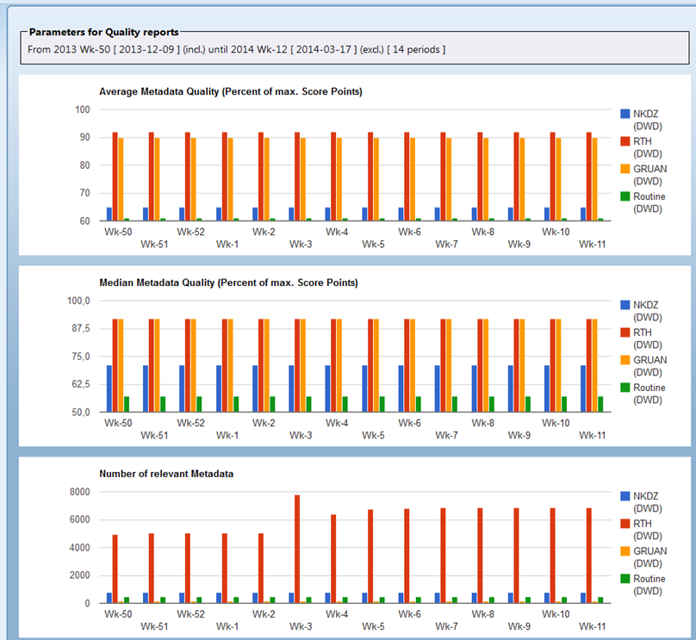
Figure 1: From the IPET-MDRD-1: WIS Metadata Quality Monitoring GISC Offenbach, weekly statistics 2013-12-09 to 2014-03-10

GISC Offenbach implemented the WMO rubric in the frontend of gisc.dwd.de [4]
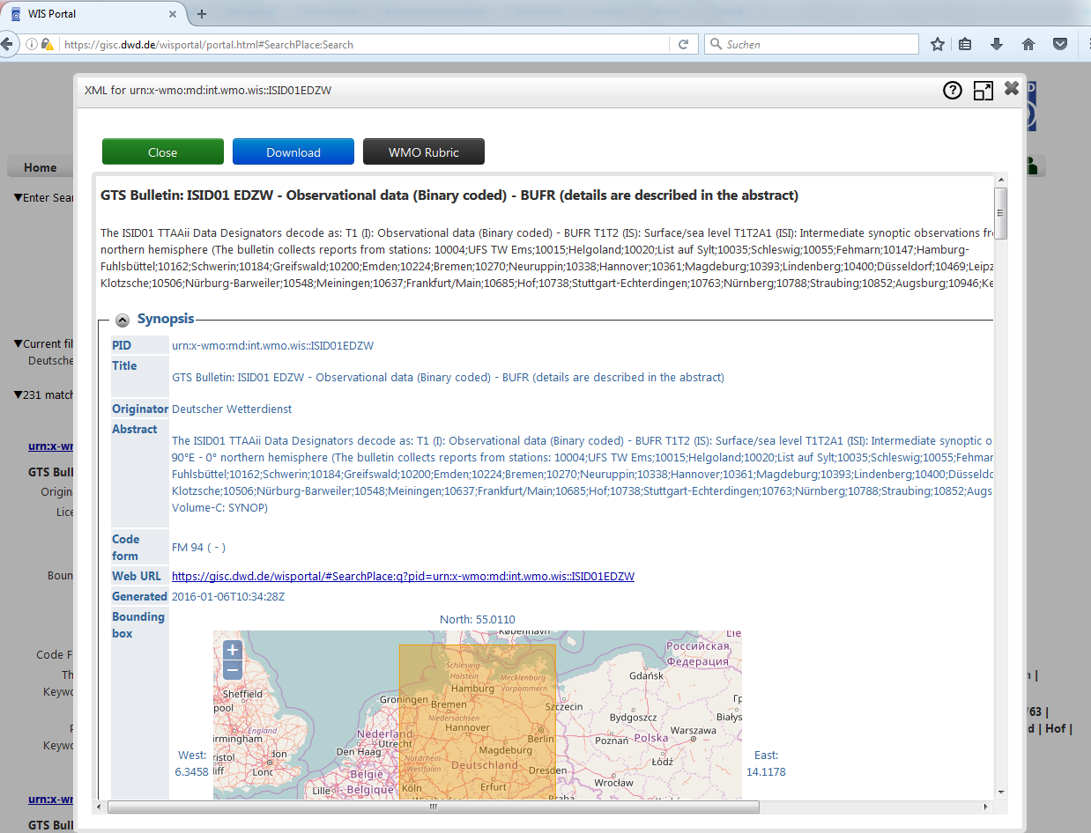
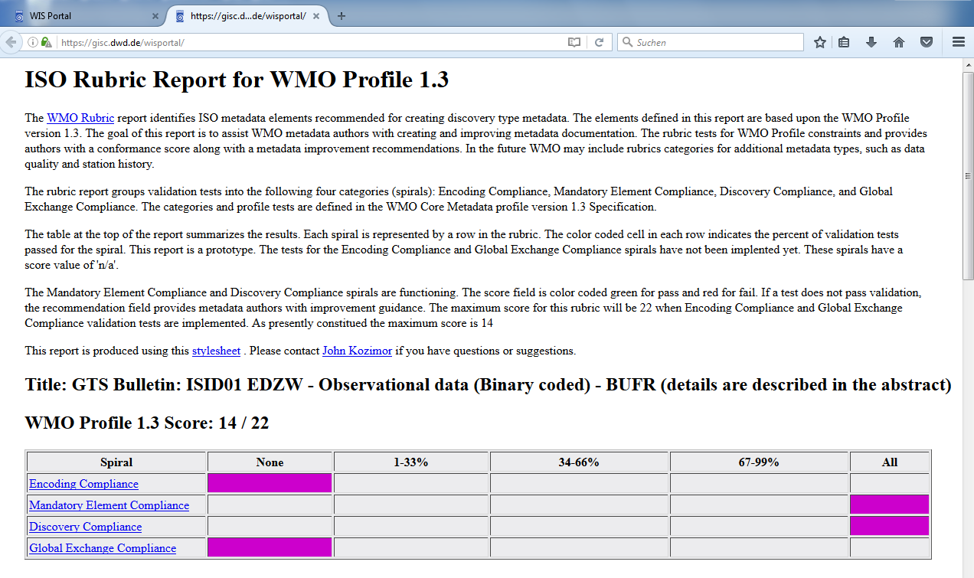A further development of the WMO Rubric as XSLT did not take place in the last years.
The “WMO Core Metadata Profile Test Suite” [2] written in python offers a different approach than the XSLT.

References
[1] https://github.com/wmo-im/wmcp
[2] https://github.com/wmo-im/wmo-cmp-ts
[3] https://wiswiki.wmo.int/tiki-index.php?page=IPET-MDRD-1
[4] https://gisc.dwd.de/

Recommended Text
Mr Hermann Asensio presented the use of NOAAs WMO Rubric at GISC Offenbach; he noted that a further development of the WMO Rubric as XSLT did not take place in the last years.

--------------------

