Writing Extensions for IWXXM

1. Introduction
ICAO Annex 3/WMO No. 306 allows for the inclusion of supplementary information in its products. Since version 2 of the IWXXM schemas, a structured way to include current and future supplementary information was implemented with the 'extension' element in many of the schemas' complex types. A complete list of IWXXM complex types containing the ‘extension’ element is in the Appendix.
The element 'extension' is essentially of XML 'any' type. This means a child of the 'extension' element is of arbitrary content since it is not known beforehand what a member state may want to provide. While arbitrary content is allowed, it must be consistent with a published XML schema. Extension elements in IWXXM documents without its contents referring to a published schema will not validate.

2. Development

2.1 XML Editors
Several commercial off-the-shelf (COTS) software products are available to assist the user in creating XML schemas. The task team settled on “Enterprise Architect” ^{[1]} (EA) to develop IWXXM in the Unified Modeling Language (UML). The UML provides a level of abstraction, allowing the user to create a logical data model that is easily manipulated and modified as requirements are made and changed over time. Once the requirements are realized, EA generates the XML schemas that corresponds to the UML model.
For purposes of writing an XML schema for IWXXM extensions, EA software is not essential. Other COTS software can be used, albeit the user needs to be familiar with the XML language. Both “XMLSpy” ^{[2]} and “<oXygen/> XML Editor” ^{[3]} provide intelligent "XML aware" editors and "as-you-type" validation checks which makes writing XML easier.

2.2 Lists
While creating the simple or complex types in the extension, most lists should written as code lists unless the list’s values are known to be truly complete and unchanging. XML enumerations can make a schema “brittle”, requiring a new schema version if any enumeration needs to be updated in the future due to changing requirements. As a code list, the contents of the list can change at any time without affecting the schema.
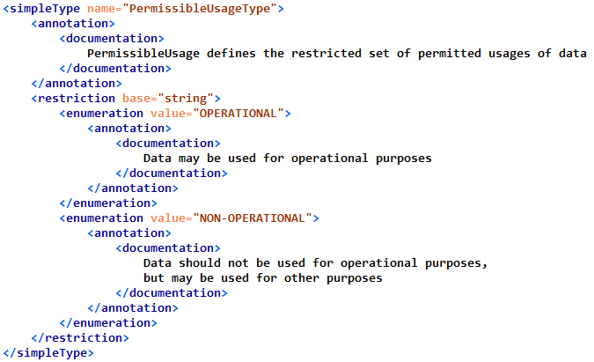
Figure 1 Example of Fixed Enumeration
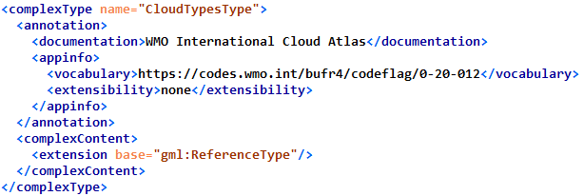
Figure 2 Example of Enumeration as a Code List

Code list URLs refer to web pages containing all possible values for that particular type. The web pages are updated as needed without requiring changes to the schemas that refers to them. The WMO and NOAA NWS manages its code list web pages using software from Epimorphics.^{[4]}

2.3 Writing XML types
Complex types should be focused to the particular IWXXM complex type to be extended. This keeps the extension’s complex types concise and the overall IWXXM document organized. To illustrate, for the United States, the IWXXM complex type ‘CloudLayer’ was extended as automated stations can report variations in ceiling height. A complex type ‘VariableCeilingHeightType’ was created:
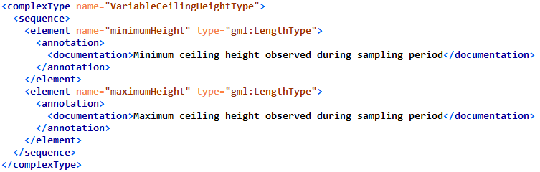
Figure 3 Complex Type for variable ceiling height
With an element of the type ‘VariableCeilingHeightType’ defined in the extension schema, the IWXXM complex type ‘CloudLayer’ can now be enhanced:
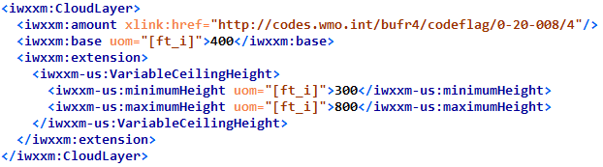
Figure 4 Extension showing variable ceiling height from 300 to 800 feet

2.4 Target namespace
Schemas for IWXXM extensions need to have a unique URI associated with them. The URI is assigned to the ‘targetNamespace’ attribute of the schema element.

3. Validation
To validate IWXXM documents containing extensions, the member state’s schema must be widely available, typically accessible as text file(s) via the Internet. The IWXXM XML document must refer to the correct target namespace URI and corresponding schema location. If these conditions are not met, the XML document will not validate. To illustrate this requirement, the United States has published its schema files with the corresponding URI, ‘https://www.weather.gov/iwxxm-us/3.0’. IWXXM documents produced by the United States containing its extensions maps the URI to the schema file location, like so:
Figure 5 URI mapping to US Extension schema file for METAR/SPECI reports
While software like <oXygenXML> and XMLSpy editors can resolve the URLs to obtain the required schema files, it can be slow and, if Internet connectivity is unreliable, validation may perform erratically or fail entirely. For these and other reasons, it is better to retrieve the schema files once, store them locally, and have XML validation performed with the copies. To avoid altering the XML document’s <xsi:schemaLocation> values, the XML validation tools can use a XML Catalog file to map portions of the URIs to a local filesystem. With XML Catalog file, XML editors can perform XML validation even when not connected to the Internet.
As an example, the canonical location of IWXXM schemas is the URL ‘http://schemas.wmo.int/iwxxm’. If the IWXXM directory tree is copied to your local directory as ‘/usr/local/oxygen/externalSchemas/iwxxm’, then the XML Catalog file can re-map strings ‘http://schemas.wmo.int/iwxxm/3.0/iwxxm.xsd’ to ‘/usr/local/oxygen/externalSchemas/iwxxm/3.0/iwxxm.xsd’ with the following entry.
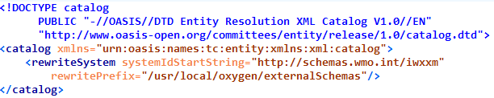
Figure 6 Example of OASIS XML Catalog File

4. Summary
This paper provides a concise review of how to write XML for inclusion into IWXXM <extension> elements. More complex and complete examples of can be found on the WMO WIS Wiki site as a tutorial page^{[5]} and schema files.^{[6]} There may be opportunities to use EA and some of the XML Tools during the meeting to create XML schema and catalog files, and perform XML validation.

5. References
[1] Sparx Systems, https://sparxsystems.com
[2] Altova, https://altova.com/xmlspy-xml-editor
[3] SyncroSoft, https://oxygenxml.com/xml_editor.html
[4] Epimorphics, https://epimorphics.com
[5] https://wiswiki.wmo.int/tiki-index.php?page=IWXXM-3.0--XML-extended-content
[6] https://nws.weather.gov/schemas/iwxxm-us/3.0

Appendix

List of all IWXXM v3.0 complex types containing <extension> element.
Class  (Package Name::Class Name) | Local extension block | Inherited extension block | Super Class  (Package Name::Class Name)
METAR/SPECI::AerodromeRunwayState | Yes
METAR/SPECI::AerodromeRunwayVisualRange | Yes
METAR/SPECI::AerodromeRecentWeather | Yes
METAR/SPECI::SeaSurfaceState | Yes
METAR/SPECI::SPECI | Yes
METAR/SPECI::VisualRangeTendency | Yes
METAR/SPECI::RunwayDeposits | Yes
METAR/SPECI::AerodromeSeaState | Yes
METAR/SPECI::AerodromeWindShear | Yes
METAR/SPECI::RunwayContamination | Yes
METAR/SPECI::MeteorologicalAerodromeTrendForecast | Yes
METAR/SPECI::MeteorologicalAerodromeObservation | Yes
METAR/SPECI::AerodromeCloud | Yes
METAR/SPECI::TrendForecastTimeIndicator | Yes
METAR/SPECI::METAR | Yes
METAR/SPECI::AerodromeSurfaceWind | Yes
METAR/SPECI::AerodromePresentWeather | Yes
METAR/SPECI::RunwayFrictionCoefficient | Yes
METAR/SPECI::AerodromeHorizontalVisibility | Yes
METAR/SPECI::MeteorologicalAerodromeReportStatus | Yes
METAR/SPECI::ForecastChangeIndicator | Yes
TAF::MeteorologicalAerodromeForecast | Yes
TAF::AerodromeAirTemperatureForecast | Yes
TAF::TAFReportStatus | Yes
TAF::AerodromeForecastChangeIndicator | Yes
TAF::TAF | Yes
SIGMET::ExpectedIntensityChange | Yes
SIGMET::SIGMETPosition | Yes
SIGMET::SIGMET | Yes
SIGMET::AeronauticalSignificantWeatherPhenomenon | Yes
SIGMET::SIGMETReportStatus | Yes
SIGMET::SIGMETEvolvingCondition | Yes
SIGMET::SIGMETEvolvingConditionCollection | Yes
SIGMET::TropicalCycloneSIGMET | Yes | Yes | SIGMET::SIGMET
SIGMET::VolcanicAshSIGMET | Yes | Yes | SIGMET::SIGMET
SIGMET::SIGMETPositionCollection | Yes
SIGMET::TropicalCycloneSIGMETEvolvingConditionCollection | Yes | Yes | SIGMET::SIGMETEvolvingConditionCollection
SIGMET::VolcanicAshSIGMETEvolvingConditionCollection |  | Yes | SIGMET::SIGMETEvolvingConditionCollection
SIGMET::VolcanicAshSIGMETPositionCollection |  | Yes | SIGMET::SIGMETPositionCollection
SIGMET::TropicalCycloneSIGMETPositionCollection | Yes | Yes | SIGMET::SIGMETPositionCollection
AIRMET::WeatherCausingVisibilityReduction | Yes
AIRMET::AIRMETReportStatus | Yes
AIRMET::AIRMETEvolvingConditionCollection | Yes
AIRMET::AIRMETExpectedIntensityChange | Yes
AIRMET::AIRMETEvolvingCondition | Yes
AIRMET::AeronauticalAreaWeatherPhenomenon | Yes
AIRMET::AIRMET | Yes
Tropical Cyclone Advisory::TropicalCycloneForecastConditions | Yes
Tropical Cyclone Advisory::TropicalCycloneAdvisory | Yes
Tropical Cyclone Advisory::TropicalCycloneObservedConditions | Yes
Tropical Cyclone Advisory::TropicalCycloneMovement | Yes
Volcanic Ash Advisory::VolcanicAshCloud | Yes
Volcanic Ash Advisory::AviationColourCode | Yes
Volcanic Ash Advisory::VolcanicAshAdvisory | Yes
Volcanic Ash Advisory::VolcanicAshConditions | Yes
Space Weather Advisory::SpaceWeatherLocation | Yes
Space Weather Advisory::SpaceWeatherPhenomena | Yes
Space Weather Advisory::SpaceWeatherRegion | Yes
Space Weather Advisory::SpaceWeatherAdvisory | Yes
Space Weather Advisory::SpaceWeatherAnalysis | Yes
Common::AerodromeForecastWeather | Yes
Common::SigConvectiveCloudType | Yes
Common::RelationalOperator | Yes
Common::CloudAmountReportedAtAerodrome | Yes
Common::CloudLayer | Yes
Common::AerodromeCloudForecast | Yes
Common::PermissibleUsage | Yes
Common::TimeIndicator | Yes
Common::AerodromeSurfaceWindForecast |  | Yes | Common::AerodromeSurfaceWindTrendForecast
Common::AerodromeSurfaceWindTrendForecast | Yes
Common::PermissibleUsageReason | Yes

https://www.w3schools.com/xml/default.asp is a good resource to start.

