Impact analysis on proposed changes to IWXXM

Introduction
- During WG-MIE/5 the IWXXM development process was discussed. IWXXM forms part of the ICAO and WMO regulatory processes and is subjected to the governance procedures associated with these which could take a long time. Therefore knowing the requirements well in advance is essential to plan for the release of major/minor changes or patches to IWXXM, and is important to all involving in the implementation and use of IWXXM.

- Concerns were raised at WG-MIE/5 on the fact that the requirements would normally be brought up for the broader community (e.g. ICAO Air Navigation Commission (ANC)) to consider at about 18 months before the effective date and the decision would come at about 12 months later. Air Navigation Service (ANS) providers had already indicated that for significant IWXXM changes they would normally need one to two years’ time to budget/plan, implement and put the change/new requirements into operation, and the existing arrangements are clearly not optimal.

- There were four ideas raised at WG-MIE/5 to improve the change management processes for IWXXM, namely:
- Raise the possibility of changes to Annex 3 that requires an update to IWXXM as early as possible.
- Invite the WMO TT-AvXML, as early as possible, to review the possible impact to IWXXM and advise the expected available time for the revised schemas, considering the frequency of IWXXM releases with breaking changes and complexity of the changes.
- Encourage the TT-AvXML to file possible/expected/confirmed changes to IWXXM in a roadmap, in consultation with those who requested the changes and communicate electronically (i.e. via the web) to inform stakeholders.
- Prepare draft changes to IWXXM in association with the proposed changes to Annex 3 for consideration by ICAO WGs, METP and the Air Navigation Commission (ANC), especially after the cessation of TAC.

- WG-MIE agreed to the following decision and action:
Decision MIE/5-11 – IWXXM Development Process
That the WG-MIE endorse the establishment of a change management process.

Action MIE/5-24 – IWXXM Development Process
That the WG-MIE review best practices for change management and develop a charter for consideration by the Meteorology Panel to ensure an open and transparent global management of the IWXXM schema and governance in accordance to SWIM principles.
- This paper describes the impact analysis conducted on the change/new requirements mentioned in the proposed Amendment 79 to ICAO Annex 3 with a view to formulate a systematic approach to the handling of requirements.

The impact analysis
- An impact analysis ^{[1]} was conducted making reference to the proposed Amendment 79 to ICAO Annex 3 distributed to collect feedbacks from stakeholders. Each of the change/addition that may affect IWXXM was accessed and the degree of change of IWXXM necessary, based on the version policy ^{[2]} adopted, was documented. The following is a sample output of the analysis:
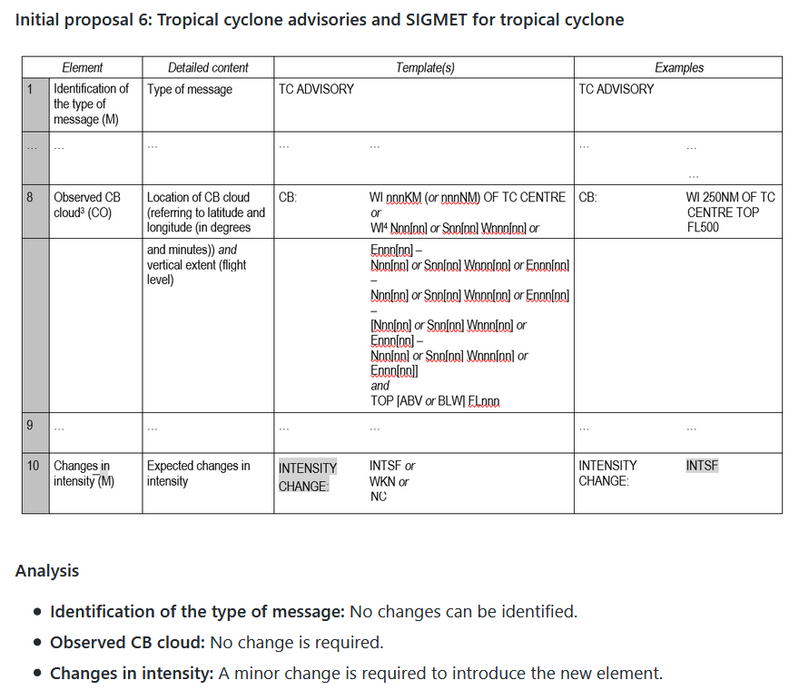

- And finally the necessary changes to the existing reports in IWXXM will be summarized:

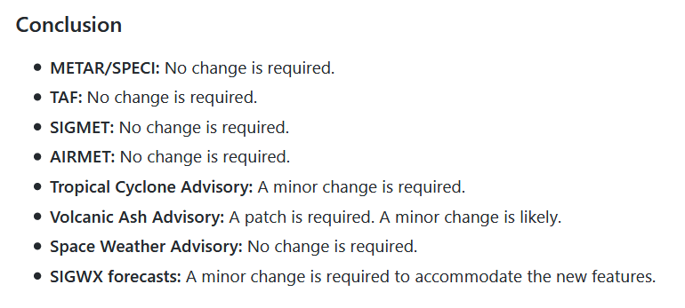

Conclusion
- The intention of the impact analysis is to give an idea to those who propose the change/addition the degree and effort required to modify IWXXM to meet the new requirements. It will also serve as the basis for negotiation whether the change, if it is a significant one, should be pushed out now or grouped together with other changes to better manage the resources required by TT-AvXML, the implementers, the end users and their expectations.

References
[1] Impact analysis of the proposed Amendment 79 to ICAO Annex 3 (https://github.com/wmo-im/iwxxm/wiki/IA-2019_01)
[2] Version policy adopted by IWXXM (https://github.com/wmo-im/iwxxm/wiki/Common-approaches-accross-exchange-models)

Recommended Text
TT-AvXML discussed the approach of analyzing change/new requirements on IWXXM and will adopt the methodology [include the agreed methodologies here] in conducting the impact analysis when necessary. A paper describing the methodology, the workflow of the team and expected response time will be prepared for WG-MIE’s discussion and consideration.

--------------------

