Remaining issues for IWXXM 3.0.0

Introduction
- This paper describes the issues raised after the publishing of IWXXM 3.0.0RC3 which may need to be resolved before finalizing and publishing of IWXXM 3.0.0.

Issues raised and proposed resolution
- Rule COLLECT.MB1 in iwxxm.sch is overly restrictive ^{[1]}
  - Schematron rule COLLECT.MB1 was borrowed from the COLLECT Construct which intends to ensure the aggregated reports are of the same type by checking the namespace + element name of the root node of the aggregated XML documents. This works well until the need to aggregate different versions of the same type of document. In this case the namespace of the two versions will be different and hence the schematron rule will always fail.

  - The fix is relatively simple; by changing the checking of namespace + element name to element name only, the checking should be safe when multiple versions of IWXXM reports of the same type are present.

  - However, Para. 2.2 only fixed the validation of the COLLECT Construct. iwxxm.sch is version dependent. If the collective has reports in, say, versions 3.0 and 2.1, iwxxm.sch of versions 3.0 and 2.1 will have to run separately for completeness. In long terms, iwxxm.sch of all known version of IWXXM will have to be run for validation.

  - The proposed resolution to the case is to apply the fix as mentioned in Para. 2.2 and inform WG-MIE of the need to run iwxxm.sch of all versions of IWXXM for validation. In long term, removing collectives would be the only way to get rid of the tedious works in association with validation.

- Missing temperatures ^{[2]}
  - The temperature forecasts in a TAF, as required by the TAC template in Annex 3 (see below), are given in pairs of mandatory maximum and minimum temperatures.
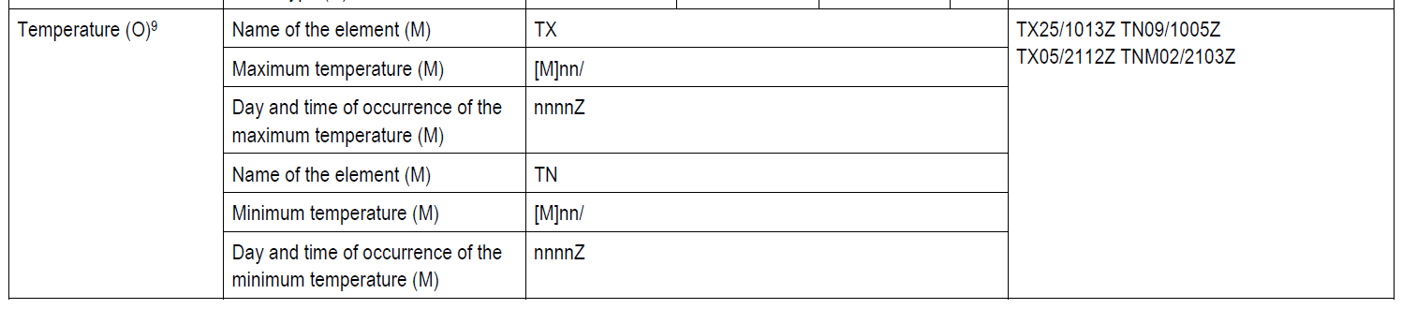
  - TAFs from around the world in 2017 indicated that only one aerodrome reported a single maximum or minimum, but there were a lot reporting 2 maxima + 1 minimum or 1 maximum + 2 minima. Only a few reported 2 maxima + 2 minima.

  - The following is a proposed resolution to the cases:
- Make iwxxm:maximumAirTemperature, iwxxm:maximumAirTemperatureTime, iwxxm:minimumAirTemperature and iwxxm:minimumAirTemperatureTime nillable or optional

  - We may want to inform WG-MIE as well to update the template as necessary.

- ICAO TCA issues ^{[3]}
  - There are cases where iwxxm:TropicalCycloneAdvisory cannot adequately describe the situation. In the issue raised, there are at least two of them:
- Only forecast positions are provided but not the associated maximum wind speeds.
- The tropical cyclone is forecast to dissipate before the first forecast time (i.e. +6 HR).

  - Making reference to Amendment 78 to ICAO Annex 3, neither the TAC template (see below) nor the examples give any clue that the mandatory forecast positions and forecast maximum wind speeds could be filled up with solidi.
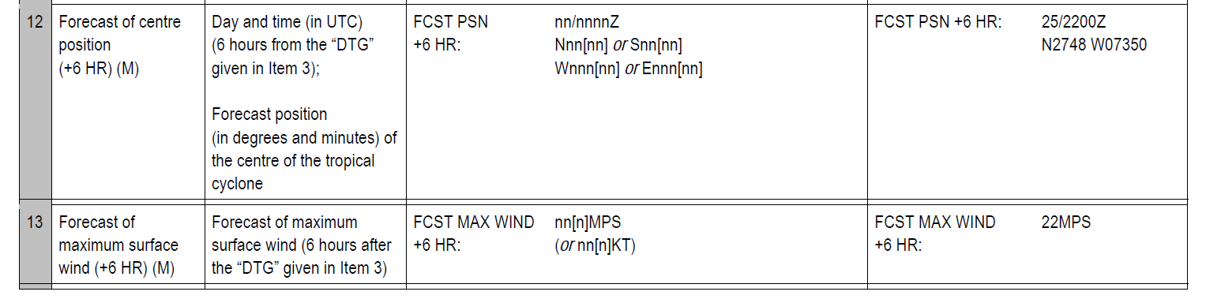
  - The following are proposed resolution to the cases:
- For the case in Para. 4.1(a), we may want to make iwxxm:forecast//iwxxm:maximumSurfaceWindSpeed nillable or optional.

- For the case in Para. 4.1(b), we may want to either:
- Make iwxxm:forecast//iwxxm:tropicalCyclonePosition nillable or optional, or
- Relax constraint TropicalCycloneAdvisory:TropicalCycloneAdvisory-2 so that iwxxm:forecast can be completely absent in an ordinary report

  - We may want to inform WG-MIE as well to update the template as necessary.

Conclusion
- For accepted resolutions it is further proposed to publish the another release candidate IWXXM 3.0.0RC4 for final checking before releasing the finalized IWXXM 3.0.0.

References
[1] Issue #162 (https://github.com/wmo-im/iwxxm/issues/162)
[2] Issue #165 (https://github.com/wmo-im/iwxxm/issues/165)
[3] Issue #166 (https://github.com/wmo-im/iwxxm/issues/166)

Recommended Text
TT-AvXML confirmed the issues raised and has determined resolutions [to be included] to be applied to IWXXM 3.0.0RC3. Another release candidate IWXXM 3.0.0RC4 will be released for checking before the publishing of the finalized IWXXM 3.0.0 by Nov 2019. It is also noticed that the identified root causes of the issues are mostly related to the TAC templates of ICAO Annex 3. It is further proposed to forward the findings and the consequences of the resolutions to WG-MIE for their information and necessary action.

--------------------

