WMO governance and data representations

Background

WMO is a specialized agency of the United Nations (UN) with 194 Member States and Territories undersigning a Convention that is establishing the purposes, membership, and bodies of the Organization. In particular, the Convention established the following bodies:
- World Meteorological Congress as the supreme body of the Organization
- Executive Council as the executive body responsible to Congress for the coordination of the programmes of the Organization and the utilization of its budgetary resources following the decisions of Congress.
- Regional Associations as the promoters of the execution of Congress and Executive Council resolution in their respective Regions
- Technical Commissions, consisting of technical experts, have the role of making studies and recommendations to Congress and the Executive Council.
- Permanent Secretariat of the Organization with functions of supporting the work of the Organization.

Manual on Codes
WMO technical regulations are published as WMO publication No. 49 and its Annexes. The regulations are designed:
(a) To facilitate cooperation in meteorology and hydrology among Members;
(b) To meet, in the most effective manner, specific needs in the various fields of application of meteorology and operational hydrology in the international sphere;
(c) To ensure adequate uniformity and standardization in the practices and procedures employed in achieving (a) and (b) above.
The regulations are of two types:
- Standard practices and procedures:
  - Shall be the practices and procedures that Members are required to follow or implement;
  - Shall have the status of requirements in a technical resolution in respect of which Article 9 (b) of the Convention is applicable;
  - Shall invariably be distinguished by the use of the term shall in the English text, and by suitable equivalent terms in the Arabic, Chinese, French, Russian and Spanish texts.
- Recommended practices and procedures:
  - Shall be the practices and procedures with which Members are urged to comply;
  - Shall have the status of recommendations to Members, to which Article 9 (b) of the Convention shall not be applied;
  - Shall be distinguished by the use of the term should in the English text (except where otherwise provided by the decision of Congress) and by suitable equivalent terms in the Arabic, Chinese, French, Russian and Spanish texts.
In particular, the WMO Manual on Codes (WMO Publication No. 306) Volume I is Annex II to the Technical Regulations, has regulatory value and contains both standard and recommended practices and procedures.
The Manual on Codes is composed of two volumes:
- Volume I International Codes
- Volume II Regional Codes and National Coding Practices
Only Volume I is considered regulatory material for its international aspect. Manual on Codes Volume I has several parts:
- Volume I.1
  - Part A Alphanumeric Codes
- Volume I.2
  - Part B Binary Codes
  - Part C Common Features to Binary and Alphanumeric Codes
- Volume I.3
  - Part D Representations derived from data models

Amendments to the Manual on Codes
It is a function of Congress to determine technical regulations and therefore changes to the technical regulations and in particular to the Manual on Codes are adopted by Congress. In some cases however the Congress delegates Executive Council or the President of WMO to adopt amendments to the technical regulations if the financial implications are not relevant and if there is the urgency to approve the regulations for operational reasons.
There are three types of procedure for the amendment of Technical Regulations: simple, standard and complex.

Simple (fast-track) procedure
The simple procedure is used only for specific components of the Manual that are already marked for fast-track. An example is the code lists. Usually, the changes using fast-track procedure don’t require software changes, and their cost of implementation is not relevant.
A schema of the procedure is reported in the following figure. The requirements for a change are submitted to the Expert Team (ET) responsible for the specific part of the Manual. The ET decides how to implement the request and drafts a proposed change. The Chair of the relevant Standing Committee approves the draft which is submitted, with an implementation date, to the National Focal Points (NFP) for Coding Matters for consultation. NFPs have two months for submitting a comment or a request. After this consultation period, the comments have to be responded, and eventual requests are taken into consideration, and the draft change is submitted to the President of the Technical Commission and after approval to the President of WMO for adoption.
The simple procedure is fast compared to other amendment procedures, and it is performed twice a year.

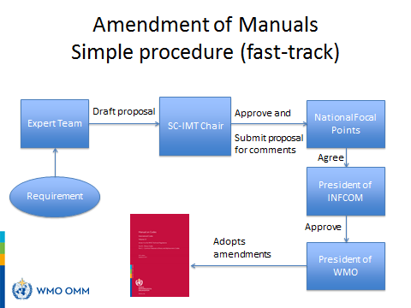

Standard procedure (approval between Technical Commission sessions)
The standard procedure can be applied when the change has operational implications, but minor financial impact. A schema of the procedure is reported in the following figure. The requirements for a change are submitted to the Expert Team (ET) responsible for the specific part of the Manual. The ET decides how to implement the request and drafts a proposed change. The Chair of the relevant Standing Committee approves the draft which is submitted, with an implementation date, to the Members (actually to the Permanent Representative of the Member). PRs have two months for approving or rejecting the proposal. After this consultation period, if the proposal is accepted, the draft change is submitted to the Executive Council for adoption.
The standard procedure can only be performed once a year and it is constrained in time by the Executive Council sessions that has yearly frequence.

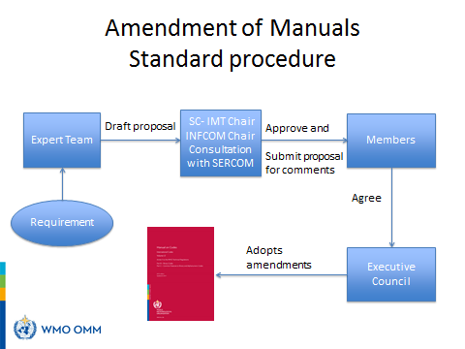

Complex procedure (approval during Technical Commission session)
The manuals are amended using the complex procedure when there is operational impact, and the financial implications are relevant. In this case the draft proposal has to be approved during a Technical commission session before being submitted to Congress for adoption. A schema of this procedure is reported in the following figure. The duration of the procedure can be of several years because the Technical Commission session is scheduled every two years and Congress every four years with the possibility of an extraordinary Congress between two ordinary Congress sessions.
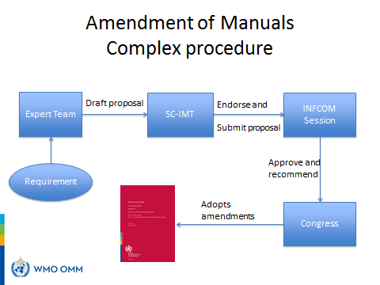

Conclusions
The data representations are part of the WMO Manual on Codes and are meant to serve the operational needs of WMO Programmes. Expert Teams dealing with amendments of the Manual on Codes are of key importance to draft the amendments and start the procedure for the change of the Manual. Due to the mandatory aspect of the Manuals it is important to take into consideration the operational and financial impact on Members of the proposed amendments, and at this purpose the changes are submitted for consultation so that the Members have an opportunity to request modifications, delay the change or oppose to it.

--------------------

