GISC Melbourne Status Report
- Area of Responsibility
  - AMDCN connectivity 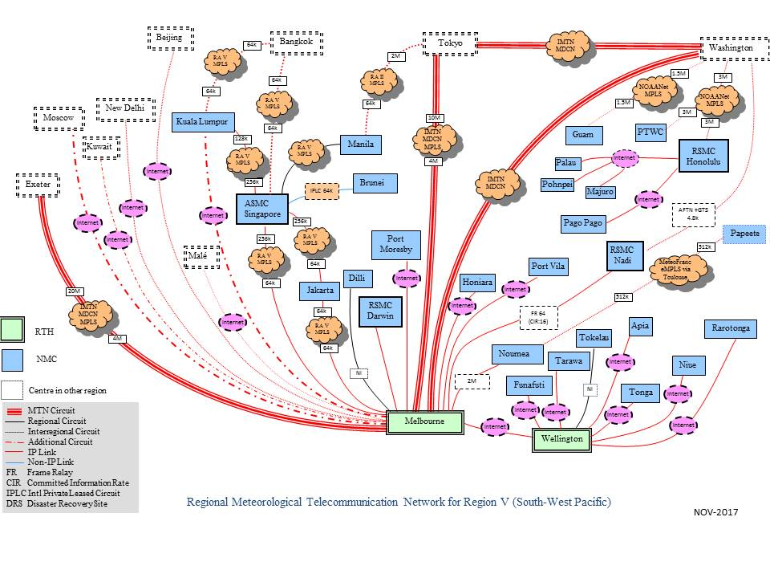

  - Link to Singapore has upgraded from 64K to 2Mb since 20 Aug 2019.

  - DCs WIS compliance

- Training – Capacity building activity
  - No new training activity in 2019
- Operational issues in last period
  - Metadata synchronization with GISC Seoul still has problem. Working on a solution.
- GISC Back up and activities
  - Slow progress on GISC backup with JMA. Backup proposal has been made and discussed. Working on backup procedures.
- Monitoring Activity & volume
  - Conducted GISC Watch from March 2019
  - Cache volume: ~1.8G/day (GTS input)
  - Data dissemination: ~ 6G/day
  - Uptime: 99.99%
- Changes in GISC, including new features since last meeting
  - No major OpenWIS system upgrade since November 2017.
- Progress on action items

- Outlook (planned changes/improvements)
  - In preparation for OpenWIS system middle-ware upgrade.

- Any other issues of interest
  - None
- Summary (Text for report)
WIS/GTS operation of GISC Melbourne and centres in its AoR has been functioning as expected.

