GISC Ticket System
- This document reviews GISC ticket management experience and propose discussion points.
  - Status update flow
  - Priority level and criteria
  - GISC watch escalation

General Information
- TT-GISC2017 developed a GISC Watch procedure to be operational from the beginning of 2018 and the plan was presented at the CBS TECO-2018, Geneva 26-29 March 2018. To maintain the issues TT-GISC establish the Issue Tracking system with strong support from GISC Brasilia. Thanks to GISC Brasilia GISC Watch programme started on 1st May 2018.
- The ticketing system is for managing the issues. On-Duty GISC issues/opens a ticket when the problem is detected and then watches it until the problem is resolved. The open tickets are handed over to the next On-Duty GISC according to pre-agreed roster [1].
- The ticketing system is working on Mantis [2] and maintained by GISC Brasilia.

Status update
- There are seven types of status in the ticketing system to share the current status of each issues with all GISCs. (new, assigned, feedback, acknowledged, confirmed, resolved and close)
- From the one year experience of the GISC ticket system, the status of each issue was maintained very flexibly and some issues had not been changed. The status should be changed by common procedure. Proposed status changing flow is attached in this document.
- BUFR issue ticket should be maintained by the same way.

- Status Changing Flow
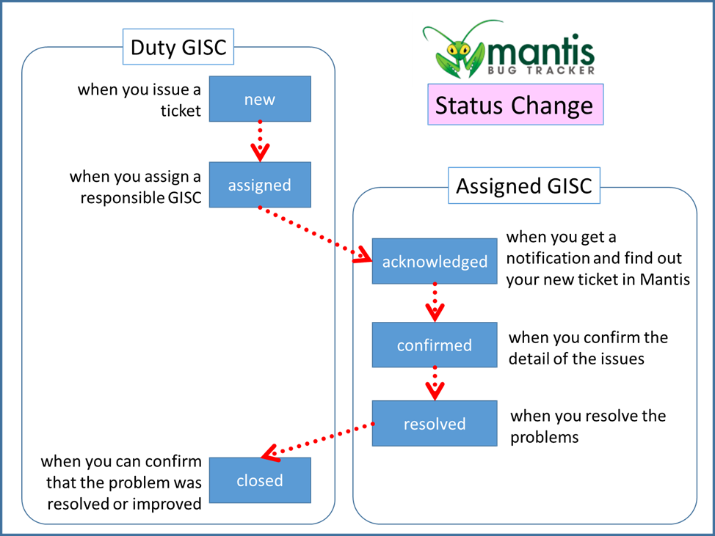

Priority Level and criteria
- The number of priority levels
  - As of 5th August, 83 GISC ISSUE TICKETs had been issued since the beginning of GISC Watch practice on 1st May 2018, and 48 BUFR Upper Air ticket had been issued since in the beginning of this year.
  - The priority level of each issue in Mantis ticketing system [2] can be set by six levels of priority (non, low, normal, high, urgent and immediate), but we used 3 out of 8 priority levels for GISC ISSUE. The priority level of the ticket have been set by each On-Duty GISC idea. And also 1 out of 8 priority levels for BUFT Upper Air issues were set by secretariat.
  - Only 3 out of 8 priority level (normal, high and immediate) have been used by both GISC ISSUE and BUFR Upper-Air project so far. Details are shown in the following table.

As of 5th August 2019
Priority | GISC ISSUE TICKET | BUFR Upper Air
Non | 0 tickets | 0 tickets
Low | 0 tickets | 0 tickets
Normal | 75 tickets | 0 tickets
High | 6 tickets | 48 tickets
Urgent | 0 tickets | 0 tickets
Immediate | 1 ticket | 0 tickets
Total | 82 | 48

- Criteria of priority
  - We should consider how many types of priority we need and define the criteria of each priority level.
Level | Impact | Sample of problem
Immediate | - the issue will bring a serious impact on whole WIS operation;  - all GISCs need to take immediate action | - massive blackout  - total failure of Systems  - natural disaster
Urgent | ?????? | ???????
High | - one or more essential services are not provided  - GISCs cannot synchronize data and metadata | - essential services are offline  - Web services is  - impossible to up/download
Normal | - essential services are not affected | - Monitoring procedure  - Json.file file format error
Low | ?????? | ??????
Non | ?????? | ??????

GISC Watch Escalation
- Regulation
  - The Cg-18 approved the GISC Watch Programme to be operational the activities officially and updated the Guide to WIS (No. 1061) Part VIII and its APPENDIX. The amendments are available from Cg-18/Doc.6.2(2)-Annex1[3].
  - “The GISC Watch Programme noted that the issue tracking system is used manage and escalate issues as needed”.
- Roster Rules
  - TT-GISC2017 agreed Roster Rules to hand over the tasks to next on-duty GISC. The rule [1] included following paragraph for escalation.
  - “ g) For any issues related to GISC Watch that requires escalation, the Chair of TT-GISC is the first escalation point for all GISCs”
- We already have a way of escalation above, however there was no escalation since the GISC Watch started on 1st May 2018. That’s because we don’t have a clear criteria for each priority level of issues to make a decision, whether the issue should be escalated or not.
- Escalation criteria will be defined after the priority criteria has been defined.
  - For example, “higher than immediately”

References
[1] Roster Rules: https://wiswiki.wmo.int/tiki-index.php?page=TT-GISC-ops&pagenum=13#GISC_Watch_tasks
[2] Mantis: http://www.inmet.gov.br/giscticket/
[3] Approved document Cg-18/Doc.6.2(2)-Annex1: http://meetings.wmo.int/cg-18/English/Forms/AllItems.aspx?RootFolder=%2Fcg%2D18%2FEnglish%2F2%2E%20PROVISIONAL%20REPORT%20%28Approved%20documents%29&FolderCTID=0x0120001ACDAD42B598C94285DCAF83C8065259&View=%7BBCBCFAB5%2D575A%2D4FDD%2D8C95%2D3DA2AED66065%7D

Recommended Text
[Include here suggested text for inclusion in Report, including any proposed amendments to the Manual or Guide to WIS, Manual on GTS or guides.]

--------------------

