GISC status report
GISC Tokyo is connected to the RMDCN, MPLS provided by NTT com, and two dedicated lines for exchanging meteorological information. GISC Tokyo is also connected to the internet at 100Mbps speed.

Area of responsibility
GISC Tokyo covers the following 18 centers:
Country | Type | Function
Cambodia | NC | NMC
Lao People's Democratic Republic | NC | NMC
Myanmar | NC | NMC
The Philippines | NC | NMC
Thailand | NC | NMC
Thailand | DCPC | RTH Bangkok
Viet Nam | NC | NMC
Japan | NC | NMC
Japan | DCPC | RTH Tokyo
Japan | DCPC | GPC/LRF
Japan | DCPC | NICT (Space Weather)
Japan | DCPC | RSMC-Geographical
Japan | DCPC | RSMC-Activity-TC
Japan | DCPC | RSMC-Activity-ATM
Japan | DCPC | RCC (Tokyo NCC, RA II)
Japan | DCPC | Satellite Centre
Japan | DCPC | WDC-GHG
Japan | GISC | GISC Tokyo

Connectivity
The communication line between Hanoi and Tokyo was started its operation in last September. GISC Tokyo also upgraded the connection speed of MPLS (NTT Com) from 2Mbps to 6Mbps in last November. The connection between Washington and Tokyo was restarted in July on the internet via the MPLS. The line between Hong Kong and Tokyo was migrated from the WMO socket to the batched FTP in August. The connection between Vientiane and Tokyo is planned to establish by the end of this year via the internet.
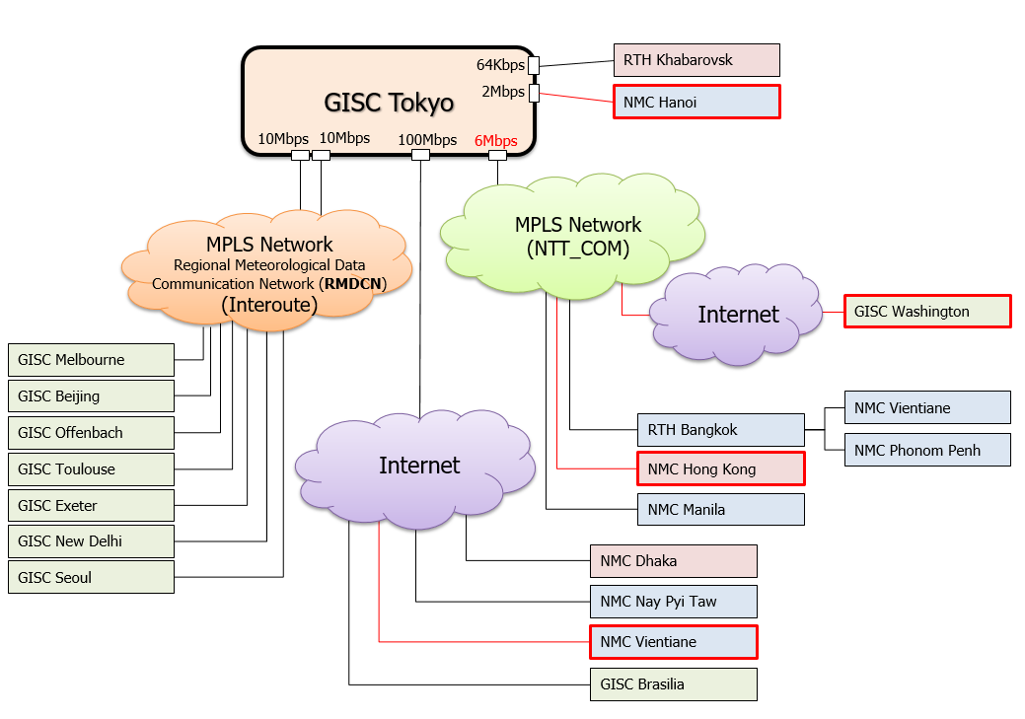

Metadata set
GISC Casablanca’s AoR metadata were migrated from WIS-UNASSOCIATED dataset to WIS-GISC-CASABLANCA in last December. GISC Tokyo started Oman’s metadata management in June in response to the request from Oman and WMO. GISC Tokyo holds the following metadata sets:
GISC | Metadataset | Harvest time
Beijing | WIS-GISC-BEIJING | 00 and 12 UTC
Brasilia | WIS-GISC-BRASILIA | 00 and 12 UTC
Casablanca | WIS-GISC-CASABLANCA | 00 and 12 UTC
Exeter | WIS-GISC-EXETER | 00 and 12 UTC
Jeddah | WIS-GISC-JEDDAH | suspended
Melbourne | WIS-GISC-MELBOURNE | 00 and 12 UTC
Moscow | WIS-GISC-MOSCOW | 00 and 12 UTC
Offenbach | WIS-GISC-OFFENBACH | 00 and 12 UTC
Seoul | WIS-GISC-SEOUL | 00 and 12 UTC
Tehran | WIS-GISC-TEHRAN | suspended
Tokyo | WIS-GISC-TOKYO | -
Tokyo (WIMMS) | WIS-TOKYO-VCCC (Colombo)  WIS-TOKYO-VGDC (Dhaka)  WIS-TOKYO-OOMS (Muscat)  WIS-UNASSOCIATED | -
Toulouse | WIS-GISC-TOULOUSE | 00 and 12 UTC
New Delhi | WIS-GISC-NEWDELHI | plan
Pretoria | WIS-GISC-PRETORIA | plan
Washington | WIS-GISC-WASHINGTON | plan

Training – Capacity building activities
The 1st WIS workshop was held in 2010. Since then GISC Tokyo has taken place the workshops for capacity building every two years. In May 2019, the 5th WIS workshop was held at the headquarters of the JMA, Tokyo. Twelve participants were invited from Cambodia, Lao Republic, Myanmar, the Philippines, Thailand and Vietnam, and three lecturers were invited from Australia, China and Germany.
The main topic of this workshop was the WIS 2.0 implementation approach, which was approved by the eighteenth World Meteorological Congress (Cg-18), and the GISC Tokyo Cloud Pilot Project. The WIS 2.0 is a game changer for the telecommunications among WMO members, and we need to take actions. The GISC Tokyo Cloud Pilot Project aims to help GISC Tokyo’s AoR members, and also to facilitate the migration of WIS 2.0. Taking an opportunity of this workshop, GISC Tokyo addressed AoR members to join Tokyo’s Pilot Project.
[TT-GISC: Action Item 18/1-12] GISC Tokyo provided training materials, which were handed in at the past workshops (2014 and 2016), in line with the request from TT-GISC-2018. The materials of the WIS workshop in Tokyo this year will be available soon from TT-GISC TrainingAids [1].
GISC Tokyo has also continued to hold an onsite technical meeting at each country. In April 2018, GISC Tokyo visited Lao PDR and Vietnam to discuss about metadata quality issues and establishment AMDCN network. GISC Tokyo will have opportunities to hold onsite technical meeting in couple of countries every year.

Monitoring activity
GISC Beijing and Tokyo are offering the Common Dashboard (WCD) service [2, 3]. The WCD is used as the GISC Watch monitoring tool, all GISCs monitor and report operational issues. GISC Tokyo performed GISC Watch duty during the below periods.
The first time: 1st May – 15th May, 2018
The second time: 16th December – 31st December, 2018
The third time: 1st August – 15th August, 2019

Current issues Assigned to Tokyo
- “Size of Data and Products in 24h cache” is showing zero. (5th July, 2018)
- The WCD shows no response (OAI-PMH and SRU) to GISC Tehran from Tokyo. (18th June, 2018)
- Invalid BUFR upper air reports. (28th February, 2019)
47580: MISAWA AB (plan to be terminated by the end of March)
47681: HAMAMATSU AB (terminated on 30th June)
89532: SYOWA

GISC backup activities

Backup connection between GISC Beijing and GISC Tokyo
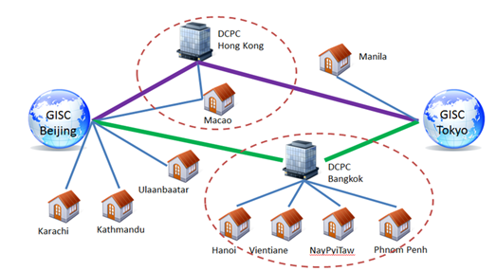
GISC backup connection between GISC Beijing and Tokyo is in operational by using GTS and DAR service. Beijing and Tokyo utilize an opportunity to have a face to face meeting is held every year, have been exchanging a list of backup bulletins, reviewing backup procedure documents since the backup operation was started.

Backup connection between GISC Offenbach and GISC Tokyo
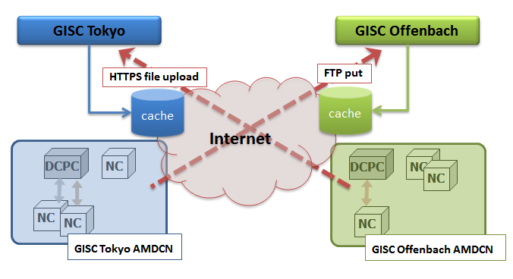
GISC backup between GISC Offenbach and Tokyo is in operational stage by using internet. Offenbach and Tokyo have had teleconference meeting to discuss backup project and metadata management every month.
Thanks to GISC Offenbach and Cyprus, the backup connection was established by https upload method in June 2019.

Backup connection between GISC Melbourne and GISC Tokyo
Signed letters on GISC backup were officially exchanged in March 2012. Tokyo has 2 options to implement GISC backup for GISC Melbourne’s AoR. Since then, Melbourne and Tokyo have had face to face meeting to move forward with backup project.

Traffic volume, number of users and uptime

Traffic volume of GISC Tokyo

Number of users

Uptime
There might be a few minutes break caused by hardware troubles in last fall. Except for this accident, GISC Tokyo system has been working well since the system replacement was implemented in March 2018. The uptime during last period was 99.99%.

Operational issues in last period
GISC Tokyo’s portal, OAI-PMH provider, SRU and so on were not available due to network equipment troubles in November. As Tokyo reported at the last TT-GISC meeting, there had been a network performance problem on GISC Tokyo. GISC Tokyo and system supplier were able to fix this issue by system tuning in August.

Changes in GISC, including new features since last meeting
GISC Tokyo plans to install “time series feature” on the WCD in line with the decision of TT-GISC 2018.

Progress on action items
[TT-GISC: Action Item 18/1-11] Metadata harvest interval in Tokyo was changed from once to twice a day on 5th November. GISC Tokyo also did full metadata harvest in November, February and May.

Outlook (planned changes/improvements)
There are some metadata, WMO core profile version of which are 1.2, in Tokyo’s dataset. GISC Tokyo is planning to upgrade core profile version to 1.3, and set DistributionScope.

Any other issues of interest
GISC Tokyo did a survey for the confirmation of GISC Tokyo user usage status for enhancement security. Some users wanted not to use continually, so GISC Tokyo deleted some user accounts.

References
[1] TT-GISC TrainingAids: https://wiswiki.wmo.int/tiki-index.php?page=TrainingAids
[2] CMA’s common dashboard: http://mon.wis.cma.cn/WCD/
[3] JMA’s common dashboard: https://www.wis-jma.go.jp/wcd/v1/top.html

Recommended Text
Shuichi Ikeda reported the current status of GISC Tokyo and the capacity building activity toward the WIS 2.0 implementation. GISC Tokyo provided training materials, which were handed in at the workshop, in line with the request from TT-GISC-2018. The materials are available from TT-GISC TrainingAids.
--------------------

