24 Hour Cache Completeness

Background
TT-GISC developed and agreed about providing a GISC Cache. Two types of Caches have been defined ([1]): The GISC Core cache and the GISC Regional cache.
Each GISC is required to hold all data flagged as “dataCentre GlobalExchange” from thesaurus WMO_DistributionScopeCode according to the Manual on WIS (9.1.1) for a minimum of 24 hours in its Core Cache. In theory this cache should be the same at every GISC. Data not flagged for GlobalExchange can be cached at the GISC Regional Cache subject to the needs of the GISC and its Area of Responsibility. Relevant information can be found in [2].
Recalling the discussion at TT-GISC 2016 [3] many of the Metadata is still in the old format WMO Core Profile 1.2 and thus missing the DistributionScope entry.

Howto
To achieve this it was agreed, that TT-GISC maintains the list of Core Cache data types, which are information flagged with “GlobalExchange”. All GISCs are required to have a common holding (according to the Manual on WIS 3.5.3.1) of this data. The list should be published through the WMO Secretariat.
Each GISC has to monitor the list and make sure, that it receives and stores to the cache all data that is marked for Global Exchange.
Problem
There are two problems with Cache Management currently:
- There is no list of Global Exchange Data available
- GISCs have to make sure they receive all Global Exchange Data

List of Global Exchange Data
Officially despite being still used in practice the Catalogue of available bulletins (WMO Volume C1) is deprecated. Thus some centers stopped maintaining their Volume C1 entries already which resulted in that some of the Globally Exchanged Data is not listed in Volume C1 any more.
Metadata in WIS is supposed to be a replacement for Volume C1. As such, all data available should be described in Metadata and Metadata synchronized among GISCs. However since the beginning of WIS there is still data on the GTS which does not have Metadata (approx.. 80000 data sets) and the synchronization is still incomplete. The latter issue being addressed in WP-5 of TT-GISC.
GISC Toulouse provided an updated statistics of the TT-GISC 2016 report [3] of the Volume und Version of Metadata and Cache reception at GISC Toulouse. This update indicates, that many Metadata do not include the distribution scope keyword which is necessary to determine if data is to be stored in the 24 hour cache (see appendix).

Ensure all data is received
Because there is no List of Global Exchange Data available it is impossible for GISCs currently to ensure that all Global Exchange Data is received. This however is vital to achieve the goal of a common 24 hour Cache for essential data as required by the Manual on WIS.
In order to solve this, the following steps would be required at GISCs:
- Monitor the list of available data for updates
- Check whether new data is received
- If not organize the reception of the new data
- Store the data to the Cache
Evaluation of Cache consistency should become a regular task. This might be added to the duties of GISC Watch or become part of the WIS monitoring information provided by GISCs.

As the evaluation of GISC Toulouse shows, there is still a dark set of data, that is not received at GISCs
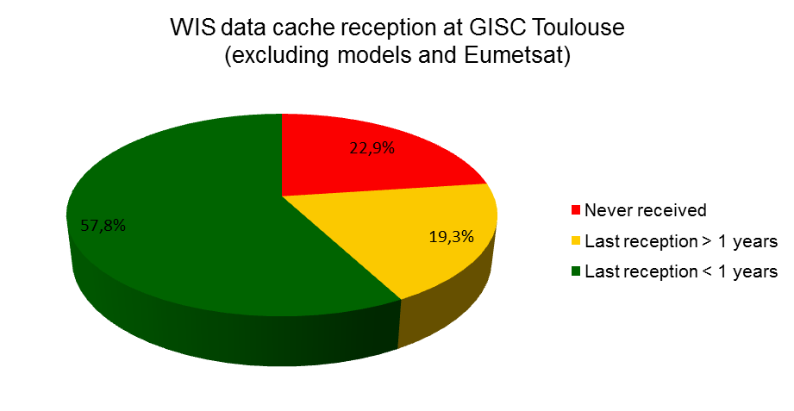

Poor Metadata
Another issue when trying to determine the contents for the 24 hour cache is the quality and granularity of the data. The analysis by GISC Toulouse shows, that there still is a large set of metadata describing NWP products at a very fine level which leads to an unnecessary large volume of Metadata
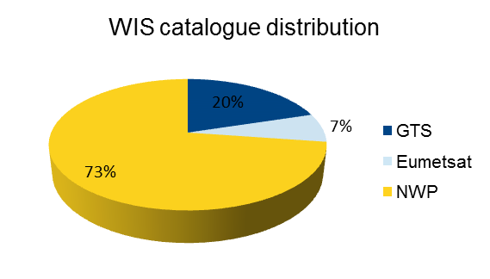

Proposal
It is not required to maintain a list of Global Exchange Data at TT GISC. If Metadata was complete and up-to-date a list of available data can be generated via SRU. For example using one of the two SRU requests:
https://sru.dwd.de/SRU2JDBC/sru?operation=searchRetrieve&version=1.1&startRecord=1&query=GlobalExchange&stylesheet=xsl/dwd-sru.xsl&x-dwd-stylesheetDetailLevel=1
https://sru.dwd.de/SRU2JDBC/sru?operation=searchRetrieve&version=1.1&startRecord=1&query=%22uuidref=globalexchange%22&stylesheet=xsl/dwd-sru.xsl&x-dwd-stylesheetDetailLevel=1

However as for the metadata quality consistency it is essential to CREATE, MAINTAIN and correctly FLAG the metadata sets. Additionally it is essential to MONITOR synchronization STATUS and UPDATES. Thus more attention on metadata has to be given by Data Originators, GISC operators and GISC Watch.
In order to be able to solve the Cache completeness requirement the problem with the metadata quality and consistency has to be solved. It is important that centers provide metadata for every data they distribute and it is important that updates in metadata are correctly synchronized and monitored. Only then the WIS catalogue can act as base for global data exchange.

Additional Procedures

Procedure to ensure global dissemination of data
- The TT-GISC estimates the peak bandwidth used for the exchange of the Core Cache data by regular analysis of results from WIS Monitoring.
- The TT-GISC coordinates and agrees on the minimum bandwidth required for each GISC to ensure the exchange of the Core Cache data.
- Where TT-GISC cannot agree, or are unable to meet the expectations of the data originator or user community, the decision will be escalated to the ITT-WIS for consideration of the President of CBS through Chair of OPAG-ISS.
- TT_GISC implements a monitoring procedure to detect missing data and follow-up actions to fill-in the gaps.

Procedure to ensure holding of all GlobalExchange data at GISCS
A GISC shall:
- connect to all other 14 GISCs directly and send its AoR data to other GISCs
- monitor the status of its core cache to improve cache completeness
- monitor available GlobalExchange data for updates

References
[1] TT-GISC ops: GISC Cache types: https://wiswiki.wmo.int/tiki-index.php?page=TT-GISC-ops&pagenum=5#GISC_Cache
[2] TT-GISC_ops: GISC core cache: https://wiswiki.wmo.int/tiki-index.php?page=TT-GISC-ops&pagenum=6
[3] Benjamin Saclier (MF): Cache Data Reception, TT-GISC 2016, AI 8

Recommended Text
Many of the issues or requirements within WIS strongly depend on the quality, accuracy and consistency of the Metadata. Additionally the granularity of Metadata is important. WIS is all about Metadata thus special care has to be taken on this matter. TT GISC noted the importance of Metadata and Metadata Synchronization for the functioning of WIS
TT GISC proposes, that the requirement to maintain a list of data for Global Exchange is removed from the GISC-OPS Page and is instead replaced by a link to access this information via SRU.
Recalling the recommendations from TT-GISC 2016 all GISCs should encourage NCs and DCPCs to migrate to WMO Core Profile 1.3 and use the “globalexchange” keyword in order to clarify the data which shall be stored in the global cache.
TT GISC agreed to add and follow-up on the following action items:
- Each GISC has to add to its Core Cache all data flagged for GlobalExchange.
- Each GISC has to implement procedures to monitor and update the GlobalExchange data to reflect changes in the Metadata. Procedures to receive all GlobalExchange data have to be taken by each GISC.
- All Metadata has to be migrated to WMO Core Profile 1.3. GISC Toulouse can offer assistance on this. Each GISC has to make sure, that all Metadata contains the GlobalExchange Keyword.
- Address the following issues (in order of priority)
  - Synchronization Status
  - Metadata Quality
  - Metadata Granularity
- TT-GISC implements procedures to monitor and follow-up issues on the Core Cache Completeness

Appendix

Scope and Access permissions for data in the 24 hour cache

Evaluation of the Metadata and Cache contents
 |  |  | FULL CACHE
 |  |  | Including models |  | Excluding NWP |  | Exluding NWP+EumetSAT
 |  |  | Nb of MD | % | Nb of MD | % | Nb of MD | %
 |  | Total of MD | 42309 |  | 11539 |  | 8552
 | Status | Essential | 37571 | 88,8% | 9433 | 81,7% | 6446 | 75,4%
 | Status | Additionnal | 3518 | 8,3% | 886 | 7,7% | 886 | 10,4%
 | Status | Others or empty | 1220 | 2,9% | 1220 | 10,6% | 1220 | 14,3%
 | Version | Core 1.2 | 7414 | 17,5% | 6529 | 56,6% | 3543 | 41,4%
 | Version | Core 1.3 | 13382 | 31,6% | 4636 | 40,2% | 4635 | 54,2%
 | Version | No information | 20000 | 47,3% | 374 | 3,2% | 374 | 4,4%
 | Cache | Never received | 28522 | 67,4% | 3276 | 28,4% | 1957 | 22,9%
 | Cache | Last reception > 1 years | 4674 | 11,0% | 2961 | 25,7% | 1652 | 19,3%
 | Cache | Last reception < 1 years | 9113 | 21,5% | 5302 | 45,9% | 4943 | 57,8%
 | METADATA Repartition | AMMC | 1049 | 2,5% | 1049 | 9,1% | 1049 | 12,3%
 | METADATA Repartition | BABJ | 278 | 0,7% | 278 | 2,4% | 278 | 3,3%
 | METADATA Repartition | EDZW | 7056 | 16,7% | 5837 | 50,6% | 2850 | 33,3%
 | METADATA Repartition | EGRR | 1864 | 4,4% | 132 | 1,1% | 132 | 1,5%
 | METADATA Repartition | GMMC | 472 | 1,1% | 472 | 4,1% | 472 | 5,5%
 | METADATA Repartition | LFPW | 2024 | 4,8% | 935 | 8,1% | 935 | 10,9%
 | METADATA Repartition | OEJD | 56 | 0,1% | 56 | 0,5% | 56 | 0,7%
 | METADATA Repartition | OIII | 63 | 0,1% | 63 | 0,5% | 63 | 0,7%
 | METADATA Repartition | RJTD | 21762 | 51,4% | 213 | 1,8% | 213 | 2,5%
 | METADATA Repartition | RKSL | 86 | 0,2% | 86 | 0,7% | 86 | 1,0%
 | METADATA Repartition | RUMS | 5053 | 11,9% | 757 | 6,6% | 757 | 8,9%
 | METADATA Repartition | SBBR | 165 | 0,4% | 165 | 1,4% | 165 | 1,9%
 | METADATA Repartition | XXXX | 2381 | 5,6% | 1496 | 13,0% | 1496 | 17,5%
 | CACHE reception repartition | AMMC | 730 | 8,0% | 730 | 13,8% | 730 | 14,8%
 | CACHE reception repartition | BABJ | 247 | 2,7% | 247 | 4,7% | 247 | 5,0%
 | CACHE reception repartition | EDZW | 2805 | 30,8% | 1855 | 35,0% | 1496 | 30,3%
 | CACHE reception repartition | EGRR | 395 | 4,3% | 84 | 1,6% | 84 | 1,7%
 | CACHE reception repartition | GMMC | 232 | 2,5% | 232 | 4,4% | 232 | 4,7%
 | CACHE reception repartition | LFPW | 1868 | 20,5% | 779 | 14,7% | 779 | 15,8%
 | CACHE reception repartition | OEJD | 24 | 0,3% | 24 | 0,5% | 24 | 0,5%
 | CACHE reception repartition | OIII | 17 | 0,2% | 17 | 0,3% | 17 | 0,3%
 | CACHE reception repartition | RJTD | 179 | 2,0% | 179 | 3,4% | 179 | 3,6%
 | CACHE reception repartition | RKSL | 80 | 0,9% | 80 | 1,5% | 80 | 1,6%
 | CACHE reception repartition | RUMS | 1886 | 20,7% | 425 | 8,0% | 425 | 8,6%
 | CACHE reception repartition | SBBR | 105 | 1,2% | 105 | 2,0% | 105 | 2,1%
 | CACHE reception repartition | XXXX | 545 | 6,0% | 545 | 10,3% | 545 | 11,0%

