Operational Information Exchange

Background
ET-WISC 2019 installed a Work Package on developing guidelines for the Exchange of Operational Information [1]. At TT-GISC 2018 the scope of the gisc_ops mailinglist was discussed. This paper takes one step forward in defining guidelines for Operational Information Exchange and wants to open for discussion on the scope and usage of the gisc_ops Mailinglist. As a result this document defines the guidelines for the communication between GISCs and should then be extended to include NCs and DCPCs.

Communication Channels

Individual Email Addresses
Each GISC shall provide two generic Email Addresses. One for contacting Administrators, Operators and the WIS Focal Points of the GISC node, the other for operational contact points (24/7). The list of generic GISC email addresses is maintained by the chair of TT-GISC.

TT-GISC discussion and information forum
The Email Addresses for contacting GISC Operators should be included into the primary email group for TT-GISC: cbs-wisc-tt-gisc@wmo.int.

GISC Ops Mailing List
The Email Addresses for contacting 24/7 operators as well as the Email Addresses for contacting GISC Operators should be included into the email group gisc_ops@wmo.int.

Scope of GISC_OPS
This email group is to exchange information between GISCs relating specifically to GISC Operations, including GISC Watch. However it is unclear what the notion of specifically to GISC Operations entails. Thus we recommend extending the scope of gisc_ops to include
- Communication on GISC Watch
- Issues with the core WIS Services (OAI, SRU, Portal, …)
- Issues in data feeds
- Issues in products and production issues like delays for products that are disseminated on the WIS
Also the recipients of gisc_ops were defined to be GISC Operators. However this term is also different at different GISCs. Thus we recommend to define the gisc_ops Mailinglist to include GISC Operators, GISC Administrators / Technical Staff and 24/7 operators.
The aim for messages to gisc_ops is to get to the operations center (or help desk) of each GISC and to be monitored by staff on duty

RSS-Feed
Each GISC provides an RSS Feed via which changes in Metadata are announced. These feeds can also be used for other announcements like planned downtimes. In order to test operations / usability of the RSS-Feed DWD prepared an RSS service and can make notifications added to the feed subscribable.
DWD will announce the RSS service to all GISCs and all WIS centers in GISC Offenbach’s AoR. Interested centers can start subscribing, evaluate and provide feedback on the service.

Mantis Ticketing System
Problem reports shall be recorded in the GISC Ticketing System. In urgent cases the GISC should also be notified via Email to the operational contact address.

JSON-Files
Monitoring information is provided in JSON-Files. Responsible for guidance on this channel is the Subgroup on WIS Monitoring.

Disaster mode
Each GISC should prepare communication channels which are available if the primary channel fails and is unavailable. Such events include Network failures or similar technical problems. The minimum requirement for these disaster communication channels is that the Backup GISC can be notified about the problem which then takes over the communication on behalf of the GISC affected.
One proposal from TT GISC 2016 [1] is to prepare a Gmail account which can be accessed via cellular networks.

WIS 2.0 messaging
In WIS 2.0 Pub/Sub Messaging Protocols will be used. Using these protocols NCs/DCPCs and GISCs can publish Operational Information directly using Pub/Sub, whereas interested centers can subscribe to notifications they are interested in. Details on these topics should be addressed at TT-eWIS, the Pub/Sub Pilot Project and ET-CTS.

Information to send

Meteorological Notifications
Meteorological Notifications are messages, that are currently sent out on the GTS as NOXX// and that are received by all WMO members. These include changes in data feeds / services. As a replacement for METNO Messages we propose using the RSS-feed channel and the following procedure
- Announce changes in data feeds or offered services at least a week in advance by editing the corresponding Metadata
- Changed Metadata is synchronized among GISCs
- Each GISC receiving updated Metadata issues an entry to its GISCs RSS-feed which contains the PID of the updated Metadata
- Interested Centers subscribe to the RSS-feed and take action upon receiving new RSS entries

System Maintenance notification
System Maintenance notification is currently also sent out as NOXX// Message and are received by system operators. These messages contain announcements on changes that are affecting one of the four GISC functions (data transfer, oai, sru or portal). We propose the following procedure as a replacement for this
- Announce changes relevant to one of the four GISC functions at least a week in advance. NCs and DCPCs shall inform their principal GISC on changes that affect data transfer or the provision of metadata.
- Add information on the update as “System Event Notification” to the RSS-feed of the GISC
- Additionally sent the information to gisc_ops@wmo.int
- Further information channels can be used if required

Outage Information including Data availability
Information on unplanned outages in one of the four GISC services as well as information currently sent out to the GTS as NP//// including delays or interruptions in data feeds should be replaced by the following procedure
- Send information on the problem to gisc_ops@wmo.int
- When the problem is solved send a message, that services are recovered to gisc_ops@wmo.int

Problem reports
Issues noted by other parties for a center shall be reported by mail and cc’ed to the GISC on-duty. In case of NCs or DCPCs communication should be performed via the principal GISCs. This is not only limited to WIS issues, but addresses any issue in any WMO Program distributed on the WIS. The GISC on-duty should open a ticket in Mantis to follow-up the issue.

Relay of Information (GISC -> AoR)
Communication from Center to Center should be relayed through the involved GISCs. That is information should be sent by a center to its principal GISC, which either includes this information in its RSS-feed, or forwards the information to the relevant recipients principal GISC.

Conversely a GISC receiving a message or an RSS-feed update should forward this information to centers in its AoR.

Examples

Format of Meteorological Information in RSS-feed:
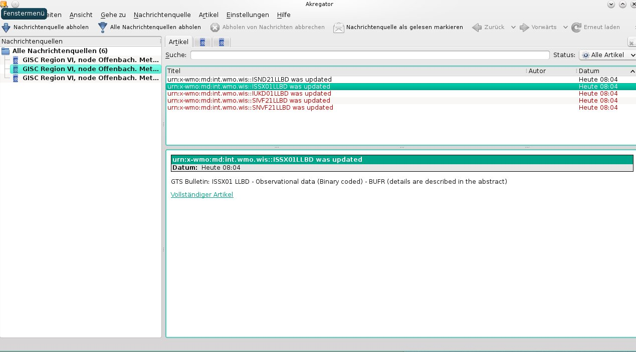

Format of Outage Information sent to gisc_ops
NPXX10 EDZW 010953
DWD OFFENBACH /GERMANY

ATTENTION: ALL RECIPIENTS OF EDZW NUMERICAL FORECAST
WE HAVE TROUBLE WITH THE IN-TIME PRODUCTION OF THE XX UTC MODEL RUN

AFFECTED PRODUCTS: [ICON/COSMO/EWAM/MOSMIX/...]
OUTPUT IS EXPECTED TO BE DELAYED BY 2 HOURS FROM THE USUAL TIME.

SORRY FOR ANY INCONVENIENCE
MET. SERVICEDESK EDZW

References
[1] Operational Information Exchange, ET-WISC 2019 AI 12

Recommended Text
ET-WISC 2019 discussed the need for regulations regarding Operational Information Exchange. The meeting noted, that there is the requirement to develop guidelines on what information to share and what exchange channels to use. TT-GISC developed these rules for GISC to GISC communication as a base to be extended to other centers and for inclusion in the Manual on WIS.
TT-GISC decided to
- maintain two lists of generic email addresses for
  - contacting GISC Operators and Focal Points (office hours)
  - contacting GISC Operators / 24/7 Operators (24/7)
- add 24/7 operators to gisc-ops@wmo.int
- update the usage of gisc-ops@wmo.int and reflect to TT-GISC-Ops web page.
- add notification providers (i.e. senders) to gisc-ops@wmo.int
- add notification recipients as agreed to gisc-ops@wmo.int
TT-GISC further decided to send the following notifications to the mentioned channels:
- NPXX// : GISC Ops Mailing List
- NOXX// : Add to GISCs RSS-Feed
TT-GISC noted that each GISC should prepare communication channels available that are available in disaster mode
TT-GISC asks TT-eWIS and ET-CTS to include Operational Information Exchange guidelines into the planned Pub/Sub mechanism for WIS 2.0

