Status Report GISC Brasilia
GISC Brasilia is connected to the Internet via two ISPs with total 1.4 Gbps.
GISC Brasilia is currently harvesting the following metadata sets:
GISC | Metadata set
Beijing | WIS-GISC-BEIJING
Exeter | WIS-GISC-EXETER
Casablanca | WIS-GISC-CASABLANCA
Melbourne | WIS-GISC-MELBOURNE
Moscow | WIS-GISC-MOSCOW
Offenbach | WIS-GISC-OFFENBACH
Seoul | WIS-GISC-SEOUL
Tehran | WIS-GISC-TEHRAN
Tokyo | WIS-GISC-TOKYO,  WIS-CATALOGUE,  WIS-UNASSOCIATED
Toulouse | WIS-GISC-TOULOUSE

AREA OF RESPONSIBILITY

Connectivity
GISC Brasilia has an Area of Responsibility (AoR) of 13 countries: Argentina, Paraguay, Uruguay, Chile, Bolivia, Colombia, Peru, Ecuador, Suriname, Guyana, Venezuela, French Guyana, Brazil. All NCs and DCPCs sending their data for global exchange to GISC Brasilia with no backup between another GISC, except Venezuela.

Training – Capacity Building Activity
No action is planned or currently ongoing.

Operational issues in last period
We have not received data from Venezuela for almost two years. We recently received a professional from there, who participated in some workshops with us, but we shall not guarantee that we will receive the data again.

GISC Backup and Activities
There were no advances in the definition of procedures for performing backups with other centres.

Monitoring Activity & Volume
GISC Brasília carried out the GISC Watch duty from 16th to 30th September 2018. Next roster is from 1st to 15th May 2019.
Brasília is responsible for administering the incident control tool for message exchange between GISCs since November 2017 (http://www.inmet.gov.br/giscticket).
Below is a summary of the incidents and their status so far.

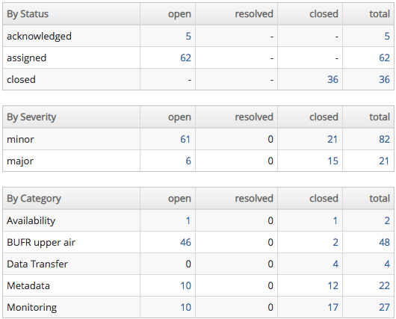

We are working on 4 issues related to BUFR Upper Air and 2 issues to Monitoring activities. I believe in the few days all of them will be resolved.

Traffic size and volumes, uptime, user registration
Daily GISC Brasilia receives 18GB of messages, divided into GRIB, TAC and BUFR formats; and sends about 63GB, as detailed bellow:

INPUT DATA
MSG TYPE | COUNT | BYTES | GB
GRIB | 177,582 | 15,979,906,654 | 14.88
TAC | 183,312 | 105,134,345 | 0.098
BUFR | 154,914 | 3,577,910,390 | 3.33

OUTPUT DATA
MSG TYPE | COUNT | BYTES | GB
GRIB | 627,726 | 48,465,129,006 | 45.14
TAC | 794,328 | 347,568,397 | 0.324
BUFR | 809,532 | 18,591,088,043.29 | 17.31
METADATA STATISTICS
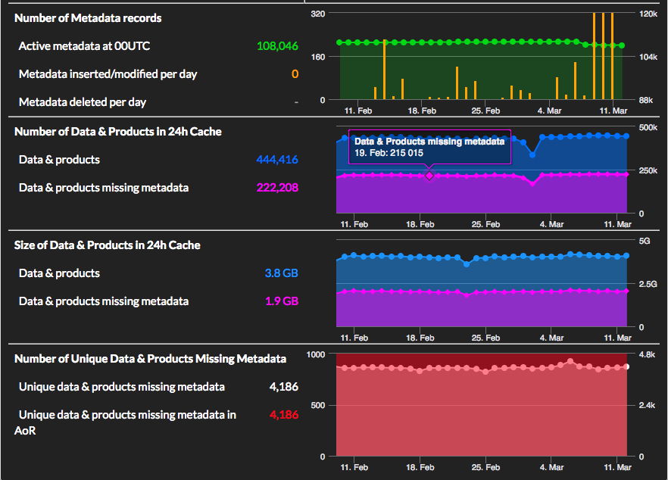
According to our availability records we are 99,5% uptime.

Changes in GISC
No actions planned to be put in place on short term.

Progress on action items
Refer to meeting documentation

Outlook
Brasilia accepted to participate in a pilot project for implementing and testing exchange of messages in Pub/Sub format. Scope to be defined.

References
[1] Status Report to TT GISC 2018

Recommended Text
The awareness of WIS in GISC Brasilia Area of Responsibility is good, although we are facing problems with Venezuela, the other countries are sending their data as expected. Members would like to know more about WIS 2.0 and how this might affect their systems.
--------------------

