GISC Melbourne Status Report
- Area of Responsibility
  - AMDCN connectivity AAfdsafdsaf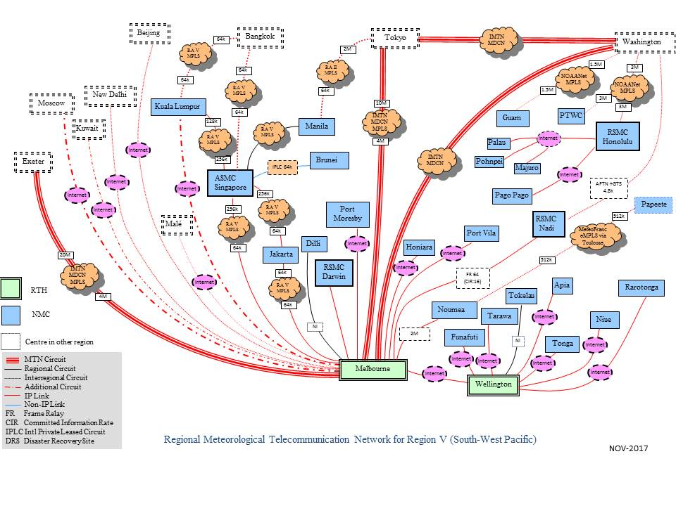
The Melbourne-Singapore link has been upgraded from 64K to 256K in March 2918. Jakarta-Singapore link remains 64K and maybe upgraded in future if needed.

  - DCs WIS compliance

- Training – Capacity building activity
  - No new training activity in 2018
- Operational issues in last period
  - Connectivity issue with GISC Seoul, i.e. incoming traffics to BoM is via the Internet, and outgoing traffic is via RMDCN, causing difficulties to access KMA OAI-PMH provider from Melbourne. Solution in progress.
- GISC Back up and activities
  - Slow progress on GISC backup with JMA. Backup proposal has been made and discussed. Working on backup procedures.
- Monitoring Activity & volume
  - Conducted GISC Watch from 15th - 31th January 2019
  - Cache volume: ~1.8G/day (GTS input)
  - Data dissemination: ~ 6G/day
  - Uptime: 99.99%
  - Active user registration: 30 (WIS system only, excluding MSS, FTP users)
- Changes in GISC, including new features since last meeting
  - No major OpenWIS system upgrade since November 2017.
- Progress on action items

- Outlook (planned changes/improvements)
  - Scheduled maintenance only.
  - Link to Fiji changed from Frame Relay to the internet.
  - Link to Manila via internet in progress.
  - BoM is working with PNG MetService on collecting synoptic observation from third party AWS in PNG and exchanging on GTS.
- Any other issues of interest
  - BUFR upper air observations from Kiribati and Tuvalu are missing sometimes.
- Summary (Text for report)
WIS/GTS operation of GISC Melbourne and centres in its AoR has been functioning as expected.

