Status Report GISC Tokyo
GISC Tokyo holds the following metadata sets:
GISC | metadata sets | Remarks
Beijing | WIS-GISC-BEIJING
Brasilia | WIS-GISC-BRASILIA
Casablanca | WIS-GISC-CASABLANCA | From Dec. 2018
Exeter | WIS-GISC-EXETER
Jeddah | WIS-GISC-JEDDAH | Unable to connect to OAI provider
Melbourne | WIS-GISC-MELBOURNE
Moscow | WIS-GISC-MOSCOW
Offenbach | WIS-GISC-OFFENBACH
Seoul | WIS-GISC-SEOUL
Tehran | WIS-GISC-TEHRAN | Unable to accept ports 8080
Tokyo | WIS-GISC-TOKYO
Toulouse | WIS-GISC-TOULOUSE
(Tokyo)  WIMMS dataset | WIS-TOKYO-VCCC (Colombo)  WIS-TOKYO-VGDC(Dacca)  WIS-UNASSOCIATED | UNASSOCIATED includes AoR of GISCC New Delhi, Pretoria and Washington

Area of responsibility
GISC Tokyo covers the following 18 centres:
Country | Type of Centres | Function
Cambodia | NC | NMC
Japan | NC | NMC
Japan | GISC | GISC (Tokyo)
Japan | DCPC | WDC-GHG
Japan | DCPC | Satellite Centre
Japan | DCPC | RTH (Tokyo)
Japan | DCPC | RSMC-Geographical
Japan | DCPC | RSMC-Activity-TC
Japan | DCPC | RSMC-Activity-ATM
Japan | DCPC | RCC (Tokyo NCC, RA II)
Japan | DCPC | NICT (Space Weather)
Japan | DCPC | GPC/LRF
Lao PDR | NC | NMC
Myanmar | NC | NMC
Philippines | NC | NMC
Thailand | NC | NMC
Thailand | DCPC | RTH (Bangkok)
Viet Nam | NC | NMC

AMDCN connectivity
- The communication line between NC Hanoi and RTH Tokyo was established in September 2018.
- Washington and Tokyo started pre-operational basis data exchange from November 2018.
- The MPLS network provided by NTT was upgraded from 2Mbps to 6Mbps in December 2018.
- Lao and Tokyo link will be operational in the first half of 2019.
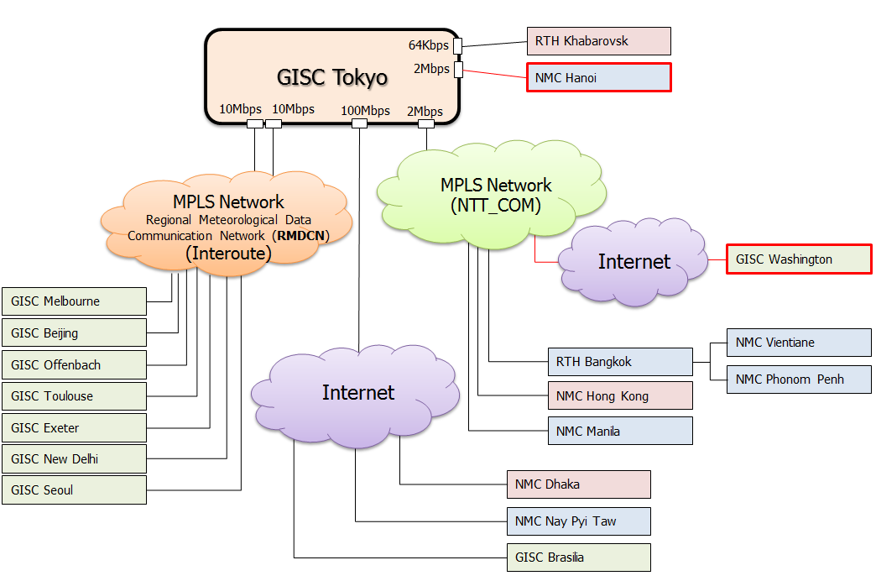

Training - Capacity building activities
The 1st WIS workshop was held in 2010. Since then GISC Tokyo has taken place the workshop for capacity building every 2 years.
The 5th workshop is being held in this week. GISC Tokyo invited AoR centres and three GISCs. The Key items are “WIS2.0” including pub/sub trial and “Tokyo’s pilot project”.
GISC Tokyo has been having onsite technical meeting at each centres in GISC Tokyo’s AoR. Tokyo will continue to provide opportunities to have onsite meeting at couple of counties every year.

Operational issues in last period
No report

GISC backup activities

Backup connection between GISC Beijing and GISC Tokyo
GISC backup connection between GISC Beijing and Tokyo is in operational by using GTS and DAR service. Beijing and Tokyo take advantage of an opportunity to have face to face meeting annually.

Backup connection between GISC Melbourne GISC Tokyo
Signed letters on GISC backup were officially exchanged in March 2012. Since then, Melbourne and Tokyo have had face to face meetings once a two-year to move forward with backup project.

Backup connection between GISC Offenbach GISC Tokyo
GISC backup between GISC Offenbach and Tokyo is in operational. Offenbach and Tokyo have monthly teleco and annual face to face meeting.

Monitoring activity
GISC Beijing and Tokyo are serving Common Dashboard (WCD) web site. The WCD is used as GISC Watch monitoring tool, all GISCs are monitoring GISC status and reporting some issues. GISC Tokyo performed GISC Watch from 1st to 15th May and 15th to 31st December 2018.

Traffic size and volumes, uptime, user registration

Traffic volume of GISC Tokyo
The daily provision volume is 250Gbytes/day.

Uptime
There was no breaking time from TT-GISC-2018 to ET-WISC-2019.

User registration
As of January 2019, nearly 180 users are registered.

Changes in GISC
No report

Progress on action items
The frequency of metadata harvesting changed to twice a day harvest. According to ANNEX 6, final report of TT-GISC 2018 [3]. Harvesting time is at 23:37 UTC and 11:37UTC.

Outlook (planned changes/improvements)
Plan : update WCD to add statistic information of the time series of the response time for all three matrices (OAI-PMH, Portal, SRU) according to ANNEX 8, final report of TT-GISC 2018 [3]

References
[1] GISC Tokyo portal site: https://www.wis-jma.go.jp/cms/
[2] Tokyo WIS Common Dashboard: https://www.wis-jma.go.jp/wcd/v1/top.html
[3] Final report of TT-GISC 2018: https://wis.wmo.int/file=4772

Recommended Text
GISC Tokyo is impossible to connect to OAI harvester operated by GISC Jeddah. The GISC Watch project issued tickets on this and assigned to Jeddah. The meeting noted that other GISCs are similar in condition.
GISC Tokyo reported its 5th WIS Workshop at JMA HQs in this week. Key agenda is Preparation for WIS2.0 and Tokyo’s pilot project. Participants tried publishing and subscribing messages using AMQP on Tokyo’s test system.
Tokyo modified Job Scheduler to harvest metadata twice a day, according to the decision of TT-GISC-2018 meeting in Casablanca.

--------------------

