TT-MDG

- Drivers for current TT-MDG activities focus – and status
Suggested actions have emerged from OPAG-ISS, GISCS feedback, and previous METADATARD activities. Another key driver aligns with WIS2.0 drivers: the importance of improving data discovery, access, and use.

IPET-DD TOR
Those aspects of the IPET-DD Terms of Reference (v.2017-02) which are relevant to the TT-MDG are indicated in Annex 1.
IPET-DD Workplan, drawn from the OPAG ISS Work Plan 2017-2020
Aspects of the IPET-DD Workplan (2017-2020) which are relevant to the TT-MDG are indicated in Annex 2
High Priority items for IPET-DD, as advised at Meeting 1, 2017-06
The full list is in Annex 3, and those aspect relevant to TT-MDG are b),c) and d) below
2) WIS metadata
a) Sorting out search - how can we help users find the information they need? This will need some work on the metadata and guidance, and some by ET-WISC on search engines - we need to work together
b) Making the WIS catalogue fit for purpose so we can stop maintaining Volume C1
c) Further improvements to the tools and guidance to help authors of metadata
d) Tackling "quality" descriptions (and provenance) in the metadata (the quotes are important, because the meaning of quality differs depending on the Programme using the information).
TT-MDG TOR developed by the group
from: http://www.wmo.int/pages/prog/www/CBS/Lists_WorkGroups/CBS/opag%20iss/ipet-dd-tt-MDG/tors
See Annex 3

TT-MDG workplan evolution/prioritisation
A Workplan was developed by TT-MDG in June 2017, and the group began to review previous guidance and support (a broad summary of previous support is below).
However, in September 2017 the team was encouraged to move its focus towards the "IPET-DD issues list" posted on the wiki.
After identifying the subset of issues that were relevant to TT-MDG, the team struggled a little with resolving the issues, due to not knowing, nor knowing how to find out, the initiating background / context (and therefore the actual problem / need) related to a number of the logged issues. Some progress was made (see current log of issues: Attachment 1); however, a higher prioritisation was given to TT-MDG activities, and to WIS2 discussions.

- Previous "support" activities (by TT-APmd of IPET-MDRD)
- WMCP Specification v1,2 (influenced implementations) –
- TEMPLATE records …. Skeletal only
- WMCP Specification 1.3 (not yet implemented by some)
- Wis wiki:
https://wiswiki.wmo.int/tiki-index.php?page=WIS+up&structure=WIS+up
- topic guidance (on using codelists, on licencing, on what an abstract should contain, etc)
- Development of "example records" per type (BUOY, SYNOP, CLIMAT, etc)
- Guidance docs, eg
- (2015?) "CGMS" Guidance Documentation on WMO Core Profile Metadata Creation For Satellite Products" http://www.wmo.int/pages/prog/sat/documents/SAT-GEN_ST-17-CGMS-TFMI-WMOCoreProfile-Satellite-Documentation-Aug2016.pdf
- "Guidance for creating WMO Core Profile Metadata in version 1.3" [2016] http://wis.wmo.int/file=3291
(now included in Manual on WIS?)
- YOPP Guide on submitting data to the WIS
- Additional activities conducted by other WMO streams (training, etc)

- Usefulness / effectiveness of support :
Although the original workplan aimed to formally survey metadata creators as well as to commence a methodical review of WIS metadata, due to other commitments, the team had instead relied on opportunistic consultations with colleagues involved in metadata creation; and each also consulted colleagues (particularly novice users) trying to use the catalogue.
Its clear that while Guidance and support have evolved, good implementation hasn't kept pace.

Possible reasons:
Resourcing; timeliness of support; reduced communication to potential editors about support available; difficulty for editors in finding relevant guidance at their point of need; Inadequacy of support and guidance material and tools. The adequacy of the content in support materials will need to be assessed separately.

Other possible solutions:
help at point-of-need: consider other solutions (a community help service?);
make it easier to maintain: consider re-design of metadata structure / and store key information only once
make it easier to know whats wrong and what to do:
… assess (then periodically monitor) metadata, with logged report backs to metadata creators.
The above considerations will form the basis of an "editor" survey

- WIS Metadata content issues

Metadata content and "searching".
The effectiveness of the metadata is related both to:-
the efficient findability of data, and a user's ability to efficiently understand and assess the suitability of the data for their purpose. Improved metadata content can also interoperability, including (for instance) providing seamless user exploration between OSCAR and WIS, etc.

TT-MDS: has focussed on deficiencies in both Catalog design and metadata content in relation to searching, and navigation within a catalogue. The implementation of facetted searching was recommended at an IPET-MDRD 2016 meeting; as was better and consistent use of keywords for data parameters (and use of Data Parameter terms consistent with those used in WIGOS metadata)

Metadata content and "understanding the suitability" of the data
Not all WIS catalogues offer temporal and spatial searching. However, if they did, the search results would not be ideal, due to that content being incorrect, or too sparse in detail, or inconsistently applied across records.
This is fairly important given that the spatial and temporal details of a dataset are 2 of the key what, where, when, who, how "discovery" aspects needed by users to easily understand /assess the data's suitability.
As well as needing to be consistently applied, sufficiently detailed, and correct, spatial/temporal information also needs complementary/ additional information.
For instance: it is useful to know whether the data is point or gridded data. If point data, its also useful have the related station id and station location. The WMCP guidelines don't currently request that detail. This additional information might also assist with metadata QC monitoring.

Spatial coverage:
At a 2016 IPET-MDRD meeting, metadata inclusion of a region keyword was recommended.
In the 2016 Guide (see above), use of the new Station Id was recommended.
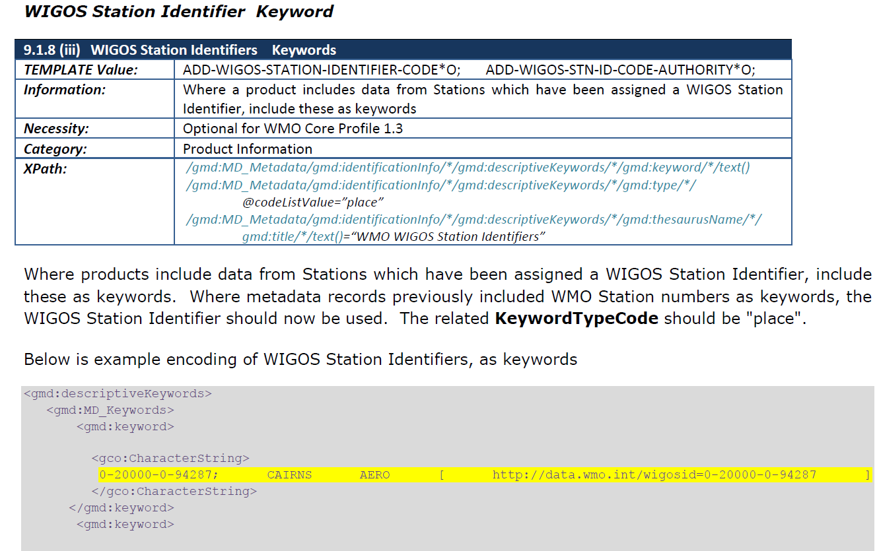
Putting aside this more recent guidance : a quick survey of WIS records indicates that station id details are sometimes in keyword (type=place), and sometimes in Extent; and that the station id is sometimes appended by the station name. Station names are sometimes, but not always, in the abstracts. And the new station Number is in very few records.
A search of the Melbourne GISC http://wis.bom.gov.au/openwis-user-portal/srv/en/main.home/ , for '0-20000-0*' ……matched 10 records.
(To explore other GISC instances: SRU training Page: http://www.wmo.int/pages/prog/www/WIS/wissruform.html )

Temporal coverage: for bulletin metadata, it is inconsistently implemented.
Additionally, TemporalExtent should reflect the temporal coverage of data available to users at the time that they search …e.g. for bulletins, "now", rather than "1970+"
If some GISCs couldn’t handle "now" in a temporal search, then it might be worth considering use of Xlink to automatically refresh that part of the record (eg for "latest month", the Xlink endpoint pointing to an xml fragment, could be changed monthly) ,

GISC cache retention policy
Users also aren't clearly advised that the GISC cache data disappears after 24 hours.
As a complement to improved "temporalExtent" content, the "Retention policy" of the cache should be clearly stated in bulletin records.
Ideally, records would also include a reference to where that same data is stored /accessible longer term.

Formats / encodings:
Non-WMO users would struggle to understand, if reliant of WIS metadata, that the bulletin data is encoded, and how they might decode that data. Ideally all bulletin records for BUFR format data should include a url to the BUFR decoder.
As well, the metadata typically don't contain a clear link to the relevant Data Structure/schema document (the url is to the generic Codes webpage) ..see separate document reviewing the metadata record for CSAU01 . Metadata would ideally:
- Refer precisely to the encoding used, and to the data structure and data parameters;
- Refer to Decoding tool(s)/programs;

Understanding Data Access options
Neither metadata records, nor catalogues ( at the top level) typically provide a clear pathway / or directions on how to access the bulletin data. There is sometimes a deadlink where a user would expect to link to the data.
This applies even for WMOEssential data, for which access should possibly be ungated (but which typically is gated).
To further compound "discovery" challenges, the related issue of "restricting" access rights to the data, based on the IP of the user would (in the absence of a clear explanation that they need to visit another GISC catalog) seem inexplicable to a general user.
A clear statement about this, and a method of re-direct/ triage might be helpful
(See CSAU01 document, for further detail).

Licencing
The metadata typically doesn’t clearly advise the novice catalogue user of whether they are allowed access. For instance, while WMOEssential data is meant to be freely accessible, the absence of a link to definitions of WMOEssential obscures this knowledge.

Other commonly heard comments [from novice users] about WIS catalogue deficiencies:
"too much jargon in the records"; "no data parameter details included in records" ; "No indication of quality", no sense of whats being included, in the catalogue"

Although WMCP 1.3 pt.1 http://wis.wmo.int/2012/metadata/WMO_Core_Metadata_Profile_v1.3_Part_1.pdf states:
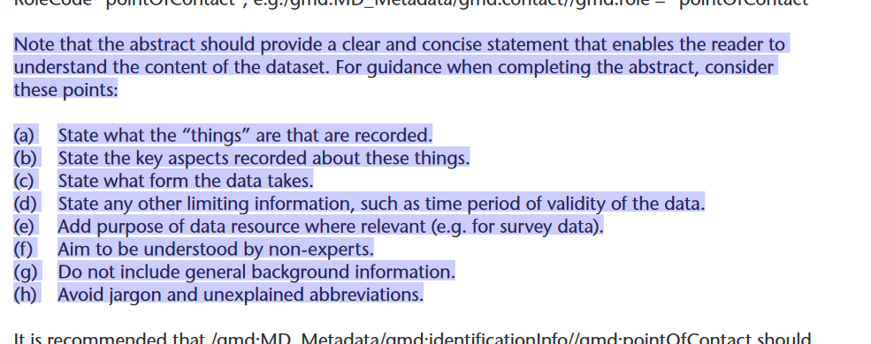…the general feedback from users who are new to the WIS catalogue(s) is that the content of the metadata, for bulletins, is quite mystifying ( particularly in aspect of what the data is, and how data can be accessed and used).

The oft-mentioned 'negative' perceptions of the WIS catalogues, rather than being about WIS software, or indeed about the metadata standard used, are most likely connected with metadata content itself. That is: the lack of key spatial / temporal details, lack of information about access, format, and data parameter content, as well as quite cryptic abstract content.
(abstracts, for bulletin metadata, are typically what was in the TEMPLATE records created at WIS inception, which were only ever intended as a shortterm solution.)

There also appears to be a perception, within the WIS implementing community, that the bulletin content, and formatting/encoding of that content is such that non-WMO users would struggle to use the data.
Other possible remediation :
- Development of some rosetta-stone tools
(e.g., for each message type, an example encoded file, a reference to a decoder, and then a plain English version of that file, with annotated descriptions)
- Reference to these, from the relevant metadata records
- a more specific reference, within the metadata record, to the encoding specification
- inclusion of data params (with an explanation that not all stations can provide all values ) in the metadata record
- other?

Other options to support improvement of metadata content:
Xlinks: can be useful for maintaining common information in one place, and resolving the links regularly.
Previous explorations of ways to more easily improve metadata content have included exploration of use of Xlink (store information once, and refer to it many times. While previous GISC responses have argued against use of Xlink, this might be worth further consideration.

- Monitoring to address "inadequate or inconsistent quality" across WIS records

A 2016 IPET-MDRD meeting discussed WIS monitoring – however this evolved to focus on software solutions to monitor and to provide a public "ranking" rather than focussing on what precisely should be measured, and with what ranking. Some current WIS monitoring systems might currently check for missing records
(possibly JMA https://www.wis-jma.go.jp/wcd/v1/detail_GISC-Tokyo-_JP_.html).
TT-MDG need to review the scope of current WIS monitoring.

Existing validation tools measure the schema/schematron rules of 1.2 and 1.3;
However, most current WIS records would pass those rules.

We need to :
- define which aspects are most critical for "findability" and "understanding the suitability"
- devise a way to make it easier for METADATA creators to revise and improve their metadata
( … possibly maintain common information in a collection-level metadata; and ensure that bulletin metadata refers to collection level record;
Or … advertise (to editors) an examplar bulletin record record, highlighting which parts need to be localised;)
- define the most effective ways to advertise support, and to advertise new metadata changes changes that are needed;
(noting that needs are always evolving …. For instance, as new additional "guidance" is available … how can we efficiently integrate that into our examples, support materials, monitoring, etc??
- define a way to check that busy GISC managers have become aware of those changes
(possibly survey .. with links to examples, Etc)

ANNEX 1

IPET-DD TOR relevant to TT-MDG
The words highlighted in yellow, in the IPET-DD TOR below are, in part, relevant to TT-MDG responsibilities. Those in green are solely the responsibility of TT-MDG

Terms of Reference for Inter-Programme Expert Team on Data Representation Development (IPET-DD) Last updated: 21/02/2017

(a) Review and further develop the WMO Core Metadata Profile, model driven code forms and WMO standards for metadata and data exchange to meet the needs of Members, WIS, WMO Programmes and cooperating organizations such as ICAO;

(b) Contribute to the review of and recommend updates to the Part D of the Manual on Codes (WMO No. 306) and the Manual on the WMO Information System (WMO-No. 1060) and associated reference and guidance material as required, publishing these in suitable electronic forms for human and automated use including codes.wmo.int;

(c) Facilitate proposals to standards development organizations, such as ISO TC 211 and OGC, changes to their respective standards that are required to meet the needs of WIS;

(d) Advise Members, technical commissions and ICG-WIGOS on WIS Discovery Metadata, the model driven code forms and associated application schema and data interoperability issues;

(e) Monitor metadata quality within the WIS DAR Catalogue and take follow-up action to address systematic issues identified;

(f) Identify implementation issues requiring the urgent consideration of the OPAG on ISS;

(g) Monitor and explore evolving data exchange and discovery technologies with the aim of improving the efficient operation and usability of WIS;

(h) Raise awareness of Members of the opportunities and risks associated with new data exchange and discovery technologies;

ANNEX 2
IPET-DD Workplan, drawn from the OPAG ISS Work Plan
Aspects of the IPET-DD Workplan (2017-2020) which are relevant to the TT-MDG are indicated in Annex 2 below
No. | Task | Deliverable/Activity | Due | Responsible
IPET-DD01 | Improve relevance of WIS Discovery metadata | WIS users are able to find information on data and services:  - User-centred analysis of effectiveness of GISC catalogue search interface  - Guidance for GISC/DCPC providers on search interface design  - Guidance for metadata authors including assessment of ‘metadata granularity’  - Guidance for metadata tool developers  - Guidance on making WIS metadata records discoverable via industry search engines  Periodical monitoring of metadata quality in WIS DAR catalogue  - Procedures for metadata quality monitoring- including tracking ‘missing’ metadata  - Metadata catalogue monitoring tool(s) | Q2 2018  monthly | IPET-DD
IPET-DD02 | WMO Core Metadata Profile (WCMP) compatible with community best practice | Releases of WCMP amended to accommodate needs of Members and Programmes (fast-track)  Assessment of value to be realised from migration of WCMP to ISO 19115-1:2014 & ISO/TS 19115-3:2016 | Biannual | IPET-DD
IPET-DD03 | Extend WMO data model(s) to address additional WMO information exchange requirements | Updates to WIGOS METADATA Application Schema in support of OSCAR implementation  Updates to IWXXM in support of ICAO Annex 3 Amendments 78 and 79 and ICAO SWIM  Application Schema (and associated code form) to encode climate station metadata and climate data streams  Updated Guidelines on data modelling (reflecting changes to METCE etc.)  Guidance regarding use of model-driven code forms available to Members |  | IPET-DD
IPET-DD04 | Publish standard vocabularies in support of WMO information exchange requirements | Consistent terminology  Definitions and language translations added to WMO Codes Registry  WMO data models (e.g. METCE, OPM, IWXXM, WIGOS METADATA) published as ontology resources within WMO Codes Registry |  | IPET-DD

ANNEX 3

High Priority items for IPET-DD, as noted at Meeting 1, 2017-06

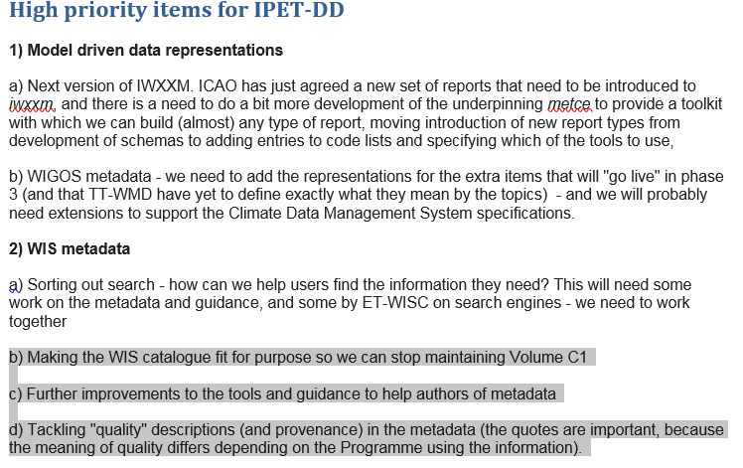

TOR for TT-MDG

(a) | Monitor metadata quality within the WIS DAR catalogue and take follow-up actions to address systematic issues identifier
(b) | Monitor effectiveness of metadata (the adequacy of the content of metadata records and its efficiency for supporting discovery), including developing an approach to assessing effectiveness
(c) | Assess the effectiveness of the examples for authors and update and maintain the examples on the wiki
(d) | Seek feedback from authors of metadata on the guidance available
(e) | Review and improve the guidance provided to authors, users and software developer
(f) | Develop training materials to support existing and new guidance for authors
(g) | Recommend tools and other products to assist with the creation of metadata records
(h) | Maintain consistency and currency across the guidance, support and training materials.

