Using Sparx Enterprise Architect for UML modelling and XML/GML schema generation for IWXXM

Introduction
- It was decided, as early as in the first meeting of TT-AvXML in 2011, that tools should be used to develop IWXXM in UML and transform it into XML schema. A systematic approach to model development and schema generation was considered to be essential for achieving quality and long-term maintainability of the whole process.

- At that time, there were not too many choices for UML modelling and UML-to-XML/GML transformation tools. Sparx Enterprise Architect (EA) is a UML modelling tool which had achieved a good compromise between price and ease of use. There were a number of UML-to-XML/GML transformation tools available, including FullMoon and ShapeChange. Either of them takes in a UML model exported from EA in XMI (XML Metadata Interchange) format for transformation into XML/GML schemas.

- EA had, starting from its Release 10 in 2013, introduced a build-in tool for the creation of GML Application Schema from UML model. Since then, UML modelling and XML/GML schema transformation can be carried out in a single piece of software. It is understood that the WIGOS Metadata Data. Representation (WMDR) XML/GML schemas were entirely developed in this environment.

Discussion
- The creation of XML/GML schemas for IWXXM, however, is a bit more complicated as it requires specific transformation rules to achieve the desired XML/GML outputs (e.g. serialization of the <<CodeList>> Type). A face-to-face discussion was conducted with Sparx to see how this could be achieved and they agreed to incorporate these special requirements into EA which could be enabled by tagged value “xsdEncodingRule” = “iso19136_2007_METCE_Extensions”. Appendix I is the requirements specifications submitted to Sparx for their implementation and these were finally implemented in EA Release 11 in 2014.

- Since then, addition serialization issues and requirements emerged. To achieve maximum flexibility, instead of trying to hardcode these new requirements into EA, XSLT Transformation were being use to post-process the XML/GML schemas generated by EA to the desired form. The following is a class diagram showing the inter-relationship between items in the generation of XML/GML schemas for IWXXM 3.0:
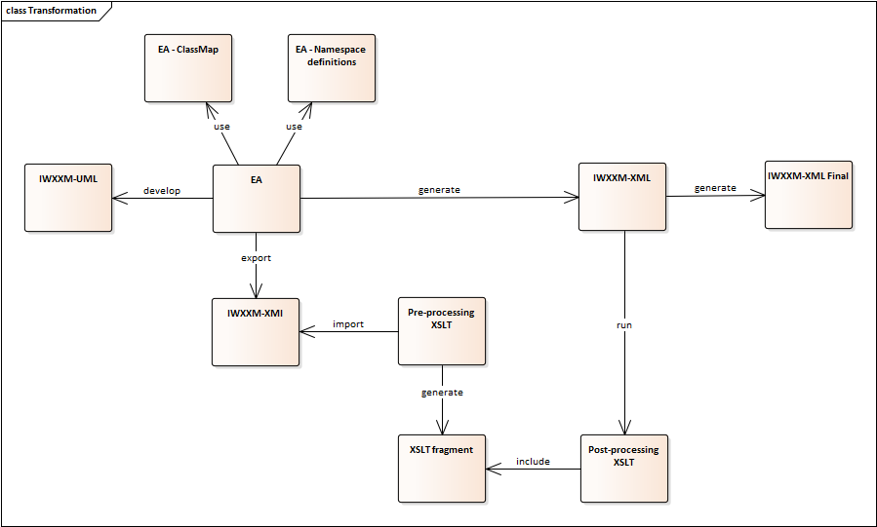
- It is perhaps time to review and streamline the preparation of IWXXM XML/GML schemas. The following questions can be the starting point of the review:
- Are the special XML serialization requirements really needed? If so will they also be applicable to other WMO data models?
- Do we want to continue using “xsdEncodingRule” = “iso19136_2007_METCE_Extensions” in EA to control the application of special XML serialization?
- What is the kind of flexibility we need with regard to special XML serialization?

Recommended Text
[To be determined at the meeting]
--------------------

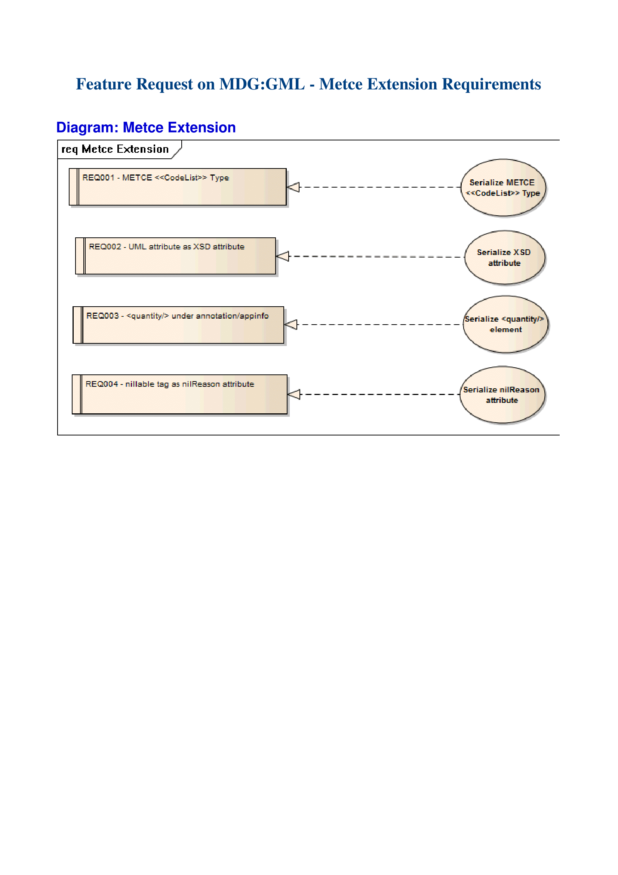
Appendix

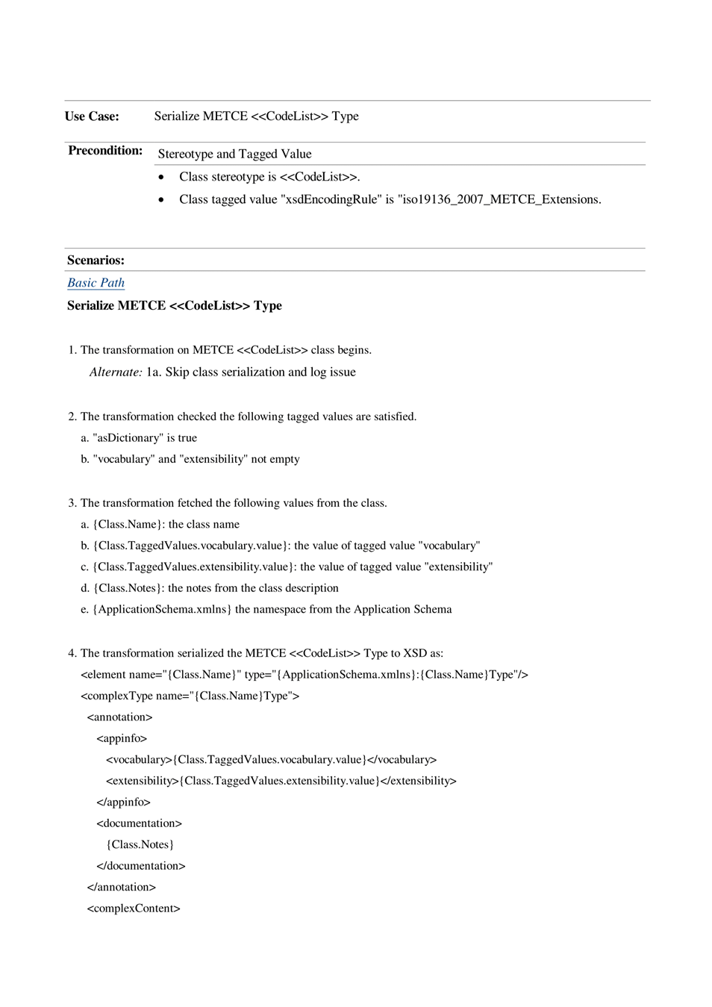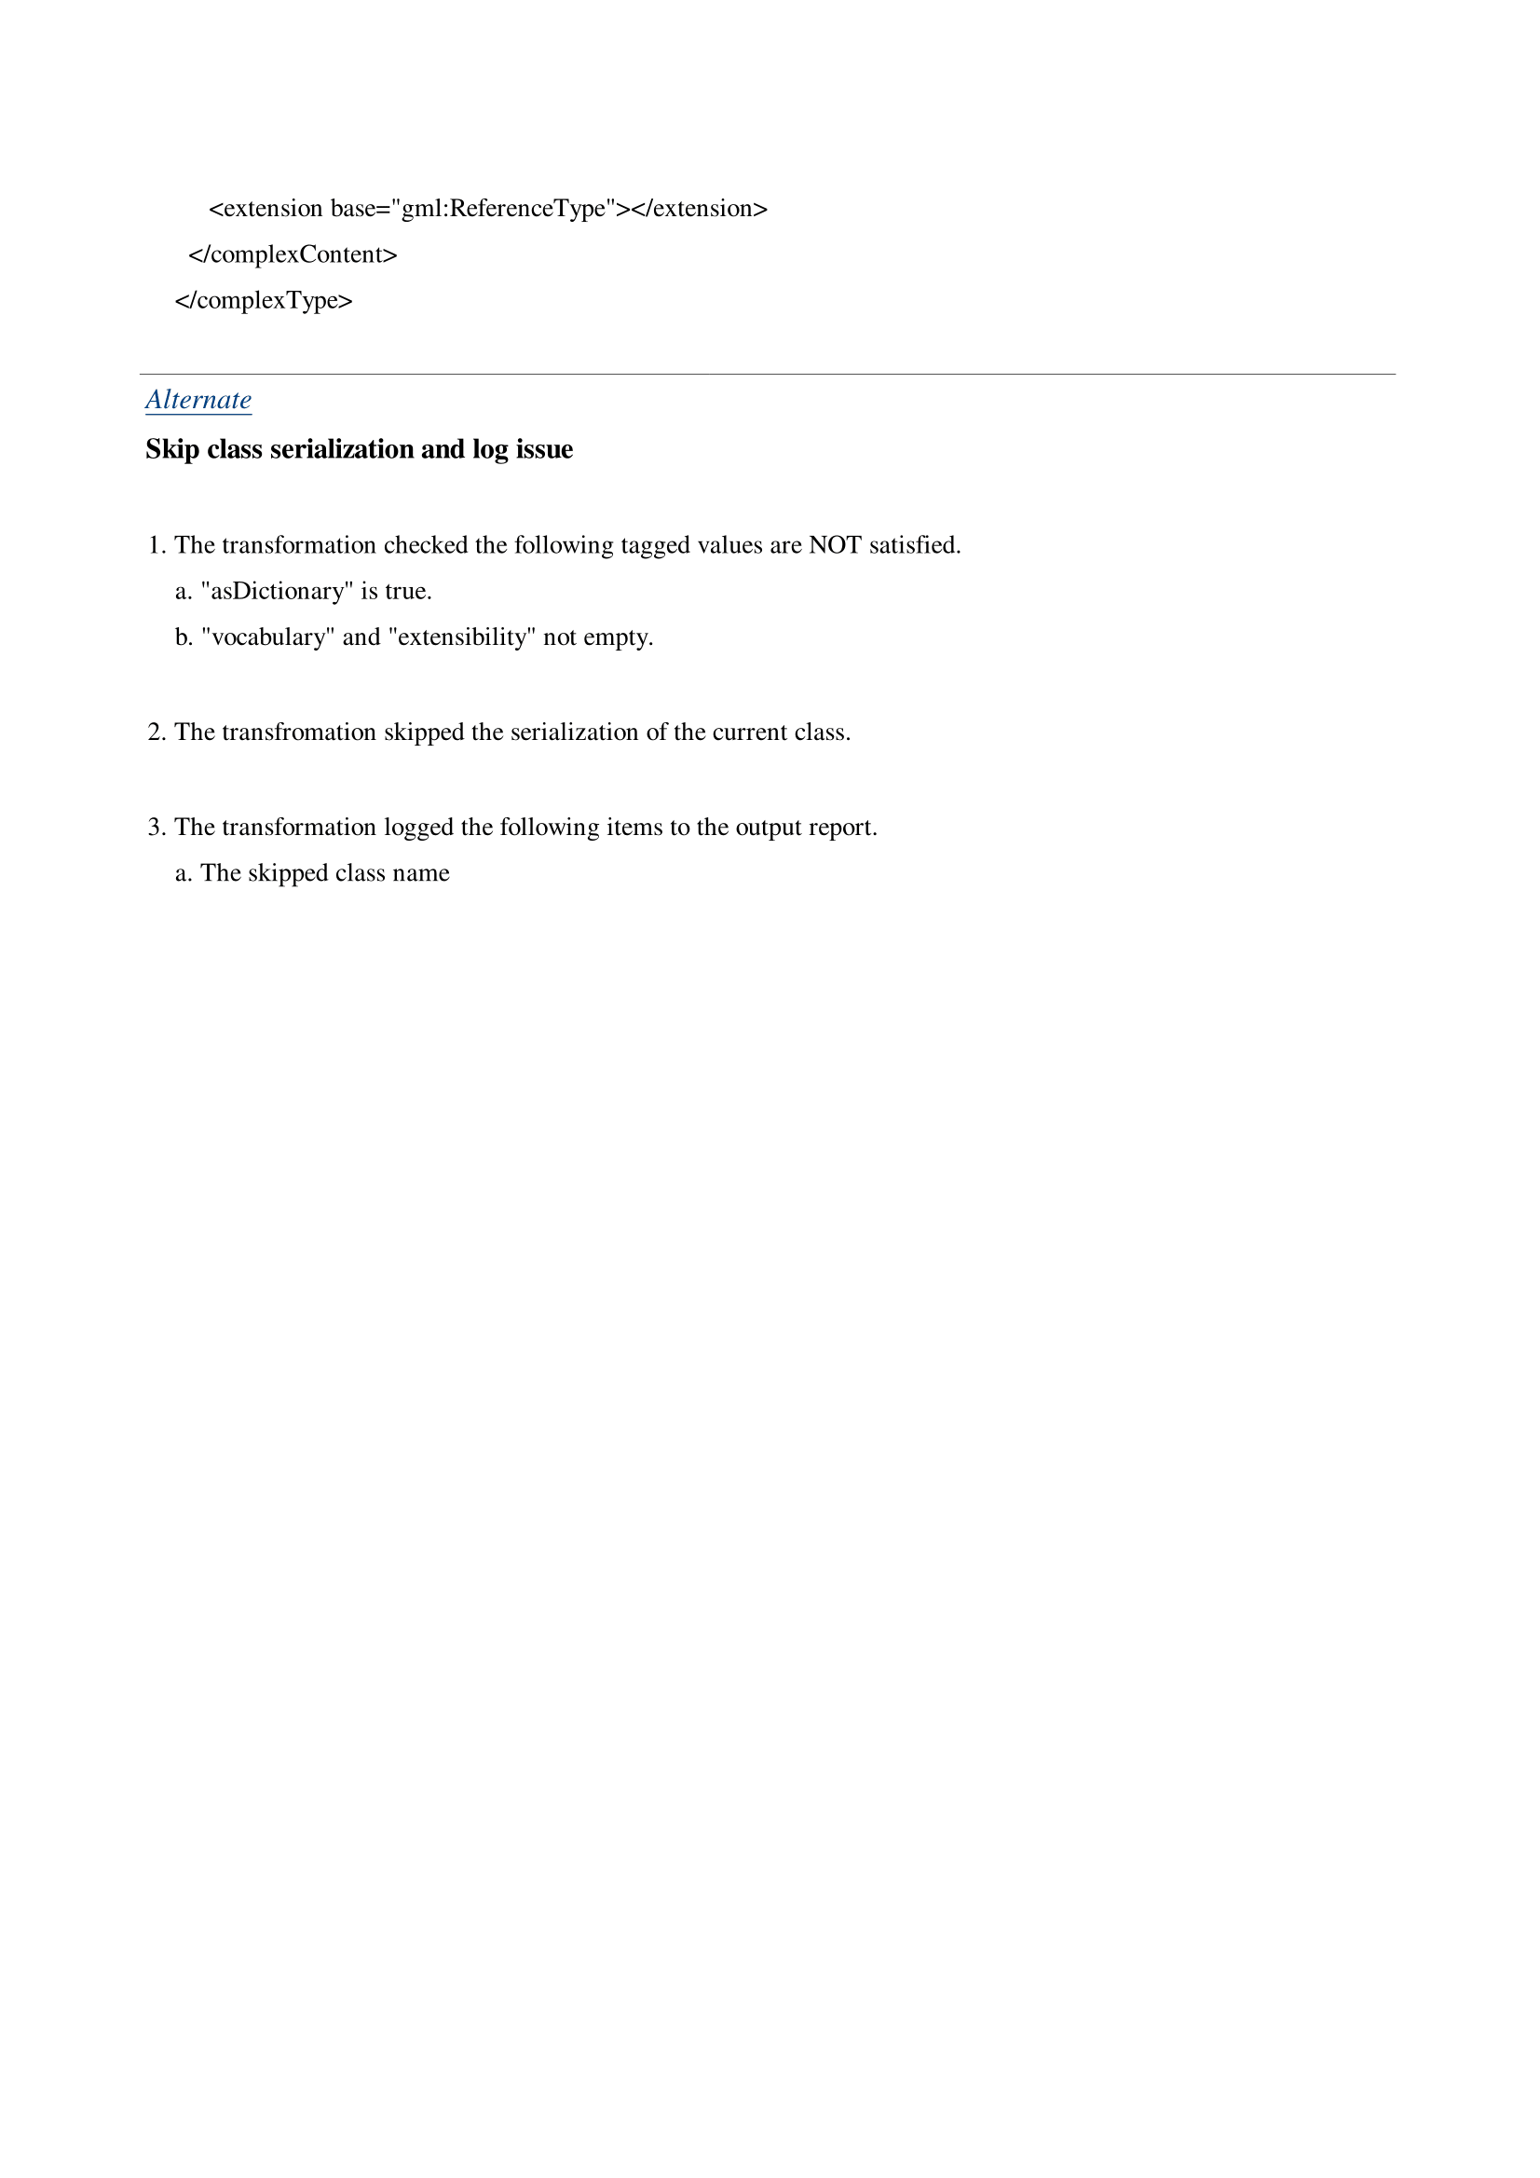
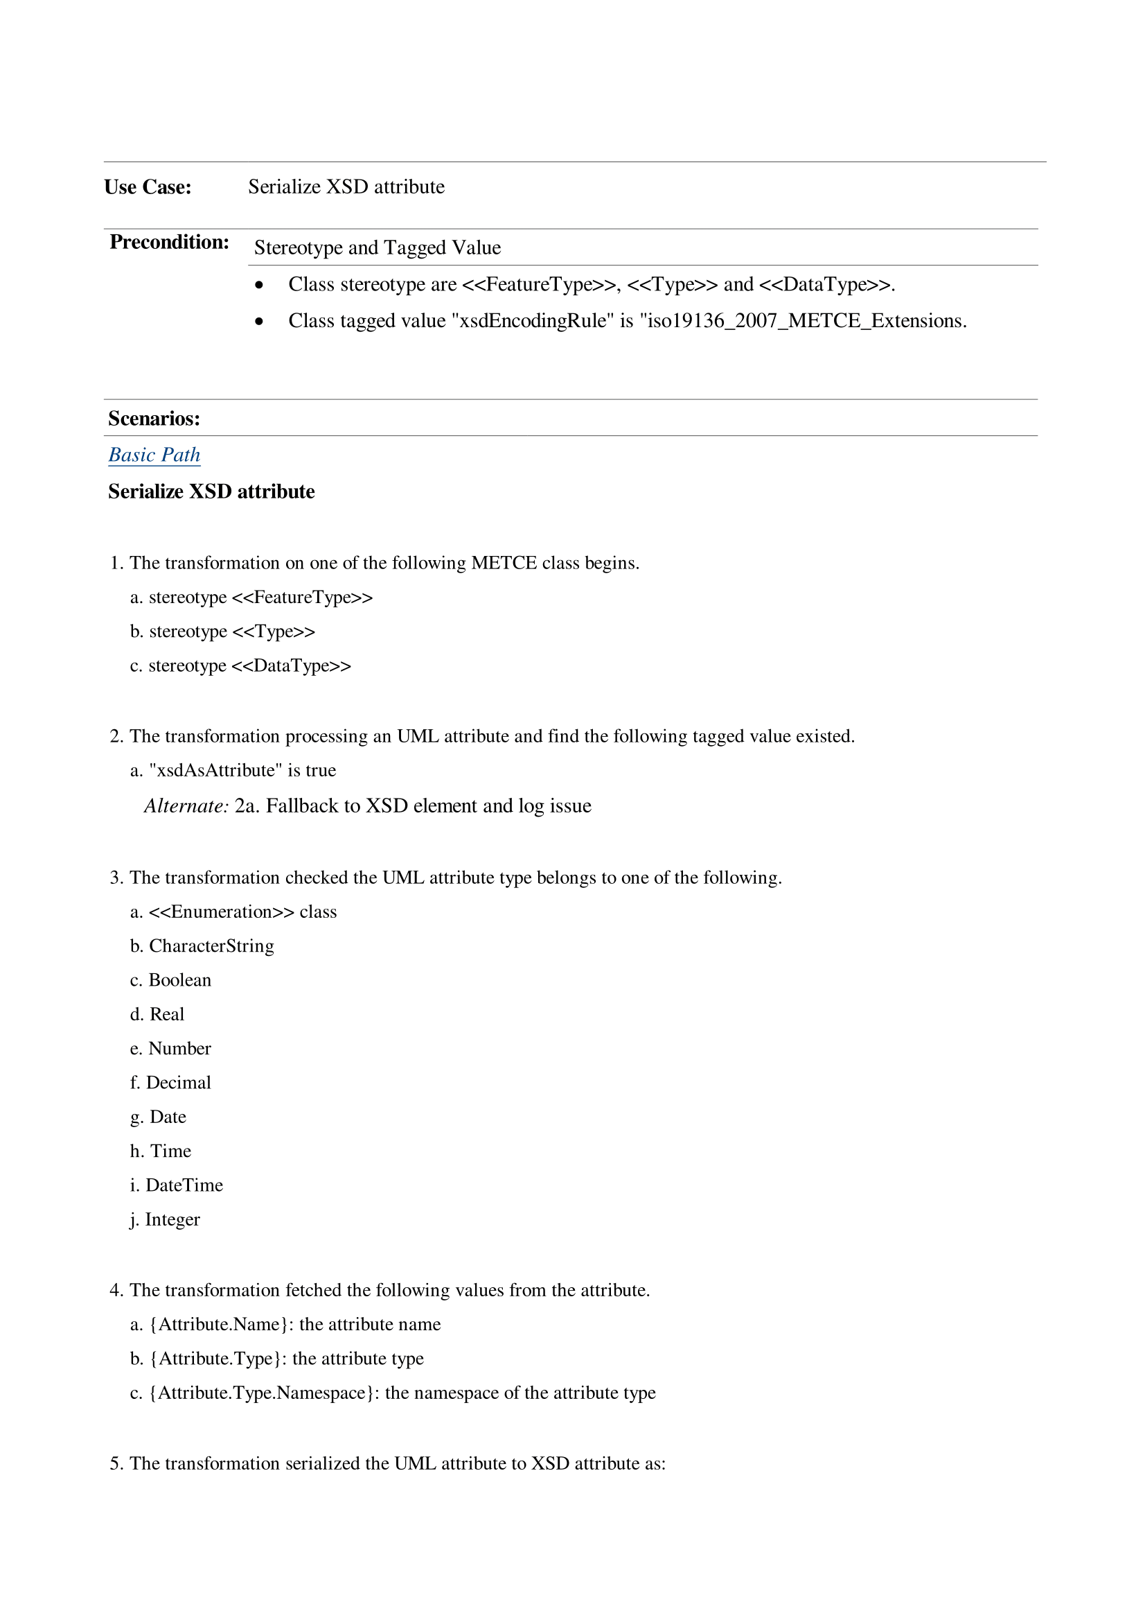
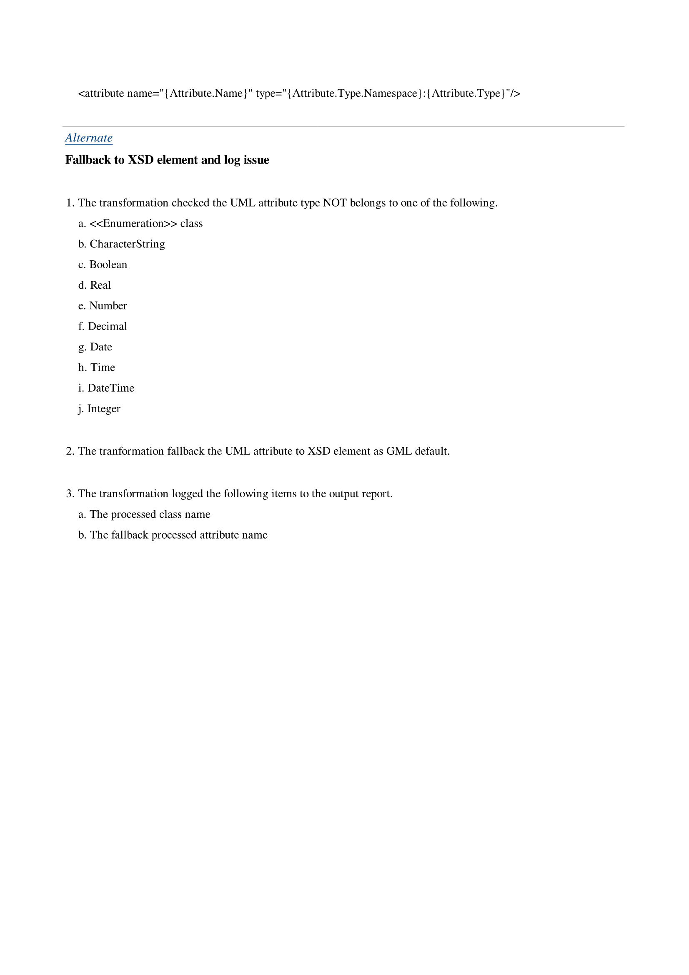
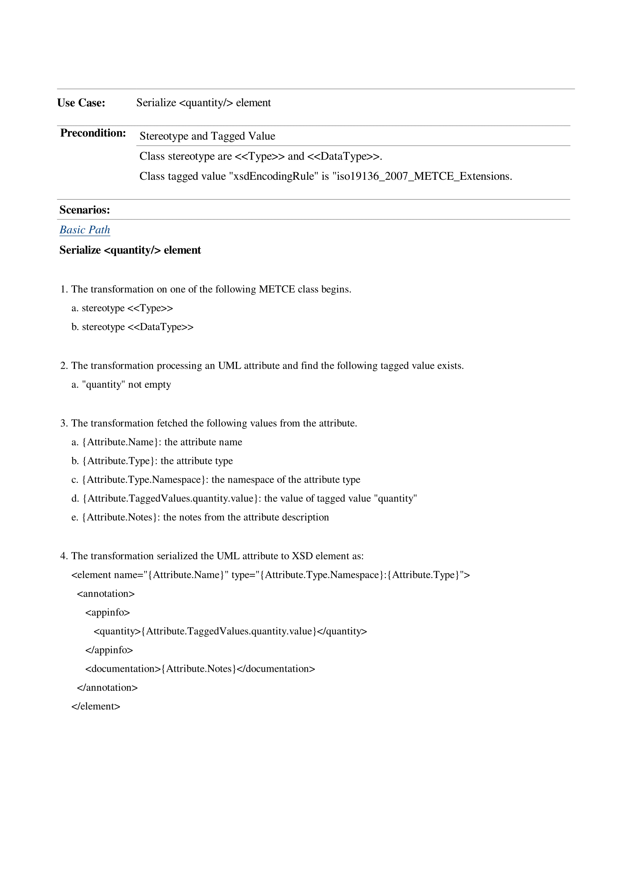
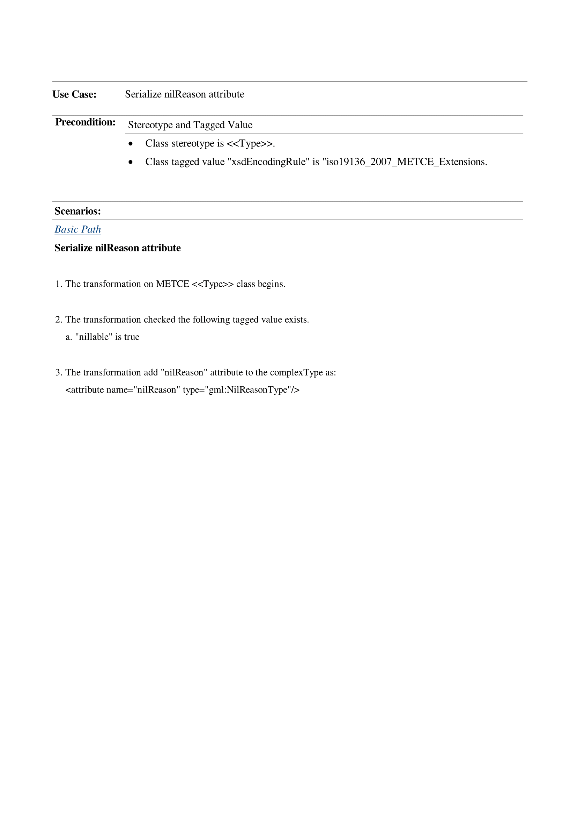

CSIRO
https://shapechange.net/
See https://sparxsystems.com/products/ea/11/

