Title: Task Team on Metadata Search

The following document summarizes the activities undergone by the TT MDS. It additionally outlines the work still be achieve and provides a list of future tasks to be completed.

TT-MDS Term of Reference

Below is the TT-MDS TOR as defined initially by the Task Team to explore and improve “data discoverability” challenges experienced by WIS users seeking information on data and services:
The team shall conduct a user-centric analysis of the effectiveness of GISC catalog search interfaces, in the context of core WMO audiences and their needs.
Working in close consultation with related WIS/GISC teams, and based on the above analysis and in the context of known other technologies, the team shall discuss and recommend on proposed solutions, providing
- Guidance for GISC/DCPC providers on search interface design
- Guidance for metadata authors including assessment of ‘metadata granularity’
- Guidance for metadata tool developers
- Guidance on making WIS metadata records discoverable via industry search engines
- Guidance on Quality assessment monitoring, and tools / other solutions to expedite the transition to improved metadata content.

TT-MDS initial WIS portal discovery services analysis

The TT-MDS TOR contains a set of actions regarding the monitoring and evolution of the WIS discovery services with the aim of improving the discovery services, the usability of such services. In addition, the team has to analyze and define recommendation for improving the quality of the metadata content to address some of the discovery and usability limitations.
The team has conducted such analysis on the different GISC catalogue discovery services based on the experience of the different members and the following challenges for users have been highlighted:
- The WIS Portals are often focusing on the GTS community using the GTS technical jargon as well as specific discovery services for the GTS (TTAAii) hence omitting to serve a larger community that is only looking to find meteorological products in its broader terms.

- The different portals provide very different search experiences that do not always follow industry standards. This is confusing for users that are looking for consistency between the different portals and expect a behaviour for such discovery services derived from their day to day interactivity with the web industry search engines.

- The different portals are not fully focusing on helping users to discover products and instead tend to be very technical, therefore creating a steep learning curve for neophyte users. The product information presentation is also very often following the ISO Metadata internal structure. ISO 19115 is an interesting format for capturing the product information but its internal structure is not to be followed to display the product information itself as it can be misleading for the user.

- A very large part of the Metadata content has been automatically generated from VOL C with a very limited set of information for qualifying accurately the products and differentiating them sufficiently for allowing a search engine to perform efficiently.

- Due to the nature of the GTS bulletins, the WIS portal catalogues are treating the same way collections of products and instances of products. Product collections describe families of products such as for instance 3 hourly forecasts without drilling down to the last parameters of the products for selecting a specific data file with a meteorological parameter and a given forecast time. They provide general discovery information on the products regrouped under the collection. Product instances are individual instances of a product family with all the necessary parameters to access the product data file itself (ie temperature of the 3 hourly forecast from the 20190110 3 am). This mix of discovery metadata and “access” metadata has the side effect of flooding the discovery results with lots of product instances results and therefore creating a degraded search experience for the user.
From this assessment, TT-MDS choose to address the different limitations as follow:
Points 1. 2. and 3. are related to the WIS user definition, the discovery services presentation, look and feel and more importantly usability and how to incorporate discovery services web industry standards in the WIS services. For this reason the team decided to create a guidance documentation on the definition of the Web discovery services by going through a Web design process: capture the different user profiles to highlight the diversity of today’s WIS users and their motivations drawing on the diverse experiences of the Task team members, then derive a minimum set of discovery services as well as usability best practices to be recommended to the WIS Development team with mock-ups to highlight the design.
In addition, industry standards or best practices should be implemented to broaden the WIS discovery services. The Task Team should also study and recommend the most relevant web discovery industry best practices for the WIS.
Point 4. is touching on the Metadata content quality which needs to be tackled by the WIS in order to have efficient and accurate discovery services. TT-MDS can recommend implementing a set of KPIs for monitoring the quality of metadata content in order to improve the discovery services with quick wins on a very short period.
Point 5. can also be addressed by recommending a different way to provide access to the GTS datasets while not penalizing the complete set of discovery services.

TT-MDS guidance documentation

Based on the assessment summarized in 2 TT-MDS initial WIS portal discovery services assessment the overall following guidance documentation structure has been defined by TT-MDS:
- WIS discovery challenges and potential improvements (based on the summary above)
- Definition of the potential users of the WIS Catalogue in 2018.
- Recommendation of a set of common functionalities and usability patterns across GISCs portals.
- Rational for improving the WIS content and recommendation for addressing it.
- Implementation of discovery industry standard and provision of a modern machine to machine interface.
- Differentiate between general product information (collection) and instance product information.
Below is the status of each individual points covered and a summary of the conclusions to be provided in the report.

WIS Discovery limitation and potential improvements

Most of the limitations and potential improvements have already been addressed in TT-MDS initial analysis. The final guidance documentation should develop each different points and define a set of recommendation for addressing the limitations.

Definition of the potential users of the WIS Catalogue in 2018

The TT-MDS has performed a capture of the different user communities and user personas that have to be covered by the WIS discovery. The details analysis is available here: http://bit.ly/WIS-userprofiles and can be summarized in the following users’ type:
- Neophyte users with limited or null knowledge in meteorological datasets. This regroups a set of users that would like to discover the different type of datasets that are available in the meteorological/climatology domain or users that want to access meteorological data but do not know how they are described in term of organisation, format. This type of users needs a way to browse through a list of available products as they do not know which keywords to use to match any datasets. Based on that first discovery by browsing, they can create more targeted search requests using filtering and keywords.
- Meteorological users. This type of users know already the domain and type of information they are looking for and wants a fast way to target specific datasets using keywords with the ability to discover related (sibling) datasets or compare datasets and this can be provided by the use of filtering search results. Such users also require a fast clear path to data and they would like to quickly access and download the data products to start their work.
- GTS specialized users. The access to the GTS using its own jargon and codification has to be maintained without having to make it too prevalent to avoid impacting the discovery of the rest of the available datasets. The TT-MDS can recommend a Web interface for the GTS that is functional but stays reserved for specialists.
More details are available in http://bit.ly/WIS-userprofiles and the guidance documentation on discovery created for the TT-MDS has to describe the different categories of users and provide set recommendations for building discovery services for each of the different categories of users.
  - Recommendation of a set of common functionalities and usability patterns across GISCs portals

Based on the user analysis above, a set of discovery services and broad navigation for the different WIS portals can be recommended. Three types of discovery are recommended: Browsing for new users, full text search with filtering (faceting) for narrowing down the search for more advanced users and a targeted independent search for GTS specialists using the GTS conventions (TTAAii classification).
In addition simple navigation organised similarly to the main Web discovery services should be recommended to follow what is expected by all internet users in 2018 when accessing discovery services.
A fast path for accessing data should be as well recommended and identified when necessary.
Technicalities should be hidden to focus solely on the product: product information, product access need to be the focus for the services. Users do not want to see the ISO metadata structure or artefacts from the GTS technical organisation but instead want to have enough product information for understanding the purpose of the data product and then have a fast and clear path for accessing it.
This can be provided by the TT-MDS as a set of recommendations with a few illustrative Web Design mock-ups to allow the implementers better understanding of what should be developed.
If possible a certain coherency and a set of commonalities in the look and feel in addition to the navigation commonalities should be implemented by all WIS discovery portals.
  - Rational for improving the WIS content and recommendation to address it

Any discovery service is as good as the content it is created from. Each different indexed products needs to contain enough information to differentiate them and have keywords accurately matching results. A big portion to the WIS metadata records has been generated using a standard template from VOL C to describe the GTS content and just changing the title and TTAAii information for each individual bulletin. It is in that case very difficult for any search engine to not return almost all those metadata records for each keyword matching the initial template. In general for avoiding such issues, the metadata quality should be monitored to understand how to improve it and allow modern search engines returning accurate results. The TT-MDS should develop and recommend the implementation of KPIs to monitor the quality of the metadata content. Additional work can be performed to define those KPIs and a Metadata quality service prototype could be implemented if time permits to demonstrate how the useful and profitable it would be for the WIS. This work has not yet started but it could be initiated in the next phase.
  - Implementation of discovery industry standard and provision of a modern machine to machine interface

In today's internet, search engines like Google.com are the main initial source of information for the large majority of users. The WIS Portals should have the ability to export the content of their catalogue in the discovery industry services and have their content easily indexed by them otherwise they stay isolated from the rest of the internet and are cutting themselves from a very large portion of users who are searching for meteorological products. Modern industry search engines are now organized as a relationship graph for linking pages and information content and make use of machine learning technics based on that initial knowledge graph to direct the user towards similar or related search results. Using structured information in the pages, the search engines can also extract additional useful information to immediately provide it in the search results. The structured information can also be used to better categorize and index websites content.
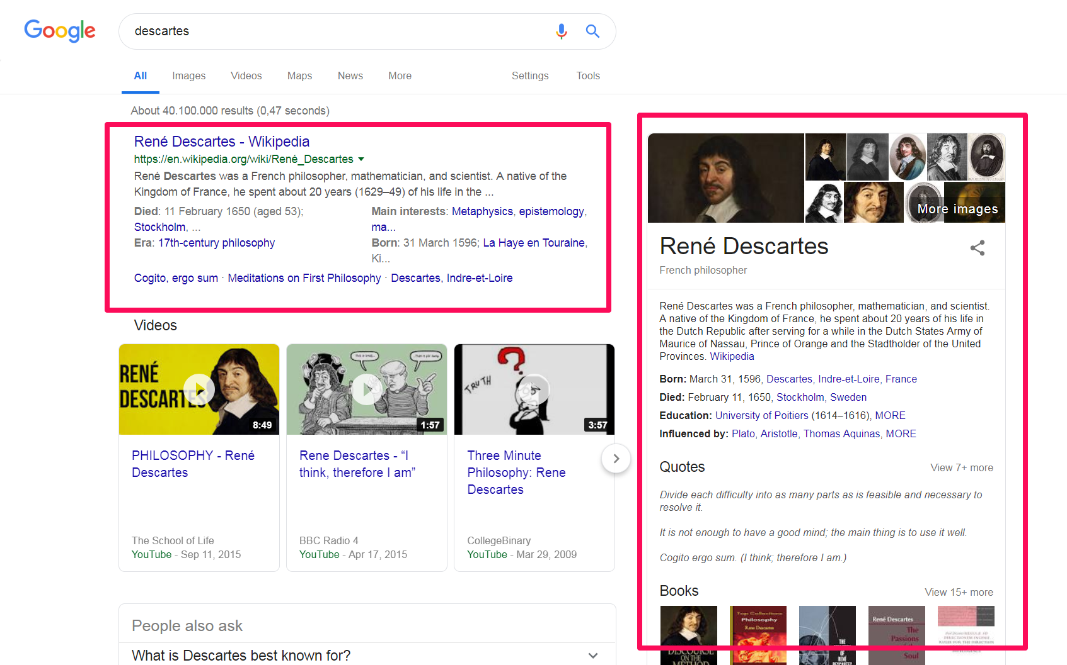
Example of the utilisation of annotated structured information in industrial search engines
A standardization effort maintains and document in http://schema.org website has been created a few years ago within the search engine industry where they are documenting the structured information that needs to be provided for different types of information (movies, video games, howTo, …). A few years ago an initiative has been started to provide structured information for datasets and have them better indexed. The information can be found here: https://schema.org/Dataset. Google is also actively working on integrating and indexing very efficiently datasets that are documented using the datasets annotations (https://developers.google.com/search/docs/data-types/dataset). The dataset schema is very generic to be applicable to any datasets and it needs to be adapted and mapped to meteorological datasets.
The TT-MDS should review the dataset schema provided by Schema.org and the Google implementation to recommend a set of mandatory information elements that should be provided by the different WIS portals to improve the accessibility to WIS portals and the indexing and presentation of product pages.
In addition, modern machine to machine API would improve the interoperability of the different WIS portals and therefore increase their presence in the web. Modern API standard such as Restful or OpenSearch should be analyzed and if judged relevant recommended for implementation. OpenSearch, for instance, is a discovery engine industry standard that can be used for discovering datasets. Best Practices for serving scientific datasets have also been developed by some of the communities that are covered by the WIS (see http://wiki.esipfed.org/images/9/97/Combined_Open_Search_Best_Practices_v0.4.pdf). Such APIs are also understood by the search engine industry and it is helping them accurately indexing information. Such standards are also understood by many dataset Catalogues and used to make the WIS services interoperable and therefore increasing the presence of the WIS services and products on the Internet.
  - Differentiate between general product information (collection) and instance product information.

As described in 2 TT-MDS initial WIS portal discovery services analysis, the mix and indexing at the same level of the product collection metadata and product instance metadata are penalizing the discovery services by returning as search results product family (collections) and individual instances. The user is then confused by that selection of almost identical results and believes the search is not able to provide sufficient information. The TT-MDS should express the issue and recommend a set of potential paths for implementing a solution. For instance, a standard approach is to implement a first search based on product family and once the user has chosen the product family he wants to access offer him an integrated way to select the instances interesting for him.

TT-MDS future work

Based on the previous paragraphs, the following proposal for the future tasks for the TT-MDS is proposed. This list of tasks has to be discussed, adjusted, prioritized and approved in session.
The guidance documentation for building WIS services can be created:
- WIS discovery challenges and potential improvements.
The different challenges for users can be developed and added.
- Definition of the potential users of the WIS Catalogue in 2018.
The different user profiles already defined and developed can be added. A set of high-level group or categories of users can be defined to focus on the implementation of a few categories.
- Recommendation of a set of common functionalities and usability patterns across GISCs portals.
Simple navigation can be recommended and a set of minimum common discovery components should be defined and proposed for implementation and discussion with the WIS development team.
- The rationale for improving the WIS content and recommendation for addressing it.
The challenges regarding that topic have to be described and TT-MDS should recommend defining a list of actions to define KPIs on metadata quality, create an implementation of such service to report on the current status. Future actions can then be defined to see how to improve the metadata content.
- Implementation of discovery industry standard and provision of a modern machine to machine interface.
The rationale describing why it is important to follow industry standards has to be outlined in the document then future actions can be defined to create a mapping between the WIS metadata and the schema.org dataset fragments. This mapping could be maintained by IPET-DD and proposed for implementation by the different WIS/GISC/DCPC teams.
- Differentiate between general product information (collection) and instance product information.

This issue can be described in the guidance documentation to highlight the effect it has on the discovery services and how it is potentially confusing users that want to use the services. Potential implementation for solving the issue can be proposed for discussion to the WIS/GISC/DCPC technical teams.
--------------------

