Review of the current status of implementation of TCP/IP procedures and applications at WIS centers

Area of Responsibility
  - AMDCN Connectivity
3DCPCs and 1NC are in the responsible area off GISC Seoul.
GISC Seoul is connected to DCPC NMSC and DCPC LC/LRFMME with 10Gbps of dedicated network. NC Seoul is operated in the same infrastructure of GISC Seoul. DCPC WAMIS is connected to each AgroMeteorological Services on web portal.

Name | Bandwidth | Type | Protocol
DCPC NMSC | 10Gbps | Dedicated | FTP
DCPC LC/LRFMME | 10Gbps | Dedicated | FTP
DCPC WAMIS | - | - | -
NC Seoul | - | - | -

  - DCs WIS Compliance
Interface of Technical Specification | NMSC | LC/LRFMME | WAMIS | NC Seoul
Uploading Metadata for data and products | √ | √ | √ | √
Uploading data and products | √ | √ | - | √
Centralization of globally distributed data | n/a | n/a | n/a | n/a
Maintenance of user ID and role information | √ | √ | √ | √
Consolidated view of distributed ID and role | n/a | n/a | n/a | n/a
Authentication of a user | √ | √ | √ | √
Authorization of user role | √ | √ | √ | √
DAR metadata | √ | √ | √ | √
Consolidated view of DAR metadata catalog | n/a | n/a | n/a | n/a
Downloading files via dedicated networks | √ | √ | - | √
Downloading files via non-dedicated networks | √ | √ | √ | √
Downloading files via other method | - | - | - | -
Maintenance of dissemination metadata | √ | √ | √ | √
Consolidated view of distributed MD catalog | n/a | n/a | n/a | n/a
Reporting on quality of service | √ | √ | - | √

GISC – GISC connectivity
  - GISC Seoul is connected to RMDCN with 6Mbps for data communication and internet with 1Gbps for web portal service.
  - GISC Seoul exchanged cache directly to 6 GISCs and still need to make direct connections with the other GISCs under bilateral consultation.
  - GISC Seoul is currently exchanging data and synchronizing metadata with GISCs;
GISC | Metadata set | Data Exchanging | Remark
Brasilia | WIS-GISC-BRASILIA | - | No direct connection  Mismatch of MD record
Beijing | WIS-GISC-BEIJING | RMDCN | Mismatch of MD record
Casablanca | WIS-GISC-CASABLANCA | - | No direct connection
Exeter | WIS-GISC-EXTER | RMDCN | -
Jeddah | WIS-GISC-JEDDAH | - | No direct connection  Mismatch of MD record
Melbourne | WIS-GISC-MELBOURNE | - | No direct connection
Moscow | WIS-GISC-MOSCOW | RMDCN | -
New Delhi | WIS-GISC-NEW-DELHI | - | No direct connection  Mismatch of MD record
Offenbach | WIS-GISC-OFFENBACH | RMDCN | Mismatch of MD record
Pretoria | WIS-GISC-PRETORIA | - | No direct connection  Mismatch of MD record
Tehran | WIS-GISC-TEHRAN | - | No direct connection
Tokyo | WIS-GISC-TOKYO | RMDCN | -
Toulouse | WIS-GISC-TOULOUSE | RMDCN | -
Washington | WIS-GISC-WASHINGTON | - | No direct connection  No metadata set
GEOSS | GEOSS- | N/A | Harvesting 43 sets

GISC Backup and Disaster Recovery
  - GISC Backup
KMA exchanged LOA for GISC Backup arrangement with IMD and had a meeting in New Delhi in November 2018.
GISC Seoul will start to make backup data communication with 4 NCs in the responsible area of GISC New Delhi according to the GISC backup procedure.
  - Disaster Recovery of GISC Seoul
GISC Seoul implemented remote backup GISC as a role of Disaster Recovery. The location of remote backup GISC is in the National Meteorological Supercomputer Center, about 100km away from Seoul. In case of GISC Seoul’s failure, remote backup GISC Seoul take over all functions of GISC. However, there’s no RMDCN DR in terms of network connection.

WIS Monitoring
  - GISC Seoul is providing metadata synchronization monitoring system [http://gischelp.kma.go.kr/wismon/].
  - GISC Seoul performs GISC Watch project in its turns of roster using with WCDs provided by CMA and JMA
  - GISC Seoul harvests metadata catalogue twice a day via http protocol and contains 112,280 records in WIS catalogue and 1,017,164 records in GEOSS catalogue. 202 users register for DAR service of GISC Seoul portal.
  - “GISC Seoul Data Monitoring” shows real-time statistical information of data retrieval and analysis of cache not defined by WIS metadata.
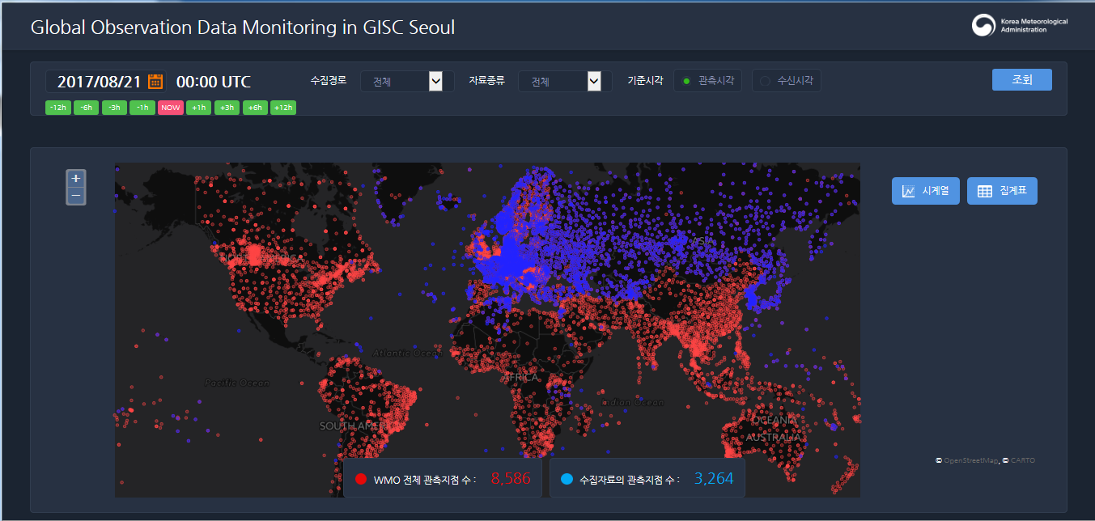

Training - Capacity Building Activity
  - RTC-Korea hosted Training course on ICT for Meteorological Services, Seoul in June 2018. Trainees were 11 staffs from 7 countries and WIS capacity development program was included in its course. Training materials were covering WIS Overview, WIS functionality, WIS metadata, Operational guide and TDCF migration. This WIS training course is provided every year to develop WIS knowledge and to help WIS implementation services in national level.

WIS and GCI interoperability Activity
  - GISC Seoul providing for WIS community with DAR service of GEOSS metadata, harvested from GEO-DAB based on ISO19139 via GISC Seoul OAI-PMH since 2013.
  - GISC Seoul provides WIS community with GEOSS metadata harvested from GEO-DAB on basis of ISO19139. GEOSS SRU server pointer is as following;
http://gisc.kma.go.kr/openwis-user-portal/srv/en/main.home/portal.sru?

Recommended Text
GISC Seoul is directly exchanging cache with 6 GISCs. Remote backup GISC was implemented as a role of disaster recovery. GISC Seoul is still going on GISC backup procedure and discussing with GISC New Delhi and its responsible NCs. For WIS capacity building, GISC Seoul has performed annual WIS training course jointed with ICT training course for WMO members in RTC-Korea. As result of WIS and GCI interoperability activities, GISC Seoul provides GEOSS metadata sets and GEOSS SRU server for other GISCs to harvest WIS compliant discovery metadata from GEO-DAB.

--------------------

