Review of the current status of implementation of TCP/IP procedures and applications at WIS centers

Current status of implementation of the Communication circuits
Current status of communication circuits connected with the RTH Tokyo is shown in Table 1 and configuration on connectivity is shown in Figure 1.
- Topics:
  - Establishment of a new link (Internet VPN) with Nay Pyi Taw; November 2016
  - Migration of the link with Exeter and Melbourne from TCP socket to FTP connection; March 2017
  - Establishment of a new link (Internet VPN) with Dhaka; May 2017
  - Establishment of a new link (Internet VPN) with Ulaanbaatar; October 2017
  - Migration of the link with Khabarovsk from TCP socket to FTP connection; January 2018
  - Establishment of a new link (IP-VPN) with Hanoi; September 2018
  - Upgrading the bandwidth of MPLS access link (NTT-COM) from 2 Mbps to 6 Mbps; December 2018
- Plans:
  - Migration of the link with New Delhi, Bangkok, Hong Kong and Manila from the TCP socket to FTP connection in 2019-2020
  - Establishment of a new link (RMDCN) with GISC Jeddah, in 2019

Table 1: Implementation status of communication circuits connected to GISC/RTH Tokyo
15th January 2019
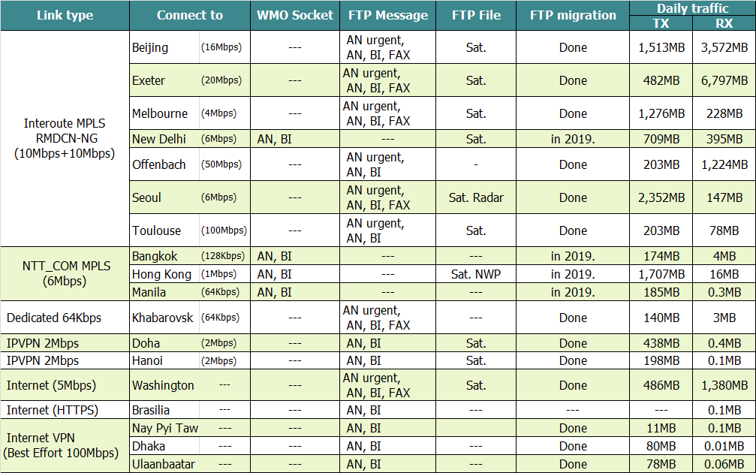
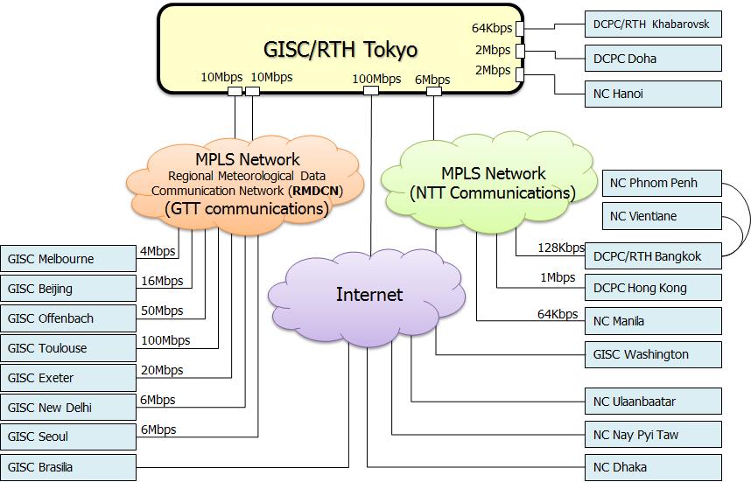
Figure 1: Configuration of the communication circuit of the GISC/RTH Tokyo

Implementation status of TCP/IP protocol and applications
TCP/IP protocol is running on all the communication circuits connected to the RTH Tokyo. HTTPS file upload function is used to exchange data with Brasilia. Simple FTP is used to exchange satellite data with Washington, Melbourne, New Delhi, Beijing, Seoul, Hong Kong, Doha and Hanoi. Currently, data and products are exchanged in the following manner.
Table 2: Manner of data exchange on FTP
From |  | To
Washington: | GET by Tokyo | Washington: | PUT by Tokyo with file renaming
Melbourne: | PUT by Melbourne with file renaming | Melbourne: | PUT by Tokyo with file renaming
New Delhi | PUT by New Delhi with file renaming | New Delhi | PUT by Tokyo with file renaming
Exeter: | PUT by Exeter with file renaming | Exeter: | PUT by Tokyo with file renaming
Offenbach: | PUT by Offenbach with file renaming | Offenbach: | PUT by Tokyo with file renaming
Beijing: | PUT by Beijing with file renaming | Beijing: | GET by Beijing
Seoul: | PUT by Seoul with file renaming | Seoul: | PUT by Tokyo with file renaming
Hong Kong: | PUT by Hong Kong with file renaming | Hong Kong: | PUT by Tokyo with file renaming
Doha: | PUT by Doha with file renaming | Doha: | PUT by Tokyo with file renaming
Hanoi: | PUT by Hanoi with file renaming | Hanoi | PUT by Tokyo with file renaming
Nay Pyi Taw | PUT by Nay Pyi Taw with file renaming | Nay Pyi Taw | PUT by Tokyo with file renaming
Dhaka | PUT by Dhaka with file renaming | Dhaka | PUT by Tokyo with file renaming
Ulaanbaatar | PUT by Ulaanbaatar with file renaming | Ulaanbaatar | PUT by Tokyo with file renaming
Note) GTS file naming convention is used in these file exchange

WIS
3.1 Status of JMA
  - Global Information System Centre (GISC)
  - 8 Data Collection or Production Centres (DCPCs)
    - RTH
    - RSMC-Typhoon
    - RSMC-Geographical
    - RSMC-ATM/EER
    - Satellite Centre
    - GPC-LRF (Forecast)
    - RCC (Tokyo Climate Centre)
    - WDC-GG (Greenhouse Gases)3.2 GISC Tokyo
Services:
  - Part A - Global Telecommunication System (GTS)
  - Part B - Data Discovery, Access and Retrieval (DAR) Services [Internet]
    - Metadata management
    - Metadata search
    - Web interface for metadata creation and modification
  - GISC cache
    - Warnings, WMO format data
    - Facilitate data subscription
  - Help desk
  - Gateway to data services by DCPC
    - SATAID service – Himawari Satellite imagery & more
    - Global Spectral Model products in 0.5 deg and 0.25 deg
  - GISC Backup
3.2 WIS Monitoring
GISC Tokyo has been operating WIS Monitoring Dashboard. And the WIS Monitoring is a collective effort of all WIS Centres to provide comprehensive and up-to-date information that enable reports on system status including availability, stability, integrity.
URL: http://www.wis-jma.go.jp/wcd/v1/top.html
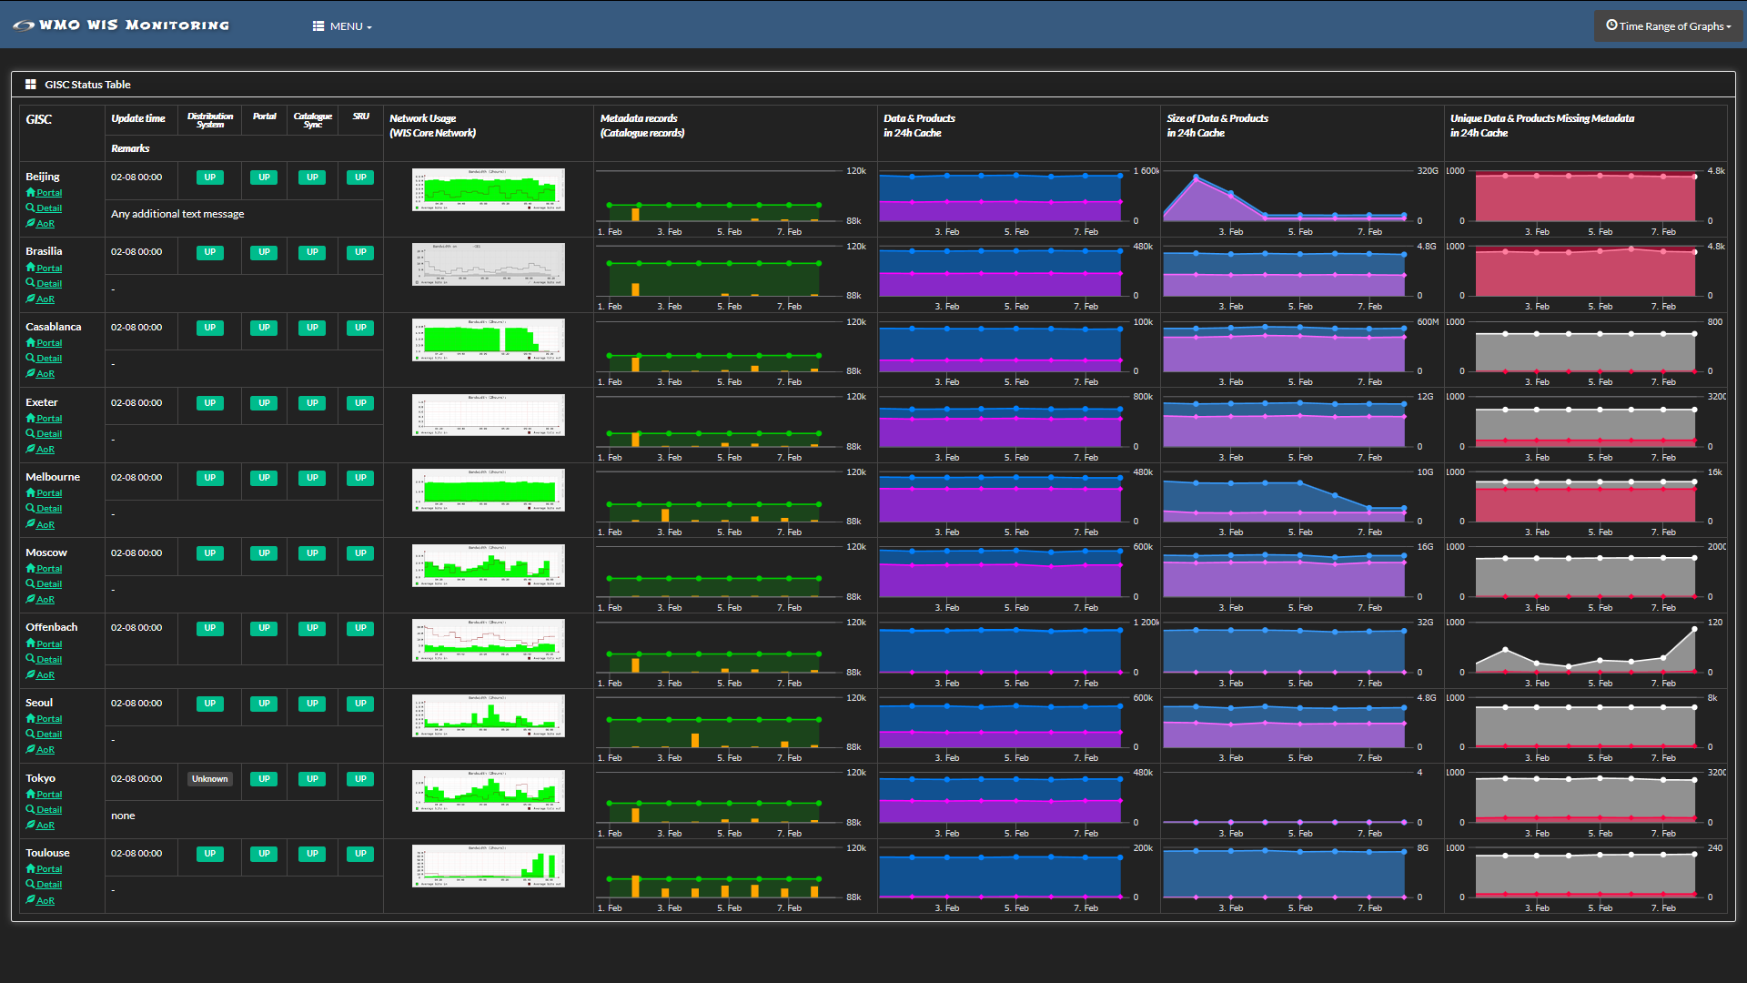
Figure 2: WIS Monitoring Dashboard

GISC Backup
GISC Tokyo has bilateral agreements on GISC backup with GISC Offenbach, GISC Beijing and GISC Melbourne.
GISC Backup between Beijing and Tokyo is in operational by using GTS and Internet DAR service.
Between GISC Offenbach and Tokyo is in operational by using Internet. The centres of the Area of Responsibilities send data to Offenbach by using FTP_PUT and to Tokyo by using HTTPS file upload function. GISC Tokyo shows their received data on the Internet.
GISC Melbourne and Tokyo, GISC Tokyo has two options for the Centre of AoR of Melbourne. Option 1 is to use existing GTS based backup and option 2 is to use Internet based backup.

Disaster Recovery Site (DRS)
JMA’s Disaster Recovery Site (DRS) on west side of Japan (Osaka city, 500km far from Tokyo) has been in operation since March 2015. If the Tokyo system has a failure, JMA will switch over to Message Switching System (MSS) of Osaka DRS to continue data exchange. The MSS of DRS has the same architecture of Tokyo’s MSS and access lines of MPLS networks. Several centres finished a connectivity test and started backup operation.
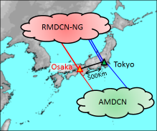
Figure 3: Disaster Recovery Site of JMA

Traffic analysis
6.1 Increasing trend of traffic volume (excluding Internet connection).
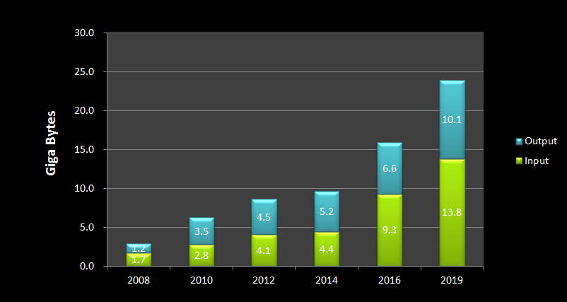
Figure 4: Statistics of traffic volume
6.2 Traffic volume in each channel
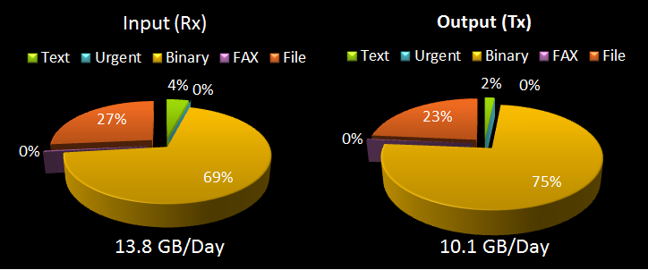
Figure 5: Statistics of traffic volume in each channel (data type)

6.3 Traffic status of each circuit
6.3.1 Beijing (16Mbps) - Tokyo (10Mbps)
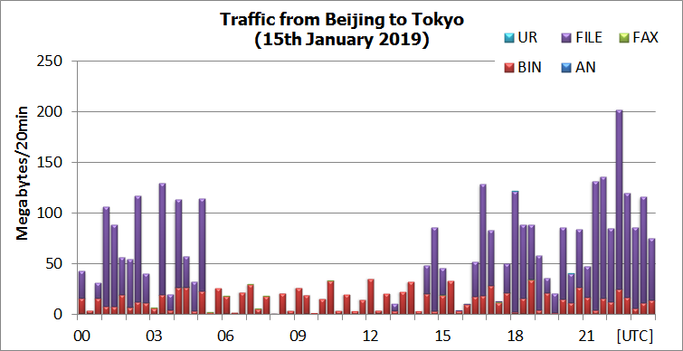
Figure 6: Traffic from Beijing to Tokyo
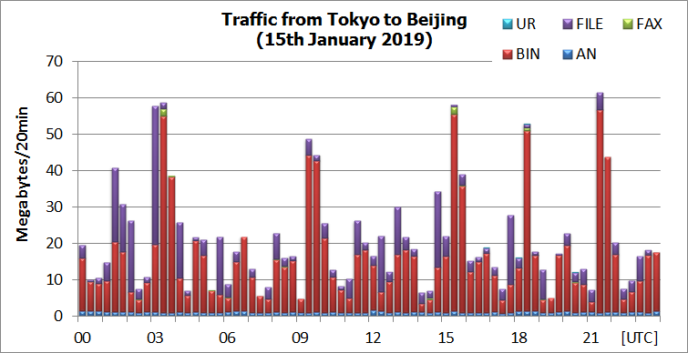
Figure 7: Traffic from Tokyo to Beijing
* UR: Urgent Message, AN: Normal Text (Alphanumeric) Message, BIN: Binary Message, FAX: Facsimile (Chart), FILE: File format data (Global File Naming Convention according to the Manual on the GTS)

6.3.2 Exeter (20Mbps) - Tokyo (10Mbps)
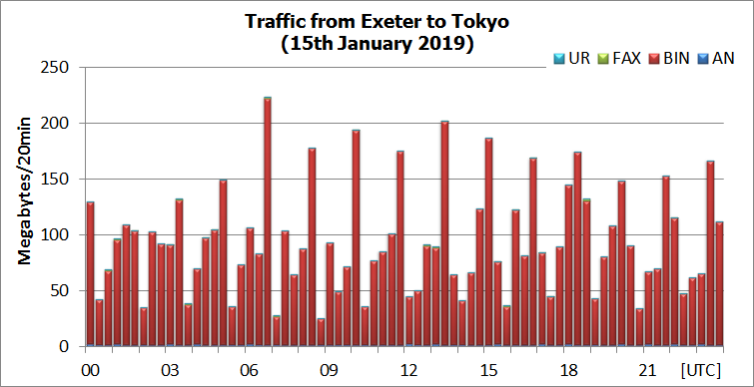
Figure 8: Traffic from Exeter to Tokyo
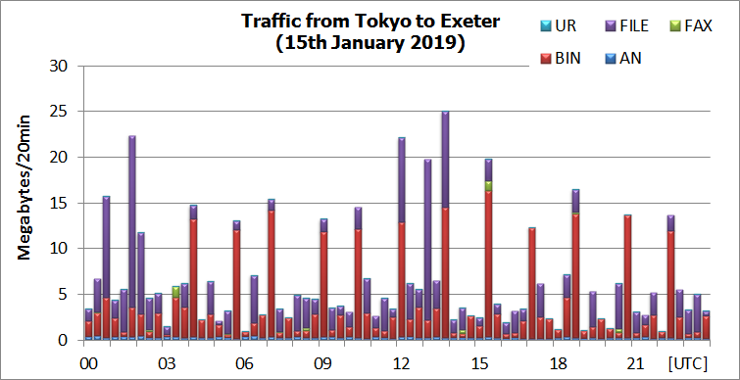
Figure 9: Traffic from Tokyo to Exeter

6.3.3 Melbourne (4Mbps) – Tokyo (10Mbps)
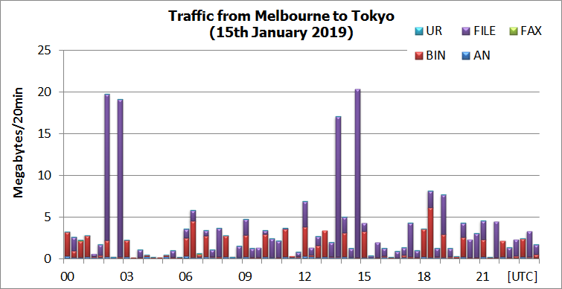
Figure 10: Traffic from Melbourne to Tokyo
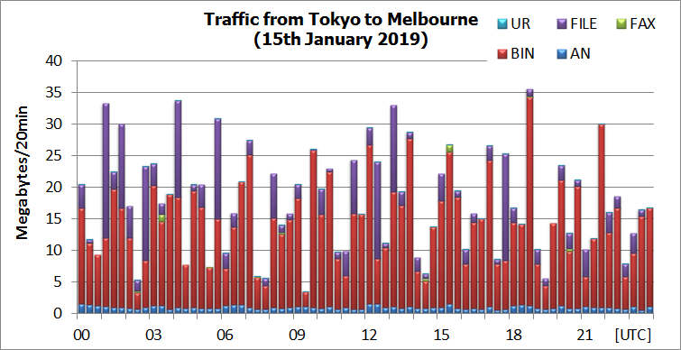
Figure 11: Traffic from Tokyo to Melbourne

6.3.4 New Delhi (4Mbps) - Tokyo (10Mbps)
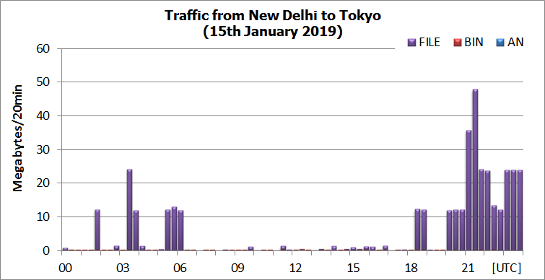
Figure 12: Traffic from New Delhi to Tokyo
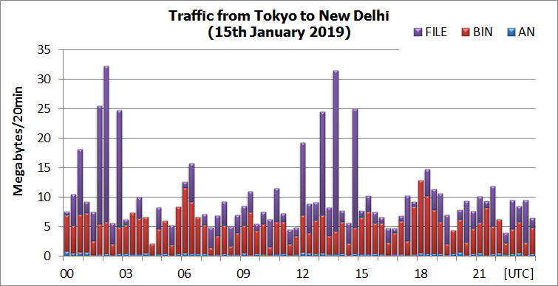
Figure 13: Traffic from Tokyo to New Delhi

6.3.5 Offenbach (50Mbps) - Tokyo (10Mbps)
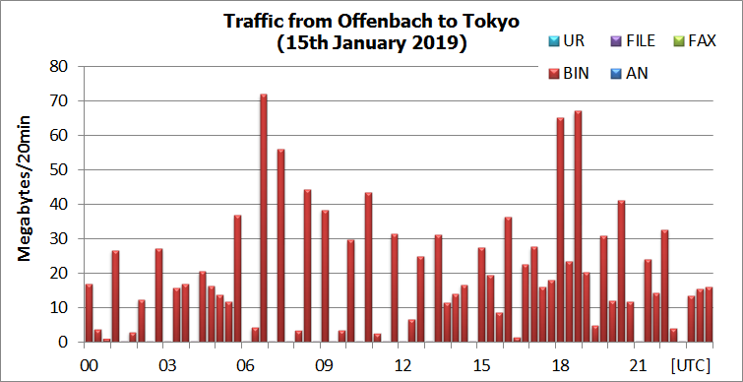
Figure 14: Traffic from Offenbach to Tokyo
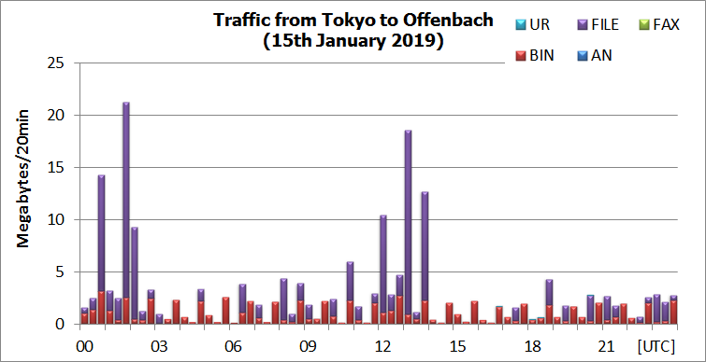
Figure 15: Traffic from Tokyo to Offenbach

6.3.6 Seoul (4Mbps) - Tokyo (10Mbps)
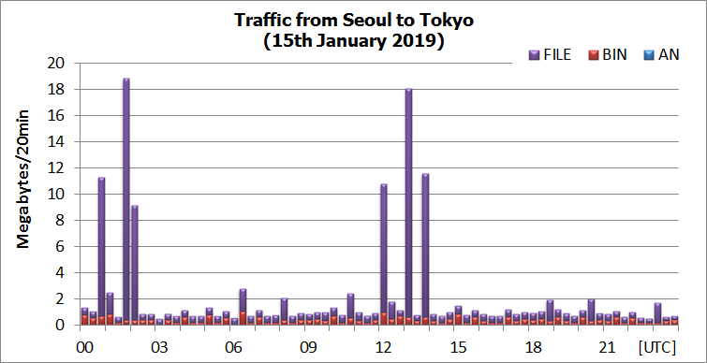
Figure 16: Traffic from Seoul to Tokyo
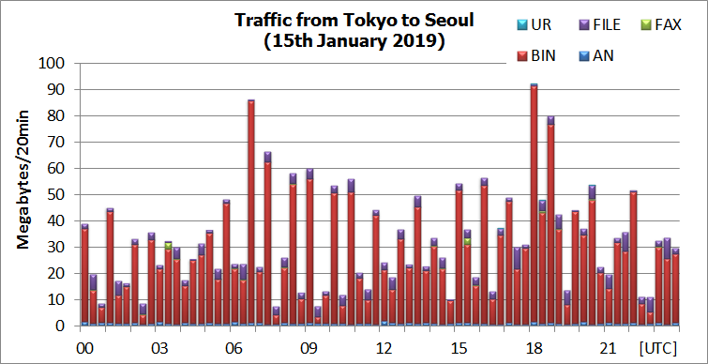
Figure 17: Traffic from Tokyo to Seoul

6.3.7 Toulouse (100Mbps) - Tokyo (10Mbps)
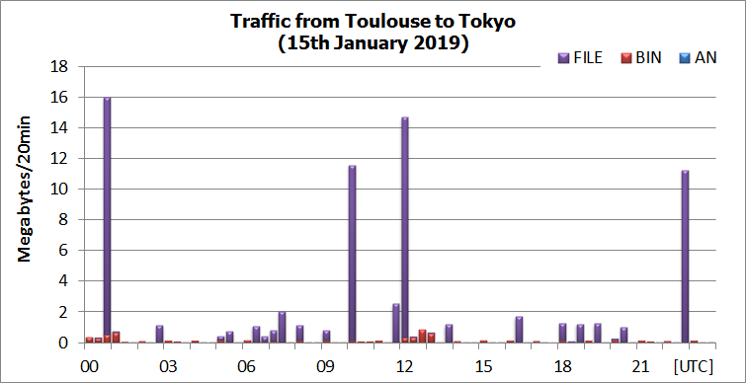
Figure 18: Traffic from Toulouse to Tokyo
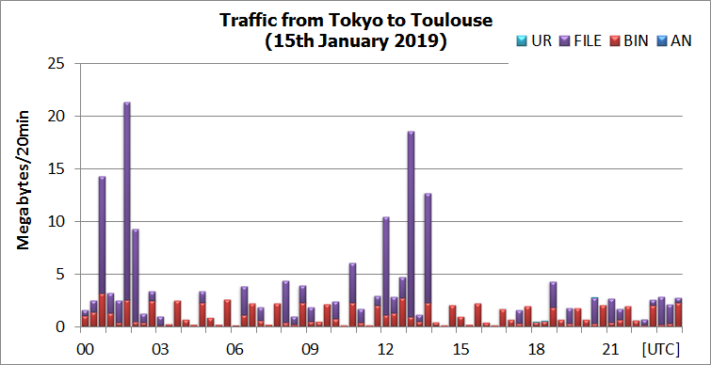
Figure19: Traffic from Tokyo to Toulouse

6.3.8 Bangkok (128Kbps) - Tokyo (6Mbps)
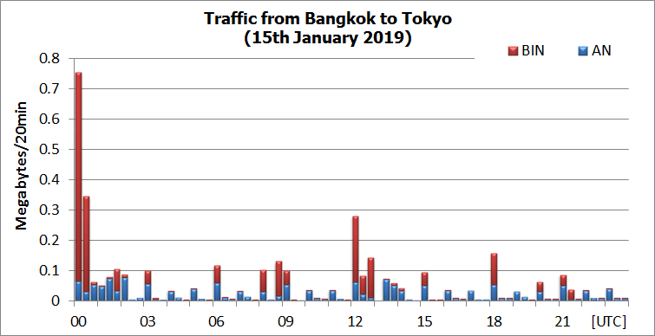
Figure 20: Traffic from Bangkok to Tokyo
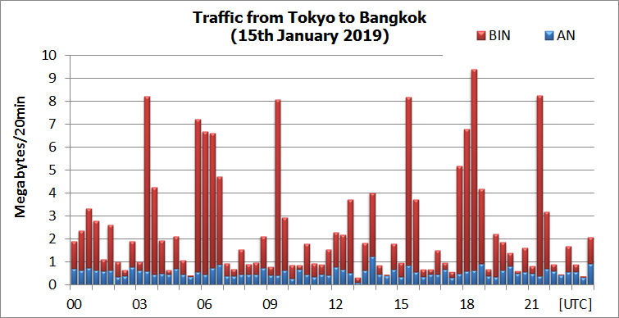
Figure 21: Traffic from Tokyo to Bangkok

6.3.9 Hong Kong (1Mbps) - Tokyo (6Mbps)
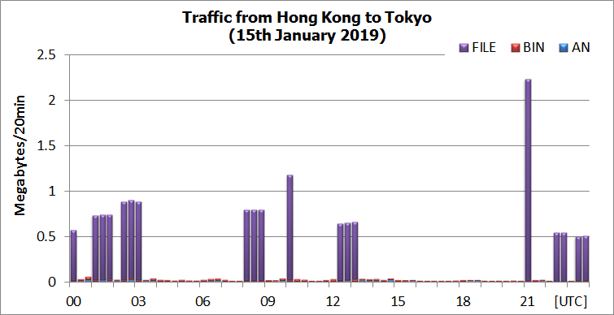
Figure 22: Traffic from Hong Kong to Tokyo
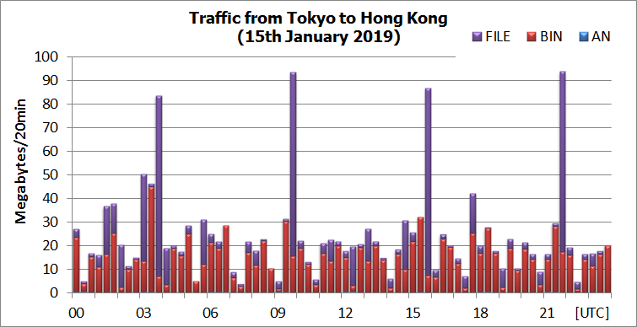
Figure 23: Traffic from Tokyo to Hong Kong

6.3.10 Manila (64Kbps) - Tokyo (6Mbps)
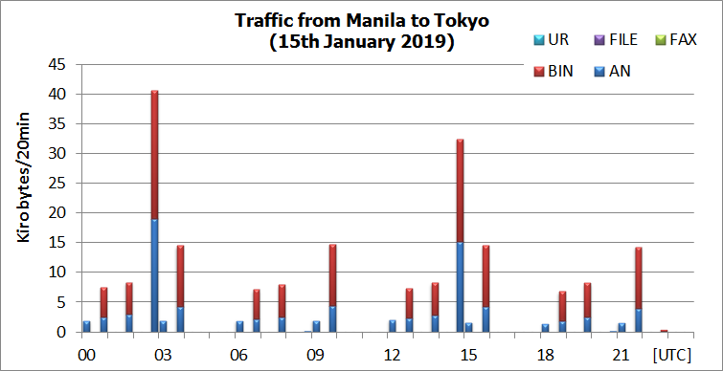
Figure 24: Traffic from Manila to Tokyo
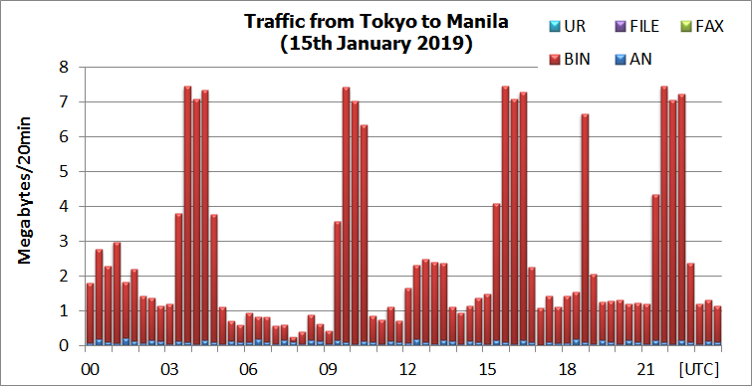
Figure 25: Traffic from Tokyo to Manila

6.3.11 Khabarovsk (dedicated 64Kbps) – Tokyo
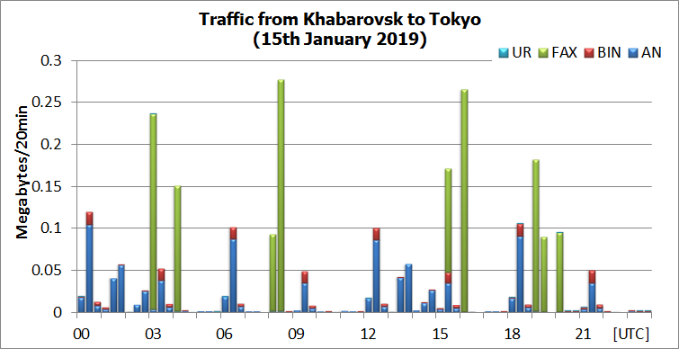
Figure 26: Traffic from Khabarovsk to Tokyo
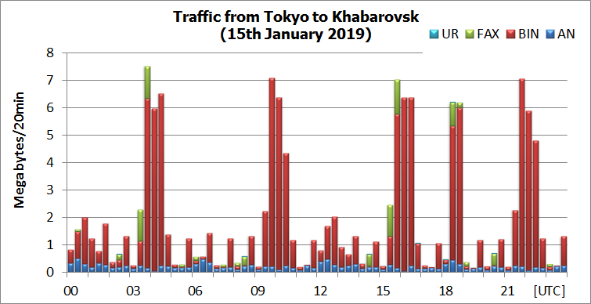
Figure 27: Traffic from Tokyo to Khabarovsk

6.3.12 Doha (IPVPN 2Mbps)- Tokyo
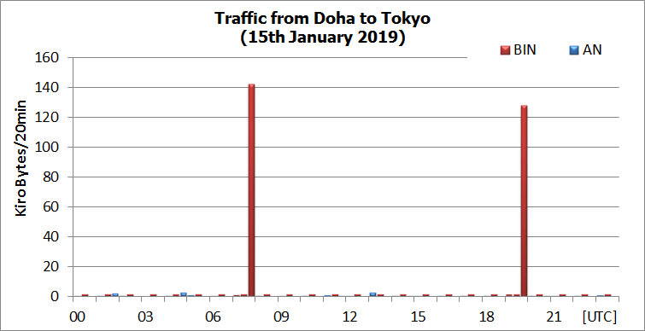
Figure 28: Traffic from Doha to Tokyo
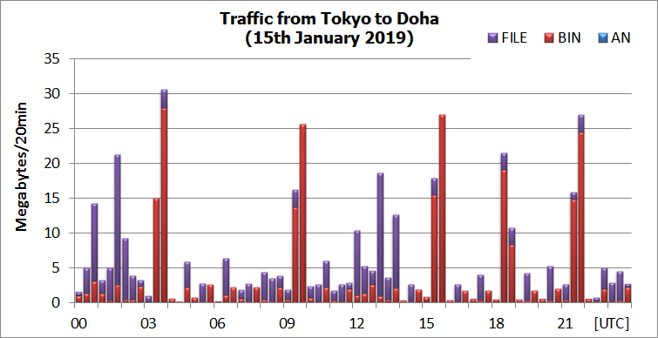
Figure 29: Traffic from Tokyo to Doha

6.3.13 Hanoi (IPVPN 2Mbps)- Tokyo
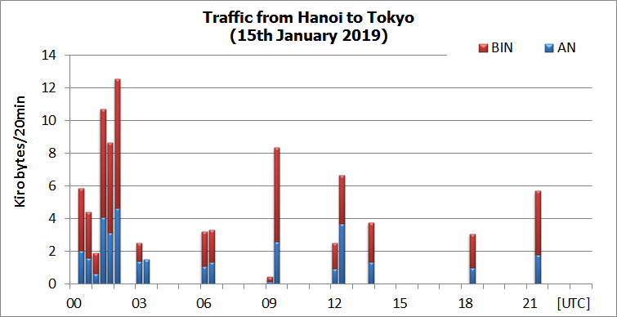
Figure 30: Traffic from Hanoi to Tokyo
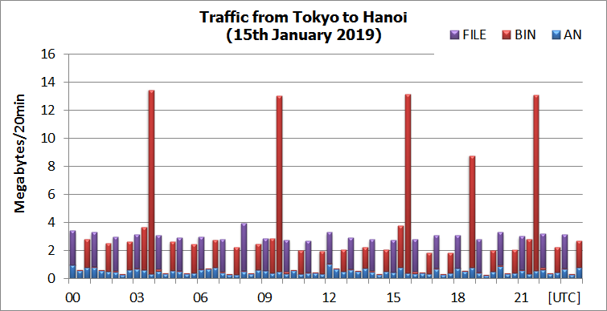
Figure 31: Traffic from Tokyo to Hanoi

6.3.14 Washington (Internet) – Tokyo (Internet)
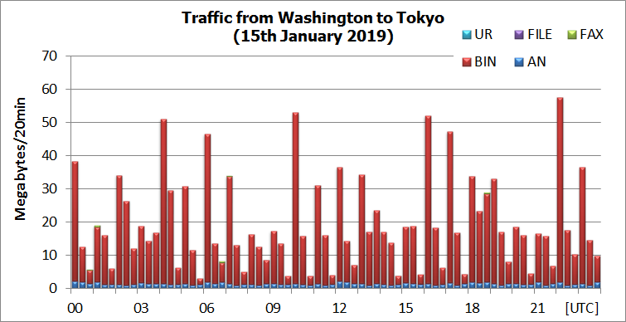
Figure 32: Traffic from Washington to Tokyo
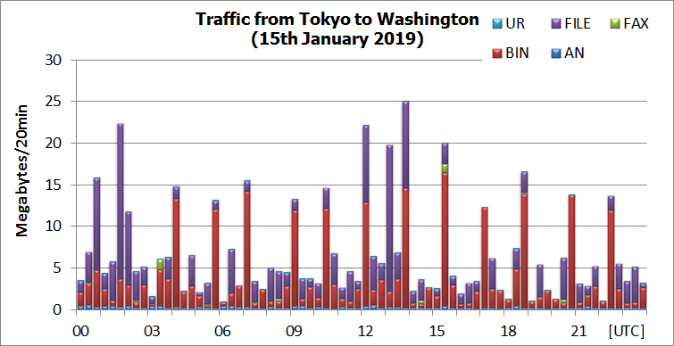
Figure 33: Traffic from Tokyo to Washington

6.3.15 Traffic status of the Internet for WIS part-B service (DAR).
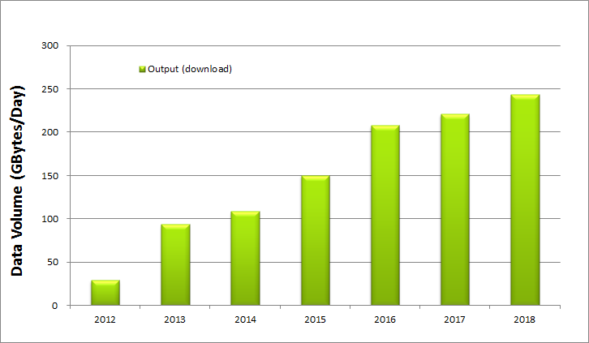
Figure 34: Average Daily Download Volume on the Internet Service of GISC Tokyo
6.3.16 Traffic condition of the Internet VPN link on AMDCN of GISC Tokyo
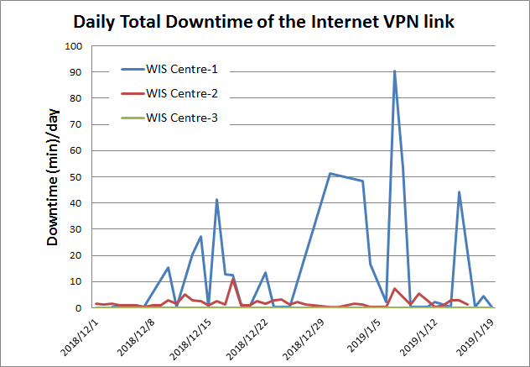
Figure 35: Daily Downtime of the Internet VPN link with connecting centres

Recommended Text
GISC Tokyo has a high availability connection to RMDCN-NG (10Mbps+10Mbps, Platinum Service), MPLS of the NTT-Communications (6Mbps) and Internet access (100Mbps Guaranteed bandwidth). And also GISC Tokyo has a Disaster Recovery Site (DRS) in Osaka city which is located in 500 km far west side of Tokyo and connecting with RMDCN-NG (10Mbps, Copper service) and MPLS of NTT-COM (6Mbps) networks to continue data exchange with connecting centres.
GISC Tokyo has bilateral agreements on GISC backup with GISC Offenbach, GISC Beijing and GISC Melbourne. Its backup procedures have been in operation.
GISC Tokyo has a plan to migrate from TCP socket to FTP connection in 2019-2020 completely.
GISC Tokyo has a plan to hold WIS Workshop in JMA HQ in 11th-12th March 2019.
--------------------

