Brief for Cloud Providers for the Future Technology Workshop
WMO information Service (WIS)

Background
The WMO facilitates a large and complex information system comprised of 192 members . The modern era information systems used to orchestrate complicated global exchanges for societal benefits have been in a state of constant development for the last 60 years, and in many cases predate and preempt what is now recognized as the Internet and Enterprise IT ecosystems. The Current WIS system was envisaged in 1992. In 2003 it was resolved that these systems would adopt international standards and the evolution to what is now recognized as WIS 1.0 , a truly global system for information exchange came into full operation and recognition. Also during this period the IT industry has undergone a radical and rapid acceleration and development and has aligned services and systems along similar global lines in data communications , networks and supporting infrastructure
The WIS system is an evolution of all the previous methods and techniques use by the meteorological community to distribute information based on an early 20th Century architectures . The WMO and partners want to build on this investment and use the best of new technology with a view to 2030 and beyond to develop a WIS 2.0 concept . Many of the components that are key elements WIS 1 .0 are now available in Cloud services that are scaled globally and need to be fully considered in any rethinking of the WIS 2.0. It is also worth noting that many of the 198 WMO members are moving or considering Cloud to operate their national services where appropriate and this technology is a natural fit for global information exchange .

The Brief
The workshop seeks to investigate the capabilities and the outlook to 2030 and beyond, for the elements of cloud that can be mapped to current and future WIS Elements :
- Global distribution and resilience of infrastructure
- Information search capability
- Internet of Things architecture
- Networks
- API services
- Open/Big Data
- Publish /Subscribe/Messaging capability
- Content Distribution Networks
- Interoperability with other Cloud providers
- Charging Models
The workshop will be attended by Senior representatives of the meteorological community that represent and chair global working groups . The total number of attendees will be small (30-50) to enable in-depth discussion to occur with the presenters .
Several cloud providers will be approached to present on part or all of the elements listed above that the provider considers is the strength of their offering . These sessions will be limited to 1-1/2 hours per provider and are requested as a capability overview only with a view to 2030 and beyond.
It is likely that any WIS 2.0 will be an ecosystem of providers and operators due to the geopolitical nature of the WMO members.
These sessions should be viewed as informational and will not lead to any direct financial engagements in the short to medium term.
The Location and Date (provisional)
WMO 7bis Avenue de la Paix Case postale 2300 Nations, 1211 Genève
Date 19-20th Jan (Cloud sessions planned on the 19th March)
Video presentations can be accommodated.
WMO Contact
Bryan Hodge : bhodge@wmo.int Ph 41227308434

Attachment 1 WIS Overview
WMO and Data Management
The mission of the World Meteorological Organization (WMO) includes facilitating scientific understanding, and the comprehensive exchange of information world wide. Data is collected and exchanged around the clock by the 192 WMO Members--data from sixteen satellites, one hundred moored buoys, six hundred drifting buoys, three thousand aircraft, seven thousand ships, and ten thousand land-based stations.
From the beginning of WMO, timely data exchange has been crucial. Operators have been routing data messages over international lines using systems dedicated to WMO. This is the WMO Global Telecommunication System (GTS). Now WMO is taking a step beyond managing messages. In committing to WIS, WMO moves to an overarching approach based on managing data and information.
WIS Implementation: In 2003, WMO Members decided that WIS will use international industry standards for protocols, hardware and software; build on the existing WMO GTS, with special attention to a smooth and coordinated transition; provide time-critical data exchange, as well as data access and retrieval services; and support all WMO and related international programmes.
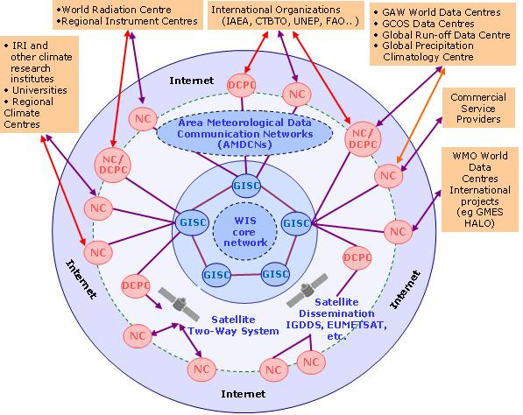
WIS is evolving in two parallel parts. One is the continued evolution of technologies in the GTS, further improving the delivery of data, products, and services such as warnings. The other extends WMO services through flexible data discovery, access and retrieval, as well as flexible timely delivery. WIS is a complex system of systems, with very diverse components and a wide array of data handling mechanisms. The most visible, new facility provided by WIS is the comprehensive Discovery, Access and Retrieval (DAR) catalogue for all of the data, products, and services encompassed by WIS and has been operational since Jan 2012.
WIS Centres: WMO Member countries will implement and operate WIS using existing centres with some additional or modified capabilities. In operational terms, WIS encompasses three types of centres: Global Information System Centres (GISCs), Data Collection or Production Centres (DCPCs) and National Centre (NCs). Existing National Meteorological and Hydrological Centres become WIS NCs. Every WIS NC must supply metadata for their data and products. DCPCs collect, disseminate, add value to, and archive regional or programme-specific data and products. DCPCs maintain catalogues of their holdings and services, and appropriate parts of these catalogues update a comprehensive catalogue of WIS holdings, hosted by the GISCs. GISCs also hold and distribute copies of at least 24 hours of WMO data and products intended for global distribution.
Existing centres in WMO Member States become WIS Centers
GTS: WMO's GTS is a key part of WIS. The WIS Core Network among GISCs uses the GTS Improved Main Telecommunications Network. Each GISC connects to other centres using its Area Meteorological Data Communications Network (AMDCN). These AMDCNs use GTS and the Internet extensively, and each WIS centre can support interoperability with external systems as well as data access via the Internet.
WIS Component Systems
GOS: The WMO Global Observing System (GOS) provides observations of the state of the atmosphere and ocean surface. These observations are used for the preparation of weather analyses, forecasts, advisories and warnings, and for climate monitoring and environmental activities carried out under programmes of WMO and other relevant international organizations. GOS is operated by National Meteorological Services, national or international satellite agencies, and several consortia.
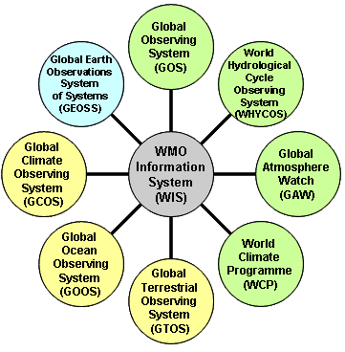
WHYCOS: The WMO World Hydrological Cycle Observing System (WHYCOS) strengthens cooperation among National Hydrological Services, coordinating measurement and collection of surface and ground water data. External interfaces include National Hydrological Services (WIS NC's), and Global Data Centres (WIS DCPC's) such as the Global Runoff Data Center.
GAW: The WMO Global Atmosphere Watch (GAW) strengthens the ability to predict climate, weather and air quality, by maintaining and applying global, long-term observations of the chemical and physical characteristics of the atmosphere. External interfaces are at the GAW Web site, the GAW World Data Centres (WIS DCPC's).
WCP: The WMO World Climate Program (WCP) coordinates activities in climate data collection, monitoring, research, prediction, applications and training. External interfaces are at National Meteorological Services, Regional Climate centers, World Climate Data Centers and Global Climate Forecast Producing Centers.
GCOS: The Global Climate Observing System (GCOS) is co-sponsored by WMO, the UNESCO Intergovernmental Oceanographic Commission (IOC), the United Nations Environment Programme (UNEP), and the International Council for Science (ICSU), GCOS focuses on comprehensive observations required for monitoring climate, detecting change, assessing impacts, and improving models of the climate system.
GOOS: The Global Ocean Observing System (GOOS) focuses on sustained observations of the oceans, generation of oceanographic products and services, and interaction between research, operational, and
user communities. GCOS has many external interfaces: the Global Observing System Information Centre, GCOS Monitoring and Analysis Centres, and the many specific Atmosphere, Ocean, and Terrestrial Networks for observations, related data centres and archives that are designated as relevant to climate.
GTOS: The Global Terrestrial Observing System (GTOS) is a programme for observations, modelling, and analysis of terrestrial ecosystems to support sustainable development. GTOS facilitates access for researchers and policy makers to detect and manage global and regional environmental change. External interfaces include the GTOS Data Centres Directory, the GTOS Resources Directory, and the Terrestrial Ecosystems Monitoring Sites (TEMS) database.
GEOSS: The WIS Architecture is very similar to the Global Earth Observations System of Systems (GEOSS) Architecture as agreed in the GEOSS 10 Year Plan and Reference Document. WIS interfaces with GEOSS at the GEOSS Clearinghouse. Because GEOSS and WIS adopted the same ISO search standard, WIS GISCs can search GEOSS Clearinghouse and WIS catalogs are searchable by GEOSS Clearinghouse. It is important to note that data and product users can access WIS GISC's and DCPC's either directly or by a referral from GEOSS. The same is true of all WIS Centres: broader catalogs and access portals supplement but do not replace existing catalogs or portals.
WIS Benefits
- WIS enhances the collection of critical data needed to monitor and predict aspects of the environment, including hazards;
- WIS catalogs the full range of data and products, simplifying search and assuring equitable access per WMO policies;
- WIS enhances the availability of time-critical data and products at centres in all nations, ensuring the effective provision of services to their populations and economies;
- WIS opens up WMO's private network (the GTS) to other types of environmental data so that all programmes have stronger infrastructure support; and
- WIS exploits opportunities as they become available with technology innovation.
WIS Reference Documents: http://www.wmo.int/pages/prog/www/WIS/ref_docs_en.html

