Sarracenia AMQPS Data Distribution for WMO WIS 2
Lighthouse Project Proposal
DRAFT version 0.1.1 / 2018-11-26

Executive Summary
As part of WMO WIS 2, current and efficient data distribution mechanisms are being considered. This document provides background on Sarracenia, a reference implementation of the Advanced Message Queuing Protocol (AMQP) in operational use at the Government of Canada. The Advanced Message Queuing Protocol is an open standard application layer protocol for message-oriented middleware. Its defining features are message orientation, queuing, routing (including point-to-point and publish-and-subscribe), reliability and security.
Sarracenia was developed by the Government of Canada to suit weather data distribution requirements following its inception at the WMO CBS Technical Conference in Namibia, 2010. Since then, Sarracenia has become the operational tool to copy tens of terabytes and tens of millions of files daily across several clusters and networks. The Meteorological Service of Canada (MSC) also leverages Sarracenia to provide public access to weather data on its MSC Datamart data server.
In order to validate the suitability the AMQP open standard and the Sarracenia reference implementation, the Meteorological Service of Canada is seeking interest from National Meteorological and Hydrological Services (NMHS) to participate in a Lighthouse Project. The outcomes of this project will be presented to the ICT-ISS Task Team on the Evolution of WIS (TT-eWIS).

Introduction
An overview of what is Sarracenia: “MetPX-Sarracenia is a data duplication or distribution pump that leverages existing standard technologies (web servers and the AMQP brokers) to achieve real-time message delivery and end-to-end transparency in file transfers. Data sources establish a directory structure which is carried through any number of intervening pumps until they arrive at a client. The client can provide explicit acknowledgement that propagates back through the network to the source. Whereas traditional file switching is a point-to-point affair where knowledge is only between each segment, in Sarracenia, information flows from end-to-end in both directions.
At its heart, Sarracenia exposes a tree of web accessible folders (WAF), using any standard HTTP server (tested with Apache). Weather applications are soft real-time, where data should be delivered as quickly as possible to the next hop, and minutes, perhaps seconds, count. The standard web push technologies, ATOM, RSS, etc... are actually polling technologies that when used in low latency applications consume a great deal of bandwidth and overhead. For exactly these reasons, those standards stipulate a minimum polling interval of five minutes. Advanced Message Queueing Protocol (AMQP) messaging brings true push to notifications, and makes real-time sending far more efficient.”
Note that the AMQP protocol specifies notifications, the actual transport of data is flexible and can use widely-used and mature mechanisms such as HTTP, HTTPS, SFTP and FTP. Sarracenia can also be improved to leverage emerging data storage and sharing methods such as the peer-to-peer InterPlanerary File System (IPFS).

Lighthouse Project
In order to validate the suitability the AMQP open standard and the Sarracenia reference implementation, the Meteorological Service of Canada is seeking interest from National Meteorological and Hydrological Services (NMHS) to participate in a Lighthouse Project.
Sarracenia is heavily and operationally used within the Shared Services Canada department, including to fulfill the data interchange requirements of Environment Canada, the Meteorological Service of Canada (MSC) and its supercomputing infrastructure.
MSC’s data is also publicly accessible via AMQPS via Sarracenia on the MSC Datamart.
A project is considered for the real-time weather radar data sharing between Environment Canada and the American Federal Aviation Administration (FAA).

Annexes
- Annex A: Mesh-Style Data Exchange for the WIS-GTS in 2018
- Annex B: Sarracenia Status January 2018

References
AMQP:
- Official website: https://www.amqp.org/
- Advanced Message Queuing Protocol on Wikipedia: https://en.wikipedia.org/wiki/Advanced_Message_Queuing_Protocol
Sarracenia:
- Sarracenia AMQPS on GitHub: https://github.com/MetPX/sarracenia
- Sarracenia in 10 minutes, YouTube video: https://www.youtube.com/watch?v=G47DRwzwckk
Public MSC Datamart:
- Meteorological Service of Canada HTTP data server: http://dd.weather.gc.ca/about_dd_apropos.txt
- MSC Datamart AMQP documentation (not updated for AMQPS): http://dd.weather.gc.ca/doc/README_AMQP.txt
- Meteorological Service of Canada moving to Secure AMQP, AMQPS, leveraging SSL encryption: https://lists.ec.gc.ca/pipermail/dd_info/2018-September/000294.html
WMO WIS TT-eWIS:
- TT-eWIS 2018 meeting: https://wiswiki.wmo.int/tiki-index.php?page=TT-eWIS2018

Authors
- Alexandre Leroux, Canadian focal point on WIS matters, alexandre.leroux@canada.ca
- Peter Silva, former Canadian focal point for WIS centres, peter.silva@canada.ca

Annex A
Mesh-Style Data Exchange for the WIS-GTS in 2018
Source: https://github.com/MetPX/sarracenia/blob/master/doc/mesh_gts.rst
DRAFT: working document, subject to change.
Contents
- Executive Summary
- GTS was Designed Long Ago
- GTS is Limited & Inflexible
- Databases are Optimal for Fixed Sized Records. No One Uses Them That Way
- Internet Push is a Poor Fit for Large Feeds
- Store And Forward is Often Better in Practice
- With AMQP Notices on a Standard File Server
- And an Agreed Directory Tree
- Simple/Scalable Peer Configurations for Nations
- Using An Open Reference Stack
- Statelessness/Crawlable
- Programmability/Interoperability
- Priorities
- Caveat: Solution for This Problem, Not Every Problem

Executive Summary
Over the past decade, the World Meteorological Organization (WMO) Information Service WIS Part 1 has implemented meta data catalogues for some world-wide meteorological datasets. In WIS-DAR, Discovery, Access, and Retrieval, the emphasis on this early work was on Discovery, as this was a major difficulty. In terms of actual data exchange, the pre-existing network: the Global Telecommunications System (GTS) has remained the WMO's accepted method to circulate weather data in meteorological real-time [1] used to achieve Access and support Retrieval. It does so by established bi-lateral agreements among individual members.
The pre-existing network feeds pre-existing systems that operate on different premises from WIS, and there isn't a particularly good mapping from D to A, and R today. Use of WIS metadata to drive real-time data exchange is not efficient, and GTS data is not easily interoperable with other industries' mostly web-based technologies.
This brief suggests that a mesh-like network of web servers is possible now because of great advances in technology that reduce the need for rules and structure for international exchange of meteorological data. Previously, technological limitations placed stringent constraints on international data exchange. These days, effective international data exchange can be arranged with fewer interveners, less hierarchy, less coordination. A more loosely coupled and flexible interconnection strategy makes it much easier for members to exchange new datasets in a systematic way, without having to develop the bi-lateral or multi-lateral exchange agreements. Indeed often, the GTS is circumvented because it is so ill-suited to such exchanges.
Members that agree to exchange data, can do so directly, which completes the dream of the WIS. The existing work on WIS, standardizing metadata exchange is completed by adding the exchange of the underlying data using standardized open methods, with a straightforward mapping from the metadata. As the proposed implementation uses existing standards, the WMO does not need to define any additional ones, and interoperability and access for other players in the broader society should be straightforward.
While it is believed that this technology has great potential to improve WMO data exchange, it will take a few years to adopt it, and prior to adoption, there needs to be agreement on the approach. Today, the next step would be to find some partner countries with which to engage in some experimental data exchanges to validate the approach, and be able to collaboratively determine implementation details.
[1] | (1, 2) real-time, in meteorological circles refers to immediately or ASAP, which can mean anything between a few seconds and a few minutes. This is very different from the computing use of the term, where it refers to hard deadlines usually expressed in milliseconds. When this document uses real-time it uses it in the meteorologically accepted meaning.

GTS was Designed Long Ago
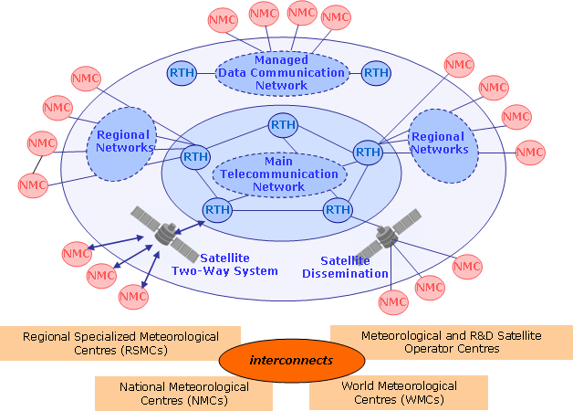
The World Meteorological Organization (WMO) Information Service (WIS)'s Global Telecommunications System (GTS) is the WMO's accepted method to circulate weather data in meteorological real-time [1] It does so by pre-established bi-lateral agreements about who circulates what to whom. When data arrives, it is sent to the proper destinations immediately. In hardware terms, the GTS used to be a set of point-to-point links. It is, in general, very reliable and has good performance for the sorts of data for which it was envisioned.
The GTS successfully and elegantly applied the technologies of the 1940's to obtain world-wide exchange of weather data, most obviously, to enable commercial air travel to expand exponentially over the succeeding decades. It was made in a world of expensive point-to-point telephone links, very low bandwidth, very little computational power, and few existing standards for reliable data transfer. Today, The underlying technologies embodied by Internet and Regional Main Data Communications Network (RMDCN) (which have already subsumed the physical links of GTS) are completely different: bandwidth and storage are relatively cheap, computing power is cheaper, point-to-point links are now more expensive than multi-point clouds. Today's WMO members want to exchange orders of magnitude more data types and higher volumes at higher speed.
The weather community has, in the past, needed to create standards because no similar need in the rest of industry existed. Over the last few decades, as internet adoption has broadened and deepened, horizontal solutions for most of the technical issues addressed by WMO standards have emerged. The WMO's strategic direction always has been and will continue to be to use technologies from the wider world and not define their own standards unnecessarily.

GTS is Limited & Inflexible
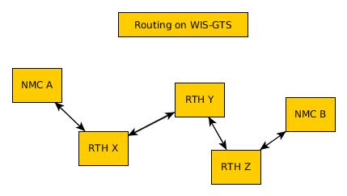
In the traditional GTS, when new data is made available by a National Meteorological Centre (NMC), it needs to issue notices, and likely discuss with their Regional Telecommunications Hub (RTH), about accepting and routing the new data. The RTHs must discuss amongst each other whether to exchange the data, and other NMC must further request from their RTH. For NMC A to make data available to NMC B, the GTS staff at both NMC's and all intervening RTHs must agree and action the request.
Also, the routing tables at each NMC and each RTH are theoretically, but in practice, not easily, inspectable. It may be that the product NMC B is looking for is already available at their local RTH, but neither A, nor B have any effective way of determining that, other than asking the administrators of B's RTH. Manual routing is ineffective, opaque and human resource intensive.
Lastly, the GTS has a maximum message size, which though it was raised from 14,000 bytes to 500,000 bytes in the last few years, is still very limiting. This rules out many modern important data sets (e.g. RADAR, Satellite, NWP). WMO doesn't need its own data transport, as is demonstrated by many members' use of protocols without such limitations, adopted from the broader internet, such as FTP, SFTP, and HTTP. Even more often, such transfers are accomplished by bi-lateral arrangement, as transfers of larger datasets cannot be expressed in current GTS protocols.
The initial WIS, as formulated over a decade ago, was in part an attempt to address this opaqueness by introducing some Information Management (IM) concepts, and support for DAR: Discovery, Access, and Retrieval. All WMO members want to know is which data is available from which centres. So we publish metadata to Global Information Service Centres, where the world's real-time weather information is available and some means of retrieval is specified.
When dealing in the abstract, without time constraints, add/or with small datasets, retrieval time does not matter, but the access penalty imposed by using databases for individual retrieval grows with the number of items stored and the number of queries or retrievals to be sustained. Initially, WIS was most concerned with getting higher visibilty of data, understanding what data was available. WIS Part 1 primarily implemented a metadata layer, while the GTS has persisted to transfer actual data. Once WIS Part 1 was in service and DAR was available, which at first blush appears much easier and friendlier, why didn't everyone just use DAR to replace the GTS?
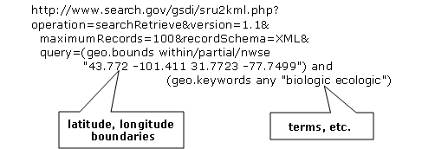
The WIS architecture tends to concentrate load at the GISCS, whether they want it or not. Even assuming they want it, answering large volumes of queries in such an architecture is a problem. The mental model for this is a database and each retrieval is conceptualized as a query. From computational complexity theory[2]_, each query is often an O(N) operation (or in the best case of perfect indexing, O(log N)) and retrieval of specific items by their key is also, at best, O(log N).
To perform Retrieval (the R in DAR) of all the items from an index, one at a time, the best algorithm has complexity N * log N. The best case only arises if the indices are properly designed for the access method intended. In practice, without careful design & implementation, the performance can devolve to N**2.
[2] | Algorithmic complexity expresses how many computer operations are needed to perform a function. For example, to search through a list of N items sequentially would require a computer to perform N operations, we then say the algorithm if on the order of N, or O(N). If one sorts the list, a binary search takes only log N operations to find a entry, written O(log N) More: Big O notation Also: Time complexity

Databases are Optimal for Fixed Sized Records. No One Uses Them That Way
There are typically two major schools of thought on meteorological data storage: Files and Databases. For many years, data was relatively small, there were relatively few datatypes, and they fit in small databases and with enough analysis one could normalize them down to fixed size fields.
Relational databases were invented a decade or two after the GTS, and they optimize storage and retrieval of fixed size data. They achieve near optimal performance by careful selection of the data model and extensive use of fixed size fields. In practice, the use of fixed size fields turns out to be a difficult constraint to satisfy and many interesting data sets, especially on systems whose primary function is data transmisssion, are most logically stored as arbitarily sized byte sequences, generally termed: Binary Large Objects, or BLOBS. When one stores BLOBS, a database becomes algorithmically a little different from a file system.
Essentially BLOBS are an indexed list of byte streams. Once a database uses BLOBS, it incurs the same overhead for data retrieval as a properly used file system. Regardless of the storage method, the cost of retrieval is going to be O(log N) for a known key. In a file system, the key is the name. In a DB, the key is an object-id or index value. If one wishes to use multiple indices, then one can still use a database, which is largely what WIS Part 1 is. It is simply a standard pratice to store the actual data in BLOBS, and file systems are a competitive method of storing those.
Over time, as data items grow in individual size, it makes progressively more and more sense to store them in file systems, and to confine use of database systems to store metadata and indices that point to the data items stored in files.

Internet Push is a Poor Fit for Large Feeds
So called Push technologies are actually Pull. A client asks a server if they have new data available for them. The server responds with the list of new data available, then the client pulls the data. This means that an entity storing data has to retrieve the items from the data store (with an O(log N) cost to each retrieval.) As the domain is real-time processing, the time for data to be obtained by a client is also relevant, and bound by the maximum frequency that a client is allowed to ask for updates. In general, the ATOM/RSS protocols expect a minimum interval between polling events of five minutes.
Each polling event requires the server to examine its database for all matching entries, this search is likely an order N operation. So the responses to polling requests are expensive, and the retrievals from the data system are likewise expensive, which likely motivates the usual discouragement of rapid polling.
In the best case, indices based on time will be present, and one will be able to search table with that dimension and incur log(N) operations to find the earliest observation to retrieve, and then walk forward along that index. In many practical cases, databases are not indexed by time, and so the initial search is for all stations, and then one must examine the time for the entries retrieved, which will incur N**2 operations, and in some cases it can be even worse.
The actual cost of serving a client depends critically on the server's indices being optimally constructed. These characteristics are hidden in a database and are not easily inspected by anyone but the database administrator.

Store And Forward is Often Better in Practice
"Store and Forward" is a term we will use here to denote technologies that deal with data on receipt, in contrast to simply storing the data and awaiting clients' polls. Real-time systems such as the GTS get around the retrieval expense problem by storing and forwarding at the same time. When a datum is received, a table of interested parties is consulted, and then the forwarding is done based on the data already "retrieved".
The cost to forward an item to a given client is closer to O( log N ).
This works as an optimization because one is forwarding the message at exactly the time it is received, so the entire lookup and search process is skipped for all those known consumers. For comparison, the polling web standards standardizes the cost of search at every polling interval.
The cost of the search is highly variable and not under server control. Poorly structured queries (e.g. by station, and then time) can result in an N*log(N) query or even N-squared complexity.
This is especially acute for weather alert information, where a high polling frequency is a business need, but the volume of data is relatively low (alerts are rare). In such cases the polling data can be 10 times or even 100 times the amount of data transfer needed to send the warnings themselves.
In practice, the load on servers with large real-time flows to many clients will be orders of magnitude lower with a real push technology, such as the traditional GTS, than supporting the same load with Internet Push technologies. A separate but related cost of polling is the bandwidth for the polling data. By forwarding notifications on receipt, rather than having to service polls, one reduces overall load, eliminating the vast majority of read traffic.
A real-world example of bandwidth savings, from 2015, would be that of a German company that began retrieving NWP outputs from the Canadian datamart using web-scraping (periodic polling of the directory) and when they transitioned to using the AMQP push method, the total bytes downloaded went from 90 Gbytes/day to 60 Gbytes per day for the same data being transferred. 30 GBytes/day was just (polling) information about whether new model run outputs were available.
The requirements for a store and forward system:
- TCP/IP connectivity,
- real-time data transmission,
- per destination queueing to allow asynchrony (clients that operate at different speeds or have transient issues),
- application level integrity guarantees.
In addition, the ability to tune subscriptions, according to the client's interest will further optimize traffic.
In terms of internet technologies, the main protocols for real-time data exchange are XMPP and websocket. XMPP provides real-time messaging, but it does not include any concept of subscriptions, hierarchical or otherwise, or queueing. Web sockets are a transport type technology. Adopting either of these would mean building a domain specific stack to handle subscriptions and queueing. The Advanced Message Queueing Protocol (AMQP) is not web technology, but it is a fairly mature internet standard, which came from the financial industry and includes all of the above characteristics. It can be adopted as-is and a relatively simple AMQP application can be built to to serve notifications about newly arrived data.
While AMQP provides a robust messaging and queueing layer, a small additional application that understands the specific content of the AMQP messages, and that is the value of the Sarracenia protocol and application offered as the protocol's reference implementation. Sarracenia sends and receives notifications over AMQP. That application neither requires, nor has, any WMO-specific features, and can be used for real-time data replication in general.
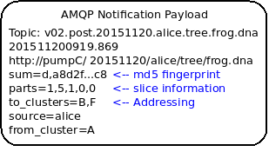
A Sarracenia notification contains a Uniform Resource Location (URL) informing clients that a particular datum has arrived, thus inviting them to download it. The URL can advertise any protocol that both client and server understand: HTTP, HTTPS, SFTP for example. If new protocols become important in the future, then their implementation can be done with no change in the notification layer.
As these notifications are sent in real-time, clients can initiate downloads while the datum in question is still in server memory and thus benefit from optimal retrieval performance. As the clients' time of access to the data is more closely clustered in time, overall i/o performed by the server is minimized.
A notification also contains a fingerprint, or checksum, that uniquely identifies a product. This allows nodes to identify whether they have received a particular datum before or not. This means that the risks of misrouting data are lower than before because if there are any cycles in the network, they are resolved automatically. Cycles in the connectivity graph are actually a benefit as they indicate multiple routes and redundancy in the network, which will automatically be used in the event of node failure.

With AMQP Notices on a Standard File Server
Several robust and mature protocols and software stacks are available for many data transport protocols: FTP, HTTP, HTTP(S), SFTP. A file server, as a means of Transporting data is a solved problem with many solutions available from the broader industry. In contrast to data transport, pub/sub is an atomized area with myriad niche solutions, and no clearly dominant solution.
The Advanced Message Queueing Protocol is an open standard, pioneered by financial institutions, later adopted by many software houses large and small. AMQP is a replacement for proprietary message passing systems such as IBM/MQ, Tibco, Oracle SOA and/or Tuxedo. RabbitMQ is a prominent AMQP implementation, with deployments in many different domains:
- Backend processing at an Internet startup ( Soundcloud )
- HPC Monitoring System ( Los Alamos National Lab )
- Cloud Infrastructure ( OpenStack )
Rabbitmq provides a mature, reliable message passing implementation currently, but there are many other open source and proprietary implementations should that ever change. AMQP brokers are servers that provide message publish and subscribe services, with robust queuing support, and hierarchical topic based exchanges.
Each Server runs a broker to advertise their own contribution, and they subscribes to each others' advertisements. Advertisements are transitive, in that each node can advertise whatever it has downloaded from any other node so that other nodes connected to it can consume them. This implements mesh networking amongst all NC/DCPC/GISCs.
An AMQP notification layer added to the existing file transfer network would:
- improve security because users never upload, never have to write to a remote server. (all transfers can be done by client initiated subscriptions, no write to peer servers needed).
- permit ad-hoc exchanges among members across the RMDCN without having to involve third parties.
- can function with only anonymous exchanges, to eliminate the need for authentication entirely.
- provide a like-for-like mechanism to supplant the traditional GTS (similar performance to existing GTS, no huge efficiency penalties).
- transparent (can see what data is on a node, without requiring human exchanges). (Authorized persons can browse an FTP/SFTP/HTTP tree).
- enable/support arbitrary interconnection topologies among NC/DCPC/GISCs (cycles in the graph are a feature, not a problem, with fingerprints).
- Shorten the time for data to propagate from NMC to other data centres across the world (fewer hops between nodes than in GTS, load more distributed among nodes).
- relatively simple to configure for arbitrary topologies (configure subscriptions, little need to configure publication).
- route around node failures within the network in real-time without human intervention (routing is implicit and dynamic, rather than explicit and static).

And an Agreed Directory Tree
Similar to the choice of indices in databases, efficiency of exchange in file servers depends critically on balancing the hierarchy in terms of numbers of files per directory. A hierarchy which ensures less than 10,000 files per directory performs well.
Example server: http://dd.weather.gc.ca
The tree on dd.weather.gc.ca is the original deployment of this type of service. As an example of the kind of service (though the details would be different for WMO), it has directory ordering as follows:
http://dd.weather.gc.ca/bulletins/alphanumeric/20180211/SA/CWAO/12/
There is an initially fixed base url: http://dd.weather.gc.ca/bulletins/alphanumeric/, Then the subdirectories begin: date (YYYYMMDD), WMO-TT, CCCC, GG, then the bulletins, whose content is:
Parent Directory -
[ ] SACN31_CWAO_111200__CYBG_42669 11-Feb-2018 12:01 98
[ ] SACN31_CWAO_111200__CYQQ_42782 11-Feb-2018 12:02 106
[ ] SACN31_CWAO_111200__CYTR_43071 11-Feb-2018 12:03 98
[ ] SACN31_CWAO_111200__CYYR_42939 11-Feb-2018 12:01 81
[ ] SACN31_CWAO_111200__CYZX_43200 11-Feb-2018 12:02 89
[ ] SACN43_CWAO_111200__CWHN_43304 11-Feb-2018 12:12 85
.
.
.
Note
These files do not follow WMO naming conventions, but illustrate some interesting questions. In WMO bulletins, one should issue only one bulletin with the AHL: SACN31 CWAO 111200 For circulation to the WMO, these individual observations are collected and indeed sent as a single SACN31 CWAO 111200, but that means delaying forwarding of CYBG, BYQQ, CYTR reports while we wait until the end of the collection interval ( 12:05? ) before emitting the collected bulletin. This datamart, for national use, offers individual observations as they arrive in real-time, appending the station id as well as a randomizing integer to the file name, to ensure uniqueness.
This is an illustration of an early prototype which remains in use. The actual tree for WMO use would likely be different.
Aside from the contents of the tree, the rest of the functionality proposed would be as described. One can easily subscribe to the datamart to replicate the entire tree as the data is delivered to it. While the application does not require it, the standardization of the tree to be exchanged by WMO members will substantially simplify data exchange. Most likely, an appropriate tree to standardize for WMO uses would be something along the lines of:
20180210/ -- YYYYMMDD
CWAO/ -- CCCC, origin, or 'Source' in Sarracenia.
00/ -- GG (hour)
SA/ -- TT
follow the naming convention from WMO-386...
If we have an ordering by Day ( YYYYMMDD ), then ORIGIN ( CCCC? ), then data types, and perhaps hour then the trees that result would be nearly optimally balanced, and ensure rapid retrieval. The optimal configuration is also clearly visible since this tree is can be inspected by any WMO member simply by browsing the web site, in contrast to databases, where the indexing schemes are completely hidden.
Nodes copy trees from each other verbatim, so the tree is the relative location on any node. WIS metadata pointers to the actual data can then be programmatically modified to refer to the nearest node for data, or a straight-forward search algorithm can be implemented to ask other nodes, without the need to resort to an expensive search query.
In AMQP, subscriptions can be organized into hierarchical topics, with the period character ('.') as a separator. For this application, the directory tree, with '/' or '' as a separator replaced by AMQP's separator is is translated into an AMQP topic tree. AMQP has rudimentary wildcarding, in that it uses the asterisk ('*') to denote any single topic, and the hash symbol ('#') is used to match any remainder of the topic tree. So examples of how one could subscribe selectively on a node are:
v02.post.# -- all products from all Origins (CCCC)'s on a node.
v02.post.*.CWAO.# -- all products from CWAO (Canada) on a node
v02.post.*.CWAO.WV.# -- all volcanic ash warnings (in CAP?) from Canada RSMC/VAAC.
Note
The topic prefix (beginning of the topic tree) is constant for this discussion. Explanation:
v02 - identifies the protocol version. Should the scheme change in future, this allows for a server to serve multiple versions at once. This has already been used to progressively migrate from exp, to v00, to v02.
post - identifies the message format. Other formats: report, and pulse. described elsewhere.
After this first level of filtering is done server side, Sarracenia implements a further level of client-side filtering using full Regular Expressions to either exclude or include specific subsets.
To exchange known data types, one needs only define the directories that will be injected into the network. Nations can adopt their own policies about how much data to acquire from other countries, and how much to offer for re-transmission. To propose a new data format or convention, a country uploads to a new directory on their node. Other countries that wish to participate in evaluating the proposed format can subscribe to the feed from that node. Other countries that start producing the new format add the directory to their hierarchy as well. No co-ordination with intervening parties is needed.
Should two countries decide to exchange Numerical Weather Products (NWP), or RADAR data, in addition to the core types exchanged today, they simply agree on the directories where this data is to be placed, and subscribe to each others' node feeds.

Simple/Scalable Peer Configurations for Nations
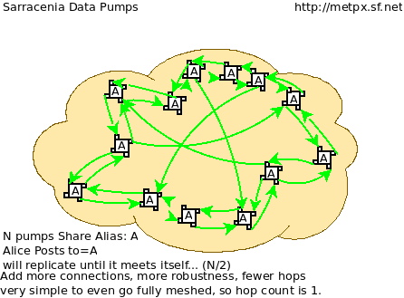
Assume a mesh of national nodes with arbitrary connectivity among them. Nodes download from the first neighbour to advertise data, transfers follow the speed of downloading from each node. If one node slows, neighbours will get advertisements from other nodes that present new data earlier. So the network should balance bandwidth naturally.
National centres can have as much, or as little, information locally as they see fit. The minimum set is only the country's own data. Redundancy is achieved by many nations being interested in other nations' data sets. If one NC has an issue, the data can likely be obtained from another node. NC's can also behave selfishly if they so choose, downloading data to internal services without making it available for retransmission to peers. Super national nodes may be provisioned in the cloud, for management or resource optimization purposes. These nodes will ease communication by adding redundancy to routes between nations. With mesh style interconnection, in the case of a failure of a cloud provisioned node, it is likely that connections between countries automatically compensate for individual failures.
There is also little to no requirement for the super-national GISC in this model. Nodes can be established with greater or lesser capacity and they can decide for themselves which data sets are worth copying locally. As the subscriptions are under local control, there is a sharply reduced need for co-ordination when obtaining new data sets. There is also no need for a node to correspond uniquely to a national centre. There are many situations where members with more resources assist other members, and that practice could continue by having nodes insert data onto the GTS on other countries' behalf. Redundancy for uploading could also be accomplished by uploading to multiple initial sites.
If there are nodes that, for some reason, do not want to directly communicate, they do not subscribe to each others advertisements directly. Each can acquire data safely through intermediaries that each is comfortable with. As long as there is a single path that leads between the two nodes, data will arrive at each node eventually. No explicit action by intermediaries is needed to ensure this exchange, as the normal network will simply route around the missing edge in the graph.
If there is misbehaviour, other nodes can cease subscribing certain data on a node or cease to bring in any data at all from a node which is injecting corrupt or unwanted data. It could happen that some nations have very good bandwidth and server performance. The motivation would be to obtain the data most quickly for themselves, however by implementing this excellent service, it attracts more demand for data from the rest of the world. If one node feels they are shouldering too much of the global load of traffic exchange, there are many straight-forward means to encourage use of other nodes: not posting, delayed posting, traffic shaping, etc... All of these techniques are straight-forward applications of industry technology, without the need to resort to WMO specific standards.

Using An Open Reference Stack
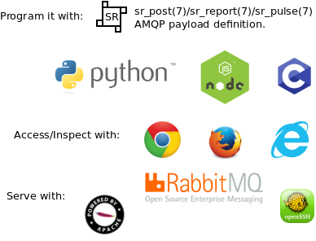
A sample national mesh node (Linux/UNIX most likely) configuration would include the following elements:
- subscription application to post national data to the local broker for others ( Sarracenia )
- subscription application connects to other nodes' brokers ( Sarracenia ) and post it on the local broker for download by clients.
- AMQP broker serve notifications ( Rabbitmq )
- http server to serve downloads (plain old apache-httpd, with indexes).
- ssh server for management and local uploads by national entities (OpenSSH)
The stack consists of entirely free software, and other implementations can be substituted. The only uncommon element in the stack is Sarracenia, which so far as only been used with the RabbitMQ broker. While Sarracenia (https://github.com/MetPX/sarracenia/blob/master/doc/sarra.rst ) was inspired by the GISC data exchange problem, it is in no way specialized to weather forecasting, and the plan is to offer it to other for in other domains to support high speed data transfers.
Sarracenia's reference implementation is less than 20 thousand lines in Python 3. Clients have contributed open source partial implementations in javascript, C#, and Go, and have implemented another in C was done to support the High Performance Computing use case. The message format is published and demonstrably program language agnostic.
This stack can be deployed on very small configurations, such as a Raspberry Pi or a very inexpensive hosted virtual server. Performance will scale with resources available. The main Canadian internal meteorological data pump is implemented across 10 physical servers (likely too many, as all of them are lightly loaded).

Statelessness/Crawlable
As the file servers in question present static files, transactions with the proferred stack are completely stateless. Search engines crawl such trees easily, and, given critical mass, one could arrange with search engines to provide them with a continuous feed of notifications so that a given user's index could be updated in real time. These characteristics require no work or cost as they are inherent to the technologies proposed.

Programmability/Interoperability
A new application to process sr_post messages can be re-implemented if there is a desire to do so, as all design and implementation information, for all three implementations (Python, C, node.js) as well as source code, is publically available. The python implementation has an extensive plugin interface available to customize processing in a wide variety of ways, such as to add file transfer protocols, and perform pre or post processing before sending or after receipt of products. Interoperability with Apache NiFi has been demonstrated by some clients.

Priorities
FIXME: Make a picture, with separate queues for separate data types?
In WMO GTS, data is segregated into alphanumeric vs. binary data, and within a single flow, a priority mechanism was available, whose implementation was not really specified. The goal is essentially for the most time critical data to be transferred before other queued information. When too much data is sent over a high priority channel, some implementations can end up starving the lower priority data, which is not always desirable.
The effect of priority is to establish separate queue for products at each priority level. In this proposal, rather than having explicit priorities within a single queue, one just uses separate queues for different data sets. As high priority data must be smaller or infrequent than other data in order to transferred and processed quickly, the queueing on these high priority queues will naturally be shorter than those containing other data. Since the mechanism is general, the details of implementation do not require rigid standardization, but can be implemented by each NMC to fit their needs.

Caveat: Solution for This Problem, Not Every Problem
AMQP brokers work well, with the sarracenia implementations at the Canadian meteorological service, they are used for tens of millions of file transfers for a total of 30 terabytes per day. Adoption is still limited as it is more complicated to understand and use than say, rsync. There are additional concepts (brokers, exchanges, queues) that are a technical barrier to entry.
Also, while brokers work well for the moderate volumes in use (hundreds of message per second per server) it is completely unclear if this is suitable as a wider Internet technology (ie. for the 10K problem). For now, this sort of feed is intended for dozens or hundreds of sophisticated peers with a demonstrated need for real-time file services. Demonstrating scaling to internet scale deployment is future work.
There are many other robust solutions for the file transfer problem. AMQP is best used only to transfer notifications (real-time transfer metadata), which can be very large in number but small in volume, and not the data itself.

Annex B
Sarracenia Status January 2018
Source: https://github.com/MetPX/sarracenia/blob/master/doc/deployment_2018.rst
Sarracenia is a small application iteratively developed by addressing one use case at a time, so development and deployment have been inextricably linked up to this point. That iterative process precipitated changes in the core of the application which have made it something of a moving target until now. In January 2018, the application has reached the point where all intended use cases are addressed by the application core. In the coming year, the emphasis will be on facilitating on-boarding, development of some derived services, and deploying the newly complete application more generally.
Contents
- Comparison to 2015 Video
- Central Data Flows
- Weather Application Flows
- GOES-R Acquisition
- HPC Acquisition Feeds
- RADAR Data Flows
- HPC Mirroring
- Application Changes in 2017
- Coming in 2018

Comparison to 2015 Video
The November 2015 video ( Sarracenia in 10 Minutes ) outlined a vision. First phase of development work occurred in 2015 and early 2016, followed by important deployments later in 2016. This update, written in early 2018, explores progress made mostly in 2017.
Use cases mentioned in the video which were implemented:
- Central meteorological pumping has made substantial progress in migrating to the new stack. This was the central initial use case that drove initial work. The transformation is not complete but is well in hand.
- Redundant RADAR acquisition through two national hubs (spring 2016)
- National Ninjo (main workstation for Forecasters) Dissemination (summer 2016)
- Unified RADAR Processing (application to transform volume scans to products) data flows (through 2017)
Use cases in the video, but not yet realized:
- End user usage. A few trials were completed in early in 2017 leading to some review, refactoring, and now retesting.
- Data sets from sequencers have been waiting for end user use cases to be improved.
- Reporting to sources who consumed their products. The feature is designed but further implementation, testing and careful deployment is needed.
- Multi-pump routing by source-routing. Currently routing through multiple pumps is done by pump administrators, rather than end users. Without end-user on-boarding, routing by sources was a low priority.
- The mesh interconnect model envisioned has not seen an appropriate use case.
Unanticipated use cases implemented:
- GTS data exchange: CMC <-> NWS. NWS requested a change in connectivity in December 2015.
- HPC mirroring (to be completed in Spring 2018).
- Legacy Application 7-way replication (for SPCs) implemented last year.
- GOES-R acquisition (live as of January 2018).
Details to follow.

Central Data Flows
The slide below corresponds to deployed daily data flows in support of Environment Canada, mostly for operational weather forecasting, in place since January 2018.
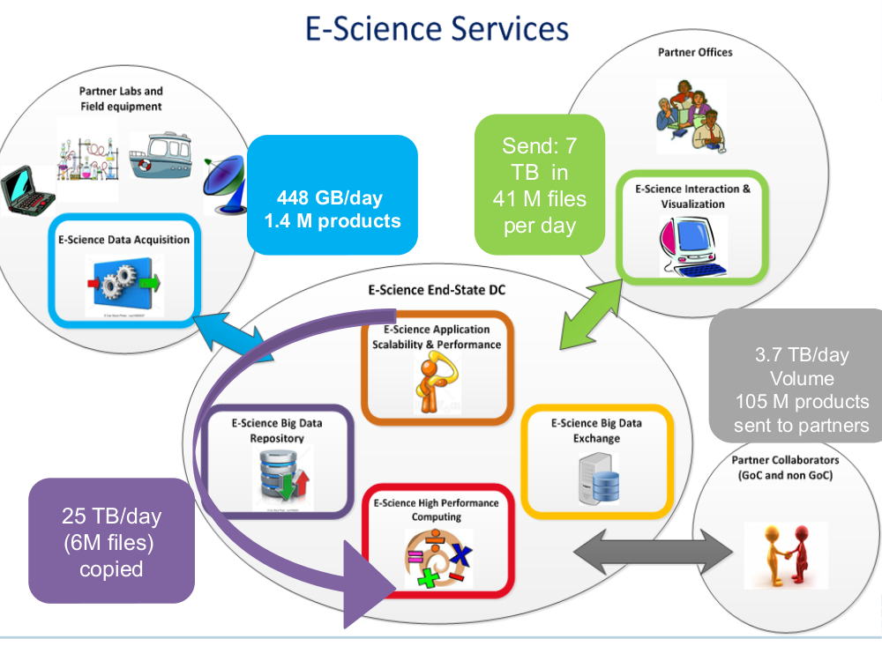
Sarracenia is being used operationally to acquire about four terabytes of observations from automated weather observing systems, weather RADARS which deliver data directly to our hubs, and international peer operated public file services, which provide satellite imagery and numerical products from other national weather centres.
Within the main high performance computing (HPC) data centre, there are two supercomputers, two site stores, and two pre- and post-processing clusters. Should a component in one chain fail, the other can take over. The input data is sent to a primary chain, and then processing on that chain is mirrored, using sarracenia to copy the data to the other chain. That's about 16 of the 25 terabytes of the data centre traffic in this diagram.
A distillation of the data acquired, and the analysis and forecasts done in HPC, is the 7 terabytes at the top right, that is sent to the seven regional Storm Prediction Centres (SPCs).
The products of the SPCs and the central HPC are then shared with the public and partners in industry, academia and other governments.

Weather Application Flows
FIXME: picture?
There is a number (perhaps a dozen?) of older applications (the most prominent ones being BULLPREP and Scribe) used for decades in the Storm Prediction Centres to create forecast and warning products. These applications are based on a file tree that they read and write. Formerly, each application had its own backup strategy with one of the six other offices and bi-lateral arrangements were made to copy specific data among the trees.
In January 2017, complete 7-way replication of the state file trees of the applications was implemented so that all offices have copies of files in real-time. This is accomplished using Sarracenia through the eastern hub. Any forecast office can now take over work of any product for any other, with no specific application work needed at all.

GOES-R Acquisition
Acquisition of simulated and real GOES-R products from NOAA's PDA, as well as via local downlinks at one location (eventually to become two) was entirely mediated by Sarracenia. The operational deployment of GOES-R happened in the first week of January, 2018.

HPC Acquisition Feeds
FIXME: picture?
The supercomputing environment was entirely replaced in 2017. As part of that, the client Environmental Data acquisition suite (ADE in French) was refactored to work with much higher performance than previously, and to accept Sarracenia feeds directly, rather than accepting feeds from previous generation pump (Sundew). The volume and speed of data acquisition has been substantially improved as a result.

RADAR Data Flows
If we begin with RADAR data acquisition as an example, individual RADAR systems use FTP and/or SFTP to send files to eastern and western communications hubs. Those hubs run the directory watching component (sr_watch) and determine checksums for the volume scans as they arrive. The Unified RADAR Processing (URP) systems sr_subscribes to a hub, listening for new volume scans, and downloads new data as soon as they are posted. URP systems then derive new products and advertise them to the local hub using the sr_post component. In time, we hope to have a second URP fully at the western hub.
In regional offices, the NinJo visualization servers download volume scans and processed data from URP using identical subscriptions, pulling the data from whichever national hub makes the data available first. The failure of a national hub is transparent for RADAR data in that the volume scans will be downloaded from the other hub, and the other URP processor will produce the products needed.
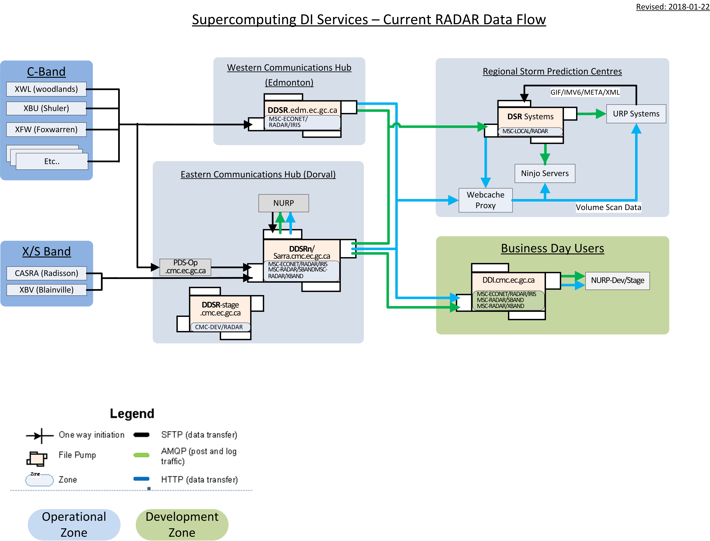
Each site has multiple Ninjo servers. We use http-based file servers, or web accessible folders to serve data. This allows easy integration of web-proxy caches, which means that only the first Ninjo server to request data will download from the national hub. Other Ninjo servers will get their data from the local proxy cache. The use of Sarracenia for notifications when new products are available is completely independent of the method used to serve and download data. Data servers can be implemented with a wide variety of tools and very little integration is needed.

HPC Mirroring
All through 2017, work was proceeding to implement high speed mirroring between the supercomputer site stores to permit failover. That work is now in a final deployment phase, and should be in operations by spring 2018. For more details see: HPC Mirroring Use Case

Application Changes in 2017
Development of Sarracenia had been exploratory over a number of years. The use cases initially attacked were those with a high degree of expert involvement. It proceeded following the minimum viable product (MVP) model for each use case, acquiring features to deal with next use case prior to deployment. In 2016, national deployment of NinJo and the Weather.
Expanded use cases explored:
- Mirroring: Prior to this use case, Sarracenia was used for raw data dissemination without regard for permissions, ownership, symbolic links, etc... For the mirroring use case, exact metadata replication was a surprisingly complex requirement.
- C-implementation: In exploring large scale mirroring, it became obvious that for sufficiently large trees (27 Million files), the only practical method available was the use of a C shim library. Having all user codes invoke a Python3 script is complete nonsense in an HPC environment, so it was necessary to implement a C version of Sarracenia posting code for use by the shim library. Once the C implementation was begun, it was only a little additional work to implement a C version of sr_watch (called sr_cpost) which was much more memory and CPU efficient than the Python original.
- Node.js implementation: A client of the public datamart decided to implement enough of Sarracenia to download warnings in real-time.
- The application was refactored to maximize consistency through code reuse, reducing about 20% of the code size at one point. The code returned to the initial size when new features were added, but it remains quite compact at less than 20 kloc.
- End-user usage: All of the deployments thus far are implemented by analysts with a deep understanding of Sarracenia, and extensive support and background. This year, we went through several iterations of having users deploy their flows, collecting feedback and then making it easier for end users at the next iteration. Many of these changes were breaking changes, in that options and ways or working were still prototypes and required revision.
Changes to support end user usage:
- Exchanges were an administrator-defined resource. Permission model changed such that users can now declare exchanges.
- Previously, one had to look on web sites to find examples. Now, the list command displays many examples included with the package.
- It was hard to find where to put settings files. The list/add/remove/edit commands simplify that.
- In each plugin entry point, one had to modify different instance variables, was refactored for consistency across all of them (on_msg, on_file, on_part, on_post, do_download, do_send, etc...).
- Partitioning specifications were arcane and were replaced with the blocksize option, with only three possibilities: 0, 1, many.
- Routing across multiple pumps was arcane. The original algorithm was replaced by a simpler one with some smarter defaults. Users can now usually ignore it.
- A much more elegant plugin interface is available to have multiple routines that work together, specified in a single plugin.
- Previously, only advertised on web servers relative to the root URL. Now, non-root base URL support was added.
The only major operational feature introduced in 2017 was save/restore/retry: if a destination has a problem, there is substantial risk of overloading AMQP brokers by letting queues of products to transfer grow into millions of entries. Functionality to efficiently (in parallel) offload broker queues to local disk was implemented to address this. At first, recovery needed to be manually triggered (restore) but by the end of the year, an automated recovery (retry) mechanism was working its way to deployment, which will reduce requirements for oversight and intervention in operations.

Coming in 2018
As of release 2.18.01a5, all of the use cases targeted have been explored and reasonable solutions are available, so there should be no further changes to the existing configuration language or options. No changes to existing configuration settings are planned. Some minor additions may still occur, but not at the cost of breaking any existing configurations. The core application is now complete.
Expect in early 2018 for the last alpha package release and for subsequent work to be on a beta version with a target of a much more long-lived stable version some time in 2018.
- HPC mirroring use case deployment will be completed.
- The Permanent File Depot (PFD) use case will be deployed. Currently, this is used to cover a short time horizon. One can extend it arbitrarily into the past by persisting the time-based tree to nearline storage. In development since 2016, gradually progressing.
- Improve deployment consistency: The changes in 2017 were confusing for the expert analysts, as significant changes in details occurred across versions. Different deployments currently use different operational versions, and most issues arising in operations are addressed by the existing code, but are not yet deployed to that use case. In 2018, we will revisit early deployments to bring them up to date.
- Continued improvement in pre-deployment testing.
- The Sarrasemina indexing tool, which facilitates finding feeds, to be deployed to assist onboarding.
- Improved onboarding documentation. Reference materials are thorough, but introductory quick-start and gateway oriented materials need work. French translations are also needed.
- Reporting: While reporting was baked in from the start, it proved to be very expensive, and so deployments to date have omitted it. Now that deployment loads are quieting down, this year should allow us to add real-time report routing to deployed configurations. There is no functionality to develop, as everything is already in the application, but mostly not used. Use may uncover additional issues.
- Pluggable checksum algorithms. Currently checksum algorithms are baked into the implementations. There is a need to support plugins to support user-defined checksum algorithms (expected in 2.18.02a1).
- Continued progressive replacement of legacy application configurations (RPDS, Sundew).
- Continued adaptation of applications to Sarracenia (DMS, GOES-R).
- Deployment of additional instances: flux.weather.gc.ca, hpfx.collab.science.gc.ca, etc...
- Continued work on the corporate approval and funding of the western hub (aka. Project Alta).

