[Jose Mauro REZENDE][RAIII] South American hydrology project aggregating hydrological observations and publishing those
Name of the Project: PLATA-HIS/WIS - Hydrologic Information System Central Web Service Registry for the Plata basin in South America

The project was proposed by Silvano Pecora, head of Hydrology – ARPA Emilia- Romagna, Italy.
Countries: Argentina, Bolivia, Brazil, Paraguay and Uruguay

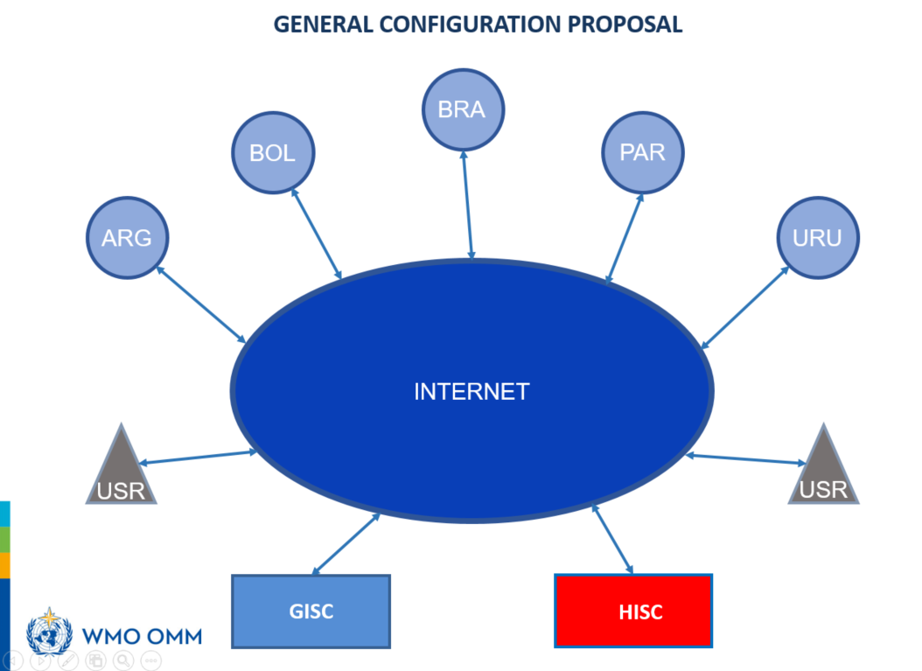

Links: http://gicat.inmet.gov.br/, http://giaxe.inmet.gov.br/ and http://sosclient.inmet.gov.br/helgoland/#/map

PLATA-HIS can be deﬁned as a collection of components, which work together to store, index, access and distribute hydrologic information. The system contains servers, catalogs and applications, which communicate with one another through a set of web services. Web services are the set of protocols and speciﬁed functions that exchange hydrologic metadata and data (i.e. time series) through the web using a common standardized language,
The individual components of PLATA-HIS each serve an important role in the data discovery and fetching process. Data providers are the principal locations for storing large volumes of hydrologic data, speciﬁcally time series. Within the provider itself, data and metadata are managed in a database and then exposed through its Principal GISC (Brasilia) as well as through a suite of web services so that remote users can then access the data through the web.

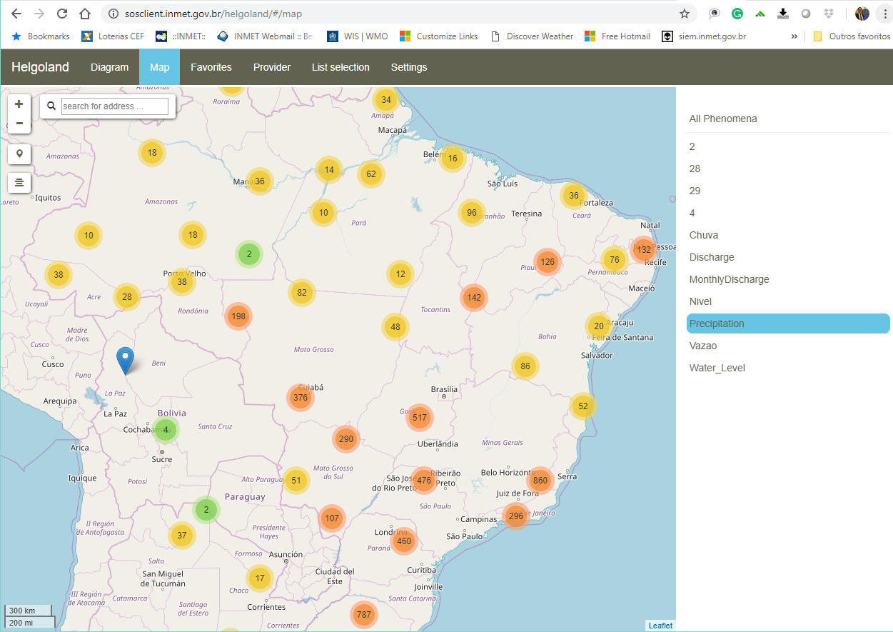

Some Considerations
A brokered architecture is proposed with a view to cause minimum disturbance to database management in each Center. The Broker and Mediator will provide adequate adaptation of formats and protocols.
The language for describing water data will be the standard WaterML. Web services techniques will be used to create the metadata catalogue of national water data sources, and users will use free software for data access. The figure below shows the general architecture:

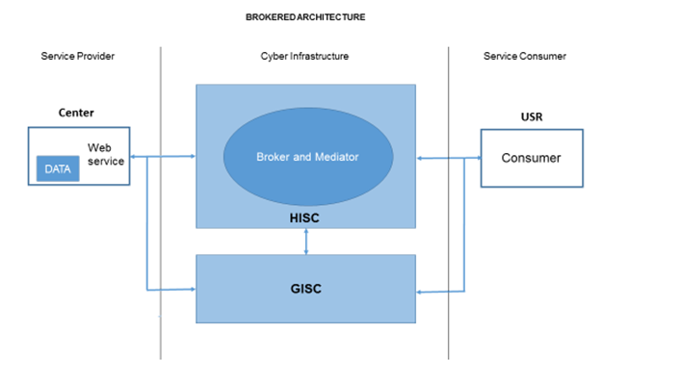

The proposal for The Hydrological Information System (HIS/SIH) is to be the hydrological data exchange component of the WIGOS-SAS/CP Project. SIH component will use standards being adopted by the hydrological community as guided by the WMO Commission on Hydrology, ensuring compatibility with WIGOS and WIS standards.
Interoperability between SIH and WIS will be ensured through appropriate interface to be installed in the regional GISC.

Timeline
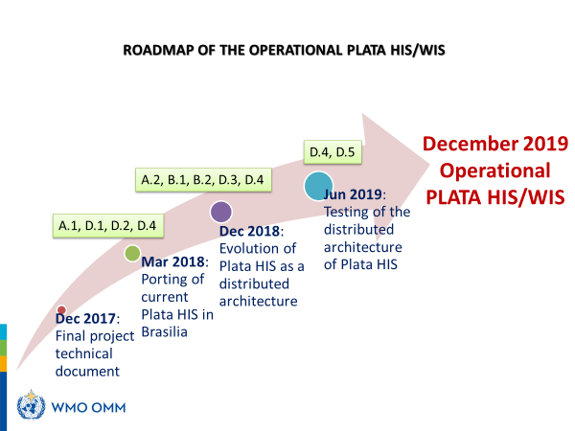

Notes:
- The system is composed of a catalog, which helps the user find the data, a catalog, which gets the data, and a taxonomy catalog to help user translate or describe what they are looking for. Once the user define WHAT, WHEN, WHERE and HOW (GI-cat) it gets a list of products to be used to fetch the data (GI-axe).

- The authentication system is not well implemented yet and is being studied.

