WP7: Capacity Development

Introduction
TT-GISC launched Work Package-7 to develop common training materials to know fundamentals of WIS by TT-GISC2017.
According to the WMO Mid-Term Performance Assessment Report 2016-2017, more than 43 percent of members had little or no knowledge of WIS and have not implemented WIS functionality.
Figure 1: National Knowledge of WIS Figure 2: Level of WIS implementation

WIS “Competencies and Curriculum” Development Workshop, Oct. 2013 Geneva, proposed WIS Training and Learning Guide. The guide was published in the Guide to the WMO Information System, WMO-No. 1061 as Appendix A and it covers the whole gamut of competencies required for people working with WIS. In the WIS training and learning guide there are seven competencies across four basic functional areas have been identified as follows:
Infrastructure
1. Manage the physical infrastructure
2. Manage the operational applications
Data
3. Manage the data flow
4. Manage data discovery
External Interactions
5. Manage interaction among WIS centres
6. Manage external user interactions
Overall service
7. Manage the operational service
Meanwhile, each Regional Association published Regional Implementation Plan of WIS including basic description of WIS and guidance of implementing WIS centre. Some of Regional Association endorsed the future WIS training activities proposed by GISCs as listed in Annex. The proposed WIS training activities include all area of WIS competencies such as managing data flow, discovery metadata, metadata management, DAR service etc. And to conclude, GISCs have developed and provided training courses with reference to the seven competencies from the WMO Information System Training and Learning Guide.

Guide to the WMO Information System
6.2.3. Capacity-building support
Each GISC should develop and provide training courses with reference to the WIS competencies and the WMO Information System Training and Learning Guide (Appendix A) to meet the capacity-development requirements of the centres in its area of responsibility.

Objectives
As undertaking activities of WIS training and workshop, each GISC has utilized its own materials according to the WIS training and learning guide. Therefore, it is required to consolidate dispersed information and to share each GISC’s training materials and then common capacity development material of WIS will be used as basic reference to acquire the required competencies.

Common Training Materials for WIS

Target
As a result of the survey from WMO Mid-Term Performance Assessment Report 2016-2017, the gaps of national knowledge of WIS among members were identified. The common training materials for WIS should be to fill these gaps and to encourage WIS competencies for members who having had little or no knowledge of WIS.

Scope
Main purpose of training material is to raise the level of competencies for who has little knowledge of WIS. Therefore, training materials should consist of fundamental contents to help NCs and DCPCs implement and facilitate their WIS centre. Key learning resources for seven WIS competencies are presented from Guide to the WIS but it is difficult for NCs and DCPCs to utilize those resources. The common training materials can provide summarized information from key learning resources as a baseline of training materials. Due to different IT environment on site and various software of GISCs, the materials focus on data management with avoiding infrastructure and operational functions.
Proposed scopes of common training materials are as follows;
Functional Area | Competency | Key learning resources
Data | Manage the data flow | - Data policies  - GTS data exchange  - Data representation  - WIS discovery, access and retrieval  - Managing GTS data exchange  - security of data exchange  - network management
Data | Manage data discovery | - WIS metadata guidance  - Metadata entry and management tools  - Samples of how to complete typical metadata record  - Metadata policies and WIS metadata guidelines  - ISO 19100 series: ISO standards on geographic information

Strategic approach
- Sharing training materials
Each GISC has performed WIS training activities with its own training materials for lecture, presentation and brochure etc. Those materials are helpful for other GISCs to refer to reference items and it can be to foster culture of compliance as a component of capacity development for WIS.
It is proposed that “WIS Training Material”, shared repository for WIS training materials be created in wis-wiki and GISCs are collaborating in collecting its own materials not limited to any language but preferred to English. Sharing materials will be collected in the directories categorized by key learning resources as shown in the proposed scopes of common training materials.

- Establishing common training materials
Regarding the proposed scopes of training materials, the detailed list of contents should be consulted with the members of work package. Each member should establish assigned common training materials in English. The baseline of the materials is suggested by key learning resources from Guide to the WIS. Those materials will be published on wis-wiki and utilized in the training, workshop and self-directed study.

- Work Plan (proposed)
Section | Timeline |  | Work | Participants
Sharing training materials | 2018 | 1Q | Creation of shared repository | WP-7 leader  WMO secretariat
Sharing training materials | 2019 | 2Q | Collection of training materials from GISCs | All GISCs
Sharing training materials | 2019 | 3Q | Review by TT-GISC2019
Common training materials | 2018 | 4Q | Sorting the range of materials from the scopes  Assigning materials for each member | WP-7 members
Common training materials | 2019 | 1Q | Outlining the assigned training materials | WP-7 members
Common training materials | 2019 | 2Q | Draft of the common training materials | WP-7 members
Common training materials | 2019 | 3Q | Reviewed by TT-GISC2019 | WP-7 members
Common training materials | 2020 | 1Q | Final version of training materials | WP-7 members

References
[1] WMO Mid-Term Performance Assessment Report [https://www.wmo.int/pages/about/documents/Full_Mid-TermReport_2016-2017.pdf]
[2] Guide to the WMO Information System, WMO-No. 1061 – Appendix A
[3] WMO Capacity Development Strategy and Implementation Plan, WMO-No. 1133
[4] RAII sixteenth session - Decision15 [https://library.wmo.int/doc_num.php?explnum_id=3549]
[5] RAVI seventeenth session – Resolution 3.2(8)/1

Recommended Text
The meeting noted the gaps of national knowledge of WIS among members from the WMO Mid-Term Performance Assessment Report 2016-2017 and recognized that common training materials are required to fill these gaps and to encourage WIS competencies of members in proper method. GISCs have developed and provided training courses with reference to the seven competencies from the WMO Information System Training and Learning Guide. The meeting recommended that “WIS Training Material”, shared repository for WIS training materials be created in wis-wiki and GISCs are collaborating in collecting its own materials to foster culture of compliance as a component of capacity development for WIS.
To develop common training materials to understand fundamentals of WIS, the methodology was discussed and next TT-GISC2019 will review the common training materials established by Work Package task members. The baseline of the materials is suggested by key learning resources from the Guide to the WIS and proposed scopes of training materials are as follows;
Functional Area | Competency | Key learning resources
Data | Manage the data flow | - Data policies  - GTS data exchange  - Data representation  - WIS discovery, access and retrieval  - Managing GTS data exchange  - security of data exchange  - network management
Data | Manage data discovery | - WIS metadata guidance  - Metadata entry and management tools  - Samples of how to complete typical metadata record  - Metadata policies and WIS metadata guidelines  - ISO 19100 series: ISO standards on geographic information

--------------------

Annex A– Training-Capacity Building Activities from status report (updated from status report)
GISC | Capacity Building Activities
Brasilia | -
Beijing | On-site CMAcast and WIS training for AoR for 4 countries in 2018  Invited CMAcast and WIS training for AoR users in 2018
Casablanca | WIS workshop in 2013 & 2015  Plan on data connectivity with centres of AoR  Plan on survey aiming to understand each centre’s capabilities and data communication
Exeter | Metadata and user training course with MF for NMCs in jointed area of responsibility in 2018
Jeddah | No training activity in 2018
Melbourne | No training activity in 2018 and no future plan yet
Moscow | Webinar for WIS training including metadata management, data uploading and metadata generation for AoR centres in 2018  Plan on webinar for data interaction in AoR to implement WIS monitoring in 2019  Training materials are shared on GISC Moscow’s portal
New Delhi | Operational WIS training for internal staff in 2017 and 2018  Plan on WIS training for NCs of AoR in 2019
Offenbach | Training for RTH Sweden in 2018  Plan on usage of GISC’s portal and metadata generator in 2019
Pretoria | Internal training twice for network administrator for GISC system in 2018
Seoul | Annual WIS training course for invited members in RTC-Korea
Tehran | No training activity in 2018
Tokyo | Workshop for WIS capacity building every 2 year for AoR members since 2010  On-site technical meeting for metadata quality and AMDCN at 2 members every year
Toulouse | Metadata and user training course with MF for NMCs in jointed area of responsibility in 2018  Plan to focus on on line training materials for NCs and DCPCs  Training materials are shared on GISC Toulouse’s portal
Washington | Plan on WIS training for RAIV in Spanish language in 2019

Annex B– Proposed WIS training activities of RAII and RAVI

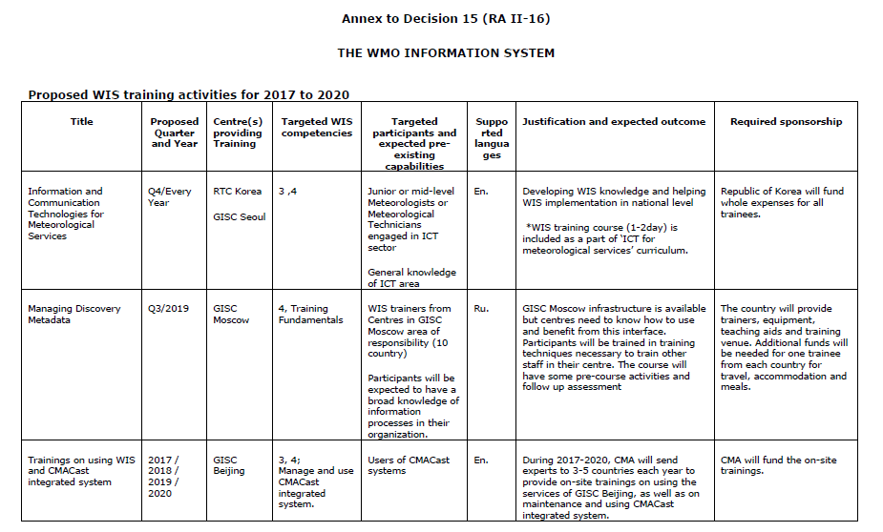
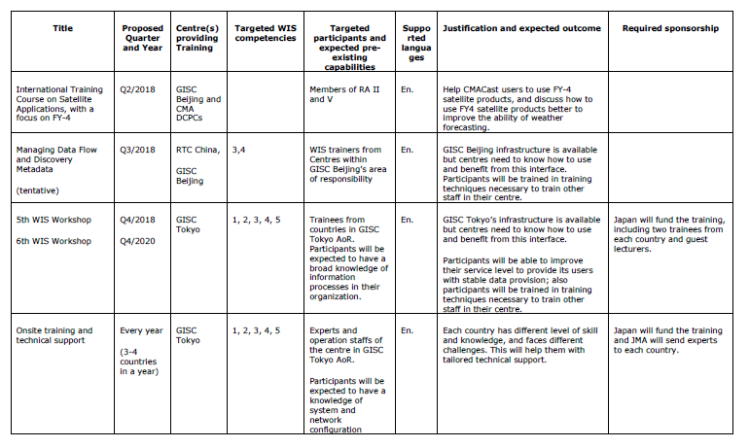

Annex to Resolution 3.2(8)/1 (RA VI-17)

WIS TRAINING ACTIVITIES
Proposed WIS training activities for 2018 to 2021

Title | Proposed Quarter and Year | Centre(s) providing Training | Targeted WIS competencies | Targeted participants and expected pre-existing capabilities | Supported languages | Justification and expected outcome | Required sponsorship
Ordering Data through GISC Offenbach | Q2/2019 | Offenbach | Usage of GISC Offenbach Portal Search and Retrieval  Subscriptions | Managers of Data Requests in AoR | English | Knowledge of GISC Offenbach Portal  Self-Service Data Requesting
Metadata Management at GISC Offenbach | Q1/2020 | Offenbach | DAR Metadata | Data Providers in AoR | English | Aim is to sharpen the awareness of the benefits of metadata  Further complete the WIS-GISC-Offenbach Set
Information and Communication Technologies for Meteorological Services |  | GISC Exeter/ Toulouse |  | Junior or mid-level Meteorologists or Meteorological Technicians engaged in ICT sector  General knowledge of ICT area | English | Developing WIS knowledge and helping WIS implementation in national level
Managing Discovery Metadata |  | GISC Exeter/ Toulouse | Training Fundamentals | WIS trainers from Centres in GISC Exeter and Toulouse area of responsibility  Participants will be expected to have a broad knowledge of information processes in their organization. | English | Training pack was created and delivered last year in Toulouse. For future training this may be delivered through an online course. | Online training, maybe sponsored via the OpenWis consortium.
Onsite training and technical support | Every year  (3-4 countries in a year) | GISC Exeter/ Toulouse | 1, 2, 3, 4, 5 |  | English | Each country has different levels of skill and knowledge, and faces different challenges. This will help them with tailored technical support.
Overview of WIS. Russian segment of WIS. Technical architecture of GISC Moscow. Demonstration of the functionality of GISC Moscow, principles of area meteorological data communication network (AMDCN), connecting a NC to GISC Moscow, using metadata to search for and retrieve data (DAR) in WIS (WMO Core Metadata Profile, especially training and supervision).  Practical exercises | Q1/2018 | GISC Moscow, RMTC Moscow | Knowledge of the WIS and the services provided by GISC Moscow. Use search and retrieval on the portal of GISC Moscow. Subscription. | Experts from centres in the AMDCN of GISC Moscow  Manage data | Russian | Knowledge of the Portal of GISC Moscow  Able to request and subscribe to data  Plan for connecting the participant’s NC to GISC Moscow and a backup GISC.
Metadata management in GISC Moscow. Virtual National Centres in GISC Moscow:  - general information about the remote workplace for accessing and editing NC metadata in GISCs by the operators of NCs within the GISC AMDCN. Organization of the work space of a “Virtual NC” (GISC profile)  - how to obtain the profile of the work space of a specialist of the NC.  - loading of data and creation of metadata | Q2/2018 | GISC Moscow, RMTC Moscow | Metadata editors | Data providers in WIS | Russian | NC is able to add and modify datasets in the WIS through GISC Moscow
Organization and interaction of GISC Moscow and NC/DCPCs in its area of responsibility for implementing the WIS monitoring. | Q4/2019 | GISC Moscow, RMTC Moscow | Monitoring in the area of responsibility of GISC | Experts responsible for NC, DCPCs | Russian | WIS monitoring within the area of responsibility of the participant’s centre

____________

